grep -R "Demo account" frontend/src

frp.admin
FrpAdmin_2026!Secure
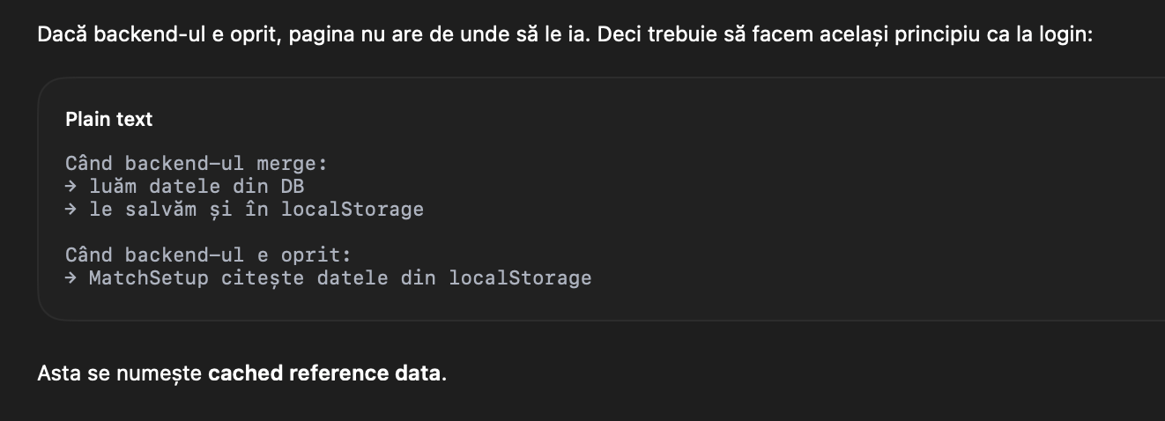

http://localhost:8080/api/matches/standings

gol dupa fault, din actiune, din penalty

