Politehnica University of Timișoara
Faculty of Automation and Computer Science




Ingineria Calculatoarelor

Water Polo Referee System

Student: Remețan Mihnea-Florin
Anul III, Specializarea Calculatoare
Subgrupa 3.2

Coordinator teachers: Prof. Dr. Ardelean Sebastian
Jura Ștefan

University year: 2025-2026, 2’nd semester
Table of contents

- Introduction
- Problem Statement and Objectives
- Objectives of the System
- Technologies Used
4.1 Frontend Technologies
4.2 Backend Technologies
4.3 Database
- System Architecture
- Application Structure
6.1 Frontend Structure
6.2 Backend Structure
- Main Functionalities
7.1 Authentication and Authorization
7.2 Administration Module
7.3 Team and Player Management
7.4 Match Setup
7.5 Live Match Management
7.6 Match History
7.7 Player Statistics
- Diagrams
8.1 Use-Case Diagram
8.2 Class Diagram
8.3 State Diagram
- Database Design
- API Overview
- Security Considerations
- Installation and Running the Application
12.1 Database Setup
12.2 Running the Backend
12.3 Running the Frontend
- Future Improvements
- Conclusion
- References

1. Introduction
The Water Polo Referee System is a full-stack web application designed to support the digital management of water polo matches. It replaces traditional manual methods with a centralized platform for recording, managing, and analyzing match data.
Referees must handle multiple real-time events, such as goals, fouls, and timing, which can be difficult to manage accurately using non-digital tools. This system addresses these challenges by providing a structured environment for live match control and data consistency.
The application follows a client-server architecture, using a React-based frontend, a Spring Boot backend, and a MySQL database for persistent storage. This design ensures scalability, maintainability, and a clear separation of concerns.
By integrating real-time match management with data storage and statistics, the system improves efficiency, accuracy, and access to information for referees and administrators.

2. Problem Statement and Objectives
Water polo refereeing involves managing multiple real-time events, including tracking player fouls, recording goals, and controlling match timing. In many cases, these activities are performed using manual or partially digital methods, which can lead to errors, inconsistencies, and difficulties in maintaining accurate records during fast-paced matches.
Additionally, the lack of centralized data storage limits the ability to review matches and analyze player performance after the game. This makes it harder to ensure transparency, improve decision-making, and generate meaningful statistics.
The main objective of this project is to develop a digital system that supports referees and administrators throughout the entire match lifecycle. The system aims to provide real-time event recording, ensure data consistency, and enable persistent storage of match information.
More specifically, the system pursues the following objectives:
• To provide a centralized platform for managing teams, players, referees, and observers;
• To support live match control through a dedicated and structured interface;
• To ensure secure access through role-based authentication and authorization;
• To store match data and generate statistics for post-match analysis;
• To maintain a clear separation between frontend, backend, and database layers.
By addressing these objectives, the system contributes to improving the accuracy, efficiency, and reliability of water polo match management.

3. System Overview
The system is structured around a role-based model that defines how different users interact with the application. Three main categories of users are supported: administrators, referees, and observers.
Administrators are responsible for managing the core entities of the system, including teams, players, and officials. Referees interact with the system during matches, using a dedicated interface to configure games and record events in real time. Observers and general users focus on accessing stored data, such as match history and player statistics.
From an operational perspective, the system follows a sequential workflow. A user first authenticates into the platform, after which a match can be configured by selecting teams and assigning officials. Once the match starts, the referee records events as they occur, while the system maintains the current state of the game. At the end of the match, all data is saved and becomes available for later analysis.
This structured interaction between user roles and system components ensures a clear separation of responsibilities and supports an efficient and consistent match management process.

4. System Architecture
The Water Polo Referee System follows a layered client-server architecture, designed to separate user interaction, application logic, and data management into distinct components. This approach improves maintainability, scalability, and clarity of the overall system.
The system is organized into three main layers, each with a well-defined role:
Layer | Responsibility
Frontend | Handles user interaction, UI rendering, and communication with backend services
Backend | Processes requests, applies business logic, and manages application workflows
Data Layer | Stores and retrieves persistent data such as users, matches, and statistics
The frontend layer is implemented as a single-page application, responsible for capturing user input and displaying dynamic data. It communicates with the backend through HTTP requests.
The backend layer exposes RESTful APIs that handle authentication, validation, and business logic. It acts as the core of the system, ensuring that all operations follow the defined rules and constraints.
The data layer consists of a relational database that ensures persistent storage and data consistency. It supports both real-time operations and post-match analysis.
Communication between layers follows a request-response model, where data is exchanged in a structured format (JSON). This design allows each layer to operate independently while maintaining a consistent and predictable data flow across the system.

5. Technology Stack
The system is built using a modern set of technologies, selected to support scalability, performance, and ease of development. Each component of the stack was chosen based on its suitability for real-time interaction, structured data management, and modular application design.
The main technologies used in the project are summarized below:
Layer | Technology | Purpose
Frontend | React | Component-based UI and dynamic rendering
Frontend | Vite | Fast development server and optimized build process
Frontend | React Router DOM 7 | Client-side navigation between application pages
Backend | Java 17 | Core programming language for backend development
Backend | Spring Boot | REST API development and application configuration
Backend | Spring Data JPA | Database interaction through ORM abstraction
Backend | Spring Security | Authentication and authorization management
Database | MySQL | Relational data storage and query support
React was chosen for its component-based architecture, which allows efficient updates of the user interface during live match operations. Vite improves development speed through fast hot-reload and optimized builds.
On the backend, Spring Boot provides a robust framework for building RESTful services, with built-in support for dependency injection and modular configuration. Spring Data JPA simplifies database access by abstracting low-level SQL operations, while Spring Security ensures controlled access to system functionalities.
MySQL was selected as a reliable relational database solution, suitable for storing structured data such as match events, player statistics, and user information.
Overall, this technology stack supports a clean separation of concerns and enables efficient communication between system components.

6. System Design
This chapter presents the internal structure of the Water Polo Referee System, focusing on how the application is organized at both conceptual and implementation levels. The system follows a layered architecture, ensuring separation of concerns between user interaction, business logic, and data persistence.
6.1 Architectural Overview
The Water Polo Referee System is designed using a client-server architecture that ensures a clear separation between user interaction, business logic, and data persistence. The application is structured into three main layers: the frontend, the backend, and the data layer.
The frontend is implemented as a single-page application using React and is responsible for rendering the user interface and handling user interactions. It communicates with the backend through HTTP requests, sending and receiving data in JSON format.
The backend is developed using Spring Boot and represents the core of the system. It processes incoming requests, applies business logic, enforces validation rules, and manages authentication and authorization. The backend exposes RESTful APIs that are consumed by the frontend.
The data layer consists of a MySQL relational database that ensures persistent storage of all application data, including users, matches, events, and statistics. The backend interacts with the database through an Object-Relational Mapping (ORM) framework, which simplifies data access and maintains consistency.
Communication between layers follows a request-response model. The frontend sends requests to the backend, which processes them and retrieves or updates data in the database before returning a response. This layered architecture improves maintainability, scalability, and flexibility, allowing each component of the system to evolve independently.
6.2 Frontend Design
The frontend is implemented as a single-page application using React. It is structured around reusable components and modular pages, enabling efficient rendering and maintainability.
The application is divided into several functional modules, each corresponding to a specific user interaction scenario.
Module | Description
Login | Authentication interface for user access
Home | Main dashboard after authentication
Match Setup | Configuration of teams, officials, and match details
Live Match | Real-time match control and event recording
Match History | Viewing previously stored matches
Match Details | Detailed inspection of a selected match
Player Statistics | Statistical analysis of player performance
Admin Page | Management of system entities
The frontend handles user input, updates the interface dynamically, and communicates with backend endpoints to retrieve and persist data. State management ensures synchronization between user actions and displayed information.
6.3 Frontend Structure
edge-app/
├── public/
└── src/
├── assets/
├── components/
├── layout/
├── pages/
└── styles/
The frontend project is organized into a clean and modular structure, focusing only on the directories relevant to application development.
- public/ – contains static files that are served directly by the application (e.g., index.html, icons).
- src/ – main source directory of the application.
Inside the src directory:
- assets/ – stores static resources such as images and logos.
- components/ – reusable UI components (e.g., scoreboard, timers, event lists).
- layout/ – shared layout elements such as navigation bars and page structure.
- pages/ – main application views corresponding to different routes (e.g., Login, Home, Live Match).
- styles/ – CSS files used for styling the application.
This structure promotes separation of concerns, reusability, and scalability.
For a complete view of all files and implementation details, the full project structure can be explored in the associated Git repository.

6.4 Backend Design
The backend is developed using Spring Boot and follows a layered architecture. Each layer has a clearly defined responsibility, ensuring maintainability and scalability.
Layer | Responsibility
Controller | Handles HTTP requests and responses
Service | Implements business logic
Repository | Manages database access
Model | Defines domain entities
DTO | Facilitates data transfer between layers
The backend exposes RESTful APIs that support authentication, match management, and statistical analysis. Business logic is centralized in service classes, while repositories abstract database operations using Spring Data JPA.
6.5 Backend Structure
backend/
└── src/
├── main/
│ ├── java/
│ │ └── com/
│ │ └── frp/
│ │ ├── config/
│ │ ├── controller/
│ │ ├── dto/
│ │ ├── model/
│ │ ├── repository/
│ │ ├── security/
│ │ └── service/
│ └── resources/
└── test/
└── java/
└── com/
└── frp/
- config/ – application configuration and initialization
- controller/ – REST API endpoints
- dto/ – data transfer objects for request/response handling
- model/ – core domain entities (Match, Player, Team, etc.)
- repository/ – database access interfaces
- security/ – authentication and authorization components
- service/ – business logic and orchestration

6.6 Database Design
The system uses a relational database (MySQL) for persistent data storage. The database is designed to support both real-time match operations and post-match analysis.
The main entities stored in the database include:
- User and Role – for authentication and authorization
- Referee and Observer – officials involved in matches
- Team, Player, and Coach – competition entities
- Match – core entity representing a game
- MatchEvent – events occurring during a match (goals, fouls, cards)
- MatchPlayerStat – statistical data per player
Key relationships:
- A Team has multiple Players
- A Match involves two teams (teamA and teamB)
- A Match contains multiple MatchEvent and MatchPlayerStat entries
- A User is associated with a Role
The database ensures data integrity through relational constraints and supports efficient querying for statistics and match history.

7. Main Functionalities
This chapter presents the main functionalities of the Water Polo Referee System from the perspective of the end user. The application supports the entire lifecycle of a match, starting from authentication and configuration, continuing with real-time match management, and ending with data storage and statistical analysis.

7.1 Authentication and Authorization
The application provides secure access through a role-based authentication mechanism. Users must log in using their credentials before accessing the system. Once authenticated, each user is granted permissions based on their assigned role, such as administrator, referee, or observer. This ensures that only authorized users can perform sensitive operations, while general users are limited to viewing data.

7.2 Administration Module
The administration module enables administrators to manage the core entities required for the proper functioning of the system. Through this module, administrators can maintain and update information related to referees, observers, teams, players, and coaches. This ensures that all data used during match configuration and execution is accurate and consistent.

7.3 Team and Player Management
The system allows structured management of teams and players, ensuring that each player is correctly associated with a team. This organization is essential for accurate match configuration and for correctly recording events during matches. By maintaining consistent player data, the system supports reliable tracking of performance and match activity.

7.4 Match Setup
Before a match begins, referees configure the match using a dedicated interface. This process involves selecting the participating teams and assigning the necessary officials. The setup phase defines the initial conditions of the match and ensures that all required data is available for the live match phase.

7.5 Live Match Management
The live match module represents the central functionality of the application. During an active match, referees interact with the system to record events as they occur. The application allows real-time updates of the score, registration of fouls and disciplinary actions, and control of match timing. All interactions are immediately reflected in the system state, ensuring an accurate and synchronized representation of the game.

7.6 Match History
After a match is completed, the system stores all associated data for future access. Users can view previously played matches through the match history module, which provides an overview of past games along with detailed information for each match. This functionality supports transparency and enables retrospective analysis.

7.7 Player Statistics
The system generates statistical data based on the events recorded during matches. Users can access performance metrics and detailed information about player activity across multiple matches. This functionality provides valuable insights for evaluating performance and identifying trends over time.

8. Diagrams
This chapter presents the main diagrams used to model the Water Polo Referee System. These diagrams provide both a structural and behavioral view of the application, highlighting how different components interact and how the system evolves during execution.

8.1 Use-Case Diagram
Figure 1 illustrates the Use-Case Diagram of the Water Polo Referee System, presenting the interaction between the system and its main actors.
The diagram identifies four primary actors: Admin, Referee, Observer and User. The Admin is responsible for managing system entities such as teams, players, referees, and observers. The Referee interacts with the system during matches, performing actions related to match configuration and real-time event recording. The Observer and the general User are limited to viewing functionalities, such as match history and player statistics.
The diagram highlights the main functional areas of the system. Administrative operations are grouped under entity management functionalities, while authentication is shared across all actors. The core of the system is represented by match management use cases, where the Referee configures and runs matches. During a match, essential actions such as recording events and updating the score are modeled as included use cases, emphasizing their mandatory nature.
Overall, the diagram illustrates how the system supports different user roles while enforcing clear boundaries between their responsibilities.
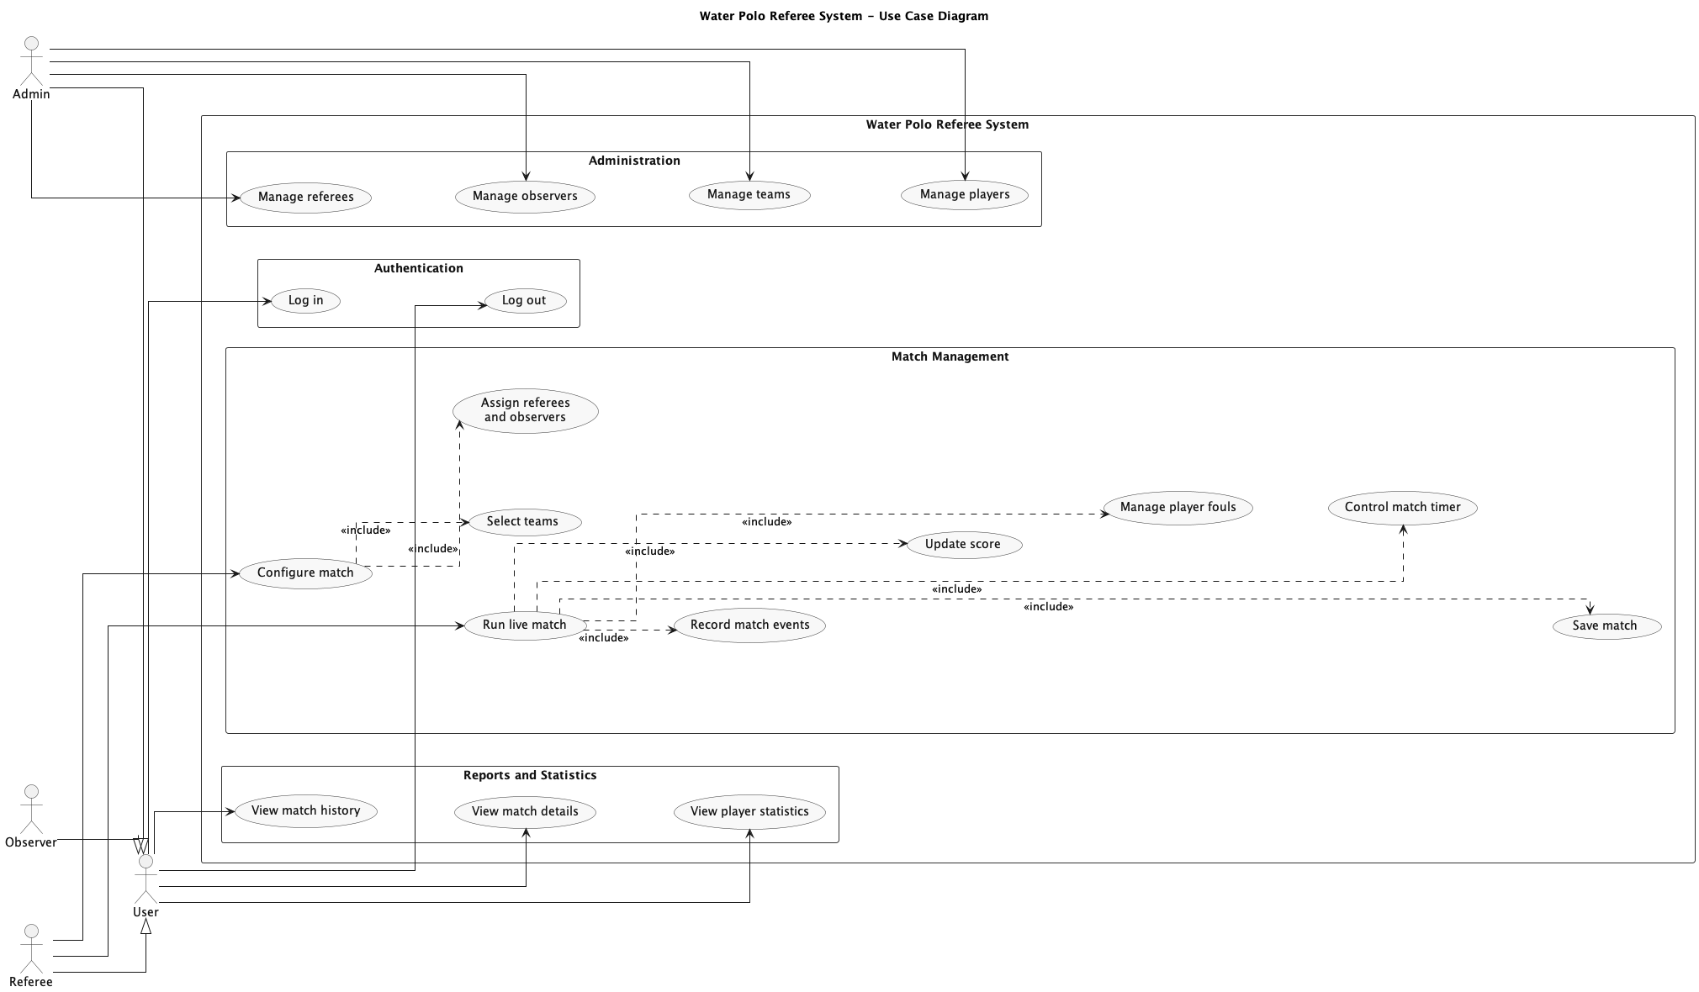 Figure 1: Use case diagram

8.2 Class Diagrams
To ensure clarity and proper separation of concerns, the system is modeled using multiple class diagrams, each focusing on a specific layer of the application.

8.2.1 Model Class Diagram
Figure 2 (page 13) presents the Model Class Diagram, which describes the core domain entities of the system and their relationships.
The central entity is the Match class, which aggregates all information related to a game, including participating teams, score, timing, and assigned officials. A Match is associated with two Team entities and maintains collections of MatchEvent and MatchPlayerStat objects, reflecting the events and statistical data recorded during the match.
The MatchEvent entity represents actions occurring during the game, such as goals, fouls, and disciplinary actions, while MatchPlayerStat stores aggregated performance data for each player. These entities are connected to Match through one-to-many relationships.
The Team entity is linked to multiple Player objects, establishing a one-to-many association, while each player belongs to a single team. Additional entities such as Referee and Observer represent officials involved in matches.
The User entity is responsible for authentication and is associated with a Role, which defines access permissions within the system.

8.2.2 DTO Class Diagram
Figure 3 (page 14) illustrates the Data Transfer Object (DTO) layer, which defines the structures used for communication between the frontend and backend.
DTOs are used to encapsulate data exchanged through API calls, preventing direct exposure of internal entities. Important DTOs include objects for authentication, match saving, event recording, and statistical data retrieval.
This separation improves flexibility, security, and maintainability, allowing the internal data model to evolve independently of external interfaces.

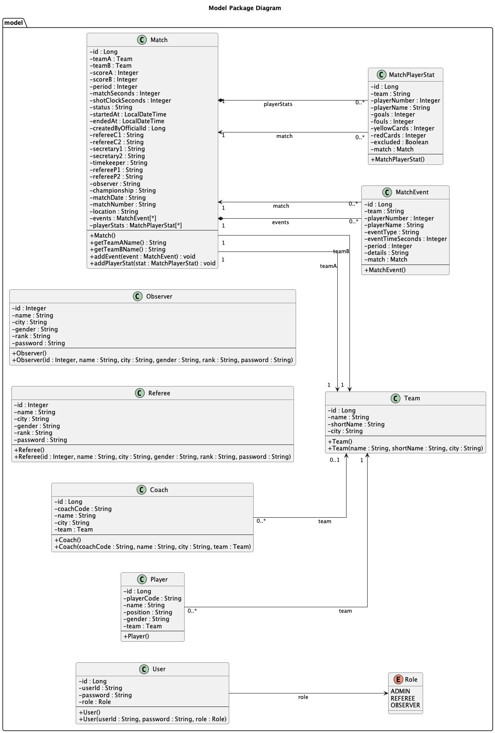
Figure 2: Model Package Class Diagram

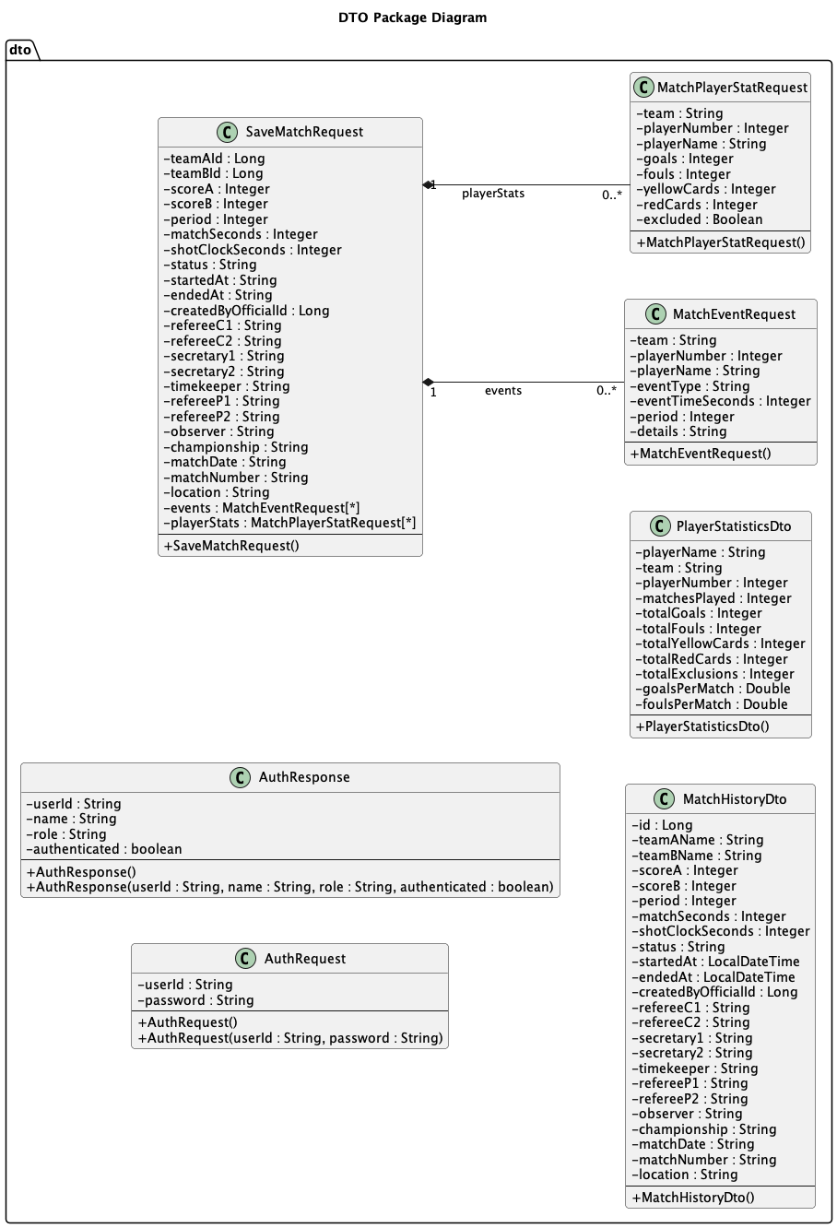
Figure 3: DTO Class Diagram

8.2.3 Backend interruction Class Diagram
Figure 4 (page 16) presents the Backend Interaction Class Diagram, illustrating how the main backend components collaborate to process requests and manage application data.
The diagram reflects a layered architecture in which each component has a well-defined role. Controllers act as entry points into the system, receiving HTTP requests from the frontend, performing basic validation, and delegating further processing to the service layer.
The service layer contains the core business logic of the application. It coordinates operations such as match creation, event recording, and statistics processing, ensuring that all business rules are consistently applied. Services also manage the interaction between multiple repositories when complex operations require data from different sources.
The repository layer is responsible for data persistence and retrieval. It abstracts database operations using Spring Data JPA, allowing the application to interact with the database through high-level methods. Repositories operate on domain entities such as Match, Player, and Team, ensuring efficient and structured data access.
The diagram also highlights the distinction between domain models and Data Transfer Objects (DTOs). Domain models represent the internal structure of the application, while DTOs are used for communication with the frontend, ensuring that internal data is not exposed directly and that API responses remain flexible.
A typical request follows a clear processing flow: it is received by a controller, forwarded to a service for processing, and then handled by the appropriate repository for data access. The result is returned through the same path back to the frontend. This structured interaction ensures separation of concerns, modularity, and scalability within the backend architecture.

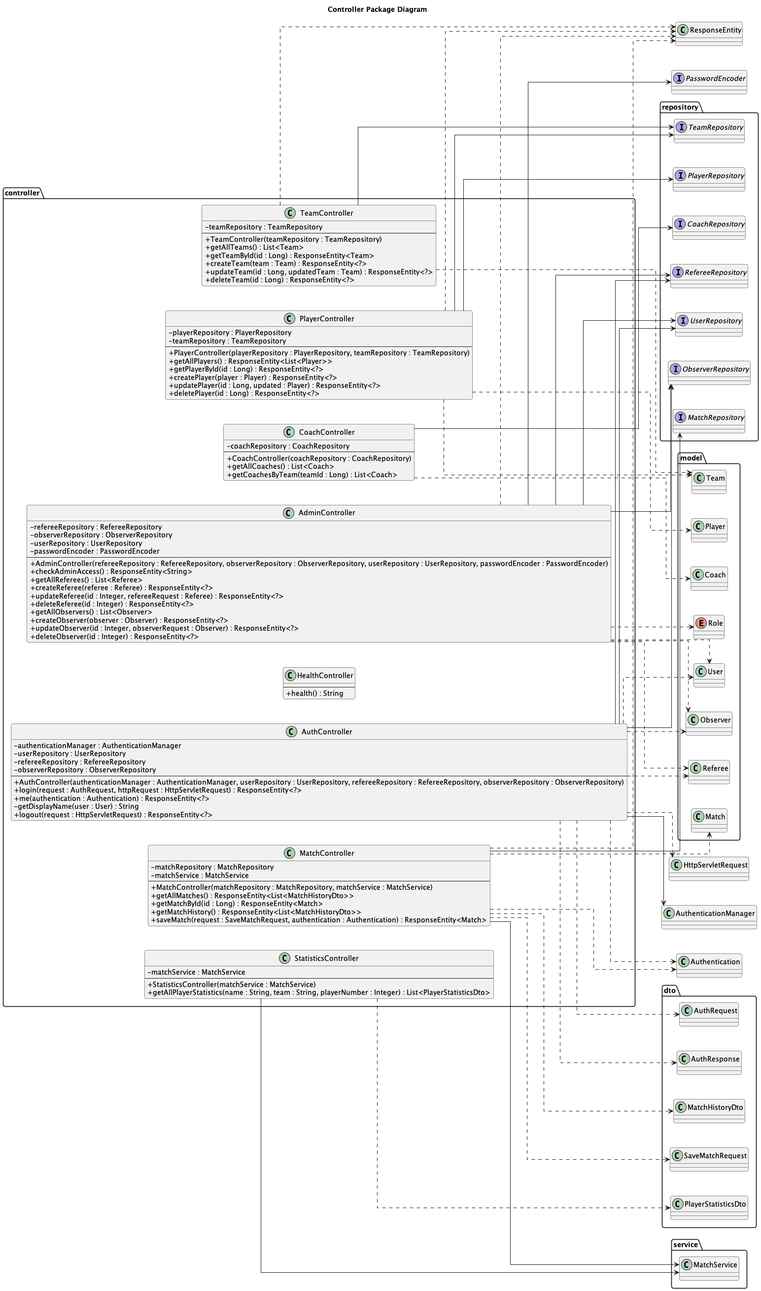
Figure 4: Backend interruction Class Diagram

8.3 State Diagram
Figure 5 (page 18) illustrates the State Diagram of the Water Polo Referee System, representing the dynamic behavior of the application during its execution.
The system begins in the LoggedOut state, where no user is authenticated. After a successful login, the application transitions to an authenticated state, allowing access to the main functionalities of the system. From this point, the user can navigate to different operational areas, such as match setup or data visualization.
During the match lifecycle, the system transitions into the MatchSetup state, where the initial configuration is performed, followed by the LiveMatch state, in which the referee records events and manages the game in real time. The system can temporarily enter a Paused state, reflecting interruptions during gameplay, before returning to the active match state.
Once the match is completed, the system moves to the MatchFinished state. After the match data is saved, it transitions to the MatchSaved state, making the information available for later access. From here, users can navigate to states such as HistoryView or StatisticsView, where stored data can be analyzed.
Transitions between states are triggered by user actions, including logging in, starting a match, pausing or resuming gameplay, and saving match data. This diagram provides a clear representation of how the system evolves over time and how different operations influence its state.

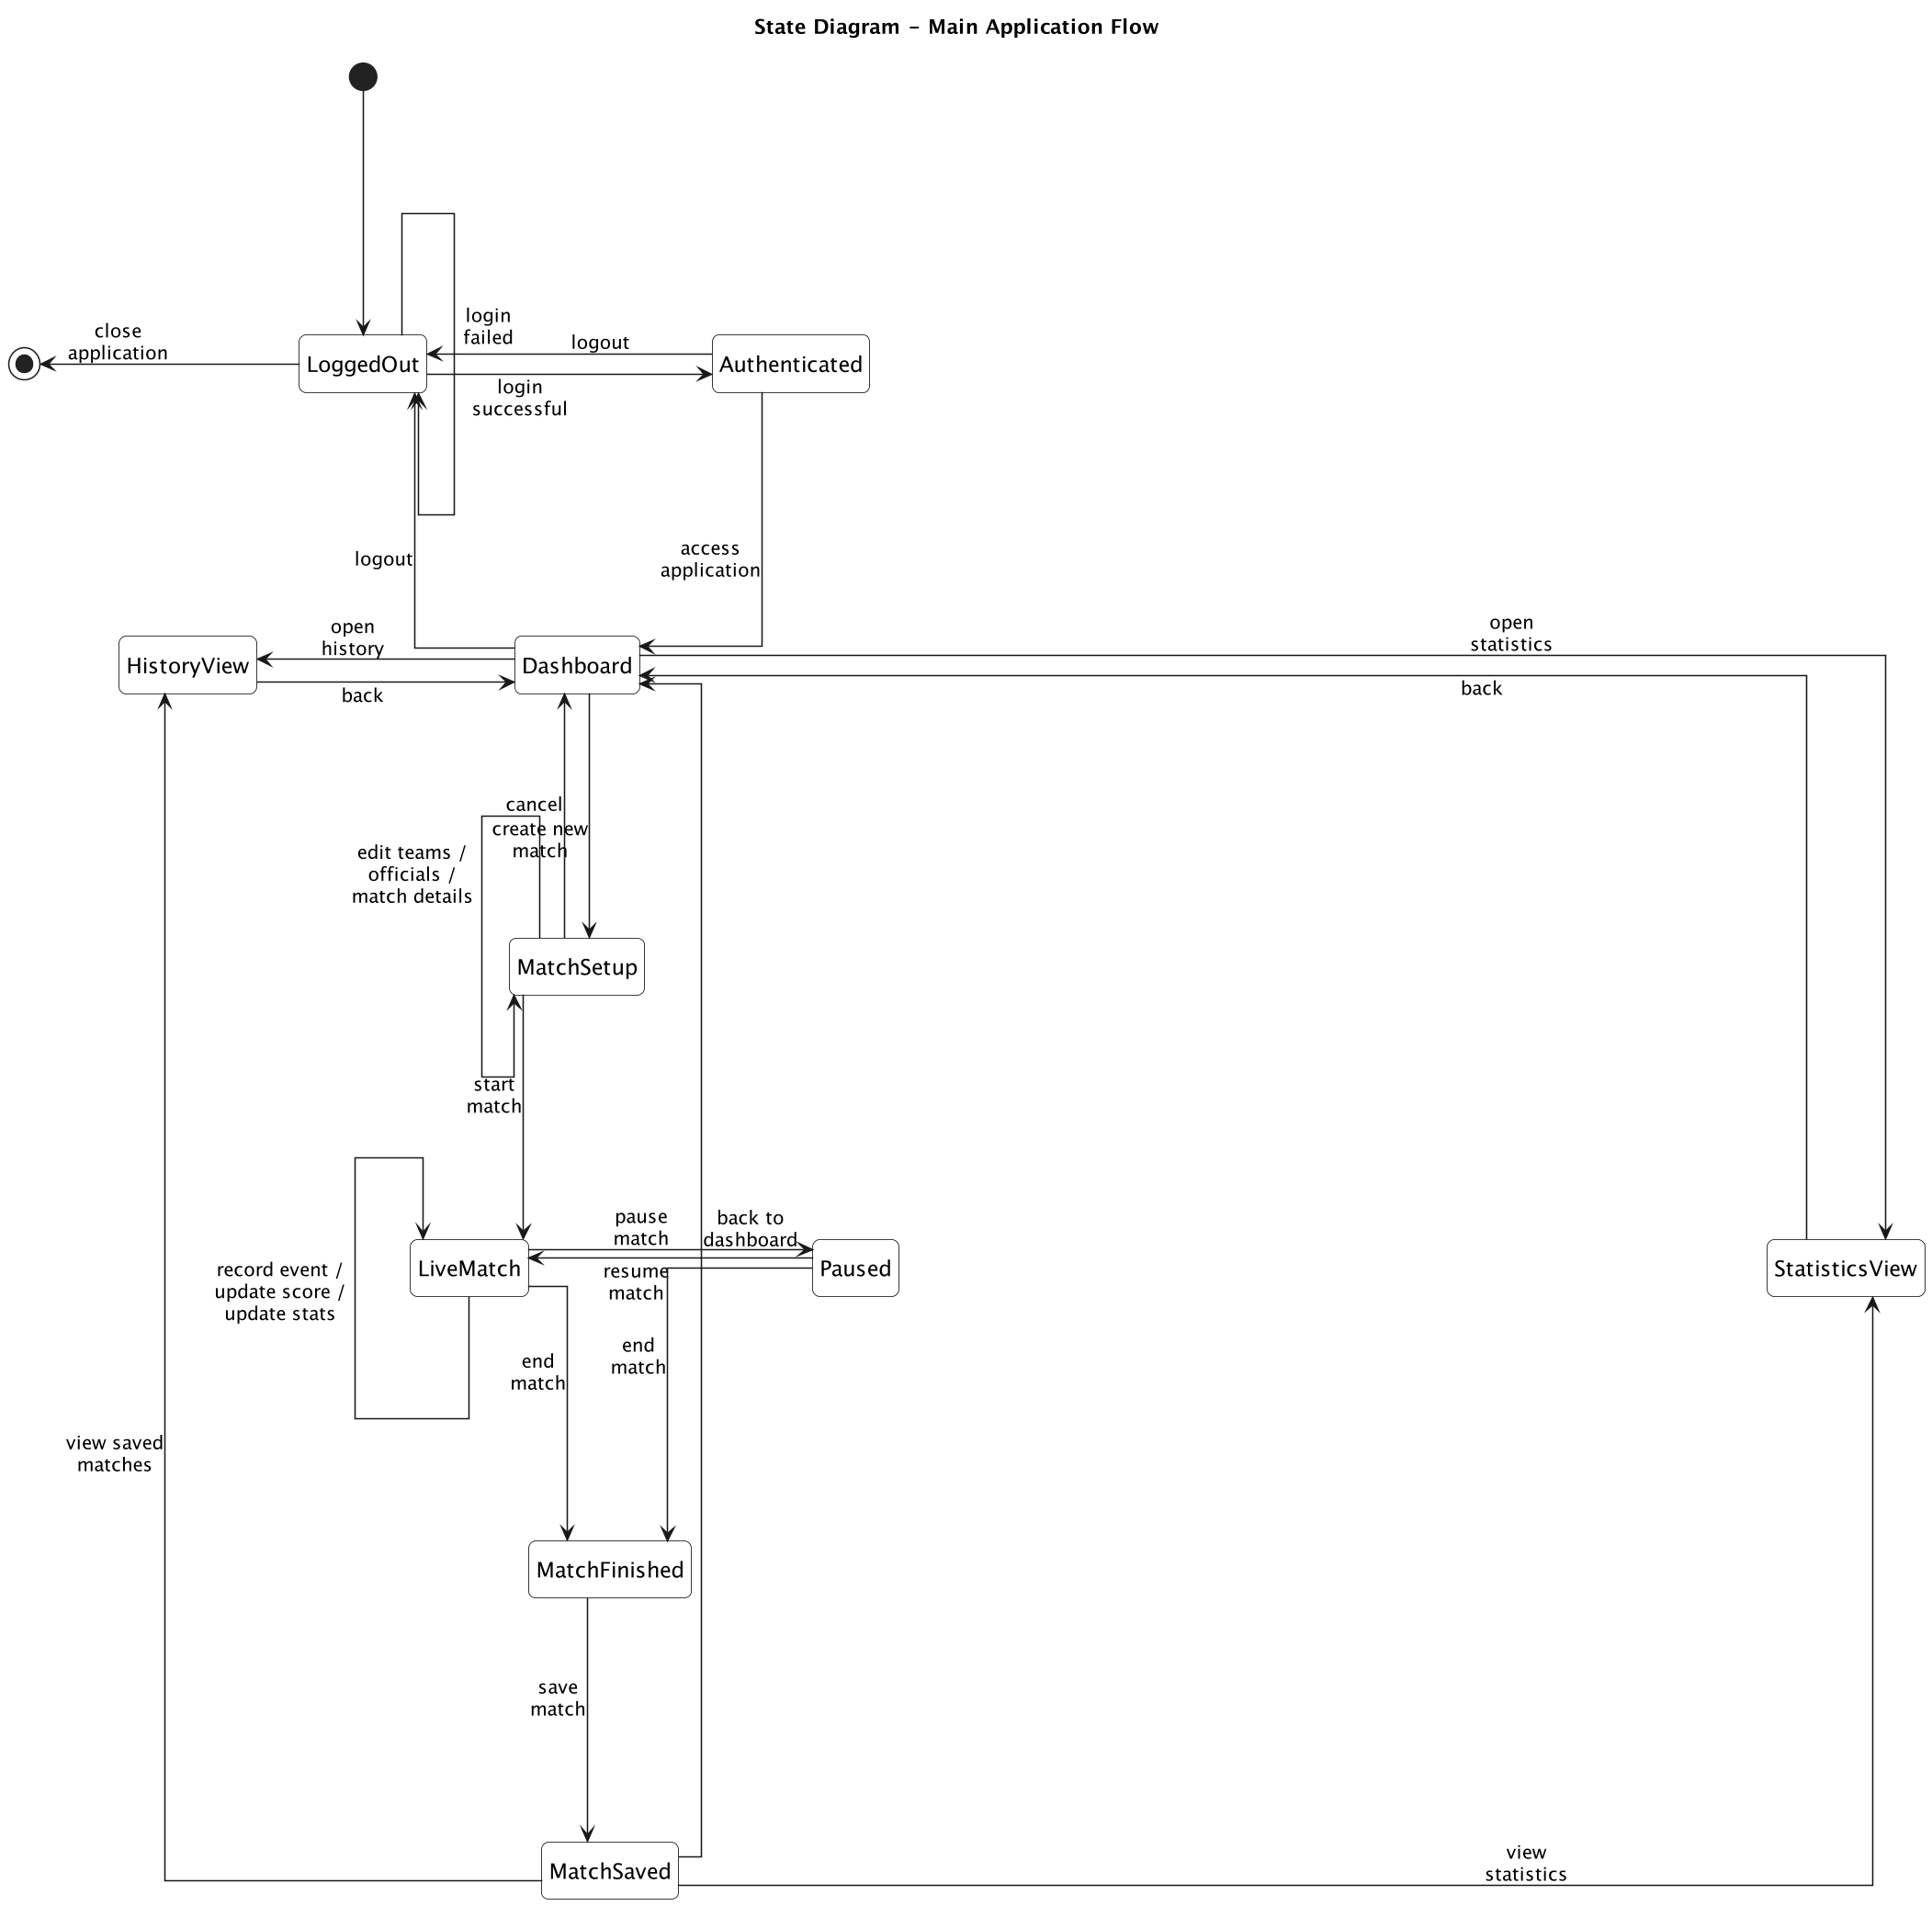Figure 5: State Diagram

9. API Overview
This chapter provides an overview of the REST API exposed by the backend of the Water Polo Referee System. The API enables communication between the frontend and backend, allowing the application to perform operations related to authentication, match management, and data retrieval.
The backend exposes multiple endpoints, each responsible for handling a specific type of request. These endpoints follow REST principles and use standard HTTP methods such as GET, POST, PUT, and DELETE.

9.1 Authentication API
The authentication API is responsible for handling user login and access control.
The main endpoint allows users to submit their credentials, which are validated by the backend. If authentication is successful, the system returns a response containing user information and access permissions.
This API ensures that only authorized users can access protected resources within the application.

9.2 Match Management API
The match management API provides endpoints for creating, updating, and storing match data.
Through these endpoints, the frontend can initialize a match, record events such as goals and fouls, update match state, and save the final match data. These operations are coordinated by the backend and persisted in the database.
This API represents the core interaction layer for real-time match functionality.

9.3 Player and Team API
The system also provides endpoints for managing teams and players. These endpoints allow retrieving and updating information about teams, players, and related entities. They are primarily used during match setup and administration operations.

9.4 Statistics API
The statistics API enables retrieval of aggregated data based on match records. It allows the frontend to request player statistics and match-related insights, supporting post-match analysis and performance evaluation.

9.5 General Characteristics
All API endpoints use JSON as the data exchange format, ensuring compatibility between frontend and backend components.
Requests and responses are structured using Data Transfer Objects (DTOs), which define the format of the data exchanged. This approach improves security and flexibility by avoiding direct exposure of internal entities.
The API design follows a modular approach, where each controller manages a specific functional area, contributing to a clear and maintainable backend architecture.

Property Area | Configured Value / Behavior
Database URL | jdbc:mysql://localhost:3306/waterpolo_db
Credentials | root / root in the current local configuration
DDL Strategy | update
SQL Initialization | always enabled
Seed Files | teams.sql, players.sql, coaches.sql, data.sql

10. Security Model
Security is implemented through Spring Security. The presence of dedicated security code and authentication controllers indicates that the system controls access to protected features rather than exposing all operations publicly. In practical terms, this supports a role-aware application where different users can access different modules depending on their permissions.
• Authentication is handled by backend security components.
• Administrative actions are separated from standard operational flows.
• The frontend provides a dedicated login page to access secured content.

11. Local Execution Workflow

11.1 Backend Startup
• Install Java 17 and ensure a MySQL server is available locally.
• Create or configure the waterpolo_db database.
• Run the backend from the backend directory using the Maven wrapper.
• Allow the application to apply schema updates and load SQL seed files.

11.2 Frontend Startup
• Open the edge-app directory.
• Install dependencies with npm install.
• Start the development server with npm run dev.
• Use the frontend to access login, administration, live match, and statistics pages.

12. Functional Value of the Project
From a software engineering perspective, the project demonstrates a realistic business application structure. It combines a modern JavaScript frontend, a Java enterprise backend, relational persistence, role-based access, and modular code organization. From a domain perspective, it addresses a concrete sports-management use case by translating match operations into digital workflows.

13. Possible Future Improvements
• Cloud deployment for remote access and centralized hosting.
• Advanced dashboards for federation-level reporting and analytics.
• Improved audit trails for official actions during live matches.
• Export options for reports and statistics.
• Stronger automated test coverage for frontend and backend modules.
• Responsive enhancements for mobile or tablet-based officiating workflows.

14. Conclusion
The Water Polo Referee System is a well-structured full-stack project that integrates user-facing match management with a layered backend and persistent data storage. Its repository organization, technology choices, and module separation make it suitable both as an academic software project and as a strong portfolio example in web application development.

