**CSCI 1100 – September 2016**

**Laboratory Report 8**

**Name: Mihyar Al-Masalma**

**Student ID: B00759975**

|  |  |  |  |  |  |  |
| --- | --- | --- | --- | --- | --- | --- |
| **Please mark your lab** | | | | | | |
| **T 8:30 L143** | **T 8:30 L134** | **T 8:30 L133** | **T 11:30 L143** | **T 11:30 L133** | **T 11:30 L142** | **T 2:30 L143** |
| **T 5:30 L143** | **T 5:30 L142** | **W 11:30 143** | **W 4:30 143** |

|  |  |  |
| --- | --- | --- |
| **Declaration: Please complete this declaration or your lab may not be graded** | | |
| 1 | This document is entirely my own work. Your lab should be the efforts of your own work. However, you may need to look something up to help you or ask someone for help. If acquired help (online or with someone) you need to acknowledge this below. | Yes |
| 2 | I obtained some help to complete this document. | No |
| 3 | This document contains some material from the Internet or another document or file or program. Note, your lab should be the efforts of your own work. However, you may need to look something up to help you – you need to acknowledge this. You should not cut and paste solutions. | No |

This lab is on Dialog Boxes, Arrays, and Methods.

**Note: For Exercise 1 – 3 you do not need to write methods (i.e., you can write all your code in the main method).**

**Exercise 1.** Write a Java program that uses two input dialog boxes to get two double values from the user. The program then determines the smaller of the two numbers and uses a message dialog box to show the smallest. Test the program with two sets of data and include the results in this report. Make sure to make your message/input dialogs neat and easy to read in this report (you will need to copy/paste them in your document).

Sample output:

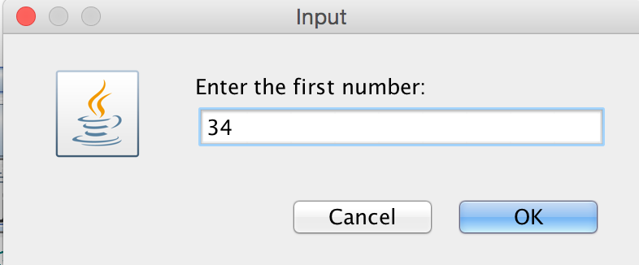 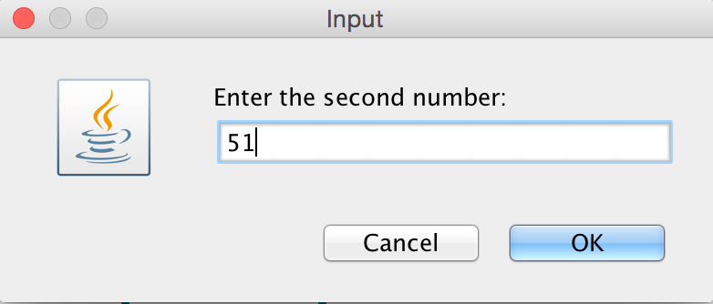 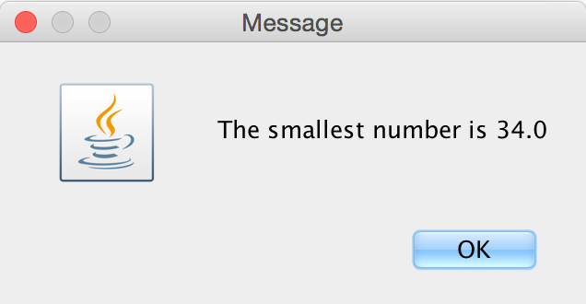

/*CSCI 1100 â€“ Lab 8 â€“ Exercise 1  
This program will take two input numbers and return the smallest  
<Mihyar Al-Masalma> <B00759975> <22/NOV/2016> */  
  
import javax.swing.JOptionPane; // import class  
public class Q1 {  
 public static void main(String[] args) {  
 double num1 = 0, num2 = 0;  
 // Ask user to enter two number and convert it to doubles  
 num1 = Double.parseDouble(JOptionPane.showInputDialog("Enter the first number: "));  
 num2 = Double.parseDouble(JOptionPane.showInputDialog("Enter the second number: "));  
 // show dialog box with the smallest number  
 JOptionPane.showMessageDialog(null,"The smallest number is "+ Math.min(num1,num2));  
 }  
}

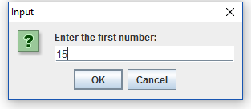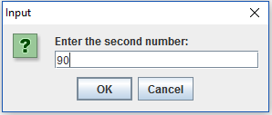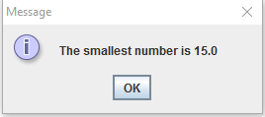

**Exercise 2.** Finish writing the program that will ask the user to enter a number of temperatures and then will calculate the average temperature. First ask the user to enter in the total temperatures to be recorded. Then ask the user to enter each temperature. Each temperature should be stored in an array called temps. Print the average of all the temperatures*.* Test the program with two sets of data.

/*CSCI 1100 â€“ Lab 8 â€“ Exercise 2  
This program will ask user to enter tempreture then will   
return the average temperture  
<Mihyar Al-Masalma> <B00759975> <22/NOV/2016> */  
import java.util.Scanner;// import Scanner class  
public class Exercise3 {  
 public static void main(String[] args) {  
 double total = 0;  
 Scanner kb = new Scanner(System.in);  
 // ask the user to enter the number of temeratures and store it  
 System.out.print("Please type the number of temperatures to enter: ");  
 int num = kb.nextInt();  
 // iterate to save the input in array  
 for (int i =0; i<num ; i++) {  
 double [] temps = new double[num];  
 System.out.print("Enter temperature: ");  
 temps[i] = kb.nextInt();  
 total += temps[i];// get the sum of the temperature  
 }  
 // print out the average  
 System.out.println("Average temperature is: "+(total/num));  
 }  
}

Please type the number of temperatures to enter: 4  
▪Enter temperature: 10  
▪Enter temperature: 10  
▪Enter temperature: 10  
▪Enter temperature: 10  
▪Average temperature is: 10.0

 ----jGRASP exec: java Exercise3  
▪Please type the number of temperatures to enter: 5  
▪Enter temperature: 5  
▪Enter temperature: 10  
▪Enter temperature: 15  
▪Enter temperature: 20  
▪Enter temperature: 25  
▪Average temperature is: 15.0  
▪  
 ----jGRASP: operation complete.

**Exercise 3.** Rework Exercise 2 so that it will ask the user to enter in the temperatures of the first week (7 days) of January 2015 which will be stored in an array called jan15. Then ask the user to enter the temperatures of the first week (7 days) of January 2016 which will be stored in an array called jan16. The program will then print out the temperatures for each day for both January 2015 and 2016 and give the difference in temperature per day. You can NOT assume that all temperatures are positive. See how the program will work below. Test the program with two sets of data.

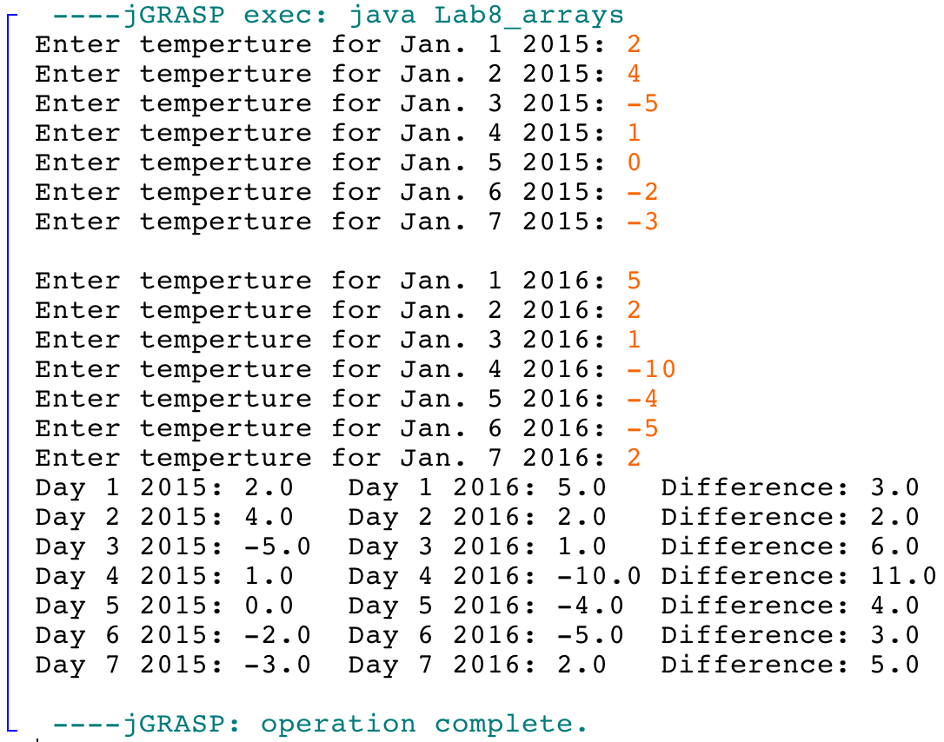

/*CSCI 1100 â€“ Lab 8 â€“ Exercise 3  
This program will ask user to enter temperatures of first  
week of Jan 2015 and Jan 2016 and compare it  
<Mihyar Al-Masalma> <B00759975> <22/NOV/2016> */  
import java.util.Scanner; // import Scanner class  
public class Q3 {  
 public static void main(String[] args) {  
 // Create instance of Scanner Class and define arrays  
 Scanner input = new Scanner(System.in);  
 double [] jan16 = new double[7];  
 double [] jan15 = new double[7];  
 // iterate to caputre the user input and store it  
 for (int i=0; i<7; i++) {  
 System.out.print("Enter temperature of Jan. "+(i+1)+" 2015: ");  
 jan15[i] = input.nextDouble();  
 }  
 // new line  
 System.out.println();  
 // iterate to capture the user input and store it  
 for (int i=0; i<7; i++) {  
 System.out.print("Enter temperature of Jan. "+(i+1)+" 2016: ");  
 jan16[i] = input.nextDouble();  
 }  
 // print out the results  
 for (int i=0; i<7; i++) {  
 System.out.println("Day "+(i+1)+" 2015: "+jan15[i]+" Day "+(i+1)+" 2016: "+jan16[i]+" Difference: "+Math.abs(jan16[i]-jan15[i]));  
 }  
 }  
}

 ----jGRASP exec: java Q3  
▪Enter temperature of Jan. 1 2015: 1  
▪Enter temperature of Jan. 2 2015: 2  
▪Enter temperature of Jan. 3 2015: 3  
▪Enter temperature of Jan. 4 2015: 4  
▪Enter temperature of Jan. 5 2015: 5  
▪Enter temperature of Jan. 6 2015: 6  
▪Enter temperature of Jan. 7 2015: 7  
▪  
▪Enter temperature of Jan. 1 2016: -1  
▪Enter temperature of Jan. 2 2016: -2  
▪Enter temperature of Jan. 3 2016: -3  
▪Enter temperature of Jan. 4 2016: -4  
▪Enter temperature of Jan. 5 2016: -5  
▪Enter temperature of Jan. 6 2016: -6  
▪Enter temperature of Jan. 7 2016: -7  
▪Day 1 2015: 1.0 Day 1 2016: -1.0 Difference: 2.0  
▪Day 2 2015: 2.0 Day 2 2016: -2.0 Difference: 4.0  
▪Day 3 2015: 3.0 Day 3 2016: -3.0 Difference: 6.0  
▪Day 4 2015: 4.0 Day 4 2016: -4.0 Difference: 8.0  
▪Day 5 2015: 5.0 Day 5 2016: -5.0 Difference: 10.0  
▪Day 6 2015: 6.0 Day 6 2016: -6.0 Difference: 12.0  
▪Day 7 2015: 7.0 Day 7 2016: -7.0 Difference: 14.0  
▪  
 ----jGRASP: operation complete.

 ----jGRASP exec: java Q3  
▪Enter temperature of Jan. 1 2015: 7  
▪Enter temperature of Jan. 2 2015: 6  
▪Enter temperature of Jan. 3 2015: 5  
▪Enter temperature of Jan. 4 2015: 4  
▪Enter temperature of Jan. 5 2015: 3  
▪Enter temperature of Jan. 6 2015: 2  
▪Enter temperature of Jan. 7 2015: 1  
▪  
▪Enter temperature of Jan. 1 2016: 1  
▪Enter temperature of Jan. 2 2016: -2  
▪Enter temperature of Jan. 3 2016: 3  
▪Enter temperature of Jan. 4 2016: -4  
▪Enter temperature of Jan. 5 2016: 5  
▪Enter temperature of Jan. 6 2016: -6  
▪Enter temperature of Jan. 7 2016: -7  
▪Day 1 2015: 7.0 Day 1 2016: 1.0 Difference: 6.0  
▪Day 2 2015: 6.0 Day 2 2016: -2.0 Difference: 8.0  
▪Day 3 2015: 5.0 Day 3 2016: 3.0 Difference: 2.0  
▪Day 4 2015: 4.0 Day 4 2016: -4.0 Difference: 8.0  
▪Day 5 2015: 3.0 Day 5 2016: 5.0 Difference: 2.0  
▪Day 6 2015: 2.0 Day 6 2016: -6.0 Difference: 8.0  
▪Day 7 2015: 1.0 Day 7 2016: -7.0 Difference: 8.0  
▪  
 ----jGRASP: operation complete.

**Exercise 4.** Define and test a method called drawSquare that will print a square and call the method from the main method. **Include the code and one output.**

_ _  
 | |

|_ _|

/*CSCI 1100 â€“ Lab 8 â€“ Exercise 4  
This program will draw a square  
<Mihyar Al-Masalma> <B00759975> <22/NOV/2016> */  
public class E4{  
 public static void main(String[] args) {  
 // calling method  
 drawSquare();  
 }  
 // other method   
 public static void drawSquare(){  
 System.out.println(" ___");  
 System.out.println("| |");  
 System.out.println("|___|");  
 }  
}

  ----jGRASP exec: java E4  
▪ ___  
▪| |  
▪|___|  
▪  
 ----jGRASP: operation complete.

**Exercise** **5**. Write a method called oddNumbers that print all the odd numbers from 1 to 50. Test this method by calling it from the main method. **Include the code and one output.**

/*CSCI 1100 â€“ Lab 8 â€“ Exercise 5  
This program will print the odd number between 1 and 50  
<Mihyar Al-Masalma> <B00759975> <22/NOV/2016> */  
public class E5 {  
 public static void main(String[] args) {  
 oddNumbers();// calling method  
 }  
  
 public static void oddNumbers(){  
 // iterate for numbers  
 for (int i =1; i<=50; i++) {  
 // if not even print it  
 if (i%2 != 0) {  
 System.out.println(i);  
 }  
 }  
 }  
}

 ----jGRASP exec: java E5  
▪1  
▪3  
▪5  
▪7  
▪9  
▪11  
▪13  
▪15  
▪17  
▪19  
▪21  
▪23  
▪25  
▪27  
▪29  
▪31  
▪33  
▪35  
▪37  
▪39  
▪41  
▪43  
▪45  
▪47  
▪49  
▪  
 ----jGRASP: operation complete.

**Exercise 6.** Define and test a method called oddNumberRange that takes one positive integer as a parameter (N). The method will then write all the odd numbers from 1 to N. Test this method by calling it from the main method. **Include the code and 2 test cases**

For example, the method call oddNumberRange (10) in the main method will print 1 3 5 7 9

/*CSCI 1100 â€“ Lab 8 â€“ Exercise 6  
This program will print the odd number between 1 and the user entered number  
<Mihyar Al-Masalma> <B00759975> <22/NOV/2016> */  
import java.util.Scanner; // import Scanner class  
public class E6 {  
 public static void main(String[] args) {  
 Scanner input = new Scanner(System.in);  
 // Ask the user to enter a number and store it  
 System.out.print("Enter a number: ");  
 int num = input.nextInt();  
 // Call the method for the number entered by the user  
 oddNumberRange(num);   
 }  
 // Method to generate odd number  
 public static void oddNumberRange(int num){  
 String total = "";  
 // iterate between 1 and the user entered number  
 for (int i = 1; i<= num; i++) {  
 // if the number is not even  
 if (i%2 != 0) {  
 // add it to the total  
 total += i+" ";  
 }  
 }  
 System.out.print(total);  
 }  
}

 ----jGRASP exec: java E6  
▪Enter a number: 25  
▪1 3 5 7 9 11 13 15 17 19 21 23 25   
 ----jGRASP: operation complete.

 ----jGRASP exec: java E6  
▪Enter a number: 39  
▪1 3 5 7 9 11 13 15 17 19 21 23 25 27 29 31 33 35 37 39   
 ----jGRASP: operation complete.

**Exercise 7.** Define and test a method called printRectangleArea that takes two parameters that are the length and width of a rectangle (area=length*width). The method calculates and prints the area of the rectangle. For example the method call printRectangleArea(10.0, 3.0) prints Area: 30.0

Test this method by calling it from the main method. **Include the code and 2 test cases.**

/*CSCI 1100 â€“ Lab 8 â€“ Exercise 7  
This program will calculate the area of a rectange using another method  
<Mihyar Al-Masalma> <B00759975> <22/NOV/2016> */  
import java.util.Scanner; // import Scanner class  
public class Exercise7 {  
 public static void main(String[] args) {  
 Scanner keyboard = new Scanner(System.in);  
 // Ask user to enter length and save it  
 System.out.print("Please type the length: ");  
 double length = keyboard.nextDouble();  
 // Ask user to enter width and save it  
 System.out.print("Please type the width: ");  
 double width = keyboard.nextDouble();  
 // call method with values entered by user  
 printRecatngleArea(length, width);  
 }  
 // method to calculate the area of rectangle  
 public static void printRecatngleArea(double length, double width){  
 System.out.print("Area: "+(length*width));  
 }  
}

  ----jGRASP exec: java Exercise7  
▪Please type the length: 20  
▪Please type the width: 10  
▪Area: 200.0  
 ----jGRASP: operation complete.

 ----jGRASP exec: java Exercise7  
▪Please type the length: 25  
▪Please type the width: 10.5  
▪Area: 262.5  
 ----jGRASP: operation complete.