**Tutorial 2: Create a timed math quiz**

* 11/03/2016
* 2 minutes to read

In this tutorial, build a quiz in which the quiz taker must answer four random arithmetic problems within a specified time. You learn how to:

* Generate random numbers by using the [Random](https://docs.microsoft.com/en-us/dotnet/api/system.random) class.
* Trigger events to occur at a specific time by using a [Timer](https://docs.microsoft.com/en-us/dotnet/api/system.windows.forms.timer) control.
* Control program flow by using if else statements.
* Perform basic arithmetic operations in code.

When you finish, your quiz will look like the following picture, except with different numbers:

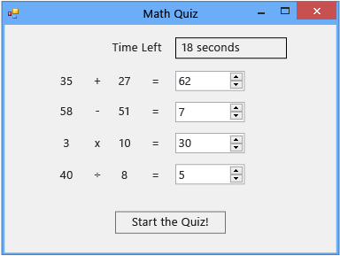

**Tutorial links**

To download a completed version of the quiz, see [Complete math quiz tutorial sample](https://code.msdn.microsoft.com/Complete-Math-Quiz-8581813c).

**Note**

This tutorial covers both Visual C# and Visual Basic, so focus on the information that's specific to the programming language that you're using.

**Related topics**

| **Title** | **Description** |
| --- | --- |
| [Step 1: Create a project and add labels to your form](https://docs.microsoft.com/en-us/visualstudio/ide/step-1-create-a-project-and-add-labels-to-your-form?view=vs-2019) | Start by creating the project, changing properties, and adding Label controls. |
| [Step 2: Create a random addition problem](https://docs.microsoft.com/en-us/visualstudio/ide/step-2-create-a-random-addition-problem?view=vs-2019) | Create an addition problem, and use the Random class to generate random numbers. |
| [Step 3: Add a countdown timer](https://docs.microsoft.com/en-us/visualstudio/ide/step-3-add-a-countdown-timer?view=vs-2019) | Add a countdown timer so that the quiz can be timed. |
| [Step 4: Add the CheckTheAnswer() method](https://docs.microsoft.com/en-us/visualstudio/ide/step-4-add-the-checktheanswer-parens-method?view=vs-2019) | Add a method to check whether the quiz taker entered a correct answer for the problem. |
| [Step 5: Add Enter event handlers for the NumericUpDown controls](https://docs.microsoft.com/en-us/visualstudio/ide/step-5-add-enter-event-handlers-for-the-numericupdown-controls?view=vs-2019) | Add event handlers that make your quiz easier to take. |
| [Step 6: Add a subtraction problem](https://docs.microsoft.com/en-us/visualstudio/ide/step-6-add-a-subtraction-problem?view=vs-2019) | Add a subtraction problem that generates random numbers, uses the timer, and checks for correct answers. |
| [Step 7: Add multiplication and division problems](https://docs.microsoft.com/en-us/visualstudio/ide/step-7-add-multiplication-and-division-problems?view=vs-2019) | Add multiplication and division problems that generate random numbers, use the timer, and check for correct answers. |
| [Step 8: Customize the quiz](https://docs.microsoft.com/en-us/visualstudio/ide/step-8-customize-the-quiz?view=vs-2019) | Try other features, such as changing colors and adding a hint. |

<https://docs.microsoft.com/en-us/visualstudio/ide/tutorial-2-create-a-timed-math-quiz?view=vs-2019>