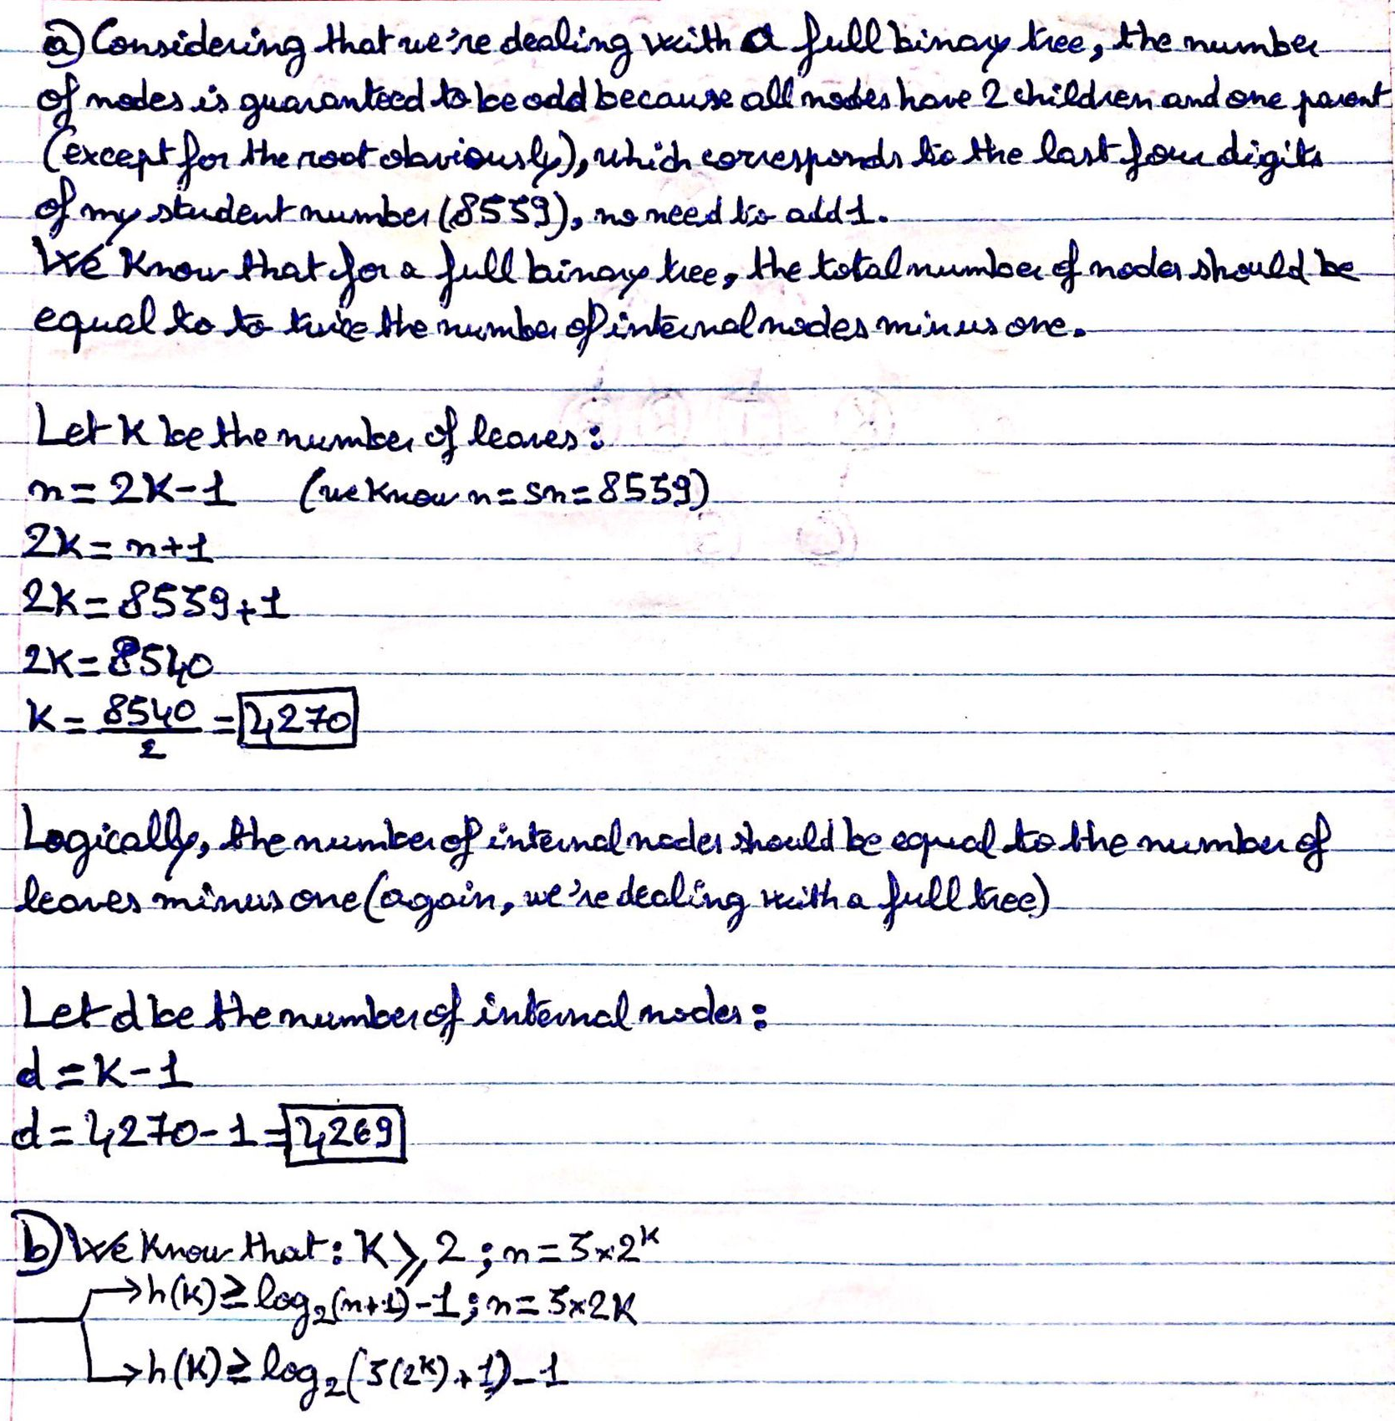**Question 1 :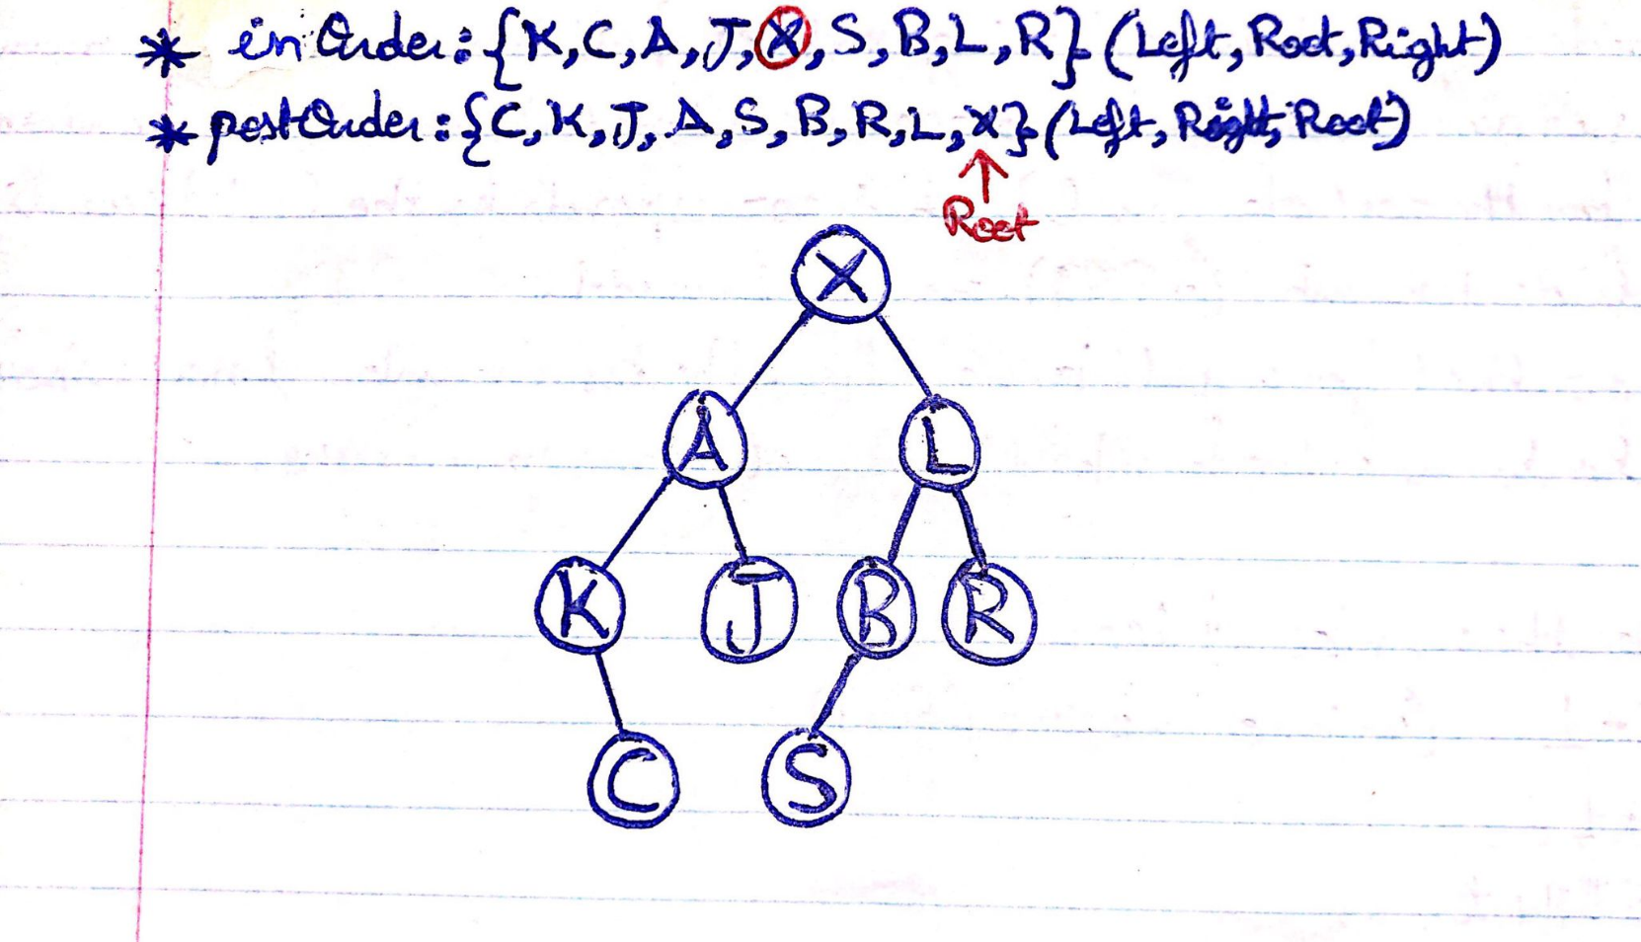Question 2 :**

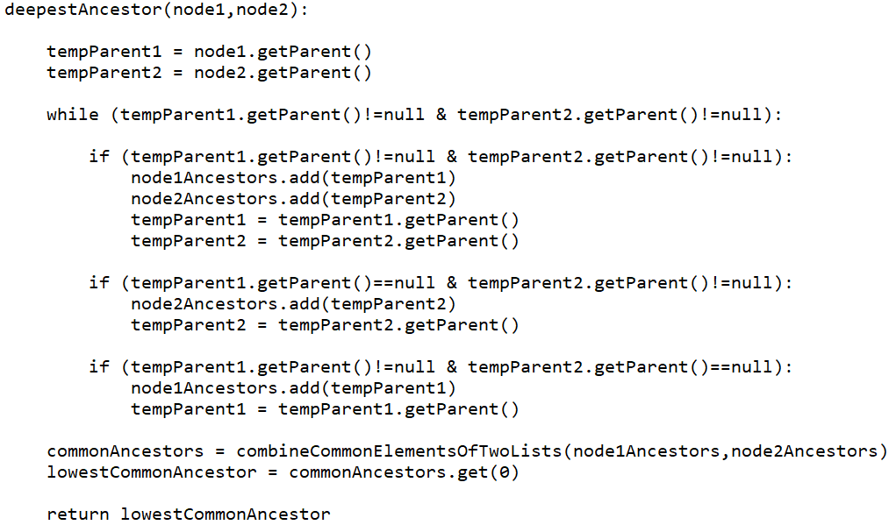**Question 3 :**  
My running time is O(d) because in the worst case scenario we would be comparing two nodes of depth equal to the height of the tree itself and the while loop is set-up in a way that would run until both node pointers have reached the root, which shouldn’t exceed the depth of the nodes (or the depth of the deepest node in a case in which we run the method on two nodes of different generations/layers).