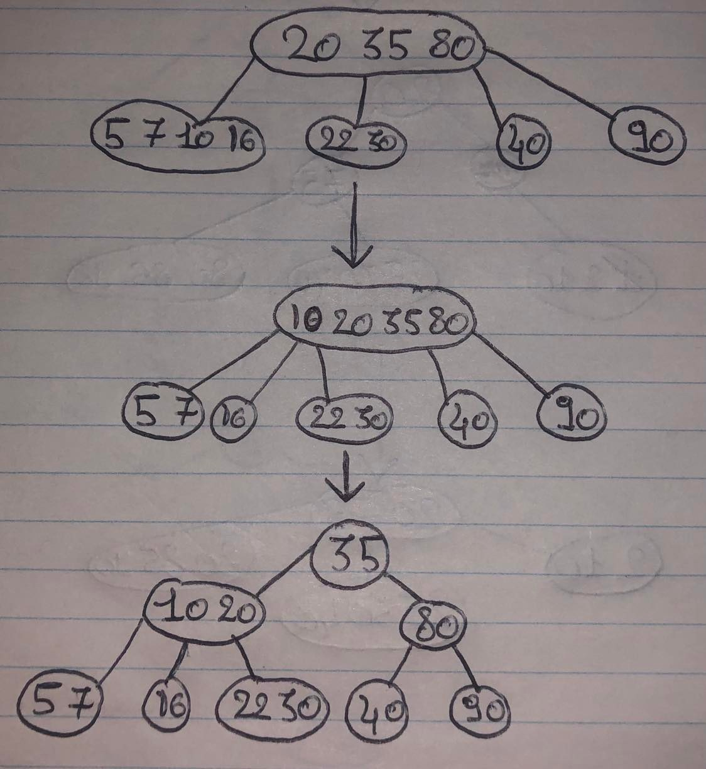**Question 1 :  
a.** The height of the 2-4 tree can be increased by inserting a key in the leftmost node to cause an overflow, which will result in the creation of a new root (and thus, increase the tree height by one)  
As an example :  
*-We insert the key 16 in the leftmost node  
-We transfer (either 7 or 10) to the root, in this case we'll be sending 10  
-We can then pick a new root (it can either be 35 or 20), we'll be sending 35*

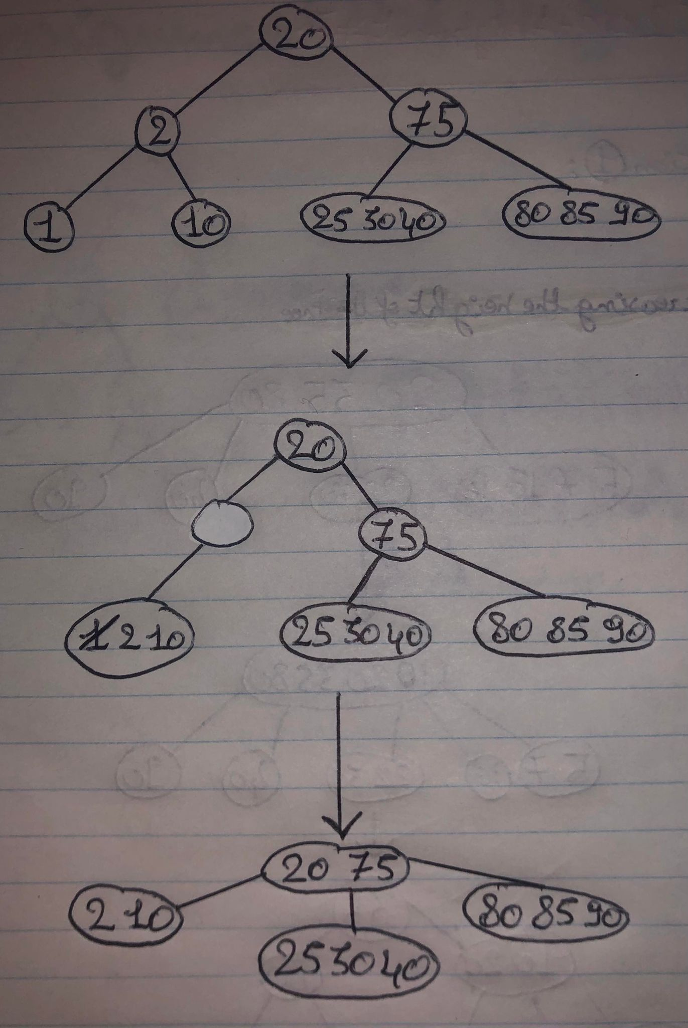**b.** The height of the 2-4 tree can be decreased by removing a key in the leftmost node to cause an underflow :  
  
  
  
  
  
  
  
  
  
  
  
  
  
  
  
  
  
  
  
  
  
  
  
  
  
  
  
  
  
  
  
  
  
  
  
  
  
  
  
  
  
  
  
  
  
  
  
  
  
  
  
  
  
  
  
  
  
  
  
  
*-We combine 2 with the leftmost deepest node (leaving 2's node empty)  
-We can remove a key (either 1 or 10), in this case we'll remove 1  
-We combine the root and 75 to get rid of the node that's null*  
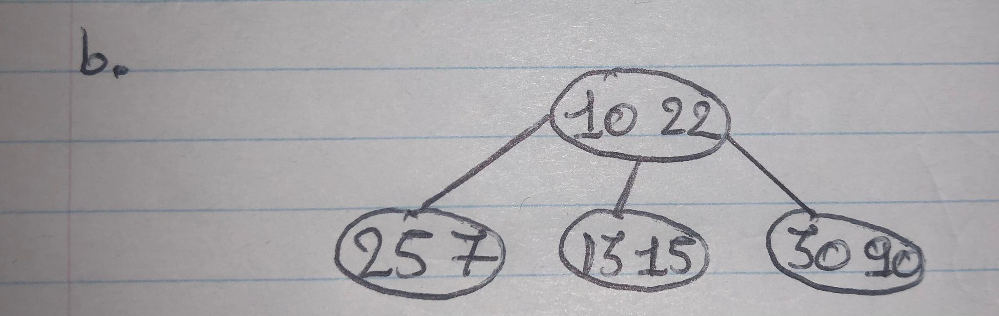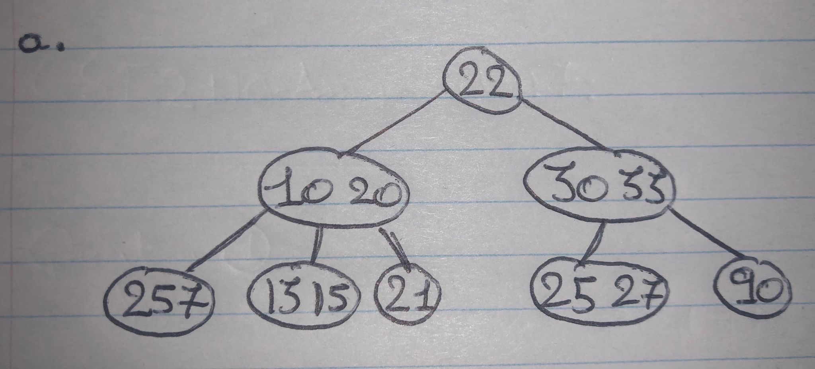**Question 2 :**  
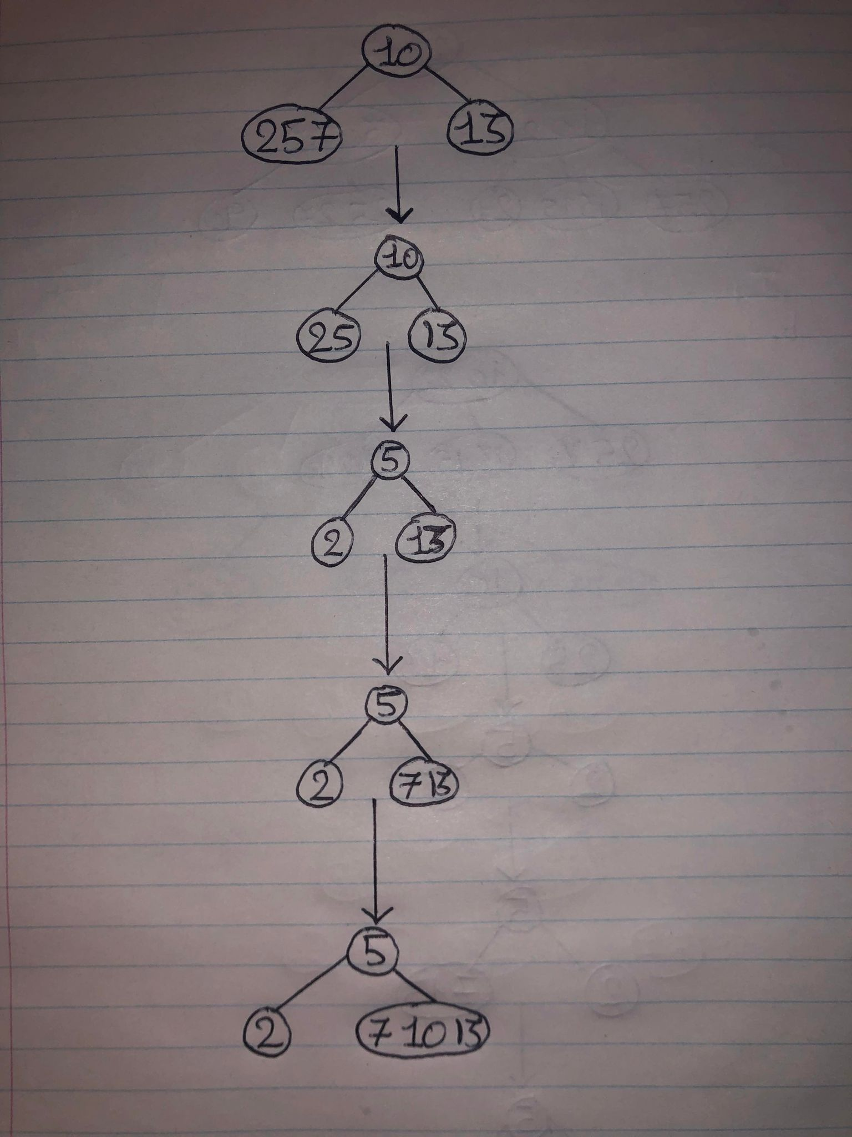**Question 3 :**