FRC 2019 Git Hub Initialization Instructions
Author: Donald Kaulukukui, donald.kaulukukui@gmail.com
Date: 01/17/2019
Version: 0.2

Understanding the Git-Hub Flow (please read, at least the first one):
- https://guides.github.com/introduction/flow/
- https://help.github.com/articles/github-flow/

Part 1: Initializing your local Git and Syncing to remote Github Repo

- Create a new project folder and open in VSCode
  - Create a new empty folder in Documents called “FRC2019_DeepSpace”
  - Open VSCode
  - Open folder within VSCode

- Within VScode Press F1 to open the command pallet, Type Git:Init.
- Select Open Repository when a window prompts you to do so.

- In Windows, Search for and open “Git Bash”
  - If you can’t find Git Bash you may need to install git:
https://git-scm.com/downloads
- In the window that opens type (replace with your email and name):
$ git config --global user.email johndoe@example.com
$ git config --global user.name "John Doe"
- Navigate to your project folder:
$ cd ~/Documents/FRC2019_DeepSpace
- Set remote:
$ git remote add origin https://github.com/Team-Magma-3008/FRC2019-DeepSpace
- Back in VScode
- Fetch remote repo
In command pallet type: Git: Fetch from all Remotes…
- Pull remote repo
In command pallet type: Git: Pull From…
- From the command window that drops down select the remote repo you added above.
- Go to the explorer window (ctrl-shift-e).
- You should see the remote files are now in your local repo.
- Build Robot Code to ensure that everything is loaded properly

Part 2: Creating a new feature branch
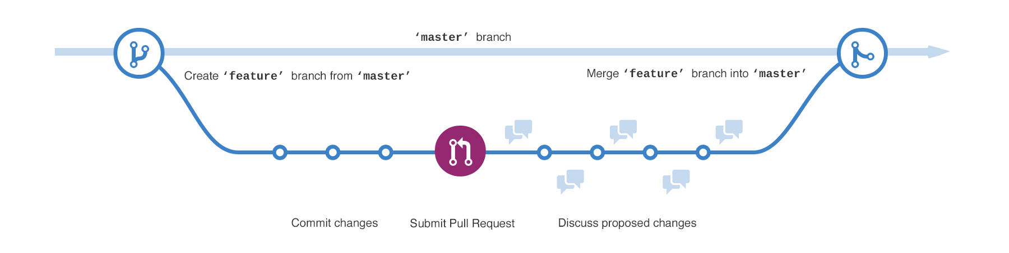

- For each new feature “Subsystem and/or Command” we will be creating a new branch to work from. The process can be seen visually above.
- Create new feature branch.
Press F1 to open the command pallet and type: Git: Create Branch
- Type in the name of your new branch: “Example_Command1”
- Push new branch to the remote Git hub (this ensures that your code is stored online).
Press F1 to open the command pallet and type: Git: Push To...
- Select your remote repo
origin https://github.com/Team-Magma-3008/FRC2019-DeepSpace
- Now you can begin working and testing code on your branch without affecting any changes on the main branch.
- Additional Info: https://help.github.com/articles/creating-and-deleting-branches-within-your-repository/

Part 3: Commiting changes to your new feature branch

- Working in your new branch you now make code changes, add files, test run and debug as needed.
- Periodically (once a day?, hourly?, after each incremental step?) you should save and “Commit” your changes to the repository.
- After making changes do a “Stage All Changes”
Press F1 to open the command pallet and type: Git: Stage All Changes
- Commit all staged changes to local git repo:
Press F1 to open the command pallet and type: Git: Commit All
- Push changes to the remote Git hub : three dots -> Push To...
Press F1 to open the command pallet and type: Git: Push To…
- Select your remote branch

Part 4: Submitting a Pull Request

- https://help.github.com/articles/about-pull-requests/

Part 5: Merging a feature branch into the Master

- https://help.github.com/articles/merging-a-pull-request/

Part 6: Fetch and update local repo with remote

Additional help:
- https://help.github.com/categories/collaborating-with-issues-and-pull-requests/
- https://google.com

