Table of Contents
A. Functional and non-functional Requirements 2
B. Modeling the Requirements 3
Epic 3: Household Food Inventory Tracking 3
Epic 4: Real-Time Expiry Alerts and Food Tracking 5
C. Architectural Design 6
D. High Level Design Components 8
i. ERD 8
ii. Site Map 9
iii. Wireframes 10
E. Database Design 20

Functional and non-functional Requirements

Modeling the Requirements
Student ID: Mijala Shristi Bajracharya (E2300561)

Epic 3: Household Food Inventory Tracking
EcoPantry must allow users to maintain an accurate, up-to-date record of the food items in their household, so that they can make informed decisions about consumption and reduce waste.

User Story 2.1 | As a household user, I need to add a food item to my inventory with its name, quantity, and category, so that I can keep track of what food I currently have.
Acceptance Criteria | Given that an authenticated user is on the Food Inventory screen and taps 'Add Food Item', when the user enters the item name, quantity, and category and saves, then the system stores the item in the local Room database and displays it in the inventory list.
MoSCoW | Must Have (M)
Tasks | 1. Design the 'Add Food Item' screen UI (name, quantity, category fields).  2. Implement input validation in the ViewModel.  3. Insert the item into the Room database via InventoryDao.
Test Cases

User Story 2.2 | As a household user, I need the system to log every change I make to my food inventory, so that I have a history of my food logging activity for the weekly tracker.
Acceptance Criteria | Given a user adds, edits, or deletes a food item, when the action is completed, then the system creates a corresponding log entry with the action type, item name, and timestamp.
MoSCoW | Must Have (M)
Tasks | 1. Create a food_log Room entity to store log entries.  2. Trigger a log entry whenever an inventory CRUD action occurs.  3. Build a basic log history view accessible from the inventory screen. 4. Ensure the log feeds correctly into the Weekly Food Tracker.
Test Cases

User Story 2.3 | As a household user, I should be able to enter the expiry date manually when adding a food item, so that the app can alert me before the food spoils, since the system does not calculate expiry automatically.
Acceptance Criteria | Given a user is adding or editing a food item, when the user selects an expiry date using the date picker and saves, then the expiry date is stored with the item and used by the Notification Module to trigger alerts.
MoSCoW | Should Have (S)
Tasks | 1. Add a DatePicker field for expiry date on the Add Item screen.  2. Store the expiry date on the Room food_items table.  3. Validate that the entered date is not in the past.  4. Pass the expiry date to the Notification Module for alert scheduling.
Test Cases

Student ID: Mijala Shristi Bajracharya (E2300561)

Epic 4: Real-Time Expiry Alerts and Food Tracking
EcoPantry must proactively inform users about food items nearing expiry, helping them act in time to consume or donate food before it spoils.

User Story 4.1 | As a household user, I need to receive a real-time alert when a food item in my inventory is close to its expiry date, so that I can use or donate it before it spoils.
Acceptance Criteria | Given a user has food items with manually entered expiry dates, when an item's expiry date is within 3 days, then the system triggers a real-time notification displaying the item name and days remaining.
MoSCoW | Must Have (M)
Tasks | 1. Schedule a WorkManager periodic task to scan the Room database daily for items nearing expiry.  2. Trigger a local notification via NotificationManager when an item is within the alert window.  3. Store the alert in a notifications table for in-app display.  4. Test alert timing using items with varying expiry dates.
Test Cases

User Story 4.2 | As a household user, I need to view a list of all my active notifications in the app, so that I can review which items need attention without relying only on push alerts.
Acceptance Criteria | Given a user navigates to the Notifications screen, when the screen loads, then the system displays all unread and recent alerts sorted by most recent first, with the option to mark them as read.
MoSCoW | Must Have (M)
Tasks | 1. Build the Notifications screen UI with a list of alert cards.  2. Query the local notifications table sorted by timestamp.  3. Implement a read/unread toggle per notification.  4. Add an empty state for when there are no active notifications.
Test Cases

User Story 4.3 | As a household user, I should be able to dismiss or clear notifications I have already acted on, so that my notification list stays relevant and uncluttered.
Acceptance Criteria | Given a user is viewing the Notifications screen, when the user swipes or taps to dismiss a notification, then the system removes it from the active list and updates the local database accordingly.
MoSCoW | Should Have (S)
Tasks | 1. Implement swipe-to-dismiss gestures on notification list items.  2. Update the notification status in the local database upon dismissal. 3. Add a 'Clear All' option for bulk dismissal.
Test Cases

Architectural Design

High Level Design Components

ERD

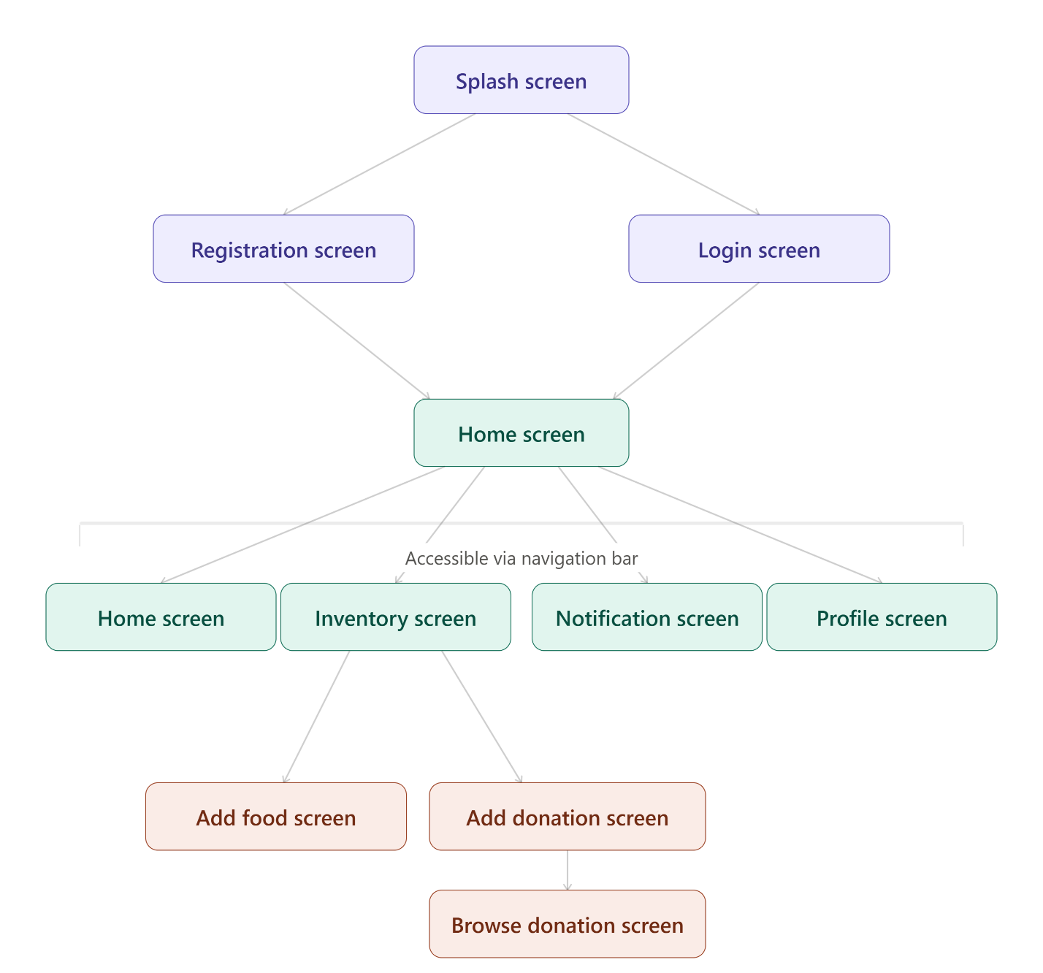
Site Map

Wireframes

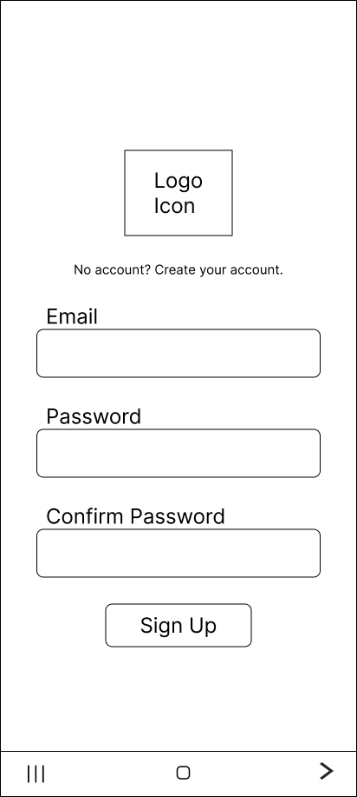
- Registration Screen

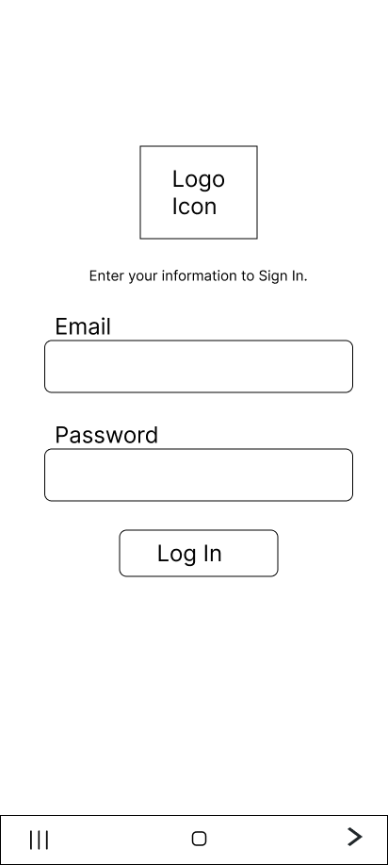
- Login Screen

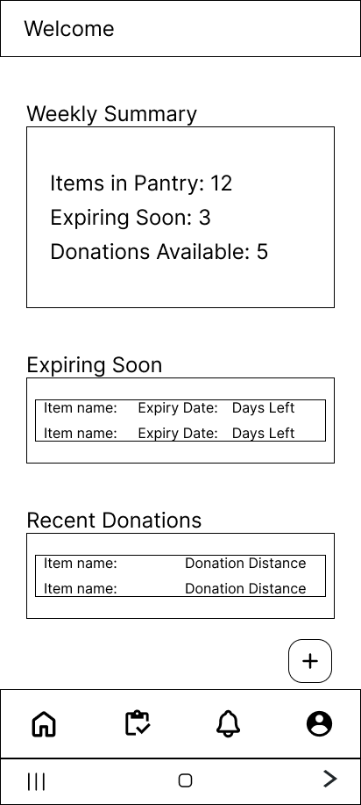
- Home Screen

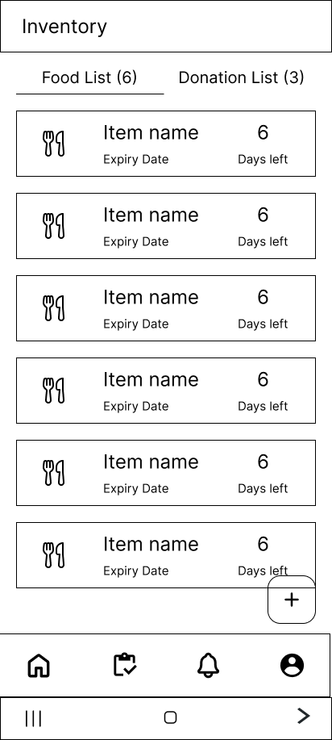
- Inventory (Food List) Screen

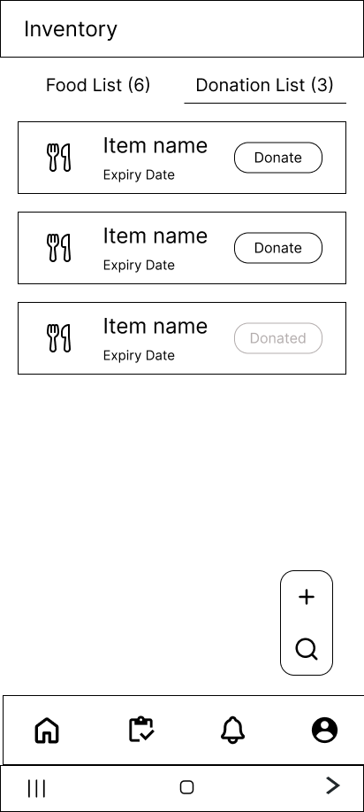
- Inventory (Donation List) Screen

- Add/Edit Food Screen
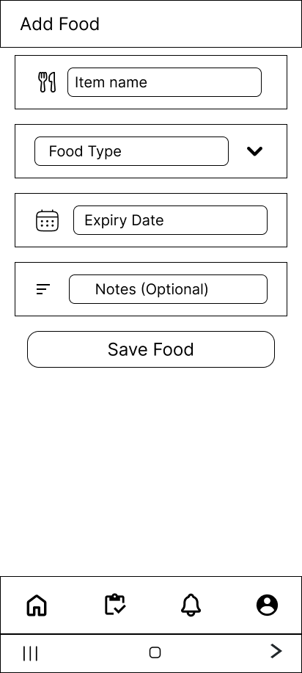

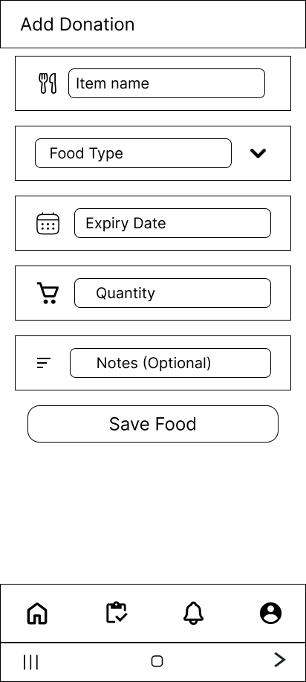
- Add donation Screen

- Browse Donation Screen
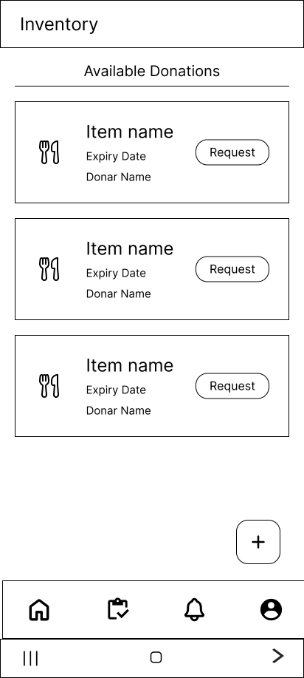

- Notification Screen
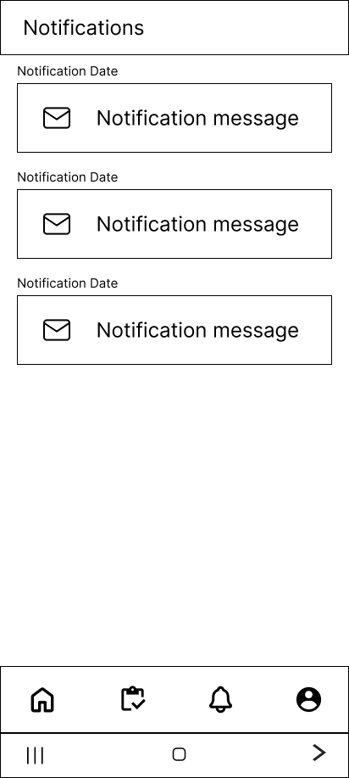

- Profile Screen

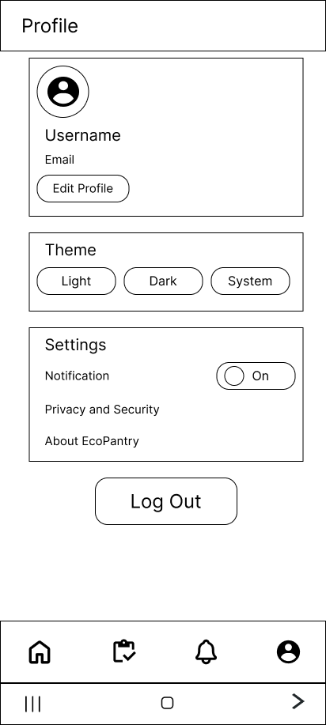

Database Design

