TANAEL, BRIAN JOSHUA P.
BSIT - 3202

Application of the CIA triad on PHILHEALTH Website
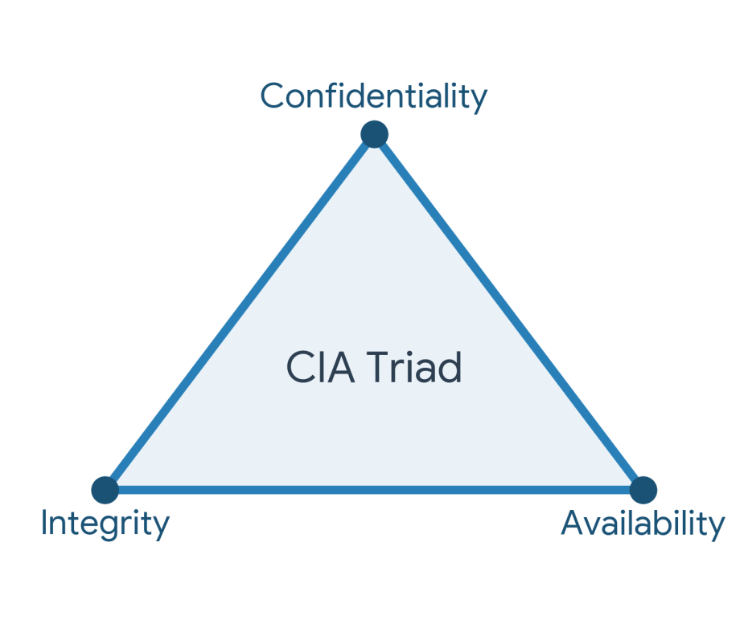

- Confidentiality: Protecting information from unauthorized access and disclosure.

PhilHealth Application: The PhilHealth Member Portal requires users to authenticate using unique credential. It uses HTTPS to ensure that sensitive member data, such as personal health information, dependents' details, and monthly contribution histories, cannot be intercepted or read by unauthorized third parties during transmission.

2. Integrity: Safeguarding the accuracy and completeness of information and processing methods.

PhilHealth Application: PhilHealth ensures integrity by implementing strict database controls so that members and employers can only view but not arbitrarily alter official contribution records. Any changes to a member's profile require formal document verification, preventing unauthorized modifications and ensuring the data remains a reliable source of truth for claiming benefits.

3. Availability: Ensuring that authorized users have access to information and
associated assets when required.

PhilHealth Application: The PhilHealth website and online payment facilities are hosted on resilient servers to provide 24/7 access. By using load balancers and backup systems, PhilHealth ensures the portal remains online and accessible even during high-traffic periods (such as payment deadlines), allowing members to access benefits eligibility and print their MDRs whenever needed.

