Prediction of IMDB movie ratings
Mladen Stajčić, Miodrag Vilotijević, Nemanja Žunić
Software Engineering and Information Technologies
Faculty of Technical Sciences
Novi Sad, Srbija
Email: diskozub@hotmail.com miodragvilotijevic@gmail.com n.zunic@yahoo.com

Abstract—In this experiment we try to predict imdb movie ratings based on the 27 different movie-related attributes. At first, we analyzed the data. We analyzed individual affect of attributes on the imdb rating, and their mutual correlations so that we can reduce the number of attributes during the prediction process. Methods used in the predictions are: Linear Regression, Ridge Regression, Lasso Regression, Support Vector Regression, Bayesian Regressor, KNN Regression, Decision Tree Regresor and Random Forest. After trying several number of attributes used in the prediction process, size of training set, and other parameters of the mentioned algorithams, Random Forest algoritham turned out to be the most efficient method with the lowest error value.
Keywords—Prediction, IMDB, Rating, Movies

Introduction
In this paper we compare results of several supervised learning prediction algorithms used to predict movie ratings. Movie data is obtained from imdb website. Data is then provided as training set to several supervised learning prediction algorithms. Trained models are used to predict imdb ratings of not familiar movie data in the test set and results are analyzed.
In the chapter II. of this paper we will focus on analysis of movie data we used as a training set for the supervised learning algorithms, in the chapter III. we will explain prediction results of algorithms we used. Chapter IV. is conclusion of our experiment and summarization of results we obtained from the experiment.

Data Analysis
Dataset we used in the experiment was downloaded from kaggle website. It contains 5043 different movie titles scrapped from imdb website, along with movie information and movie imdb rating.
In total, there are 28 attributes for every movie in the dataset:
- Color
- Director Name
- Number of Reviews from Critics
- Number of Reviews from Users
- Duration
- Facebook likes for Director
- Main actor’s name
- Secondary actor’s name
- Third actor’s name
- Facebook likes for main actor
- Facebook likes for secondary actor
- Facebook likes for third actor
- Movie facebook likes
- Budget
- Gross
- Genre
- Title
- Number of users that voted
- Total facebook likes for the cast
- Number of faces in the movie poster
- Plot keywords
- Movie’s imdb link
- Language
- Country
- Content Rating
- Year
- Aspect Ratio
- IMDB rating

Roughly speaking, one half of the attributes is directly related to the movies, like: title, year, duration, etc. while the other half is related to the people who were involved in the making of the movie, like: director name, director facebook popularity, movie rating from critics etc.

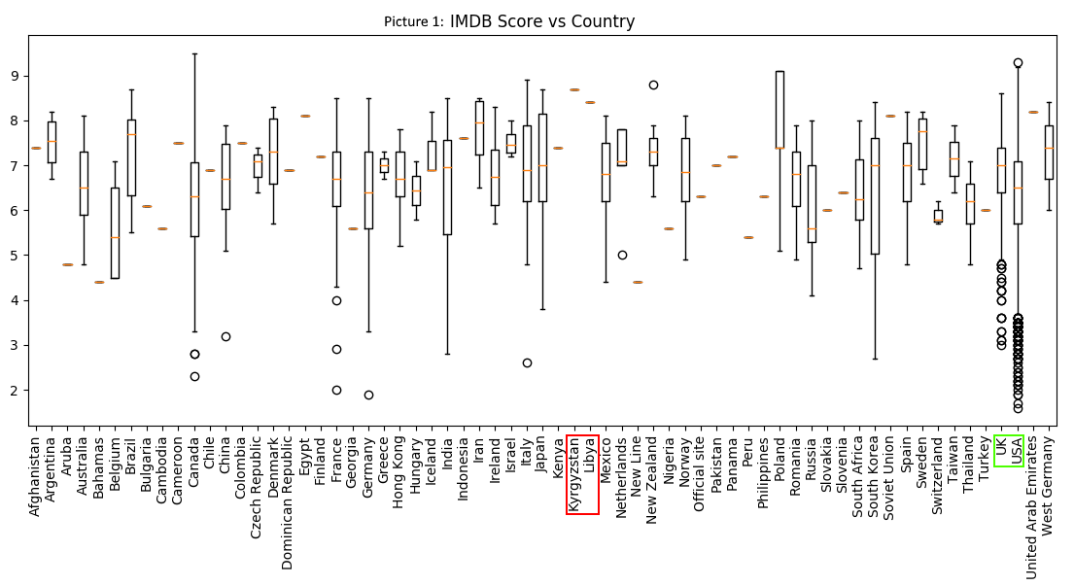
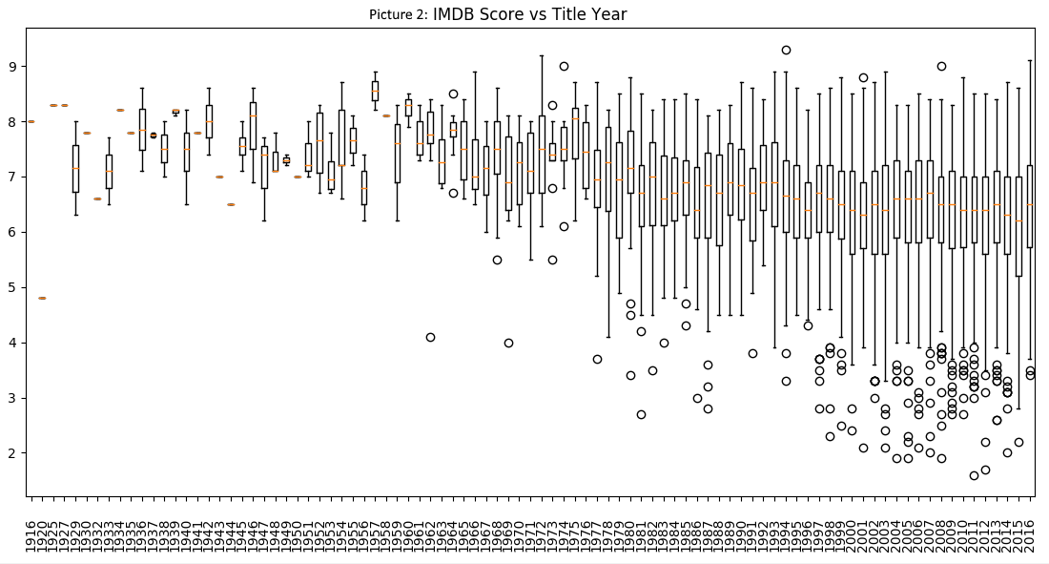
The most interesting attribute in the list is IMDB movie rating, and we are especially interested in how do the other 27 attributes affect it. On IMDB website movies are rated by users of the website on a rating scale from 0 to 10, where movies from 8 to 10 are all probably great, must watch movies and movies below 5 are probably the ones you would skip watching.
On the picture 1 we can see the correlation between IMDB movie ratings and movie’s country of origin. Notice that UK and USA (marked green) have high number of movies with not a very high average rating, while Kyrgyzstan and Libya (marked red) have low number of movies with high average ratings.
On the picture 2 we can see the correlation between IMDB movie ratings and movie’s year of release. We can notice an increase in number of movies made from ’80s onward, but decrease in average movie ratings.
Another interesting correlation is between movie duration and movie ratings, as seen on picture 3. Here, we can see that most of the movies’ duration fall in the 80 minute to 180 minute time window. Also, we can see an increase in imdb ratings in that time window as well, where movies closer to 180 minute duration mark tend to get better ratings.
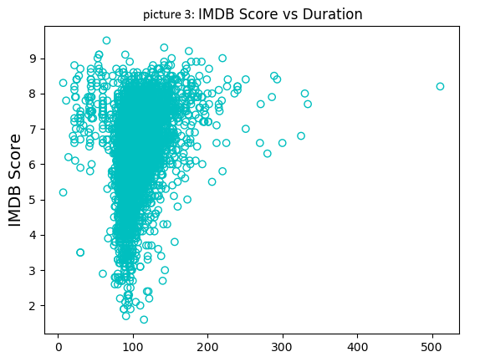
Correlation between imdb ratings and number of users that voted for a paticular movie can be seen on picture 4. We can notice that movies with low number of voters vary in ratings, so we can’t say if movie will have good or bad ratings if low number of users voted. With an increase in user votes for a movie we can notice an increase in ratings as well. For example, huge majority of movies with more than 500 000 votes have ratings over 7.
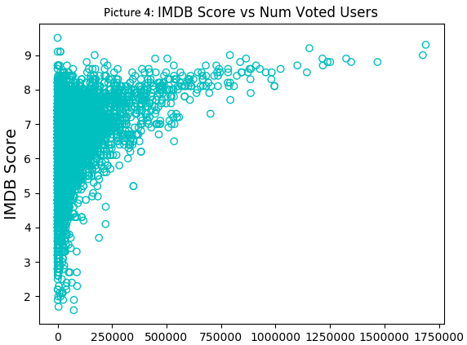
Similarly, big number of movie’s facebook likes tend to mean better ratings, which is to be expected. People are more willing to give a facebook like to a movie they enjoyed watching. This correlation can be seen on picture 5.
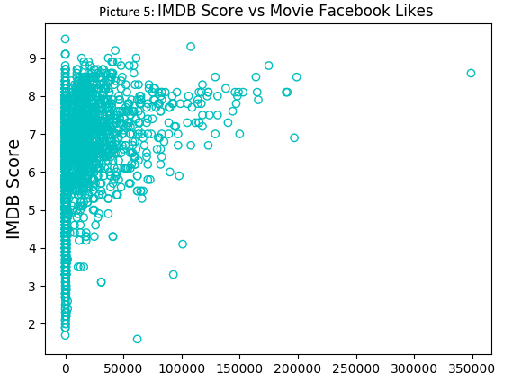
Movie cast can also play a big role in movie’s ratings. Cast with big number of facebook likes can mean better actors with lot of fans that will give the movie good ratings. This correlation is displayed on picture 6.
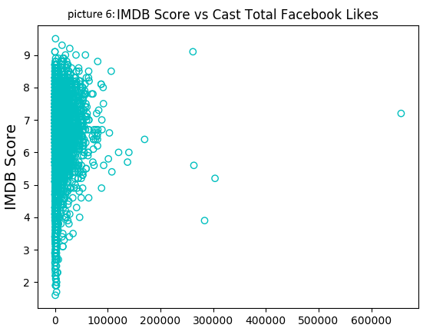
Until now we analyzed how separate attributes affect imdb ratings, and now we will create correlation matrix (picture 7) and see how all numerical attributes affect eachother. We can see that attributes: num_critic_for_reviews, duration, num_voted_users, num_user_for_reviews and movie_facebook_likes have the highest correlation coeficients with imdb_score, meaning, they affect imdb_score the most.
Another method we use for reducing dimensionality of training data is Prinipal Componenet Analysis (PCA) . After calculating individual explained variance for every attribute we choose number of attributes that together can explain about 95% of the variance.
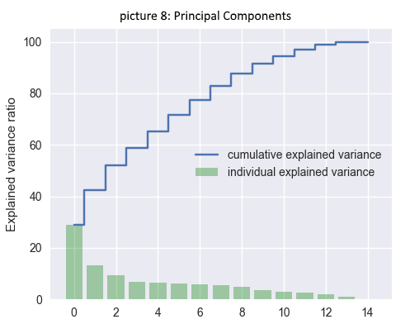
We see that number of componets that explain most of the variance is 10. One of the possible soultions can be prediction of imdb ratings based on only these 10 attributes. Prediction results will be presented in the next chapter.
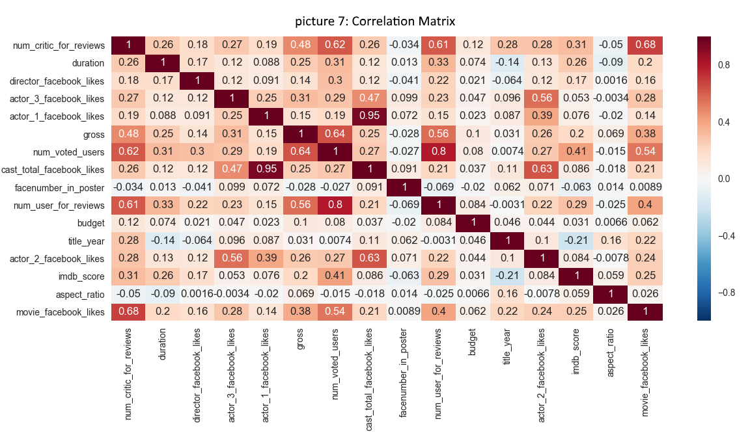

Prediction Results
Since the variable we are predicting is continual (float) there’s no need for using any of the classification algorithms. We will use several regression models for prediction such as Linear Regression, Lasso, Ridge, Bayesian, K-Nearest-Neighbours, SVM Regressor, Decision Tree and Random Forest Regressor. For regression we use all numerical data from dataset. Then we compare mean squared error these regressors produce on test set (Table 1).We will also compare average error which represents difference from real and predicted value of imdb score for every movie.
Regression | MSE | Average Error
Linear Regression | 0.901 | 0.711
Ridge Regression | 0.900 | 0.711
Lasso Regression | 0.907 | 0.714
Support Vector Regressor | 1.201 | 0.832
Bayesian Regressor | 0.906 | 0.715
KNN Regression | 1.207 | 0.843
Decision Tree Regressor (depth=7) | 0.792 | 0.650
Random Forest Regressor  (n_estimators=10) | 0.652 | 0.586
Table 1

As we see from the table, Random Forest Regressor gives the best results. Let’s compare its residual plot with some of the models that scored the least. On picture 9 we can see how good/bad are the decision tree’s predictions. On x axis are the predicted values of decision tree. On the y axis are diffences of predicted values and real values. Notice that most of the set is located around y’s zero value.
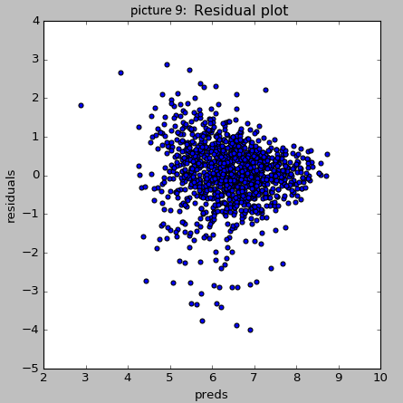

Similarly, on picture 10 we displayed residuals for Support Vector Reggresion. In this case, we can see that most of the predictions have value of 6.5, and thus big differences from the real values. This is the worst-case scenario.
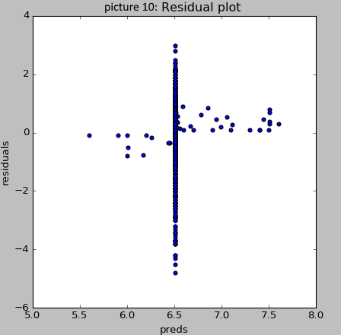

We might get even better result by adjusting n_estimators parameter of random forest regressor. Trying different values for n_estimators and then looking for the one with smallest mse will give us the desired parameter value, which can be seen on picture 11.
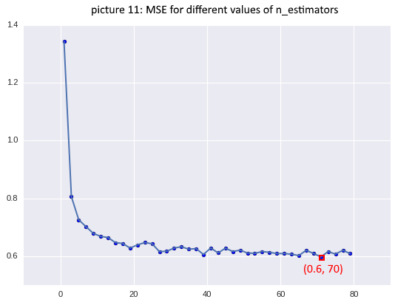
For n_estimators value 70, we get the minimal MSE which equals 0.6. At the same time, thats the minimal MSE we got from the prediction process.
In chapter II. Data Analysis we discussed about how we can reduce the number of attributes during the prediction process. As we mentiond in the Correlation Matrix, we got 6 attributes, of which 2 depend one of the other: movie_facebook_likes and num_critic_for_reviews. Because of that we will not use those two attributes. Prediction results for tese five attributes are displayed in the table 2.

Regression | MSE | Average Error
Linear Regression | 0.993 | 0.755
Ridge Regression | 0.993 | 0.755
Lasso Regression | 0.993 | 0.775
Support Vector Regressor | 1.204 | 0.834
Bayesian Regressor | 0.993 | 0.756
KNN Regression | 1.051 | 0.782
Decision Tree Regressor (depth=7) | 0.880 | 0.707
Random Forest Regressor  (n_estimators=10) | 0.914 | 0.717
Table 2

If we compare results from table 1 and table 2 we can see that prediction from the table 1 is better for all the attributes except KNN Regression.
Now we will get predictions from 10 attributes obtained from PCA. Results are displayed in table 3.

Regression | MSE | Average Error
Linear Regression | 0.964 | 0.735
Ridge Regression | 0.965 | 0.735
Lasso Regression | 1.013 | 0.770
Support Vector Regressor | 0.802 | 0.647
Bayesian Regressor | 0.963 | 0.735
KNN Regression | 0.884 | 0.719
Decision Tree Regressor (depth=7) | 0.936 | 0.718
Random Forest Regressor  (n_estimators=10) | 0.832 | 0.681
Table 3
In this case we can see that prediction with all attributes from table 1 gave us better results.

Conclusion
We got the best result with Random Forest method using n_estimators value 70 and all numerical values from the dataset. In this case calculated MSE value is 0.6

www.imdb.com
https://www.kaggle.com/deepmatrix/imdb-5000-movie-dataset

