BantayLedger AI: An AI-Assisted Inventory,
Sales and Insight Platform for Philippine Small Businesses

A TECHNOLOGY STARTUP VENTURE PROPOSAL

Technopreneurship Emerging Technologies and
Application Development (Ionic)
Artificial Intelligence

Submitted by:
Decierdo, Kim G.

Submitted to:
Edmar B. Ubatay
Carolina L. Saraos
Auron M. Pader

November 2026

CHAPTER 1
STARTUP OVERVIEW

1.1 Introduction
BantayLedger AI is a proposed technology startup that gives small Philippine businesses, such as sari-sari stores, mini marts, carinderias and neighbourhood retailers, a simple web and mobile-friendly application for keeping track of what they sell, what they buy and what is left on the shelf. Its name combines "bantay" (to watch over or guard) and "ledger" (the record of money and goods), because the product exists to watch over a small business's stock and money so the owner does not have to rely on memory and paper.
The idea came from a common situation in neighbourhood stores: sales, stock and supplier prices are recorded in a notebook (the "listahan") or only remembered. The owner notices a problem only after a product is already out of stock, after a supplier has quietly raised a price, or after goods have spoiled. BantayLedger AI addresses this by turning the store's daily records into a live view of stock, profit and warnings, and by using simple forecasting and rules to suggest what to restock, when, and at what selling price.
The primary beneficiaries are owners and staff of micro and small retail businesses. The proposed solution is an Ionic React application, delivered as a website, an Android app, a Windows app and an iPhone or iPad home-screen app, connected to a Laravel backend and a MySQL database, in English, Filipino (Tagalog) and Cebuano (Bisaya), with an AI-assisted insights feature that explains trends in plain language.

1.2 Vision
To become the everyday "bantay" of every small Filipino business: a trustworthy, easy-to-understand assistant that helps ordinary store owners make better stocking, pricing and spending decisions in their own language.

1.3 Mission
BantayLedger AI exists to help Philippine micro and small business owners record their sales, purchases and stock quickly, understand their numbers without accounting jargon, and receive timely, practical advice (what to reorder, which prices are rising, what is selling fast) so that they waste less, run out less, and earn more from the same capital.

1.4 Startup Goals and Objectives
Goal: Reduce lost sales, spoiled stock and guesswork for small retailers by giving them a simple, affordable digital ledger with built-in intelligence.
Specific objectives:
1. Solve the identified problem by providing live stock levels, low-stock warnings and a record of every sale, purchase, expense and spoiled item.
2. Develop a working Ionic React application with secure sign-in, role-based access (owner and staff) and a Laravel/MySQL backend.
3. Provide a point-of-sale style "Add Sale" experience that supports cash, GCash or combined cash-and-GCash payments and a change calculator.
4. Reach the target market of micro retailers by supporting English, Tagalog and Cebuano and by using everyday words (for example "Spoiled & Damaged" with Taglish reasons).
5. Integrate AI features that provide demand forecasts, supplier-price warnings, price-versus-demand advice, trending and seasonal insights, stock-up lists for upcoming events, and an optional AI-written explanation.
6. Create business opportunities through a freemium subscription model that can be sustained by a small number of paying shops.

1.5 Startup Identity
Startup Name: BantayLedger AI.
Logo Explanation: The logo is a shield that holds the letter B, a watchful animal curled around its base, three rising bars and an upward arrow. The shield and the animal stand for the "bantay" that watches over the store, and the bars and the arrow stand for its records and growth. It uses a bright green, a dark green and black with clean white gaps, so that it stays readable at a small size on a phone screen. See Figure 1.1.

Figure 1.1 BantayLedger AI logo

Tagline: "Bantay ang tindahan mo, kahit hindi mo tinitingnan." (Watching over your store, even when you are not looking.)
Brand Personality: Trustworthy, friendly, practical and respectful. The product speaks like a helpful neighbour: short sentences, everyday words, no accounting jargon, and a mix of English and Filipino where it feels natural.
Brand Colors: Green is the primary colour of the interface (#1F6F5B, with a darker #174F42 and a light #E9F4EF) because it suggests money, growth and health of stock; the logo itself uses a brighter green (#26A554), a dark green (#17693B) and black. Amber (#8A5A10) is used for warnings and red (#B23E3E) for urgent problems, so the colours carry meaning on alerts and stock badges. These text colours meet the 4.5:1 contrast minimum. The palette is part of the visual design system. (See Figure 8.9)

CHAPTER 2
PROBLEM DISCOVERY AND VALIDATION

2.1 Problem Statement
Many small Philippine retailers manage their stock and money informally. Sales are written in a notebook or not written at all, the quantity left on the shelf is judged by eye, and supplier prices are remembered rather than tracked. As a result, owners often do not know their real profit, run out of fast-moving products at the worst time, buy too much of items that sell slowly, and lose money to expired or damaged goods.
These are not application problems; they are everyday business problems. The consequences are lost sales (a customer leaves because the item is out), tied-up cash (money sitting in slow stock), wasted goods, and decisions made without knowing whether a price increase from a supplier has already eaten the store's margin. The problem is specific enough for a technology-based solution because it involves repeated, small records and simple calculations that a computer can do instantly and a person cannot do reliably from memory.

2.2 Existing Process / Current Situation
Today the typical process is manual. Items are sold for cash or, increasingly, GCash. The sale is noted in a notebook if at all. The owner checks the shelf to decide whether to restock, buys from a market or supplier at whatever price is current, and estimates profit from memory. (See Figure 2.1) The process has the following weaknesses:
• There is no single, reliable record of sales, so profit and best-sellers are guessed.
• Stock is checked by eye, so shortages are discovered late.
• Supplier price changes are noticed only when the owner remembers the old price.
• Spoiled, expired or damaged goods are rarely recorded, so the loss is invisible.
• GCash payments are recorded separately from cash sales, and references are easy to lose.
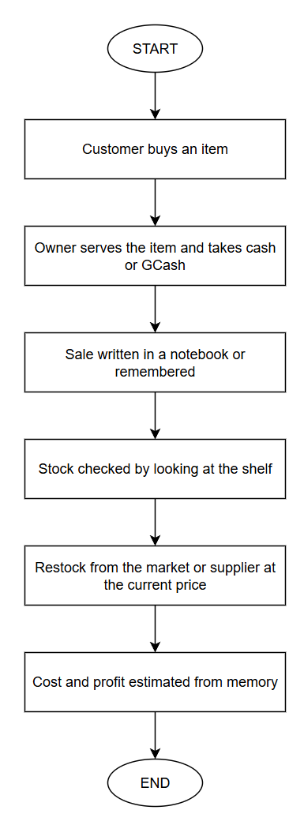
Figure 2.1 Current manual process of a small store
2.3 Target Users and Stakeholders
Primary Users: Owners and staff of sari-sari stores, mini marts, small food stalls and similar neighbourhood retailers who record daily sales and purchases.
Secondary Users: Family members who help run the store, part-time helpers who record sales, and a trusted bookkeeper or relative who reviews the numbers.
Stakeholders: Suppliers and wholesalers (who receive purchase orders), customers (who benefit from products being in stock and from GCash options), barangay and local business groups, and the platform operator, who is responsible for data privacy under the Data Privacy Act of 2012.

2.4 Market Validation
This proposal was not able to run a formal survey or interview round. In its place, the validation method used is a self-observation by the proponent, a Filipino who has grown up around neighbourhood stores and buys from them regularly. The method is simple observation: noting how stores in the proponent's own community record sales, keep stock, set prices and handle payments, and how those practices cause trouble. It is a limited, personal and non-statistical method, and the findings below should be read as informed observation, not as survey results.
A survey questionnaire and an interview guide that can be used to extend this validation are included in Appendix A.

2.5 Validation Results and Discussion
The self-observation produced the following consistent observations:
• Records are informal: Many stores rely on a notebook for "utang" (credit) and on memory for everything else. Few keep a running record of daily sales.
• Stock is judged by eye: The owner knows an item is almost gone only when the shelf looks empty. Popular items such as soft drinks, instant noodles, coffee sachets and cigarettes can run out between supplier trips.
• Price changes are felt, not tracked: Owners notice that "mas mahal na" (it is more expensive now) but rarely know by how much, or whether their selling price still leaves a profit.
• Loss from spoilage and damage is hidden: Expired, spilled or damaged goods are quietly absorbed into the cost of doing business instead of being recorded.
• Digital payments are now normal: GCash is widely accepted in neighbourhood stores, which adds a second stream of money that must be reconciled with the cash drawer.
• Phones are the main computer: Owners and helpers use smartphones daily; a desktop-only tool would not fit how they work.
• Language matters: Most store owners think and talk in Tagalog or Cebuano; an English-only, jargon-heavy tool is a barrier.
These observations support the proposed startup in three ways. First, the problem is real and frequent, because the same pattern repeats across stores. Second, the pain is serious but small-scale: no single mistake is catastrophic, but the combined loss from stock-outs, slow stock and hidden waste affects thin margins. Third, the observed users already have the device (a phone) and the habit (GCash, social media) that a lightweight digital tool needs. The features users would most expect are quick recording of sales, clear low-stock warnings, a view of profit, and plain-language advice.
The limitation of this validation must be stated honestly: it reflects one person's observation and has not been tested with respondents. The recommended next step is to run the survey and interview in Appendix A with at least a small group of store owners before any commercial launch.

CHAPTER 3
PRODUCT SOLUTION AND VALUE PROPOSITION

3.1 Product Overview
BantayLedger AI is an application built with Ionic React. It is available as a live website, an Android app, a Windows app and an iPhone or iPad home-screen app, and it keeps working without internet. It lets a business owner and staff record sales, purchases, expenses and spoiled items; keeps stock levels up to date automatically; shows a dashboard with profit and warnings; and generates forecasts and insights from the shop's own records.

3.2 Proposed Solution
The solution connects the three parts of the problem. Recording is made fast (tap a product tile, choose Cash, GCash or both, save). Stock is updated by the system every time something is sold, bought, spoiled or adjusted, so the quantity on hand is always current shown in table 3.1. The system then uses those records to warn and advise. The chain is:
Problem → Proposed Solution → Expected Improvement
Table 3.1 Current process compared with the proposed solution
Aspect | Current process | With BantayLedger AI
Sales record | Notebook or memory | Every sale saved with items, payment method and GCash reference
Stock level | Checked by eye | Updated automatically from every transaction
Restock decision | When the shelf looks empty | Reorder alerts and suggested quantity
Supplier price | Remembered | Price trend, forecast and what-if for price changes
Spoilage | Not recorded | Recorded with reason and estimated cost
Profit | Estimated | Calculated from weighted-average cost

3.3 Product Features
Core Features:
- Secure sign-in and roles: Owner and staff roles control who can edit the catalogue or delete records. It addresses unauthorised changes.
- Inventory management: Products with photos, categories, suppliers, buying and selling prices, low-stock levels, and Enable/Disable instead of deleting. Used by the owner.
- Add Sale (point-of-sale style): Tap product tiles to build a cart, choose Cash, GCash or Cash + GCash with the GCash reference, and see a change calculator. Used by staff; it replaces the notebook.
- Purchases and suppliers: Record purchases as pending or received, with a monthly purchase budget warning and supplier map location.
- Expenses and Spoiled & Damaged items: Records money out and goods lost, with friendly Taglish reasons.
- Dashboard and reports: Totals, trends and status of stock at a glance.
- Works without internet: Sales, purchases, expenses and spoiled items recorded offline are kept on the device and sent automatically when the connection returns.
- Website and installable apps: A live website with download buttons for Android and Windows, and an iPhone or iPad home-screen app. The Android and Windows apps announce new versions.
- Password reset by email: A one-time link, valid for 60 minutes, lets a user choose a new password.
- Policies and your data: Public Privacy, Terms, Refund and Cookie pages. Creating an account asks the user to confirm they are 18 or older and agree to the Terms, and Settings lets anyone download their data or delete their account.

Advanced Features:
• Demand forecast: A 7-day forecast per product so owners know what to stock.
• Supplier-price forecast and what-if: Three-month price outlook and a calculator for price changes.
• Alerts and AI Insights: Reorder, price-rise, slow-moving, thin-margin and price-versus-demand advice.
• Trending and seasonal insights: Explains why a product is selling fast and whether it is seasonal.
• Optional "Explain with AI": An AI-written explanation for a trending product when a provider key is configured.
• Multi-language: English, Tagalog and Cebuano, including server messages and insights.
• Event stock-up lists: Before Christmas, New Year, Undas, a barangay fiesta and other events, lists what to stock and how much, with an Order button for each product.
• Local events: The owner adds the barangay fiesta or another local event once, and it repeats every year.

Future Enhancements:
• Barcode scanning for adding products and ringing up sales.
• Customer credit ("utang") tracking.
• An App Store release for iPhone and iPad.
• Real online subscription payments through GCash or Maya.

3.4 Value Proposition
BantayLedger AI saves time (a sale is recorded in a few taps), saves money (fewer stock-outs, less spoilage and better-informed pricing), is accessible (works in the user's own language and on a phone), and improves decisions by showing, in plain words, what to do next. It also helps the owner see the real effect of a supplier price change on profit before it hurts.

3.5 Unique Selling Proposition (USP)
The USP is the combination of a store-sized, easy-to-use ledger with advice that is written for a Philippine small business: price-versus-demand scenarios ("Bought low and demand is high, so stock up"), a seasonal guide for Philippine months (summer, rainy season, "-ber months", back-to-school), stock-up lists for events such as Christmas and the barangay fiesta, Taglish wording, GCash support, and three languages. Users should choose it over a notebook, a spreadsheet or a generic point-of-sale app because it does not only record; it explains and recommends in everyday language.

3.6 Expected Benefits
Benefits to Users: Faster recording, fewer surprises, a clear view of profit, less money lost to spoilage, and advice they can understand without bookkeeping training.
Benefits to Organizations or Businesses: Better working capital use, more stable supply of fast-moving products, and a record that can support a loan or permit application.
Benefits to Society or Community: More resilient neighbourhood businesses, a gentle step toward digital record-keeping, and a model of AI that is transparent and respects user data.

CHAPTER 4
MARKET AND BUSINESS MODEL

4.1 Industry and Market Analysis
The startup operates in the retail technology and small-business software sector. The proposed market is the micro and small retailer segment of the Philippines, where neighbourhood stores are an important part of everyday buying and where more owners are adopting smartphones and GCash. Relevant conditions include rising supplier prices, strong competition among nearby stores, and a growing comfort with digital payments. These conditions suggest there is a potential market for a tool that helps small owners protect thin margins. The sector facts used here are general and have not been formally measured in this proposal; a sourced market-size estimate is listed as a recommended next step.

4.2 Competitor Analysis
Alternatives that address the same problem include the paper notebook, spreadsheets such as Excel or Google Sheets, general-purpose point-of-sale and inventory apps (for example free POS apps such as Loyverse), and general bookkeeping apps. The comparison below is based on the proponent's general understanding of these options and is not a formal benchmark.

Table 4.1 Comparison with alternatives
Criteria | Notebook | Spreadsheet | General POS apps | BantayLedger AI
Setup effort | None | Medium | Medium | Low
Live stock updates | No | Manual | Yes | Yes
GCash reference on sales | No | Manual | Varies | Yes (required, duplicates blocked)
Supplier price insight | No | Manual | Limited | Forecast, what-if, warnings
Price-vs-demand advice | No | No | Limited | Yes
Event stock-up lists | No | No | Limited | Yes
Filipino / Cebuano language | Owner's own | Owner-made | Often English | English, Tagalog, Cebuano
AI capability | None | None | Limited | Forecast, insights, optional explanation
Price to user | Free | Free | Free to paid | Freemium (assumed)

4.3 Customer Persona
Table 4.2 Customer persona
Item | Description
Persona label | Aling Nena, sari-sari store owner (a composite, not a real person)
Age range | 35 to 55
Occupation | Owner and operator of a neighbourhood sari-sari store, with a family member helping
Background | Runs the store from the front of the house; buys goods weekly from a market or wholesaler; accepts cash and GCash
Needs | Know what to buy and when; know whether the store really earns; keep track of spoiled goods
Goals | Grow the store, avoid running out of popular items, keep money from leaking
Problems | Notebook is messy; prices keep changing; hard to remember what sold
Technology behaviour | Uses a smartphone, Facebook and GCash daily; prefers Tagalog or Cebuano; avoids complicated screens
Expectations | Fast to use, works on a phone, in her language, and tells her what to do in plain words

4.4 SWOT Analysis
Table 4.3 SWOT analysis
Strengths (internal) | Weaknesses (internal)
Working system on a live website, with Android and Windows apps and offline recording; plain-language, three-language interface; AI insights that use the shop's own data; low running cost; no vendor lock-in for AI provider. | Single developer; no live pilot or user testing yet; free hosting limits (the server can sleep and the database powers off when idle); translations not reviewed by native speakers; AI explanation not yet tried with a live key.
Opportunities (external) | Threats (external)
Growing smartphone and GCash use; many small stores without any digital tool; possibility of partnership with suppliers and community groups; low-cost cloud hosting. | Established POS apps and free competitors; owners' reluctance to change habits; data privacy obligations; dependence on third-party free-tier limits (hosting, database, AI); internet reliability.

4.5 Business Model Canvas
Table 4.4 Business Model Canvas
Component | BantayLedger AI
1. Customer Segments | Micro and small retailers (sari-sari stores, mini marts, food stalls); later small wholesalers and multi-branch shops.
2. Value Propositions | Live stock and profit, GCash-ready sales, plain-language AI advice, three languages, works on a phone.
3. Channels | Website with Android and Windows downloads, social media pages, community and barangay demos, word of mouth, supplier partners.
4. Customer Relationships | Self-service with in-app guidance; chat or message support; community tips and tutorials.
5. Revenue Streams | Freemium: a free plan and a paid plan (weekly, monthly or yearly) with AI insights, more products and more users.
6. Key Resources | Application code, database, cloud server, AI provider key, developer time.
7. Key Activities | Development and maintenance, customer onboarding, support, privacy compliance, content updates (seasonal guide).
8. Key Partnerships | Hosting and service providers (Render, Aiven, Brevo, GitHub), AI provider, OpenStreetMap services, suppliers, local business groups.
9. Cost Structure | Hosting, domain, AI usage beyond the free tier, internet, marketing, maintenance and legal review.

CHAPTER 5
MARKETING AND FINANCIAL PLAN

All amounts in this chapter are in Philippine pesos (PHP). Each figure is labeled Actual (known today), Estimated (based on typical prices) or Assumed (a planning assumption). None of these is a guaranteed result.

5.1 Marketing Strategy
The strategy is low-cost and community-based, to fit the target market. It includes: (1) short demo videos and tips on Facebook and TikTok showing a sale being recorded in a few taps; (2) in-person demonstrations in a pilot barangay; (3) referral rewards where an owner who brings another store receives a free month; (4) partnerships with suppliers and local business groups that can introduce the tool to their customers; and (5) content in Tagalog and Cebuano that explains the benefits in everyday language.

5.2 Pricing Strategy
A freemium model is proposed. The free plan allows one business with a limited number of products so that an owner can try it without risk. A paid plan, assumed at PHP 129 per month (or PHP 39 per week, or PHP 1,199 per year), includes unlimited products, more members, forecasts and AI insights. The price was set by assumption to be roughly the cost of a few items from the store itself and to be affordable for a micro business; it must be tested with real users. For the project defense, the Subscription page in the application is a demonstration: typing a 13-digit GCash reference number activates the Plus label, no real payment is taken, and every store keeps every feature.

5.3 Revenue Model
Revenue comes from paid subscriptions. Secondary, future sources may include referral commissions from suppliers and optional premium reports. The free plan contributes by building the user base and word of mouth.

5.4 Startup Cost
Table 5.1 Startup cost (one-time)
Item | Amount (PHP) | Basis
Development equipment (existing laptop) | 0 | Actual (already owned)
Development labour (academic project) | 0 | Actual (not charged)
Software (React, Ionic, Laravel, MySQL) | 0 | Actual (free and open source)
Domain registration (first year) | 700 | Estimated
Business name registration | 500 | Assumed
Data privacy and legal review | 5,000 | Assumed
Launch marketing materials and demos | 3,000 | Assumed
Total startup cost | 9,200 | Sum of the above

5.5 Operating Expenses
Table 5.2 Monthly operating expenses
Item | Per month (PHP) | Basis
Cloud hosting (small server) | 500 | Estimated (currently 0 on free plans)
AI provider usage (free tier now; reserve for paid use) | 300 | Assumed (currently 0 on free tier)
Internet | 1,000 | Assumed
Domain (monthly share) | 58 | Estimated (700 / 12)
Ongoing marketing | 1,000 | Assumed
Total operating expenses | 2,858 | Sum of the above

Maintenance and developer time are not charged in this projection. Payment-gateway fees are not included. The system currently runs on free plans (Render, Aiven, Brevo, GitHub), so the actual hosting cost today is PHP 0; the amounts above allow for paid plans as the number of stores grows.

5.6 Revenue Projection
The projection assumes 5 additional paying subscribers each month for 12 months, reaching 60 paying shops by month 12, at PHP 129 per month. The growth rate is an assumption and has not been validated. Revenue in month m is 5 x m x 129.
Table 5.3 Twelve-month revenue projection (assumed)
Month | Paying shops | Revenue (PHP) | Operating cost (PHP) | Cumulative net after startup cost (PHP)
1 | 5 | 645 | 2,858 | -11,413
2 | 10 | 1,290 | 2,858 | -12,981
3 | 15 | 1,935 | 2,858 | -13,904
4 | 20 | 2,580 | 2,858 | -14,182
5 | 25 | 3,225 | 2,858 | -13,815
6 | 30 | 3,870 | 2,858 | -12,803
7 | 35 | 4,515 | 2,858 | -11,146
8 | 40 | 5,160 | 2,858 | -8,844
9 | 45 | 5,805 | 2,858 | -5,897
10 | 50 | 6,450 | 2,858 | -2,305
11 | 55 | 7,095 | 2,858 | 1,932
12 | 60 | 7,740 | 2,858 | 6,814
Total assumed first-year revenue is PHP 50,310 (390 paying-shop months x PHP 129). These are projections, not guaranteed income.

5.7 Break-even Analysis
Operating break-even: with monthly operating expenses of PHP 2,858 and a price of PHP 129, the startup needs about 23 paying shops (2,858 / 129 = 22.2) to cover its monthly running cost. Break-even including the one-time startup cost of PHP 9,200: under the assumed growth, the cumulative net becomes positive in month 11 (Table 5.3). This depends entirely on the assumed growth of 5 paying shops per month.

5.8 Projected ROI
Total first-year cost under the assumptions is PHP 43,496 (startup PHP 9,200 plus 12 x PHP 2,858). Assumed first-year revenue is PHP 50,310, so net gain is PHP 6,814. ROI = 6,814 / 43,496 = about 15.7% for the first year. The figure is highly sensitive to the subscriber assumption, excludes the proponent's time, taxes and payment fees, and should not be treated as a forecast of actual return. The computations are in Appendix B.

CHAPTER 6
TECHNICAL AND AI OVERVIEW

6.1 Technical Scope and Limitations
Major system functions: Authentication and consent; catalogue (products, categories, suppliers); inventory ledger; sales; purchases; expenses; spoiled and damaged items; reports; forecasts; alerts; AI insights; event stock-up lists and local events; offline recording and sync; password reset by email; update notices; demo subscription; policy pages; data download and account deletion; language and settings.
Included modules: Frontend (Ionic React, in src/), backend (Laravel, in laravel-server/), Android app (Capacitor, in android/) and Windows app (Electron, in desktop/), connected by a REST API.
User roles: Owner and Staff. The owner is created at sign-up and can edit the catalogue, delete records and manage the team (add staff, reset a staff password, remove staff), local events and the demo subscription. Staff can record sales, purchases, expenses and spoiled items and adjust stock.
System boundaries: The system covers one business per account context with its members. It does not process payments itself; GCash is recorded as a payment method with a reference, and the Subscription page is a demonstration that takes no real payment.
External systems or services: Render (server and website hosting), Aiven (MySQL database), Brevo (password reset email), GitHub Releases (app downloads and update check), OpenStreetMap and Photon (address search and map), and an optional AI provider (Gemini by default).
Current limitations: The free server can sleep after a period without visitors; the free database powers off when idle and must be powered on again; Android updates are downloaded and installed by the user; the iPhone version is a home-screen app, not an App Store app; signing in and changing settings need internet; a sign-in expires after 30 days; forecasts need sales history; AI explanation not yet tested with a live key; translations not reviewed by native speakers.

6.2 Technical Objectives
1. Develop a responsive application using Ionic React and TypeScript.
2. Provide secure user authentication with token-based access and role checks.
3. Store and manage business data in a relational database with transactional stock updates.
4. Integrate AI-assisted features that produce forecasts, alerts and insights from the business's own records.
5. Provide a user-friendly interface in English, Tagalog and Cebuano.

6.3 Target Platform
The system is cross-platform from one codebase: a responsive website that works on desktop and mobile browsers, an Android app built with Capacitor, a Windows app built with Electron, and a home-screen app for iPhone and iPad added from Safari, which opens without internet after one visit. An App Store release needs a Mac and a paid Apple Developer account and remains a future option.

6.4 Technology Stack
Table 6.1 Technology stack and reasons
Layer | Technology | Why it was selected
Frontend | Ionic React, TypeScript, Vite | One codebase for desktop and mobile; fast development; type safety
Backend | Laravel 12 (PHP) | Mature framework for routing, validation, authorisation and migrations
Database | MySQL 8 on Aiven (live); MariaDB on XAMPP (development) | Reliable relational storage with transactions for stock accuracy
APIs | REST + JSON | Simple contract between the application and the server
Authentication | Laravel Sanctum bearer tokens | Lightweight, no cookies, works with a mobile-style client
Hosting | Render (server and website), GitHub Releases (app downloads) | Free plans are enough for the prototype; downloads and update checks need no extra server
App packaging | Capacitor (Android), Electron (Windows), service worker (iPhone home-screen and offline website) | The same application reaches every device
Email | Brevo | Sends password reset emails over HTTPS, which works on the free server plan
Maps | OpenStreetMap, Photon | Free address search and map for suppliers
AI provider (optional) | Google Gemini free tier, or OpenAI-compatible / Ollama | Low-cost optional explanation; provider can be swapped
Localization | i18next (client), Laravel lang files (server) | English, Tagalog and Cebuano across screens and messages
Tools | Node.js, npm, Composer, XAMPP, Git | Standard development tooling

6.5 Artificial Intelligence Integration
6.5.1 AI Function
The AI component performs forecasting and decision support. It predicts weekly demand per product, forecasts supplier price and purchasing cost, detects price-versus-demand situations, identifies trending products and gives reasons, lists what to stock before upcoming events, and (optionally) writes a plain-language explanation of why a product is trending.
6.5.2 AI Technology or Approach
The core insights use statistical methods and business rules, not a trained machine-learning model. The demand forecast is 0.6 x the last-7-day average plus 0.4 x the 28-day average, with a range of one standard deviation. Supplier price is projected from received purchases with a damped trend capped at 5% of the latest price per month. A rule engine (ForecastService) turns these numbers into alerts and recommendations. A small seasonal knowledge base (SeasonKnowledge) matches products to Philippine seasons. An event calendar (EventCalendar) holds Philippine events and the store's own local events; before each one, the system uses what the store sold in the same period last year, or a clearly labelled general guide when it has no records for that period yet. The optional explanation uses a large language model through a provider API. This approach was chosen because a small shop has little data, which makes rules and simple statistics more reliable and easier to explain than a trained model.

6.5.3 AI Data Requirements
• Data sources: The shop's own sales, purchases, stock movements, spoiled items and supplier records, entered by users.
• Type and volume: Structured records; forecasts require at least some days of sales history, and the price forecast requires purchases on two or more different dates.
• Data quality: Depends on users recording transactions; sales are bucketed by their own date; low history lowers the stated confidence.
• Privacy: Only the product name, category and four weekly unit counts are sent to the optional AI provider; business name, customers, prices and user details are never sent.
The proponent does not own a large external dataset; the system uses only data the shop itself records.

6.5.4 AI Integration Architecture
The user opens AI Insights; the application shows the saved results straight away and asks the API in the background to refresh if records changed or it is a new day; the server computes forecasts and insights with ForecastService and stores them in a language-neutral form; the application re-reads them quietly and displays them in the reader's language. The optional AI explanation is a separate request that is cached per business, product and week. (See Figure 6.1)
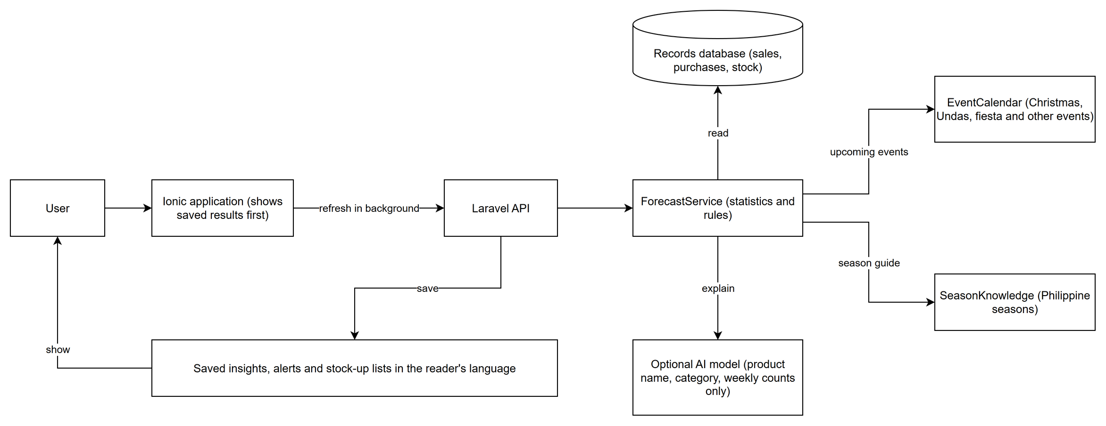
Figure 6.1 AI integration architecture

6.5.5 AI Benefits
Because of the AI features the application does more than record. It can warn that a product will run out within three days, point out that a supplier price is rising, explain that "bought low and demand is high" is the time to stock up, suggest a selling price that keeps a margin, and list what to stock before Christmas or the barangay fiesta. A notebook or spreadsheet cannot do this without the owner doing the calculations.

6.5.6 Responsible AI Considerations
• Privacy: Minimal data is sent; the key stays on the server; a data notice and consent step is shown before use; people can download or delete their own data in Settings.
• Accuracy: Forecasts show how sure the system is; AI-written text can be wrong and is labelled as such.
• Transparency: The seasonal guide is labelled "General knowledge, not verified for your area" unless the shop's own history supports it.
• Human oversight: The system only advises; the owner decides. Nothing is ordered or changed automatically.
• Cost and misuse guards: A limit of one answer per product per week and ten per business per day, and a request timeout.
CHAPTER 7
EMERGING TECHNOLOGY AND TECHNICAL FEASIBILITY

7.1 Emerging Technology Used
• Artificial Intelligence: Forecasting, rules-based insights and optional language-model explanation.
• Cloud computing / APIs: A REST backend hosted in the cloud on Render with a managed MySQL database on Aiven, and third-party services accessed through APIs.
• Geolocation and maps: Supplier address search and a draggable map pin using OpenStreetMap services.
• Progressive web access: A responsive Ionic application usable from a phone browser, which can be added to the iPhone or iPad home screen and opens without internet after one visit.
• Offline storage and sync: Records are kept on the device with no signal and sent later, with a one-time key so they cannot be saved twice.
Technologies such as IoT, computer vision and voice were not added because they do not have a purpose in the current scope.

7.2 Technology Justification
Table 7.1 Technology justification
Technology | What it does | Why it is needed | Problem it helps solve
AI forecasting and rules | Predicts demand and price; creates advice | Owners cannot compute trends by memory | Stock-outs, overstocking, hidden margin loss
Optional language model | Writes plain-language explanation | Explains "why" in the user's language | Understanding trends and seasons
Maps and geocoding | Finds and stores supplier location | Quick, accurate supplier records | Remembering where and from whom to buy
Cloud-hosted REST API | Serves data to any client | Allows access from phone and desktop | Records trapped in one device or notebook

7.3 Technology-Enabled Innovation
The innovation is not a new technology but its application: a store-sized tool that combines record-keeping with price-versus-demand reasoning, a Philippine seasonal guide and three-language plain wording, so that small owners get advice that is usually only available to larger businesses with analysts.
7.4 Technical Feasibility
• Technical requirements: A PHP/MySQL server, Node.js build tooling, a browser.
• Required skills: React/TypeScript, Laravel/PHP, SQL, basic statistics, UI design.
• Available tools: All used tools are free and open source.
• Difficulties: Keeping stock consistent across concurrent writes, translations quality, forecasting with little data.
• Limitations: Free-plan hosting (the server can sleep and the database powers off when idle); AI explanation depends on a third-party free tier.
• Risk areas: Data privacy, free-tier quota changes, reliance on user data entry discipline.
• Feasibility in the academic period: The prototype already implements the core and advanced features listed in Chapter 9; remaining items are marked as future work.

CHAPTER 8
SYSTEM AND USER EXPERIENCE DESIGN

8.1 System Architecture
The system follows a three-tier structure: the Ionic React application (presentation), the Laravel API on Render (application logic and authorisation) and the MySQL database on Aiven (data). The same application reaches users through the website, the Android and Windows apps and the iPhone or iPad home-screen app. (See Figure 8.1)
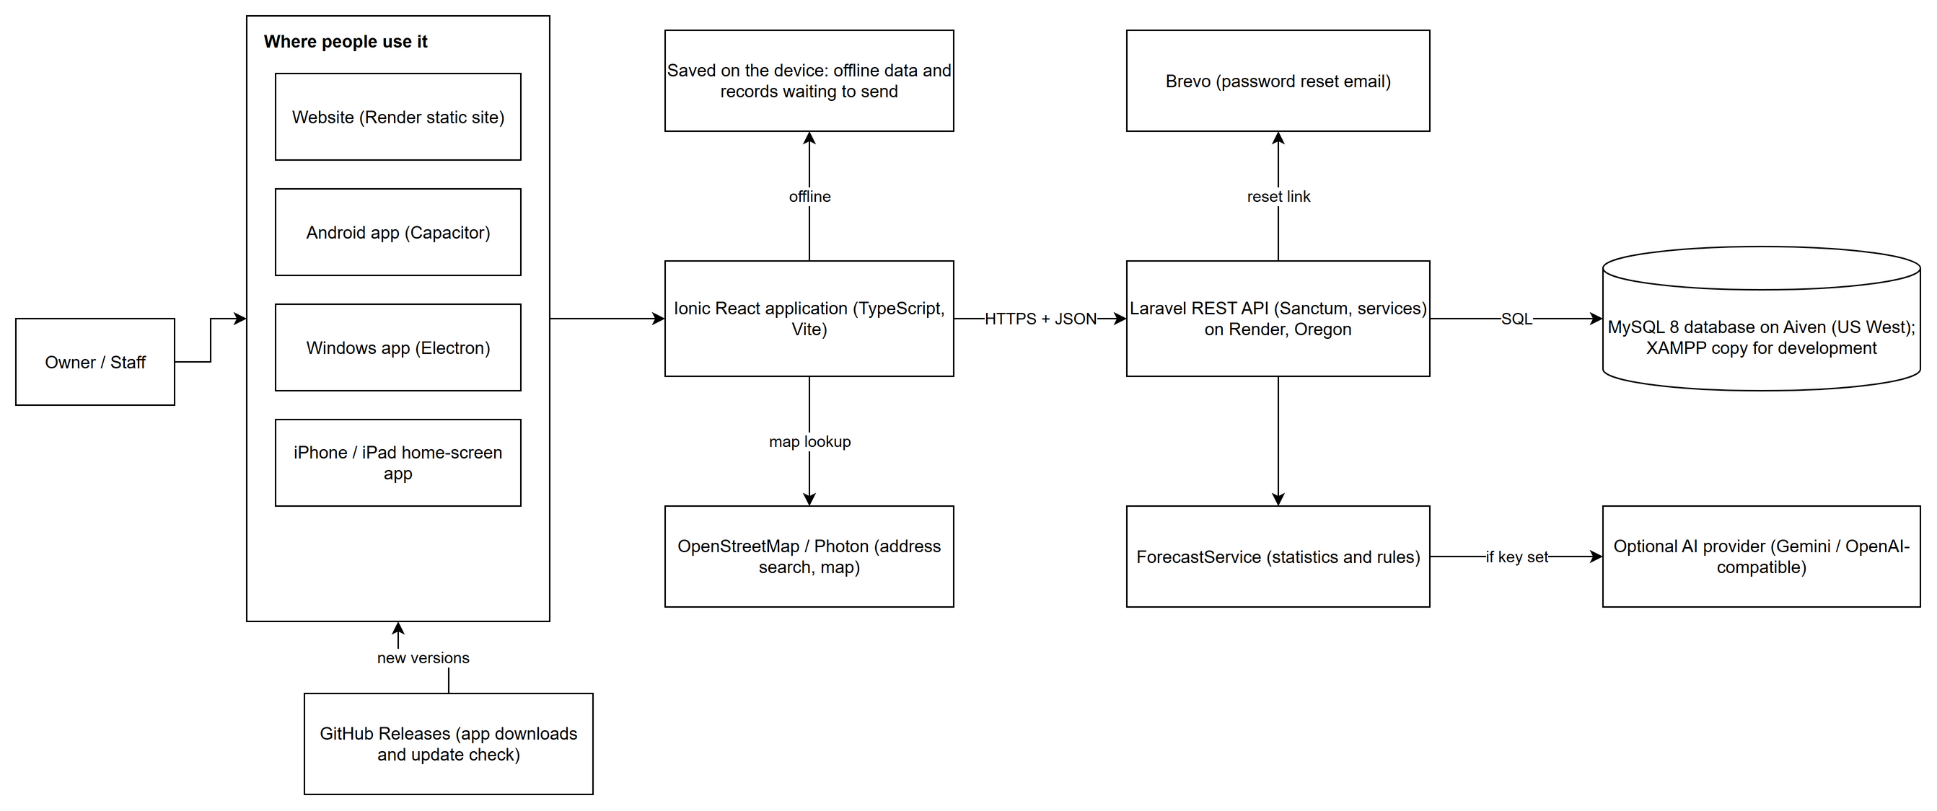
Figure 8.1 System architecture
8.2 Context Diagram
The context diagram shows the people and outside services that exchange information with BantayLedger AI. (See Figure 8.2)
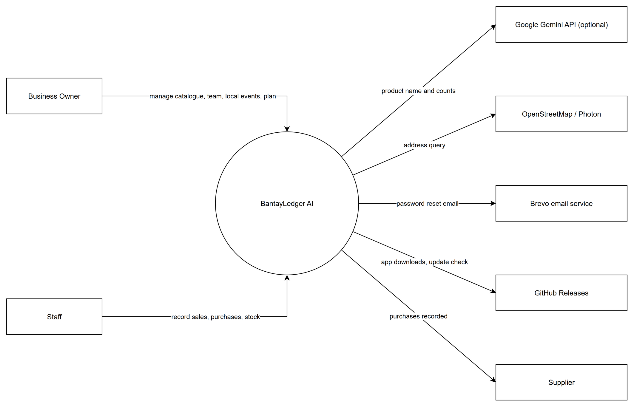
Figure 8.2 Context diagram
8.3 Use Case Diagram
The use case diagram shows what the Owner and Staff can do in the system. (See Figure 8.3)
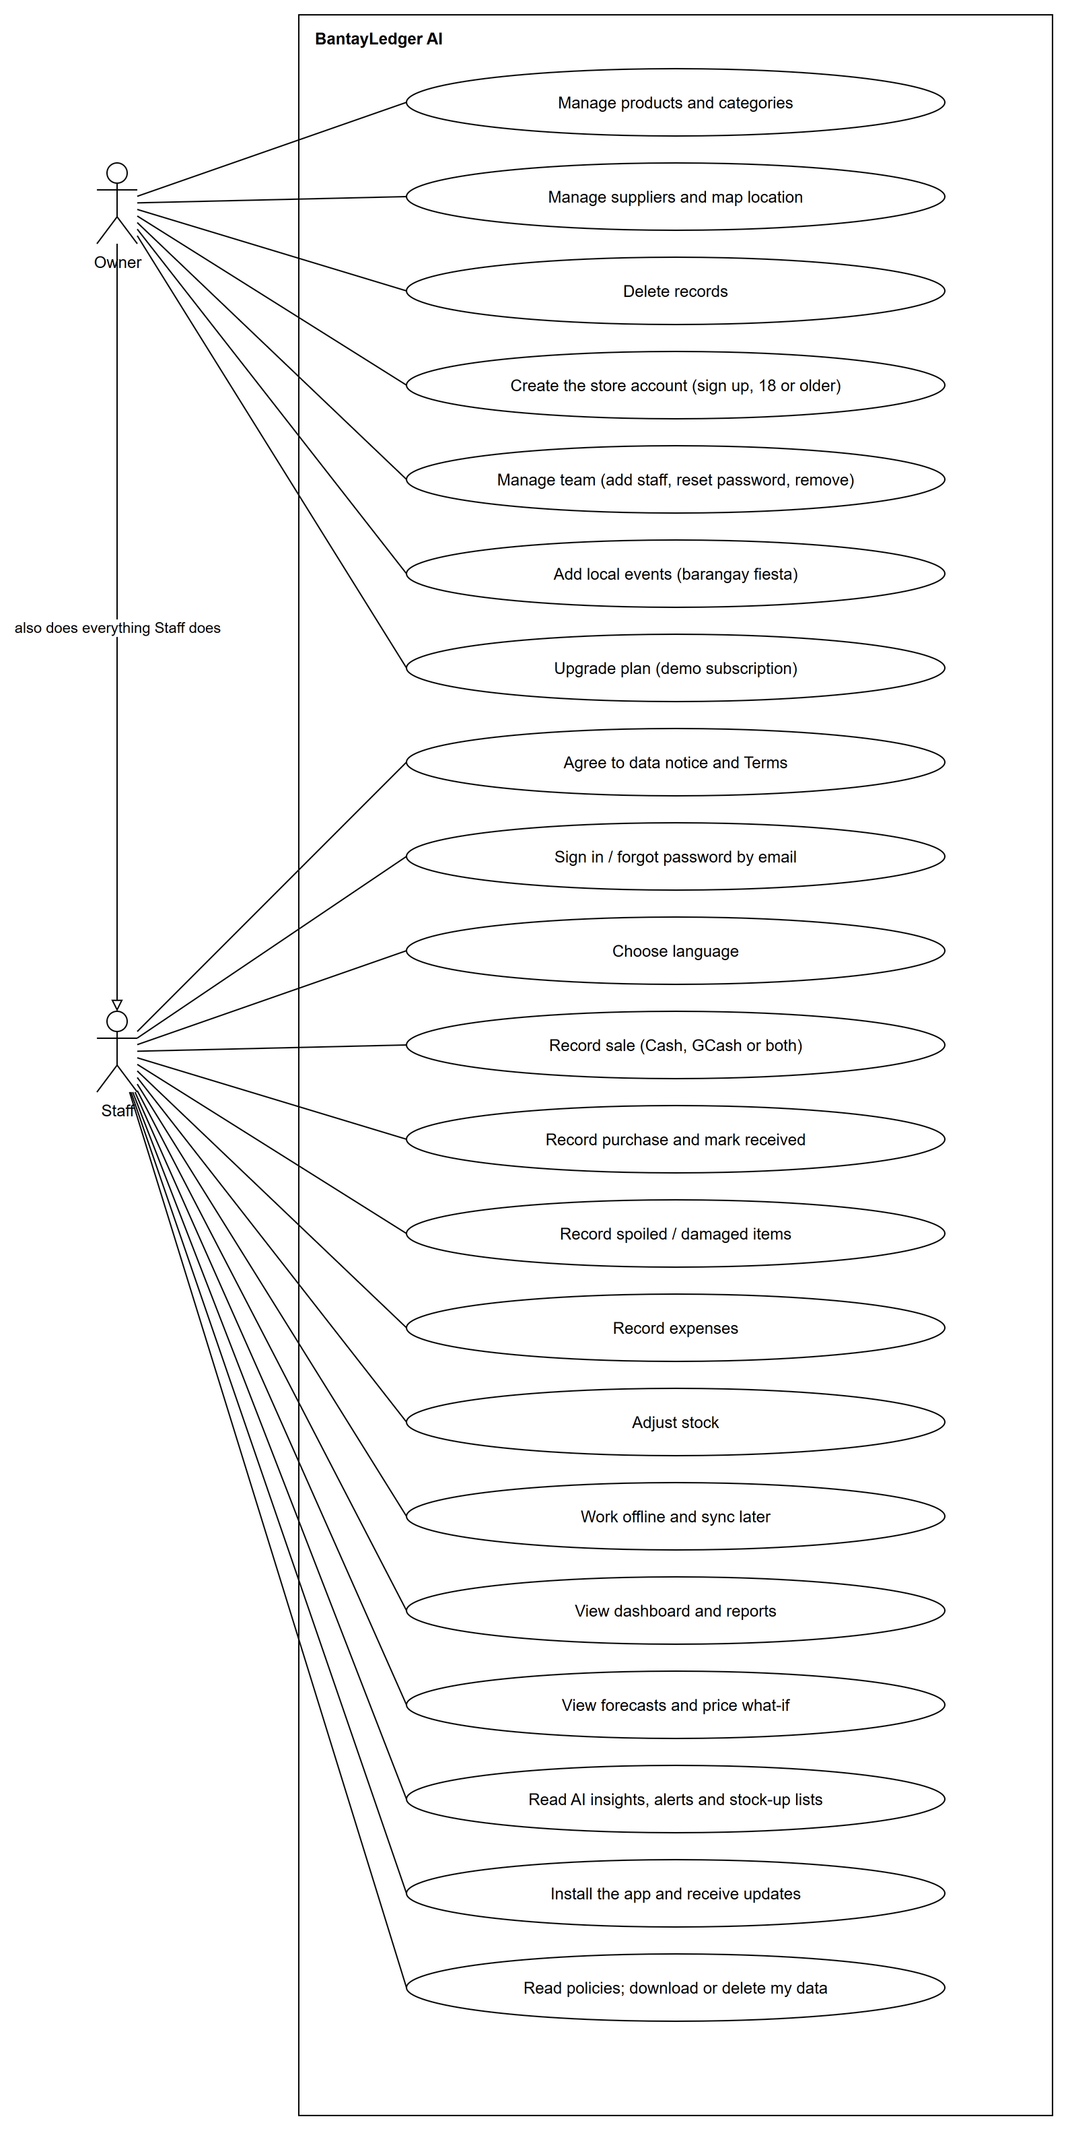
Figure 8.3 Use case diagram (the Owner can also do everything Staff can do)
8.4 Activity Diagram
The activity diagrams show three main processes step by step: recording a sale (See Figure 8.4a), refreshing insights (See Figure 8.4b), and recording offline and syncing later (See Figure 8.4c). Every decision has a Yes path and a No path.
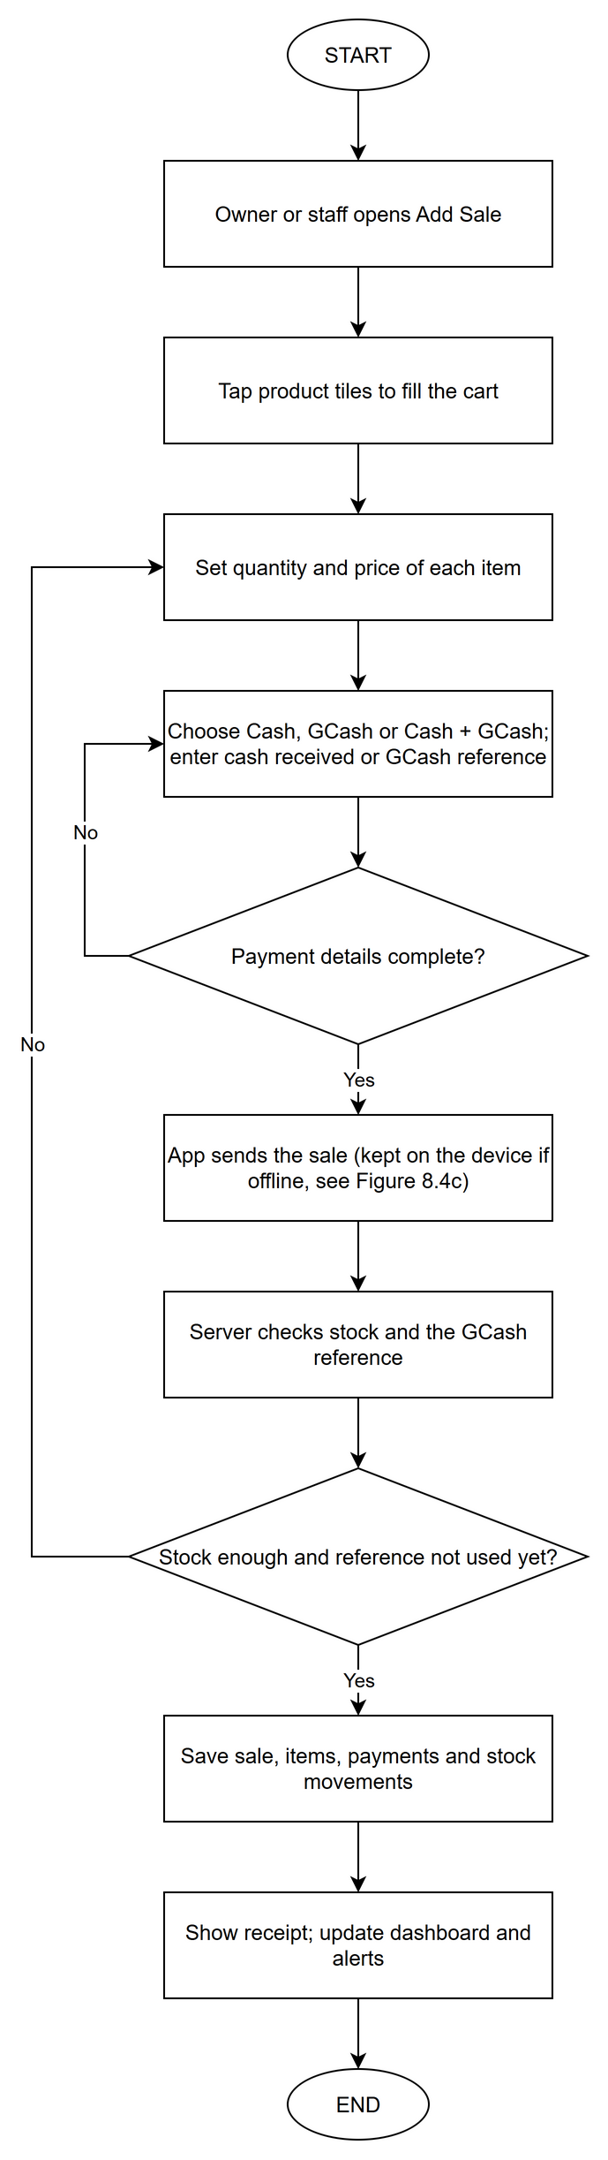
Figure 8.4a Activity diagram: recording a sale
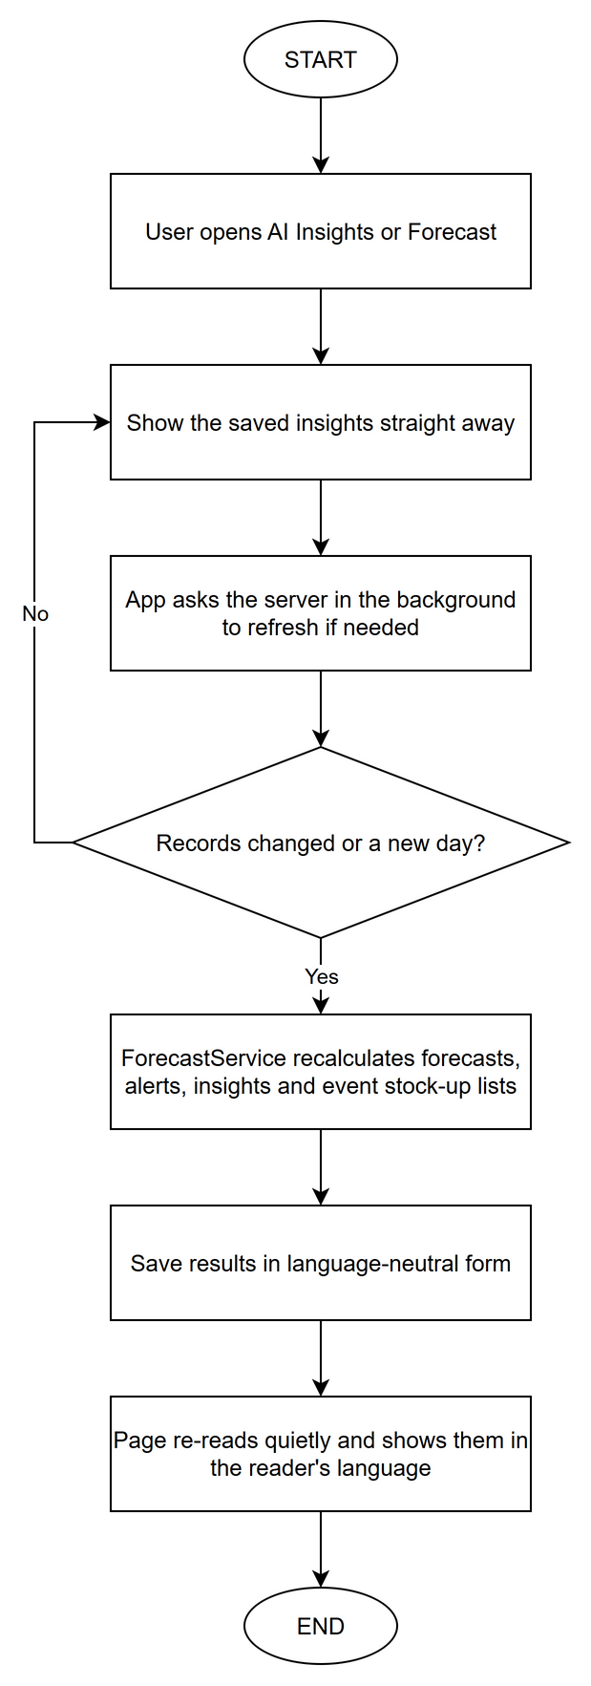
Figure 8.4b Activity diagram: refreshing insights
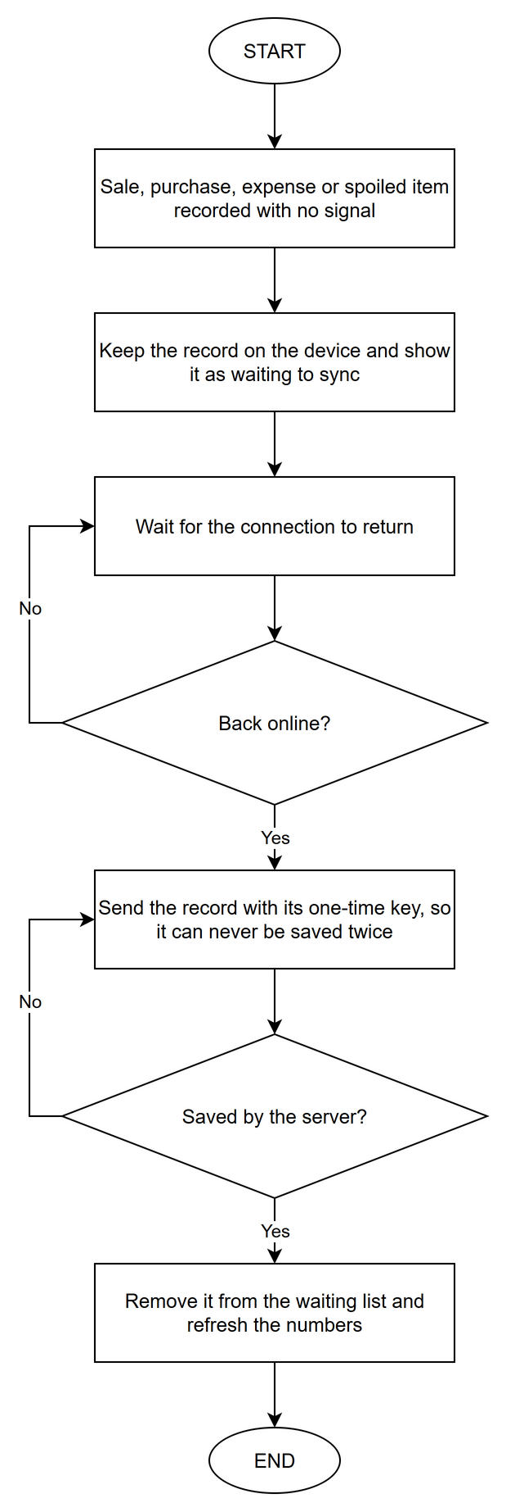
Figure 8.4c Activity diagram: recording offline and syncing later

8.5 Database and Data Design
The database contains tables for users and businesses (with member roles), the catalogue (categories, suppliers, products), transactions (sales, sale items, sale payments, purchases, purchase items, expenses, spoiled and damaged records), the stock ledger (inventory movements), and signals (forecast runs, demand/price/cost forecasts, alerts and recommendations), the store's local events and the demo subscription payments. Every primary key is named after its table (for example products.product_id) and a foreign key keeps the name of the key it references; all 23 business tables and their main columns are shown in the entity relationship diagram (See Figure 8.5a); foreign keys cascade or restrict so that business data remains consistent.
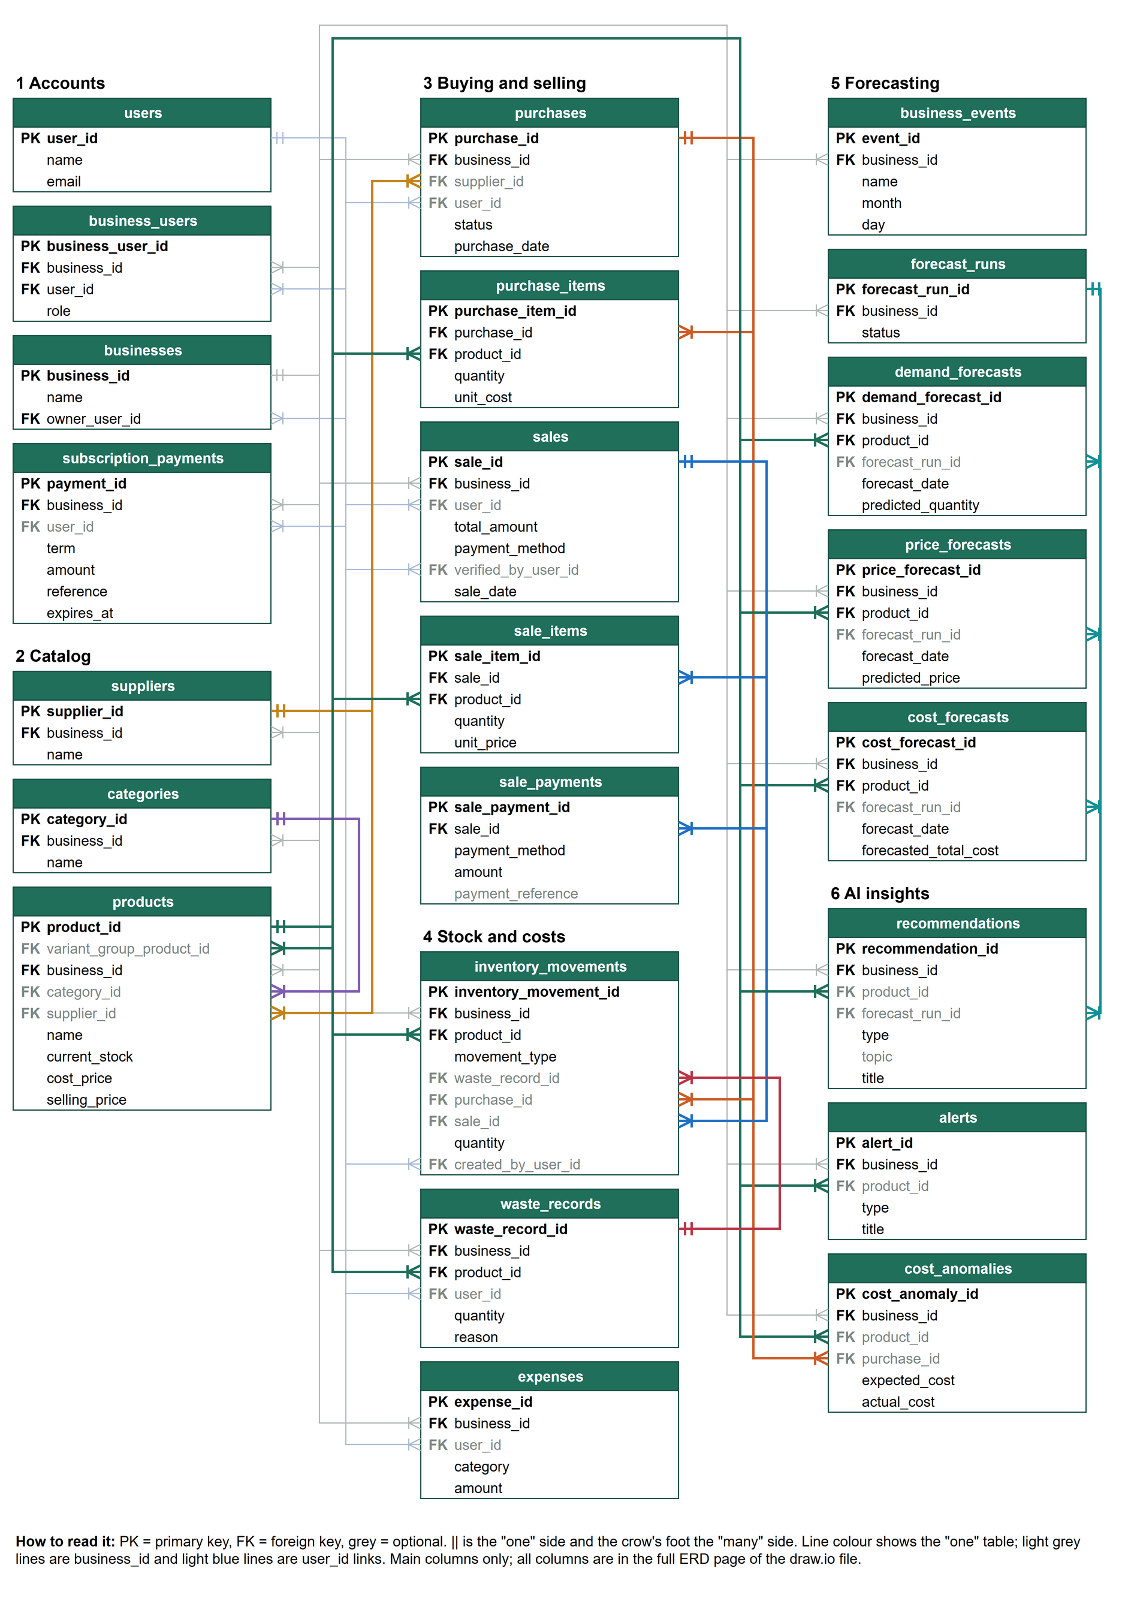
Figure 8.5a Entity relationship diagram (all business tables, main columns)

Table 8.1 Data dictionary (selected tables)
Table | Key fields | Purpose
users | user_id (PK), email, name, phone, language, privacy_accepted_at, terms_accepted_at | Accounts, language and consent
businesses | business_id (PK), owner_user_id (FK), name, monthly_purchase_budget | The business
business_users | business_user_id (PK), business_id (FK), user_id (FK), role | Membership and roles
products | product_id (PK), business_id, category_id, supplier_id, variant_group_product_id (FKs), current_stock, cost_price, selling_price, is_active | Catalogue and stock
sales / sale_items | sale_id (PK), user_id, verified_by_user_id (FKs), payment_method, payment_reference; sale_item_id (PK), sale_id, product_id (FKs), quantity, unit_price | Sales with items
sale_payments | sale_payment_id (PK), sale_id (FK), payment_method, amount, payment_reference | How a sale was paid: cash, GCash or both
purchases / purchase_items | purchase_id (PK), supplier_id (FK), status; purchase_item_id (PK), purchase_id, product_id (FKs), quantity, unit_cost | Purchases with items
inventory_movements | inventory_movement_id (PK), product_id, sale_id, purchase_id, waste_record_id, created_by_user_id (FKs), movement_type, quantity | Stock ledger with its source record
recommendations / alerts | recommendation_id / alert_id (PK), business_id, product_id, forecast_run_id (FKs), topic, i18n | Insights and alerts
forecast_runs | forecast_run_id (PK), business_id (FK), fingerprint | Run history and freshness
categories | category_id (PK), business_id (FK), name, description | Product categories
suppliers | supplier_id (PK), business_id (FK), name, contact_person, address, latitude, longitude, status | Suppliers and their map location
expenses | expense_id (PK), business_id (FK), user_id (FK), category, description, amount, expense_date | Money spent on running the business
waste_records | waste_record_id (PK), business_id (FK), product_id (FK), user_id (FK), quantity, reason, estimated_cost, waste_date | Spoiled and damaged items
demand_forecasts | demand_forecast_id (PK), business_id (FK), product_id (FK), forecast_run_id (FK), forecast_date, predicted_quantity, lower_bound, upper_bound, confidence | Expected sales per product per day
price_forecasts | price_forecast_id (PK), business_id (FK), product_id (FK), forecast_run_id (FK), forecast_date, predicted_price, lower_bound, upper_bound, confidence | Expected supplier price per product
cost_forecasts | cost_forecast_id (PK), business_id (FK), product_id (FK), forecast_run_id (FK), forecast_date, forecasted_quantity, forecasted_unit_price, forecasted_total_cost | Expected purchasing cost
cost_anomalies | cost_anomaly_id (PK), business_id (FK), product_id (FK), purchase_id (FK), expected_cost, actual_cost, difference, severity | Unusual purchase costs
business_events | event_id (PK), business_id (FK), name, month, day, prep_days | The store's own yearly events, such as the barangay fiesta
subscription_payments | payment_id (PK), business_id (FK), user_id (FK), term, amount, reference, starts_at, expires_at, cancelled_at | Demo subscription activations (no real payment)
idempotency_keys | user_id, idempotency_key (composite PK), request_path, response_status, response_body | Stops a record sent again after going offline from being saved twice
sessions | id (PK, framework), user_id (FK), ip_address, user_agent, payload, last_activity | Laravel login sessions (key name kept for the framework)

8.6 Navigation Flow
The navigation flow shows how a user moves from the website to the main pages, in the order they are used. (See Figure 8.6)
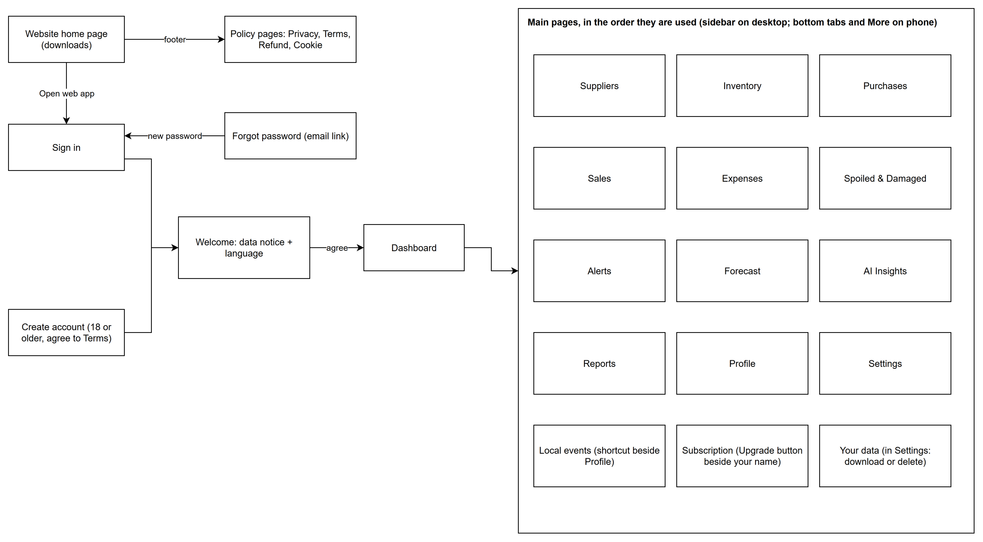
Figure 8.6 Navigation flow

8.7 UI Design Principles
• Consistency: The same layout, buttons and wording across pages; pinned summary cards on every list page.
• Simplicity: One main task per screen; friendly terms such as "Spoiled & Damaged" and "Profit".
• Accessibility: Large tap targets, visible focus rings, text labels in addition to colours, reduced-motion support, and text colours that meet the 4.5:1 contrast minimum.
• Readability: Short sentences and enough contrast.
• User feedback: Toasts, status badges, loading states and clear error messages.
• Ease of navigation: Sidebar on desktop in the order the system is used; bottom tabs, a raised Quick add button and a "More" sheet on phones.
• Error prevention: Required-field markers, stock checks before saving a sale, duplicate GCash reference blocking, and a strong-password indicator.
• Motion: The Android and Windows apps open with a short logo animation, and a page slides up once its loading skeleton finishes. Both respect the reduced-motion setting.
8.8 Wireframes
The wireframes show the layout of the main screens: the Dashboard (See Figure 8.7a), Add Sale (See Figure 8.7b), AI Insights (See Figure 8.7c) and the demo Subscription page (See Figure 8.7d).
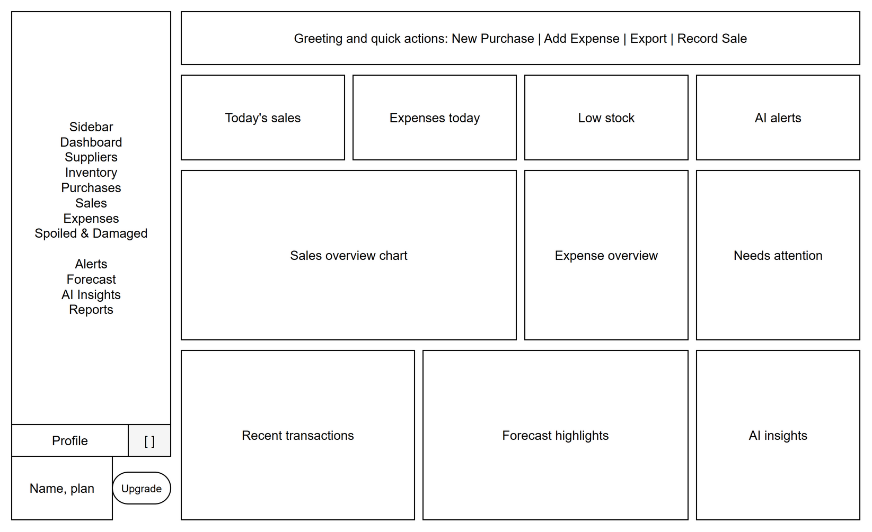
Figure 8.7a Wireframe: Dashboard
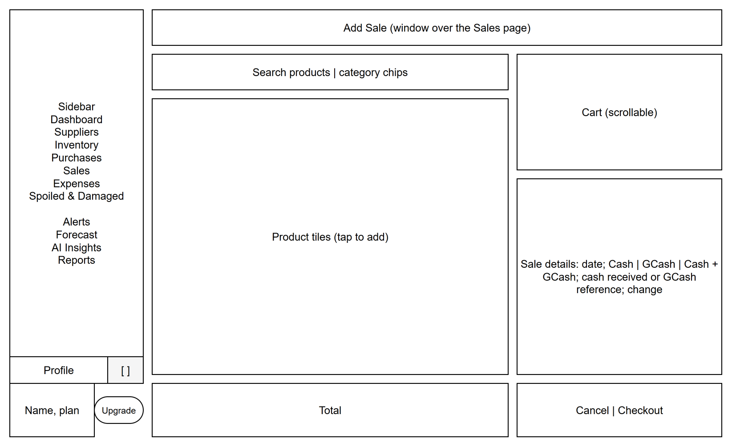
Figure 8.7b Wireframe: Add Sale
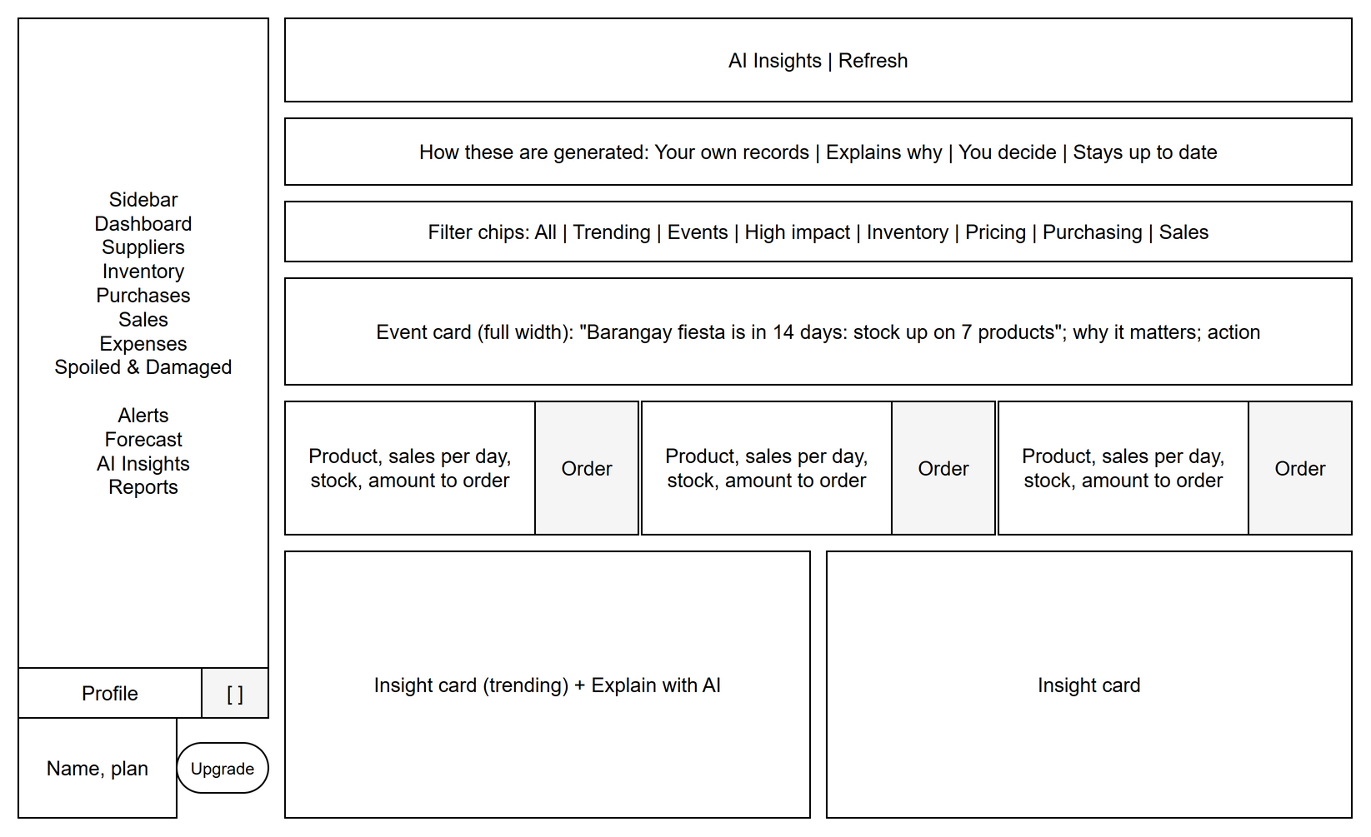
Figure 8.7c Wireframe: AI Insights
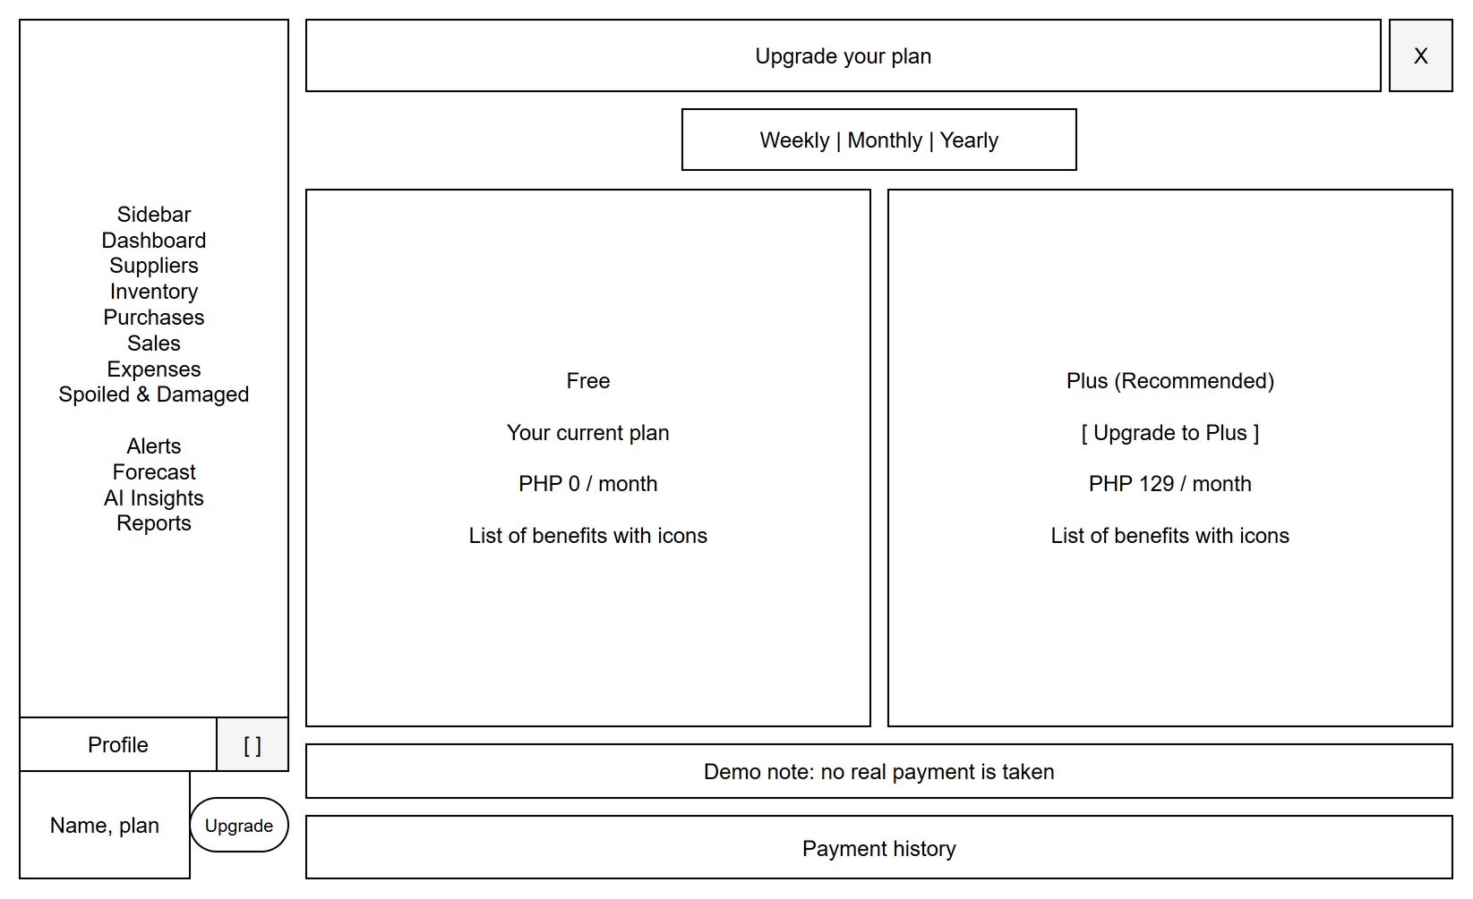
Figure 8.7d Wireframe: Subscription (demo)

8.9 High-Fidelity Mockups
The working application serves as the high-fidelity design. The screenshots below are from the current application, using a made-up sample store: the Dashboard (See Figure 8.8a), Add Sale (See Figure 8.8b) and AI Insights (See Figure 8.8c).
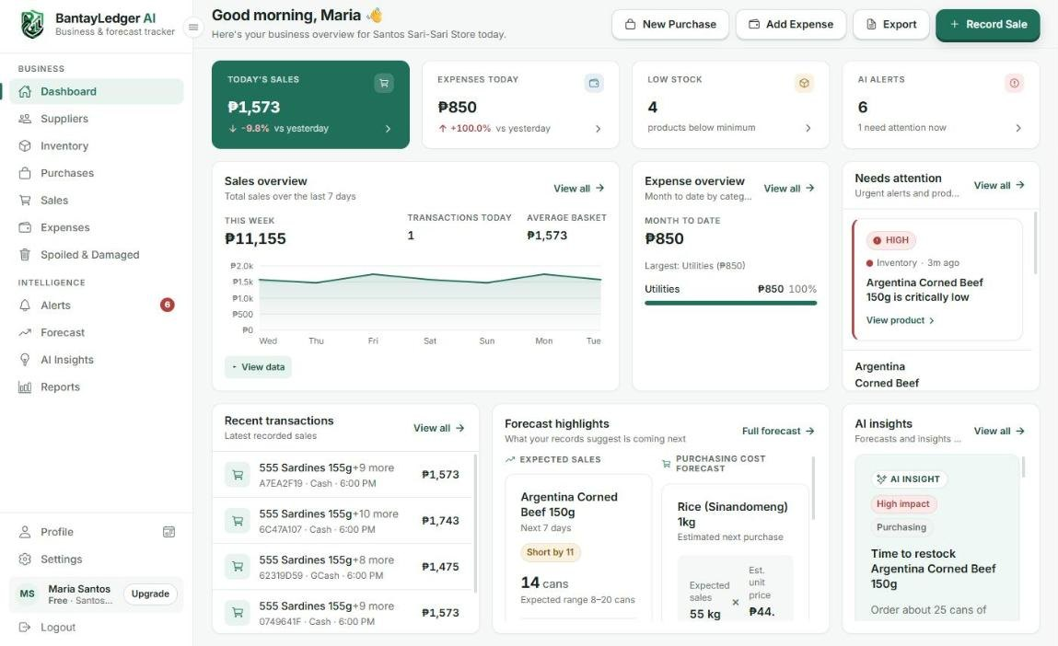
Figure 8.8a Dashboard
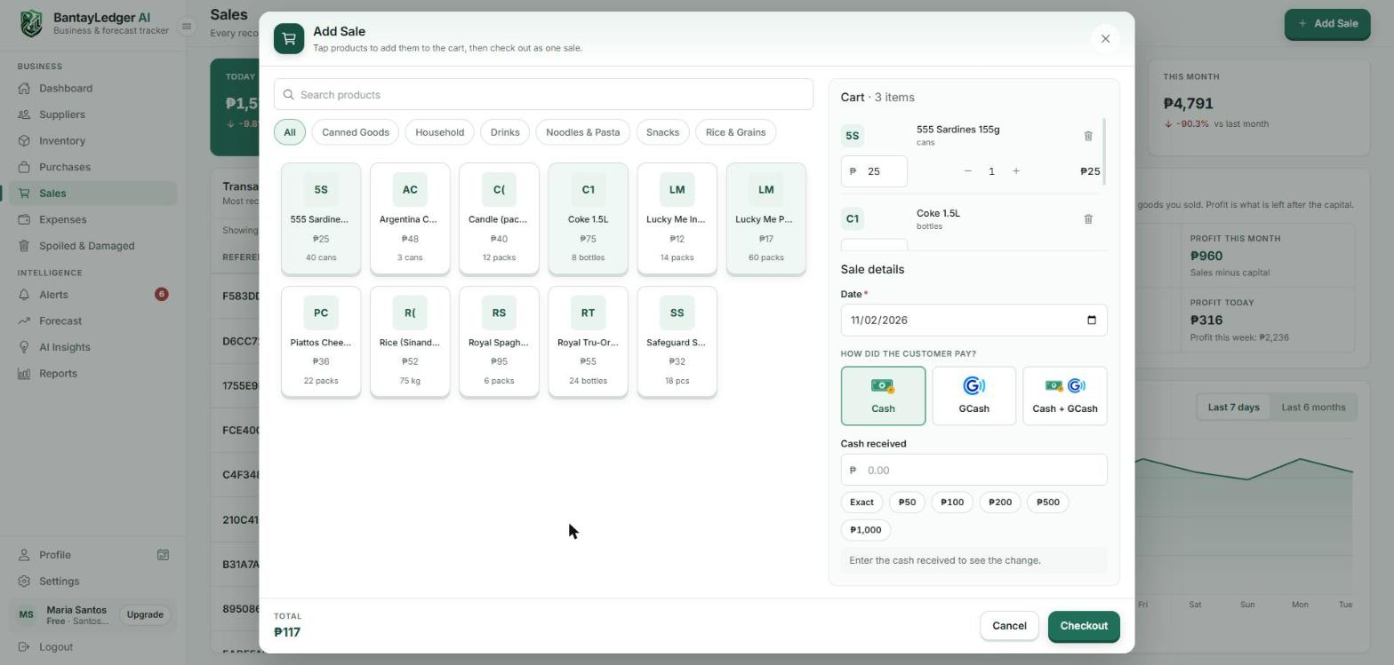
Figure 8.8b Add Sale
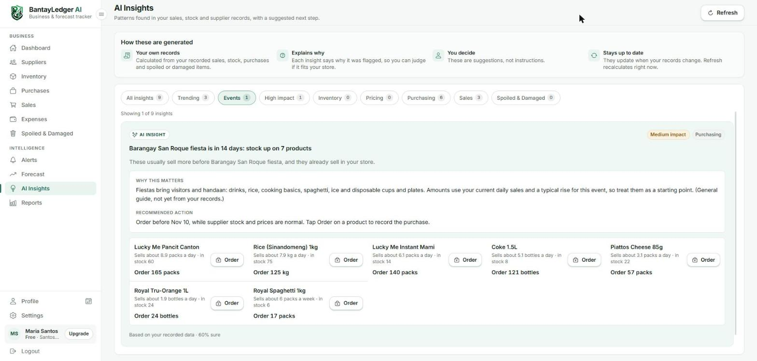
Figure 8.8c AI Insights

8.10 Visual Design System
The green palette expresses care and money; amber and red carry warning meaning; icons come from Ionicons; buttons are primary (green), secondary (outline) and danger (red). These elements keep the interface consistent and reinforce the brand's friendly, trustworthy personality. (See Figure 8.9)
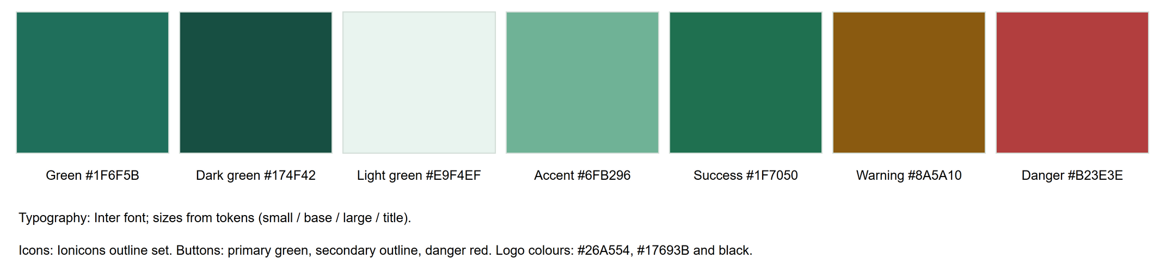
Figure 8.9 Visual design system: colours, typography, icons and buttons

8.11 Responsive / Cross-Platform Design Considerations
On a computer, each page fits the screen, with long lists scrolling inside their own panel. The layout adapts from a desktop view (sidebar, sticky page header and table headings) to a tablet and a phone view (bottom tabs, a raised Quick add button, stacked cards). Modals use a standard width, and the Add Sale modal avoids horizontal scrolling and keeps the cart in a scrollable sidebar. Longer Tagalog and Cebuano words may tighten some headings and have not yet been checked on every screen size.

CHAPTER 9
DEVELOPMENT AND IMPLEMENTATION PLAN

9.1 Development Methodology
Agile/Scrum is used in short iterations. Each iteration chooses a few features, builds them, checks them against the running application, and adjusts the next iteration from what was learned. For an individual project, the sprint review is done by the developer against a written checklist.

9.2 Development Phases

1. Planning
2. Problem and requirements analysis
3. UI/UX design
4. Ionic development
5. Database and backend development
6. AI integration
7. Integration and refinement
8. Deployment and release
9. Prototype demonstration

9.3 Sprint Plan
Table 9.1 Sprint plan
Sprint | Target tasks | Expected output | AI-related tasks
1 | Requirements, database schema, authentication | Sign-in and business creation working | -
2 | Catalogue, inventory ledger, sales | Add Sale, stock updates | -
3 | Purchases, expenses, spoiled items, dashboard | Core records and dashboard | Alert rules for low stock
4 | Forecasts, alerts, insights | Forecast and AI Insights pages | Demand and price forecast, recommendations
5 | Price-vs-demand, trending, seasonal, what-if | Scenario insights and what-if | Scenario rules, seasonal guide, optional explanation
6 | Languages, consent, polish, testing | Three languages, welcome step, final fixes | Language-neutral insights
7 | Offline recording and sync, online deployment, Android and Windows apps | Live website and downloadable apps | Saved insights available offline
8 | Update notices, iPhone home-screen app, password reset email, event stock-up lists, speed work, demo subscription | Release 1.0.2 and later updates | Event calendar and stock-up lists
9 | Policy pages, age and Terms consent, data download and account deletion, contrast and keyboard fixes, new logo, opening animation and Slide-Up Reveal | Policies and data rights live | -

9.4 Development Timeline / Gantt Chart
The timeline shows when each phase of the project takes place across 16 weeks. (See Figure 9.1)
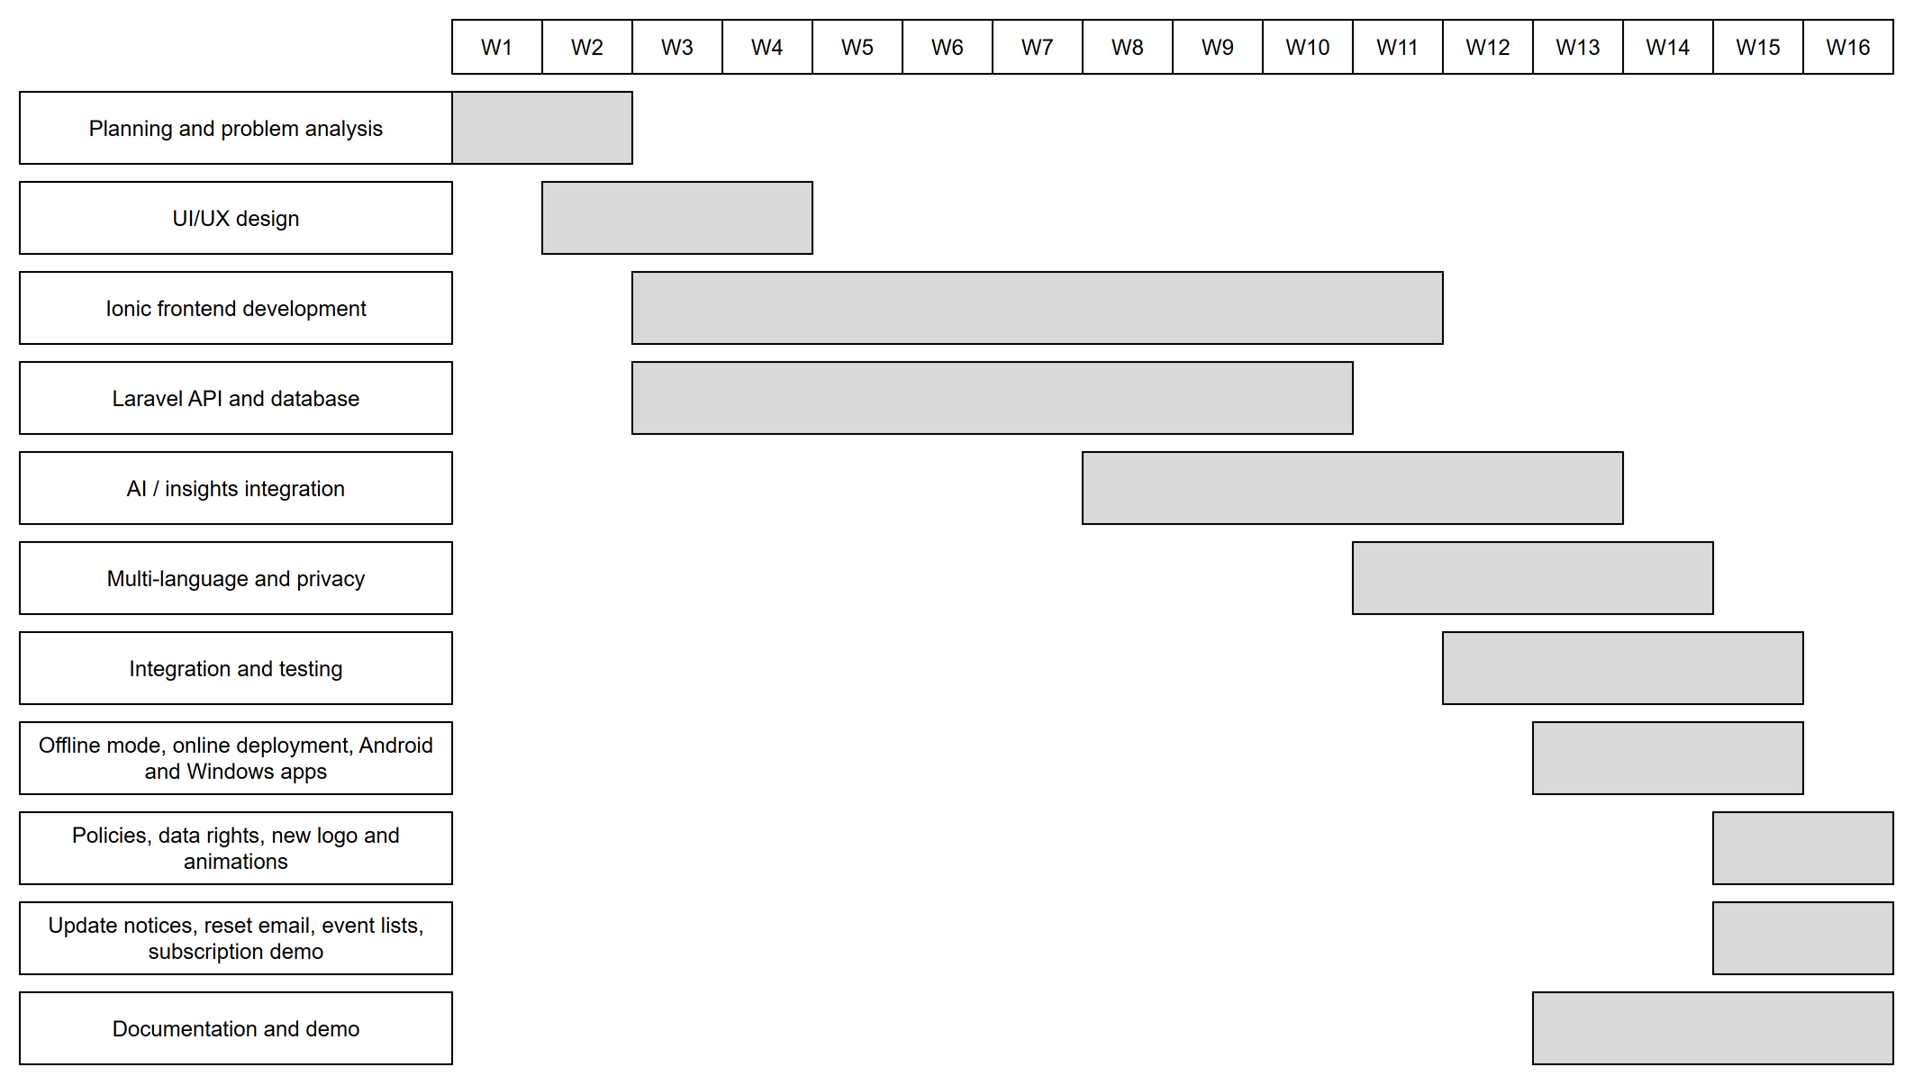
Figure 9.1 Development timeline (16 weeks)

9.5 Individual Project Roles and Responsibilities
Table 9.2 Roles and responsibilities (all performed by one student)
Role | Responsibilities
Project Manager | Scope, schedule, sprint planning
Business Analyst | Problem analysis, validation, business model
UI/UX Designer | Wireframes, visual system, accessibility
Ionic Developer | Pages, components, state, i18n
Database Developer | Schema, migrations, indexes
Backend Developer | API, authorization, stock logic, services
AI Developer/Integrator | Forecast engine, scenarios, optional explanation
Documentation | System overview and this manuscript

9.6 Prototype Evaluation
Evaluation is based on the developed prototype and uses the three statuses required by the guide. The table separates what is implemented from what is only proposed or future.
Table 9.3 Feature status
Feature | Status | Note
Sign-in, roles, consent step | Implemented | Sanctum tokens; role checks
Inventory with photos, enable/disable | Implemented
Add Sale with Cash/GCash and change calculator | Implemented | GCash reference required, duplicates blocked
Purchases, budget warning, suppliers with map | Implemented
Expenses, spoiled and damaged items | Implemented
Dashboard and reports | Implemented
Demand and price forecasts, what-if | Implemented | Statistics and rules
Alerts and AI insights, trending and seasonal | Implemented | Rules and offline knowledge base
Optional AI explanation | Implemented, not tested live | Tested with simulated provider responses only
English, Tagalog, Cebuano | Implemented | Translations not native-reviewed
Strong-password rules and strength meter | Implemented
Offline recording and sync | Implemented | Sales, purchases, expenses and spoiled items; sent when back online
Password reset by email | Implemented | Sent through Brevo; tested on the live system
Android and Windows apps, live website | Implemented | Installed from the website; not in an app store
iPhone and iPad home-screen app | Implemented | Added from Safari; not an App Store app
Update notices (Android, Windows) | Implemented | Not yet proven with a real update
Event stock-up lists and local events | Implemented | Tested with sample data; uses a labelled guide at first
Subscription page | Implemented (demo only) | No real payment; every store keeps every feature
Privacy, Terms, Refund and Cookie pages | Implemented | Plain-language drafts; not reviewed by a lawyer
18+ and Terms consent at sign-up | Implemented | Also asked in the updated notice
Download my data, delete account | Implemented | Tested on a throwaway database; the Android app opens the website to download
Opening animation and Slide-Up Reveal | Implemented | Windows app and emulator; not yet seen on a real phone
Barcode scanning, customer credit tracking | Future | Proposed
iOS App Store release, real online payments | Future | Needs a Mac and an Apple Developer account; a payment provider
Formal user testing | Proposed | Survey and interview guide in Appendix A

Overall, the prototype aligns with the identified problem, implements the major proposed features, has a functioning Ionic interface and a demonstrable AI feature, matches the proposed design, and is deployed on a live website with Android and Windows apps. Real-user evaluation has not yet been done.

CHAPTER 10
SUSTAINABILITY AND FUTURE DEVELOPMENT

10.1 Future Features
• Barcode and QR scanning.
• Customer credit ("utang") tracker.
• Email and push notifications.
• Real online subscription payments.
• Exportable reports for loans and permits.
These features are not implemented in the current system.

10.2 Scalability Plan
The application already runs on free cloud plans and can move to paid plans that do not sleep or power off; the database can be indexed and, if needed, read replicas added. Forecast runs are per business and can be queued so that more users do not slow the interface. More locations can be added as additional businesses with members and roles, and extra services can be added as new API modules.

10.3 Business Expansion
• New markets: carinderias, small farms and agri-supply stores, pharmacies and pharmacy-like shops.
• Additional services: supplier ordering and delivery tracking.
• Geographic: other regions with additional local languages (the language system is designed to accept more).
• Partnerships: wholesalers, cooperatives and payment providers.
• Revenue: premium reports, supplier referral fees.

10.4 Technology Enhancement
• Improved AI models trained on anonymised, consented data once enough exists.
• More automation, such as suggested purchase orders.
• Advanced analytics and benchmarking against similar shops.
• An iOS App Store release through Capacitor.
• Improved security: two-factor authentication and audit logs.

10.5 Long-Term Sustainability
Sustainability depends on keeping users: the product must save them time every day, so reliability and simple recording come first. Revenue sustainability depends on a modest number of paying shops covering low running costs. Maintenance includes framework updates and AI provider changes. The seasonal guide and translations should be reviewed regularly, and market changes tracked so that advice remains useful.

CHAPTER 11
CONCLUSION AND RECOMMENDATIONS

11.1 Conclusion
The problem observed is that many small Philippine businesses manage stock, prices and money informally, which causes stock-outs, slow stock, hidden waste and thin or negative margins. The self-observation supports that this problem is real and common, although it has not been confirmed with a formal survey. BantayLedger AI proposes to solve it with a simple, three-language ledger and sales tool that turns the shop's own records into forecasts, warnings and plain-language advice.
The business potential rests on a freemium model with a small paid plan; under stated assumptions, the startup could cover its running costs with about 23 paying shops and recover its startup cost in about eleven months, though these are assumptions, not guarantees. The Ionic application and Laravel backend are already implemented and deployed on a live website with Android and Windows apps, and the AI integration provides forecasting, price-versus-demand reasoning, trending and seasonal insights and an optional explanation. The innovation is the combination of these capabilities in a store-sized tool with local language and context. The project is feasible within an academic period because it uses free and open-source technology and a clear, limited scope.

11.2 Recommendations
• Further validation: Run the survey and interviews in Appendix A with a sample of store owners before any launch.
• AI improvement: Test the optional explanation with a live key, and compare forecasts with actual sales once enough history exists.
• Application enhancement: Add barcode scanning and customer credit tracking.
• Hosting: Move to paid plans before real stores depend on the system, because free plans can sleep or power off.
• Language quality: Have the Tagalog and Cebuano text reviewed by native speakers.
• Privacy: Complete the privacy contact in the notice and the policy pages and have them reviewed against the Data Privacy Act of 2012.
• Business expansion: Pilot in one barangay, then extend to nearby areas and partner suppliers.
• Additional research: Obtain a sourced estimate of the number of micro retailers and their technology use.

REFERENCES

Aiven. (n.d.). Aiven for MySQL documentation. Retrieve on November 2026 from: https://aiven.io/docs/products/mysql

Brevo. (n.d.). Brevo API documentation. Retrieve on November 2026 from: https://developers.brevo.com/

Capacitor. (n.d.). Capacitor documentation. Retrieve on November 2026 from: https://capacitorjs.com/docs

Electron. (n.d.). Electron documentation. Retrieve on November 2026 from: https://www.electronjs.org/docs

Google. (n.d.). Gemini API documentation. Google AI for Developers. Retrieve on October 2026 from: https://ai.google.dev/

i18next. (n.d.). i18next documentation. Retrieve on October 2026 from: https://www.i18next.com/

Ionic. (n.d.). Ionic Framework documentation. Retrieve on October 2026 from: https://ionicframework.com/docs

Laravel. (n.d.). Laravel 12.x documentation. Retrieve on October 2026 from: https://laravel.com/docs

Laravel. (n.d.). Laravel Sanctum. Retrieve on October 2026 from: https://laravel.com/docs/sanctum

MariaDB Foundation. (n.d.). MariaDB documentation. Retrieve on October 2026 from:https://mariadb.com/kb/en/documentation/

Meta Platforms. (n.d.). React documentation. Retrieve on October 2026 from: https://react.dev/

OpenStreetMap Foundation. (n.d.). OpenStreetMap. Retrieve on October 2026 from: https://www.openstreetmap.org/

Render. (n.d.). Render documentation. Retrieve on November 2026 from: https://render.com/docs

Republic of the Philippines. (2012). Republic Act No. 10173: Data Privacy Act of 2012. Retrieve on October 2026 from: https://www.privacy.gov.ph/data-privacy-act/

Appendix A – Survey Questionnaire and Interview Guide
This questionnaire has not yet been administered. It is provided so that validation can be completed.
Part 1. About the store
1. What type of store do you run?
2. How long have you been operating?
3. How many people work in the store, including family?
4. What device do you use every day?
Part 2. How you manage the store now
1. How do you record sales (notebook, memory, phone, other)?
2. How do you know when to restock?
3. How often does a popular item run out?
4. How do you track supplier price changes?
5. How do you handle spoiled or expired goods?
6. Do you accept GCash? How do you record it?
Part 3. Interest in a solution
1. Would a phone app that records sales and warns of low stock be useful? Why?
2. Which features would you want first?
3. Which language do you prefer?
4. How much would you pay per month, if anything?
Interview guide (5 to 10 minutes)
• Ask the owner to walk through one typical day of buying and selling.
• Ask about the last time they ran out of something or threw something away, and what it cost.
• Show the wireframes and ask what is confusing or missing.

Appendix B – Computations
Startup cost = 700 + 500 + 5,000 + 3,000 = PHP 9,200.
Monthly operating expenses = 500 + 300 + 1,000 + 58 + 1,000 = PHP 2,858.
Paying shops in month m = 5m. Revenue in month m = 5m x 129 = 645m. Revenue for 12 months = 645 x (12 x 13 / 2) = 645 x 78 = PHP 50,310.
Total first-year cost = 9,200 + (12 x 2,858) = 9,200 + 34,296 = PHP 43,496.
Net gain = 50,310 - 43,496 = PHP 6,814. ROI = 6,814 / 43,496 = 15.7%.
Operating break-even customers = 2,858 / 129 = 22.2, rounded up to 23 paying shops.
Cumulative net after month m = 645 x m(m + 1)/2 - 2,858m - 9,200; positive from m = 11 (1,932).

