* SLIP

It is a simple form of encapsulation for IP datagram on serial lines.

增加C0標示start和end，並暫時把有c0換掉

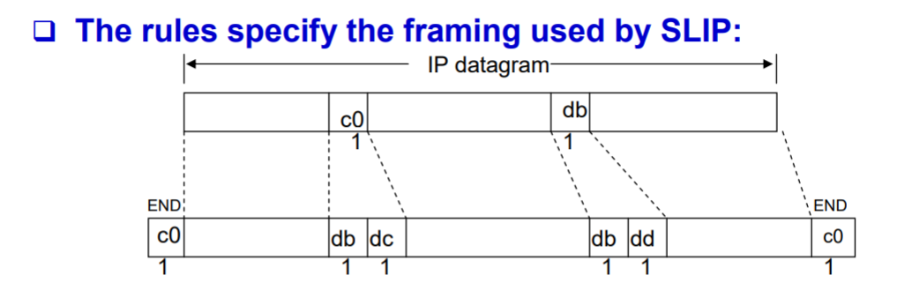

* Compressed SLIP

SLIP performance drawback

Slow, to carry 1 byte of data requires 40 bytes header (IP and TCP

header), an overhead of 40 bytes

CSLIP

normally reduces the 40-byte header to 3 or 5 bytes

* ping自己ip跟ping localhost的差別

自己ip: 走Loopback driver

localhost: 走Ethernet driver

* MTU (maximum transmission unit)