Courseware Project Proposal

Members: Carina Herzog & Michael Fuchs & Hector Vidal

# Idea

We would like to provide a software that is able to provide the user with different kinds of information revolving around our SWENGB-Course. The user should be able to have insight into the students, the different assignments that were given and so on.

# Database

The database will be a SQLite-Database that is based on the ER-Model shown below.

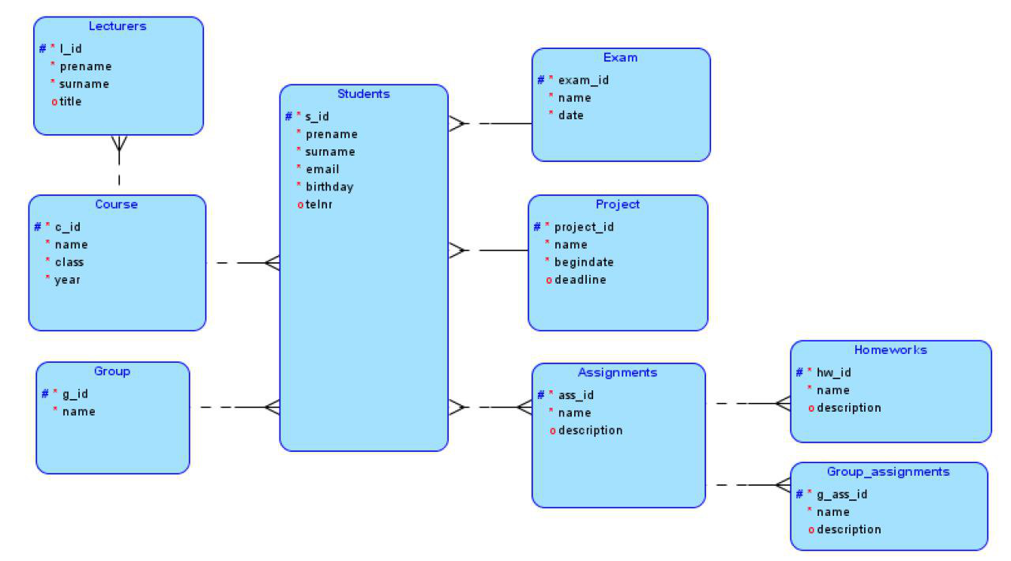

The whole structure should enable us to provide information how many percent of people submit their homework in time or what the general participation rate is. The information can either be seen inside the GUI or via a markdown report.

# GUI

As of now there is only a rough idea on how the GUI will look like. But basically we would like to have the input-area on the left, having input-field and buttons for the user to specify the information required. The right hand side will show the according results and a button on the bottom right hand side will generate the report.

generate report

reset

get information

Label:

Label:

Label:

Label: