Finderzettel für Amateurfunk-Radiosonden von DL8MIK Englisch

https://github.com/Mika-1818/Finderbrief-Amateurfunk-Radiosonden

Ungefährliches Wetterexperiment!
Dear finder, this is an amateur radio Radiosonde. It is a harmless instrument but it does pollute the environment which is why I kindly ask you to send it back to me or to dispose of it as electronic waste. Warning: it contains a battery. I will reimburse the shipping cost if you send your bank or PayPal information along with the radiosonde. Thank you!

Callsign: Call
Start time:
Address:
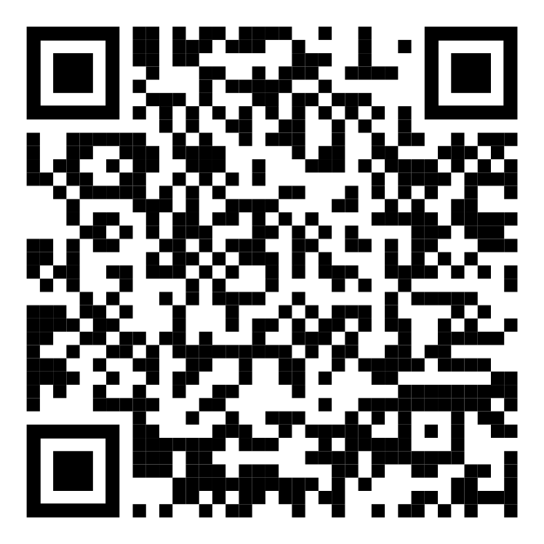More information

Name
Straße
Ort
Finderbrief-Amateurfunk-Radiosonden by DL8MIK is licensed under CC BY-NC-SA 4.0. To view a copy of this license, visit https://creativecommons.org/licenses/by-nc-sa/4.0/
Tel.: Telefonnummer

Ungefährliches Wetterexperiment!
Dear finder, this is an amateur radio Radiosonde. It is a harmless instrument but it does pollute the environment which is why I kindly ask you to send it back to me or to dispose of it as electronic waste. Warning: it contains a battery. I will reimburse the shipping cost if you send your bank or PayPal information along with the radiosonde. Thank you!

Callsign: Call
Start time:
Address:
More information

Name
Straße
Ort
Finderbrief-Amateurfunk-Radiosonden by DL8MIK is licensed under CC BY-NC-SA 4.0. To view a copy of this license, visit https://creativecommons.org/licenses/by-nc-sa/4.0/
Tel.: Telefonnummer

Ungefährliches Wetterexperiment!
Dear finder, this is an amateur radio Radiosonde. It is a harmless instrument but it does pollute the environment which is why I kindly ask you to send it back to me or to dispose of it as electronic waste. Warning: it contains a battery. I will reimburse the shipping cost if you send your bank or PayPal information along with the radiosonde. Thank you!

Callsign: Call
Start time:
Address:
More information

Name
Straße
Ort
Finderbrief-Amateurfunk-Radiosonden by DL8MIK is licensed under CC BY-NC-SA 4.0. To view a copy of this license, visit https://creativecommons.org/licenses/by-nc-sa/4.0/
Tel.: Telefonnummer

