Designing a tool for measuring well-being parameters(May 2025)

Mika Gielkens, *Student, UHasselt & KU Leuven*Dr. Eva Geurts (Promotor), Prof. Dr. Gustavo Rovelo Ruiz (Co-promotor)

*Abstract*— Employee wellness is ever more recognized as a vital factor in workplace productivity and job satisfaction, yet low-cost and accessible solutions for monitoring health metrics are limited. The article details the design and implementation of a low-cost and portable real-time measuring device for important physiological parameters like heart rate, blood oxygen level (SpO₂), galvanic skin response (GSR), and respiration rate by using an Arduino Nano ESP32 microcontroller. The system employs calibrated sensors and transmits data via Bluetooth Low Energy to a custom mobile application, which includes user-friendly graphical visualizations and multi-user capability for organizational deployment. Design focuses on usability, accessibility, and flexibility, with baseline calibration and color-coded feedback to facilitate interpretation by non-specialists. In contrast to commercial solutions, this open and extensible toolkit provides a transparent and affordable approach to workplace well-being monitoring. The program establishes a basis for more general use of physiological health assessment and is a stepping-stone for follow-on research and development in occupational health technology.

*Index Terms*—Health metrics, mobile application, portable devices, physiological sensors, workplace well-being

# INTRODUCTION

I

n today's workplace, employee well-being is becoming a significant part of productivity and job satisfaction [1]. Stress is one of the leading causes of work discomfort and can have negative impacts on physical and mental health. Therefore, the ability to measure and monitor stress-related physiological parameters effectively plays a critical role in creating a healthier workplace.

There are commercial alternatives such as smartwatches, but these often lack transparency in how they perform measurements. In addition, most measurements are typically only taken from the wrist, which can be limiting for certain parameters – such as GSR or respiration. Although some wearables have become more affordable, they are still not always accessible or versatile. This highlights the need for an affordable, transparent, and flexible solution. This thesis explores the development of a small and portable device for monitoring a person's well-being while performing work activity. The project entails the construction of a well-being toolkit based on Arduino technology, with emphasis on determining the physiological parameters best suited to monitor stress or general well-being, including heart rate and skin conductance.

The aim of this project is to create and implement a system that not only collects data but also presents it in a useful format through a dedicated application. The application will enable users to monitor their well-being in real-time by measuring relevant physiological parameters such as heart rate and skin conductance. The hardware and software in this project are designed to provide a user-friendly tool for measuring workplace well-being.

To achieve this, the research first explored relevant sensor technologies used to measure health parameters. This is followed by developing a system architecture that would ensure seamless communication between the sensors and Arduino and data processing and visualization in the app.

By providing a low-cost and user-friendly solution to health monitoring, the project aims to be a contributor to the new wave of workplace well-being technology and a foundation for more data-driven solutions for managing stress.

# Related Work

## Stress Detection using Galvanic Skin Response: An Android Application

Research [2] presented an Android application that uses GSR for detecting stress levels when mobile texting. The application measures skin conductance, reflecting sweat gland activity regulated by the sympathetic nervous system. The results of the application were similar to those achieved by utilizing the commercially produced eSense GSR device, thus proving its effectiveness in real-time stress measurement. While the study focused mainly on stress levels while using mobile phones, it highlights the potential of GSR-enabled mobile apps as convenient and affordable tools for tracking emotional states [2].

In contrast, this thesis extends the application range by integrating different physiological sensors into a generalized, low-cost user-friendly system for more extensive use in workplace and daily environments, even for non-expert users.

## Stress detection in daily life scenarios using smartphones and wearable sensors: A survey

Recent advances in stress detection via smartphones and wearables have enabled monitoring beyond the lab. Research [3] highlights the combination of physiological sensors (e.g., heart rate, GSR) and smartphone data (e.g., location, usage) to increase accuracy and robustness in real-life settings. It also stresses the role of machine learning, personalized models, and multimodal data fusion in addressing individual variability [3].

Challenges in translating laboratory-based techniques to daily life, such as sensor noise and user compliance, are noted by the authors, who stress the need for unobtrusive and easy-to-use systems [3].

This work presents a multi-sensor system integrating heart rate, GSR, blood oxygen saturation, and respiration rate into one low-cost device with an accompanying multi-user, user-friendly application. The system supports real-time and retrospective monitoring, subject-specific calibration, and emphasizes clean data visualization and education, making stress monitoring more accessible and understandable in the workplace.

## A Critical Review of Consumer Wearables, Mobile Applications, and Equipment for Providing Biofeedback, Monitoring Stress, and Sleep in Physically Active Populations

Research [4] undertook a critical review of consumer-worn technologies and mobile applications aimed at the measurement of biofeedback, stress, and sleep in physically active groups. The result was that merely 5% of the technologies had been independently validated, whereas more than half had not received any scientific review at all. The authors stress the need to match technological advancements with practical requirements and refer to the drawbacks of most existing solutions, such as high expense, lack of verification, and complexity in data interpretation without expertise [4].

These observations support the motivation of this thesis, which is to offer a more affordable and cost-effective health-monitoring tool based on physiological sensors and an effective and clear user interface.

# Methods and Materials

## This section describes the hardware configuration and software architecture of the wearable health measurement system. The system is built around an ESP32 microcontroller and incorporates multiple physiological sensors to capture heart rate, blood oxygen saturation (SpO₂), GSR, and respiratory activity. The sensor data is processed locally and transmitted via Bluetooth Low Energy (BLE) to a mobile application for visualization and analysis.

## Arduino Nano ESP32

The health parameter measuring device is powered by an Arduino Nano ESP32, which is based on the ESP32-S3 System on Chip. The main reason for using this microcontroller instead of other Arduino microcontrollers is the presence of Bluetooth and Wi-Fi. In this project, Bluetooth is used to wirelessly transmit the sensor data to a smartphone that runs software to present and visualize the stress level and the related measurements. Other criteria for choosing this microcontroller include:

* Compact size
* Low power consumption
* Dual-core processor for real-time processing of sensor readings
* I2C interface, used by the MAX30102 and MAX30205 sensors for communication

Its compact size and energy efficiency make it ideal to use in a portable device. A consolidated overview of all sensors used in this system and their integration with the Arduino Nano ESP32 is presented in table 1.

## MAX30102: heart rate and oxygen saturation sensor

The MAX30102 is an optical biosensor that measures the subject’s heart rate and peripheral blood oxygen saturation (SpO₂). It uses the I2C interface for communication with the microcontroller. Due to its compact design and low-power requirement, the MAX30102 sensor is optimal to use in wearable/mobile devices.

The sensor includes LEDs, photodetectors and low-noise electronics capable of ambient light rejection. Although it contains ambient light rejection, it is still advised to limit the ambient light interference to ensure measurement accuracy. The sensor uses both a red and an infrared (IR) LED to extract heart rate and SpO₂ via signal processing.

The sensor is initialized with a sampling rate of 100 Hz and is read in sequences of 100 samples to calculate the heart rate and SpO2 using an open source algorithm.

## Grove GSR Sensor: skin conductance sensor

The GSR sensor measures the skin conductance between two electrodes, which varies with sweat activity. Since skin conductance is linked to autonomic nervous system activity, it serves as a reliable indicator of stress.

It works by placing two electrodes on the skin (usually fingers) and applying a small amount of voltage. The resulting conductance is measured, with higher values indicating increased sweat gland activity. This can be the result of elevated stress levels.

The sensor outputs an analog voltage which is read using the pin A2 on the ESP32. An average over 40 samples is calculated to lessen the impact of fluctuations.

## Plux Piezo-Electric Respiration (PZT) Sensor: respiration rate

The Plux PZT Sensor is a sensor that is capable of gathering basic respiration data. It includes a chest-belt with a built-in piezoelectric sensing element (piezoelectric film) that gathers data by measuring respiratory motion. The sensor detects mechanical deformation of the sensor caused by changes in thoracic or abdominal volume when breathing [5].

The signal is read using the analog pin A0. A peak detection algorithm is used over a 60-second window to count the inhalations made within a minute. This results in a value for breaths per minute (BPM).

|  |  |  |  |
| --- | --- | --- | --- |
| **Component** | **Function** | **Connection** | **Pin(s) used** |
| MAX30102 | Heart rate and SpO₂ via PPG | I²C | SDA/SCL (default Wire) |
| Grove - GSR Sensor | Galvanic skin response (skin conductance) | Analog | A2 |
| Plux PZT Sensor | Respiratory effort (chest movement) | Analog | A0 |

*Table 1: Summary of sensor functions, interfaces, and microcontroller pins used*

## Software Architecture

The firmware is written in C++ using the Arduino framework. The software handles sensor initialization, data acquisition, BLE communication, and command handling.

For BLE communication a custom BLE GATT service is implemented using the following UUIDs.

* **Service UUID**: 180C.
* **Sata Characteristic (UUID: 2A6E)**: Used to transmit sensor data (HR, SpO₂, GSR, and respiration).
* **Sommand Characteristic (UUID: 2A6F)**: Receives control commands from the mobile application.

The ESP32 is programmed to support following commands.

* **START:** Begin continuous measurement from all sensors.
* **START HEART, START SPO2, START GSR, START BREATHING:** Begin measurement from a specific sensor.
* **STOP:** End all measurements and reset system flags.

Each sensor is handled by a dedicated function that enables sensor data acquisition. In each measurement loop, following steps are executed.

* **MAX30102**: Samples 100 values in a time frame of 500ms with a short delay in between reads, each from red and IR channels, processed by maxim_heart_rate_and_oxygen_saturation() function.
* **GSR**: Samples the analog input 40 times over 200ms with a short delay between reads and calculates the average value.
* **PZT (Breathing)**: Over a 60-second window, the analog signal is sampled at 20 Hz. A basic threshold-based peak detection method is used to count breaths.

To avoid conflicts, the sensor readings are performed sequentially, particularly for analog inputs. A delay of 100 ms is introduced in the main loop to ensure system responsiveness and allow BLE event handling.

After each data acquisition, the data from each sensor is combined into a single string (e.g., "HR:75 SpO2:97 GSR:523 Breathing:15") which is sent to the BLE client via a notification.

## Application

This software offers a unified platform for the simultaneous monitoring of four key physiological parameters: heart rate, GSR, blood oxygen saturation (SpO₂), and respiration rate, in real-time and retrospectively. The program is designed with an emphasis on usability and interpretability, employing customized data visualizations for each parameter to be easily understood by users independent of technical background. In this way, the application tries to cohere with usability principles like user-centricity, consistency and standards, visibility of system status, simplicity and minimalism, match between system and real world, ease of learning, error prevention and flexibility [6].

### Giving meaning to data through color-coded visualization

A core functionality of the system is the visual representation of physiological data in a clear and meaningful way. Heart rate, respiration rate, and GSR are displayed using radial gauges, providing an immediate and intuitive indication of current values relative to predefined healthy ranges. As shown in figure 1, a color gradient is applied across normal, warning, and critical ranges, for the heart rate gauge. This allows users to quickly assess their physiological state. SpO₂ levels are displayed graphically through the use of a dynamic color-coded progress bar, enabling instant recognition of safe versus potentially concerning values.

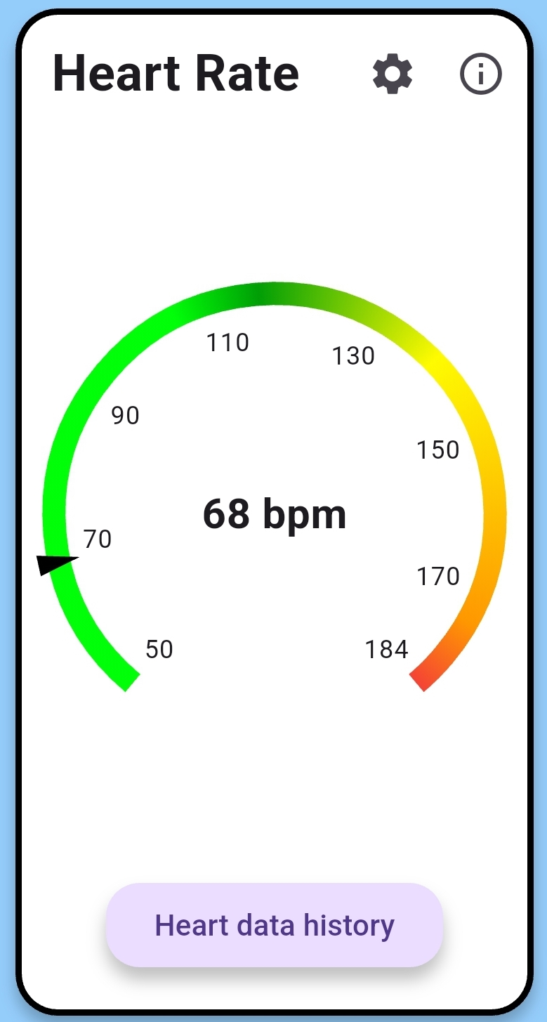

*Figure 1: Heart rate widget*

### Baseline and setup

As part of the initial setup process, new users are prompted to enter their age, which is used for the purpose of estimating maximum heart rate. It is determined using a standard physiological formula that is shown to be the most accurate by research (e.g., 208-0.7*age) [7], and serves as the basis for the calculation of heart rate zones represented in the application's radial gauge visualization. These areas are color-coded to distinguish between resting, moderate, and increased levels of exertion, permitting intuitive evaluation of cardiovascular status.

Further, the configuration process includes a brief baseline measurement period during which the user's resting respiratory rate, mean heart rate, and mean GSR are recorded. These baselines are necessary to individualize the application's detection of stress level, as both resting respiration and GSR are inputs to the stress estimation algorithm, which allows the system to adapt to the physiological norms of each user.

### Indicating stress

A central feature of the application is indicating stress, which integrates data from GSR and respiration rate to estimate the user’s current stress level. Research shows that GSR and respiration rate are valuable for stress detection, but does not establish specific threshold values for stress states. The focus of this research is the usability and not the algorithms or best values. For this reason, a “dummy” value for the critical GSR and respiratory rate is used. This approach enables the evaluation of interface usability independent of clinical validation. The resulting composite measure is communicated using a straightforward color-coded scheme—green, orange, or red—supplemented by a dialog box offering interpretive guidance. This approach ensures that feedback remains both transparent and actionable, supporting informed user response.

### Visualizing trends over time

To enable longitudinal health tracking, the app features a history page for each parameter tracked. The screen is easily accessible by a button below each parameter. The user can toggle between graphical and tabular data presentation formats and select pre-established time-based filters ("Today", "Last 7 Days", "Last 30 Days") to modify the data range displayed. They are introduced as buttons positioned at the top of the interface, a design decision intended to preserve vertical screen space and interface legibility on handheld devices. The layout supports fast, low-effort navigation and minimizes cognitive load, thereby enhancing overall usability. The application follows the same data visualization strategy as Samsung Health [8] for displaying monthly and weekly trends, namely by utilizing bar graphs to represent the minimum and maximum value for each day. Figure 2 shows an example of a bar graph filtered on last 30 days. This is a method of providing a concise and easy-to-understand overview of daily variations without bombarding the user with excessive information. The graph emphasizes variability and outliers by plotting a day-to-day range instead of specific data points, thereby preserving visual clarity, which is necessary in case numerous days are plotted within small screen space. The approach enables users to compare easily between days and to spot trends. It is especially useful for mobile devices, where spatial constraints imply short but significant visual representations are required. Moreover, the utilization of bars over line graphs here avoids visual clutter and promotes interpretability, in accordance with proven best practices in mobile health data design, as identified by Abdelrazek et al. [9]. Taking a cue from the effective interface of Samsung Health, this approach balances information density with user comprehension, supporting both day-to-day check-ins as well as longer-term trend analysis.

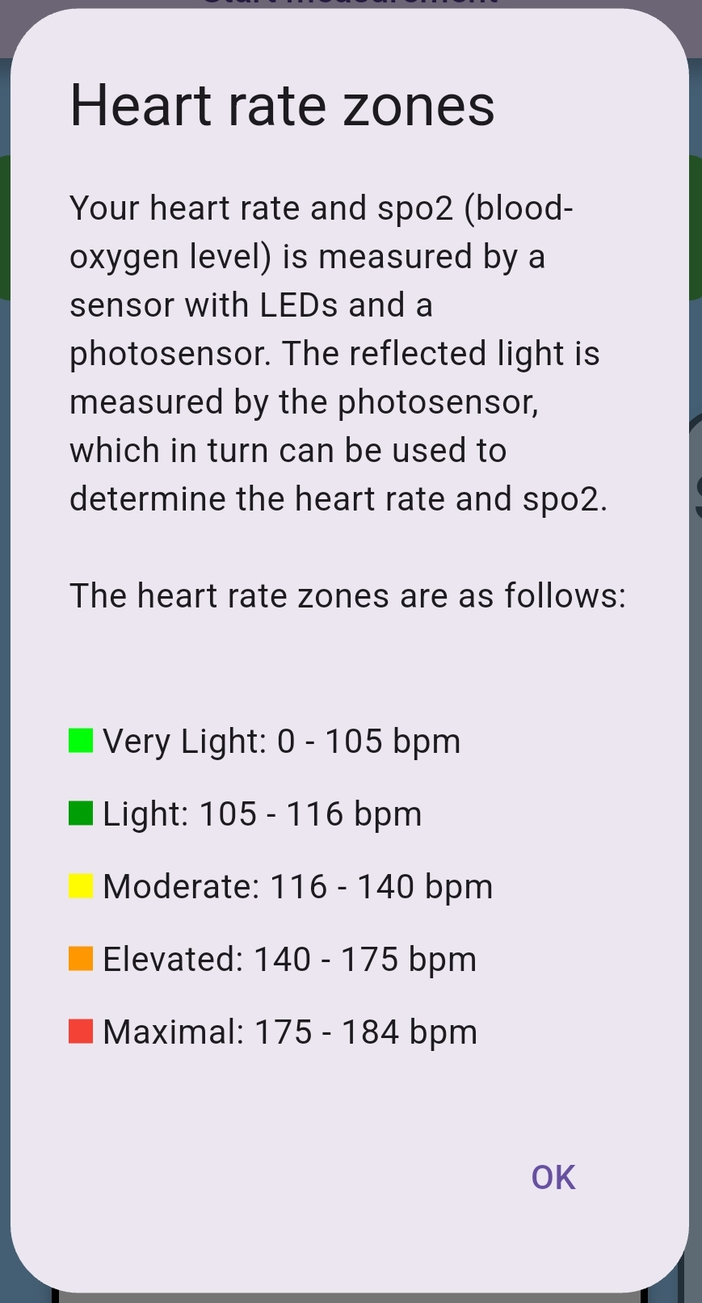

*Figure 3: Heart rate info panel dialog*

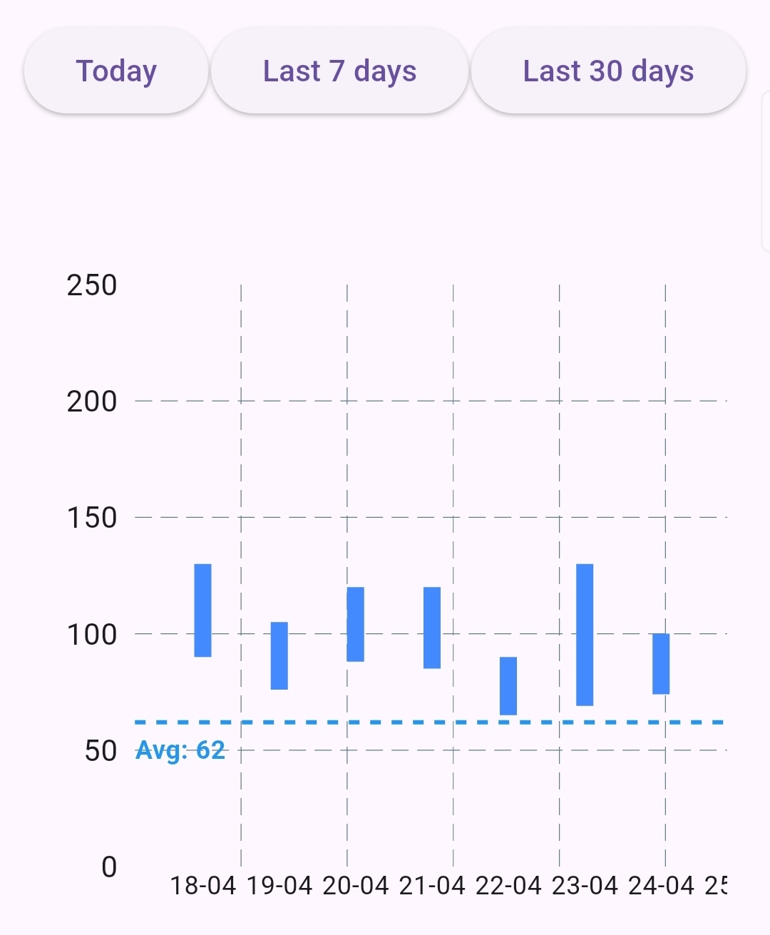

*Figure 2: Heart rate history page, filter on “last 30 days”*

### Clarifying health metrics to build trust and understanding

To further enhance user comprehension and create trust in the system, the application includes a dedicated information panel for each health metric. This panel can be accessed via an info button on each parameter’s widget page. As shown in figure 3, the dialog provides clear and concise explanations of what each physiological metric represents (e.g., heart rate, GSR, SpO₂, respiration rate), why it is important for health, its color-coded zones and their meanings, and how the measurement is obtained by the device. The information panel serves two purposes. First, it allows users to understand the significance of their readings. Such transparency explains health information, making the app more accessible and reducing confusion over unknown terms. Second, by explaining the sensor methods and the physiological basis for each measurement, the panel helps users understand the accuracy and limitations of the measurements. Together, these features help to reduce the "blackboxing" effect that remains a common issue among health monitoring apps today.

### User account system

Another functionality that was introduced is a user account system, which allows organizations to deploy the monitoring tool without needing to purchase an individual device for each employee. The design allows multiple users to log in on a shared device, thus saving both capital expenditures and operating costs. Consequently, organizations can assign one hardware unit to be used by a group of users, who can use it at their convenience to assess their physiological measurements. The shared-device model not only reduces the cost per user but also enhances the overall accessibility of the system, thereby enhancing broader adoption in resource-scarce settings.

# User Study

To evaluate the usability and user experience of the health monitoring toolkit, a structured user study was conducted. Participants were asked to complete a series of typical tasks using the app and then respond to a questionnaire covering various aspects of usability, clarity, and usefulness. Each question was rated on a 5-point Likert scale. The goal of the study was to assess how intuitive, informative, and engaging the app is for end-users, and to identify areas for improvement.

A total of five participants (two students and three researchers) took part in the study. The participant group consisted of four males and one female between 22 and 24 years old. Most had limited prior experience with health monitoring apps, allowing for a representative evaluation of ease of use from a general user perspective.

# Result

Participants rated each question on a scale from 1 to 5. They had a positive overall impression of the onboarding experience of the app. Device pairing was rated 3.6, reflecting an easy experience, while creating and selecting profiles was slightly less intuitive (3.4). Some participants were puzzled by the new user and existing user login screens being the same. Initiating a measurement was rated 3.8, reflecting that the majority of participants found it quite easy.

The clarity of the app was universally received, and the display of measurement results rated 4.6. Graphic elements like gauges and progress indicators hit 4.4, and the color-coded system scored an optimal 5.0 as proof of how effectively it assists users in interpreting their physiological values. The text content within the app was helpful (3.7), though one participant noted, however, that the quantity of the information could be viewed as excessive. But it did enhance the understanding of and working of the stress level indicator with a score of 4.4.

Graphical display of data was favored by participants over tables, with graphs receiving 4.4 for usability in monitoring trends. Most were unaware, however, that the "last 30 day" filter graph was touchable or scrollable and therefore gave incorrect min/max readings. Min/max rows in the table were rated lower (2.6), suggesting that this form of data presentation may be confusing or meaningless to users.

The history function itself was considered moderately (3.6) easy to access, while filtering by date range was perceived as intuitive (4.4).

Participants indicated gauge settings were easy to use (4.8) but were neutral in perceived usefulness (3.0), indicating a need to more clearly explain the benefits they may offer (e.g. indicating the acceptable range for the values for yourself).

Overall, the application was considered easy to use (3.6), with good functional integration (4.2) and minimal complexity (2.0). The application had minimal technical assistance dependency (1.4), and the majority of the participants believed that it could easily be accessed by novices (3.8). Nevertheless, the drive to utilize the application on a daily basis was inadequate (2.6), which indicates perceived long-term value deficiency. Confidence in the application was moderate (3.2), and prerequisite knowledge needed was minimal (1.8), indicating an easy learning process. Figure 4 displays the average scores given by users for each category.

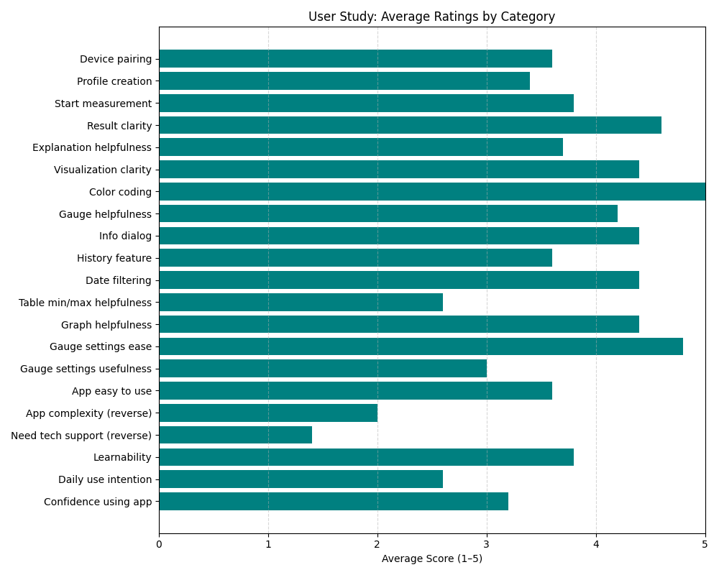

*Figure 4: Average scores given by the users for each category*

# Discussion

The user study highlights both strengths and areas for improvement in the app’s usability. Figure 5 shows these strengths and weaknesses of the application in a radar chart. As reflected in the results, participants appreciated the clarity of visualizations, especially the color-coded feedback and trend graphs, indicating successful communication of stress data. However, onboarding steps such as profile setup and device pairing were only moderately rated, suggesting a need for clearer instructional support.

While visual graphs were preferred, the table format for min/max data was confusing, pointing to a mismatch in how users interpret historical data. Similarly, although gauge settings were easy to adjust, their purpose was not clearly understood, showing a need for better explanation of features..

Enhancing the positioning of the measurement buttons (e.g. not as options under another button) or renaming the 'Start Measurement' button would significantly increase usability.

Aside from the software, the entire health measurement toolkit, as a portable sensor and mobile app, is an affordable and accessible solution for non-invasive health monitoring. The physical product has potential application in work or school environments where there is limited access to inexpensive and interpretable tools for mental health screening. With additional refinement and streamlined onboarding processes, the toolkit would be poised to facilitate preventive mental health initiatives, biofeedback training, or ongoing wellness tracking in multiple environments.

# Conclusion

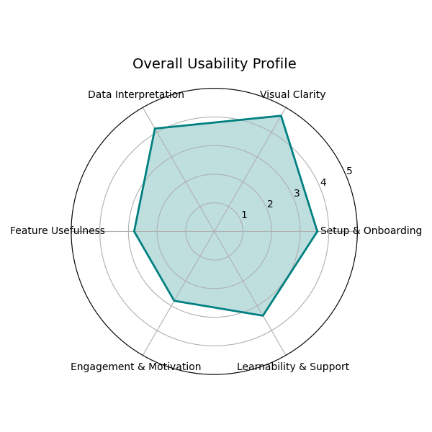

*Figure 5: Strengths and weaknesses in a radar graph*

This project demonstrates the feasibility and value of a low-cost, portable system for real-time monitoring of workplace well-being using physiological sensors and open-source hardware. By integrating heart rate, blood oxygen saturation, galvanic skin response, and respiration rate measurements into a single, user-friendly platform, the toolkit addresses limitations of commercial alternatives such as: high cost, lack of transparency, and limited accessibility. The accompanying mobile application further enhances usability by offering intuitive data visualizations, baseline calibration, and feedback, making physiological health monitoring accessible even to non-expert users.

The modular design and open architecture of both hardware and software provide a flexible foundation for future research, such as improved stress detection algorithms, additional sensor integration, or broader deployment within organizations. While the current system prioritizes usability and accessibility over validation, it establishes a robust platform for further research and development in occupational health technology. Ultimately, this work contributes to the growing field of workplace well-being by offering a practical, scalable solution for health monitoring, with the potential to inform data-driven interventions and promote healthier, more productive work environments.

# Acknowledgments

I would like to thank my promotor, Dr. Eva Geurts, and my co-promotor, Prof. Dr. Gustavo Rovelo Ruiz, for their guidance and support during this project. I also appreciate the contributions of everyone who participated in the testing and development process.

References

1. T. Bui, R. Zackula, K. Dugan, and E. Ablah, “Workplace Stress and Productivity: A Cross-Sectional Study,” *Kansas Journal of Medicine*, vol. 14, no. 1, Feb. 2021, doi: <https://doi.org/10.17161/kjm.vol1413424>. Available: <https://pmc.ncbi.nlm.nih.gov/articles/PMC7889069/>. [Accessed: May 18, 2025]
2. R. F. Navea, P. J. Buenvenida, and C. D. Cruz, “Stress Detection using Galvanic Skin Response: An Android Application,” *Journal of Physics: Conference Series*, vol. 1372, p. 012001, Nov. 2019, doi: <https://doi.org/10.1088/1742-6596/1372/1/012001>. [Accessed: May 18, 2025]
3. Y. S. Can, B. Arnrich, and C. Ersoy, “Stress detection in daily life scenarios using smart phones and wearable sensors: A survey,” *Journal of Biomedical Informatics*, vol. 92, p. 103139, Apr. 2019, doi: https://doi.org/10.1016/j.jbi.2019.103139. Available: https://www.sciencedirect.com/science/article/abs/pii/S1532046419300577. [Accessed: May 18, 2025]
4. J. M. Peake, G. Kerr, and J. P. Sullivan, “A Critical Review of Consumer Wearables, Mobile Applications, and Equipment for Providing Biofeedback, Monitoring Stress, and Sleep in Physically Active Populations,” *Frontiers in Physiology*, vol. 9, no. 9, Jun. 2018, doi: https://doi.org/10.3389/fphys.2018.00743. Available: https://europepmc.org/backend/ptpmcrender.fcgi?accid=PMC6031746&blobtype=pdf. [Accessed: May 18, 2025]
5. “Piezo-Electric Respiration (PZT) Sensor,” *PLUX Biosignals*, 2025. Available: https://www.pluxbiosignals.com/products/respiration-pzt?srsltid=AfmBOoqX-ZqraYTy9DBPU243tGuNZ-K0sgG5AEa1SrWpJkrOwiXdz8Sm. [Accessed: May 18, 2025]
6. J. Nielsen, “10 Heuristics for User Interface Design,” *Nielsen Norman Group*, Apr. 24, 1994. Available: https://www.nngroup.com/articles/ten-usability-heuristics/. [Accessed: May 18, 2025]
7. J. Lach, D. Śliż, S. Wiecha, S. Price, A. Brzozowski, and A. Mamcarz, “How to calculate a maximum heart rate correctly?,” *Folia Cardiologica*, vol. 17, no. 5, pp. 289–292, Oct. 2022, doi: https://doi.org/10.5603/fc.2022.0057. Available: https://journals.viamedica.pl/folia_cardiologica/article/view/92507. [Accessed: May 18, 2025]
8. “Samsung Health | Apps en Diensten | Samsung NL,” *Samsung nl*, Mar. 04, 2025. Available: https://www.samsung.com/nl/apps/samsung-health/?srsltid=AfmBOooJKtwJCQacqPGU1X9D35zN7cRpG8v84B7khVgoM3ZQlFHcImtg. [Accessed: May 18, 2025]
9. Yasmeen Anjeer Alshehhi, M. Abdelrazek, B. Philip, and Alessio Bonti, “Understanding User Perspectives on Data Visualization in mHealth Apps: A Survey Study,” *IEEE Access*, vol. 11, pp. 84200–84213, Jan. 2023, doi: https://doi.org/10.1109/access.2023.3302325