BA820 – Alone TV Show Analysis Refinement
Milestone 4
Team B02
Mika Ismayilli

1. Refined Problem Statement & Focus (~0.5 page)
I am investigating whether the survival item selection among the contestants reflects survival strategies and whether or not these strategies are associated with longer survival outcomes. For this analysis, I will use the contestant-item selection level as a primary unit where each contestant’s loadout represents a strategic choice. The question remains the same as M2 but M4 adds defensibility through tuning, stability testing, and a clustering-based method.
The success metrics will be reflected in variables like days_lasted, medically_evacuated and tap_out_reason. These metrics capture both endurance and failure modes of the contestants.
This question matters to multiple stakeholders. For example, contestants and their trainers can use insights to refine the preparation and prioritization of items that supports longer survival rather than comfort. Other stakeholders include the producers and rule designers of the TV Show. They can benefit from this analysis to figure out whether or not some items promote dominant strategies and might reduce the suspense and variability. With this, they can adjust the rules and constraints to keep the competitive balance as well as ensure safety. Lastly, this analysis also provides insight into how people allocate the scarce resources under uncertainty, which makes it a realistic case of decision-making with pressure rather than being driven by entertainment.

2. EDA & Preprocessing: Updates (~0.5 page)
The preprocessing was carried over from M2 without any changes. Column names were standardized across 4 tabled by lowercasing, removing whitespace, and replacing spaces with underscores. The loadout table was merged with survivalist on season and name to attach the outcome variables like days_lasted, medically_evacuated, tapout_reason, gender, and age. From there, the loadout data was transformed into a binary basket matrix. That matrix has 94 contestants and 27 item types.
The EDA from M2 still holds. Item frequencies split into near-universal picks and strategic differentiators (Figure 1). The top six items: fishing gear, pot, sleeping bag, axe, saw, and ferro rod all exceed 80% selection. Therefore, the real variation happens in the remaining 4–5 slots. No new cleaning or transformations were needed for M4. The same basket matrix feeds directly into both the sensitivity analysis and the clustering work.

3. Analysis & Experiments (~2 pages)
Association Rules — Baseline
M2 used an Apriori algorithm to find item combinations that appear together more than random chance predicts. Each contestant picks 10 items from 27 options, which creates a natural basket scenario. The algorithm was run at three support levels being 0.10, 0.15, and 0.20 to test how item sets behave at different thresholds. Medium support (0.20) gave the best balance between noise and signal. From there, association rules were generated at 70% confidence with a lift filter above 1.2. The result was a set of rules showing directional dependencies like "if axe and ferro rod, then pot" (Figure 2, 3).
The limitation of M2 was that everything depended on one threshold. A rule that looks strong at support=0.20 and confidence=0.70 might vanish at 0.15 or 0.80. There was no way to tell which findings were strong and which were scraps of a single parameter choice. M4 addresses this directly.
Sensitivity Sweep
To test threshold dependence, Apriori was run across six support values (0.05 - 0.20) and four confidence values (0.50 -0.80), all filtered at lift > 1.2. This produced 24 threshold combinations (Figure 4). The results show a clear pattern: rule counts drop sharply as support increases and the drop is steeper at higher confidence levels (Figure 5). At the loosest setting of support=0.05 and confidence=0.50, over 28,000 rules survive. At the tightest of support=0.20 and confidence=0.80, only 900 survived.
The more useful output is tracking which specific rules persist across many settings versus which only appear at one. Rules involving core items like ferro rod, fishing gear, pot, axe, sleeping bag, trapping wire survived all 24 threshold combinations (Figure 6). These are the backbone of the dependencies. Meanwhile, rules involving rarer items like paracord, canteen, or multitool only appeared at 2–3 settings which makes them fragile and not worth building conclusions on.
Bootstrap Stability
The sensitivity sweep tests threshold sensitivity but does not test data sensitivity. A rule could survive every threshold combo yet still depend on a handful of specific contestants. To check this, the contestant pool was resampled with replacement 100 times and Apriori was re-run on each sample at the M2 baseline settings which was support=0.20, confidence=0.70 and lift>1.2.
The top rules appeared in 99–100 out of 100 bootstraps (Figure 7). Combinations like (axe, ferro rod, trapping wire -> bow and arrows) and (axe, sleeping bag, trapping wire -> fishing gear) showed up every single time. On the other end, rules with appearance rates below 20% are unstable and depend on which contestants happen to be in the sample. This confirms what the sensitivity sweep suggested. The core-item rules are rock solid while rare item rules are not.
Redundancy Filtering
Association rules generate duplicates by design. If axe -> pot exists, so does pot -> axe. Nested antecedents add more bloat. (Axe, saw) -> pot is redundant if axe -> pot already exists at similar confidence. The raw rule set from the baseline had 2,728 rules. After removing reciprocals by keeping only the higher-confidence direction, that dropped to 2,707. After removing redundant supersets where the confidence difference was less than 5%, the final count landed at 472 clean rules (Figure 8). This table is what the findings section draws from meaning each rule is unique, directional, and not a bloated version of a simpler rule.
Clustering Contestants by Loadout
Association rules answer "what goes with what" but do not answer "what types of contestants exist." To get at the strategy archetypes, the same binary basket matrix was used as input to clustering. Each contestant is a 27-dimensional vector of 1s and 0s representing their item choices.
Hierarchical clustering with Ward linkage was run first to visualize groupings. The dendrogram shows a natural split into 2–3 major branches (Figure 9). K-Means was then run with the elbow method suggesting k=3 as the bend point (Figure 10). The silhouette plot at k=3 shows reasonable separation. (Figure 11).
Three clusters break down (Figure 12, Figure 13):
Cluster 0 (n=14) centers on fishing gear, saw, pot, tarp, and rations. Every member selected saw and a tarp at 100%, which is notably higher than the overall rate. Average survival was 31.4 days which was the lowest of the three. Tap-out reasons skewed toward family/personal at 67%. This group leans on tool based, food preparation, and shelter building kits.
Cluster 1 (n=42) is the largest group. Top items are sleeping bag, ferro rod, pot, fishing gear, and multitool, all at +90% selection. Average survival was 45.5 days which was the highest. Medical/health exits lead at 67%, which makes sense meaning these contestants lasted long enough for physical wear to become the main exit driver. This was labelled the endurance archetype.
Cluster 2 (n=38) selected fishing gear, knife, and sleeping bag at 100%, with pot and ferro rod at 95%. Average survival was 34.7 days. Tap-out reasons split evenly between medical/health and family/personal at 47% each. This group carries a balanced and generalist loadout without heavy commitment to any one strategy.
The gap between Cluster 1 (45.5 days) and the other two (31–35 days) stands out. Contestants who prioritize warmth and fire-starting — sleeping bag and ferro rod as their top two items — outlast those who lean on tools or spread their picks evenly. That said, this is correlation, not causation. Cluster 1 may also capture more experienced contestants who happen to favor that loadout.

4. Findings & Interpretations (~1 page)
Three main takeaways stand out from my analysis.
First, item dependencies among the contestants are not random and the strong ones hold up under pressure. The sensitivity sweep and bootstrap together confirm that core pairings like axe with ferro rod, pot with sleeping bag, and trapping wire with fishing gear persist across every threshold setting and nearly every resampled dataset (Figure 5, 6, 7). These items function as the backbone of survival. Contestants treat them as complements, not substitutes. Weaker pairings involving rarer items like canteen, paracord, or gillnet only appear under loose thresholds and drop out quickly. Hence, any advice built on those pairings would be unreliable.
Second, contestants fall into three distinct loadout archetypes. The clustering reveals a tool-heavy group (Cluster 0), an endurance group (Cluster 1), and a balanced generalist group (Cluster 2). The tool-heavy group invests in saws and tarps. The endurance group locks in sleeping bags and ferro rods early. The generalists spread their picks without a clear anchor. Each archetype fills roughly the same 10 item slots but allocates them differently, which confirms that contestants do approach the show with distinct strategies rather than copying a single template.
Third, the shelter first strategy lasts longer. Cluster 1 averaged 45.5 days compared to 31.4 and 34.7 for the other two groups. Their exit reasons lean toward medical and health issues at 67%, which suggests they survived long enough for physical breakdown to become the limiting factor rather than early withdrawal. The tool-heavy group exited mostly for family and personal reasons at 67% which potentially indicates that their strategy did not sustain morale or comfort over time. This does not prove that sleeping bags and ferro rods cause longer survival. Skill, experience, and location all play a role. But the pattern is consistent enough to warrant attention from contestants planning their loadouts.
For producers, the findings suggest that item selection rules do not need adjustment to maintain competitive balance. The 20–25% variation even within strong association rules shows contestants still customize based on personal strengths. No single dominant loadout exists that would make outcomes predictable. For contestants and trainers, the data points toward prioritizing warmth and fire capability over tools.

Appendix
Shared GitHub Repository (Required)
https://github.com/MikaIsmayilov/B02_Alone_TVShow_Unsupervised_Project/tree/main
Supplemental Material (Highly Recommended)
Figure 1
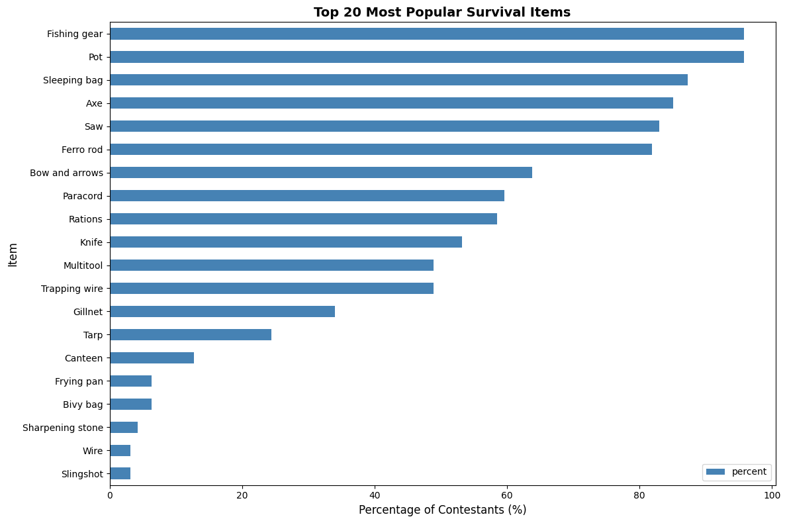
Figure 2
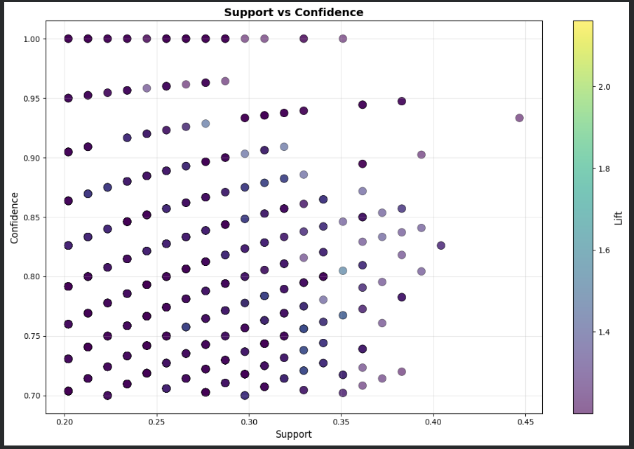
Figure 3
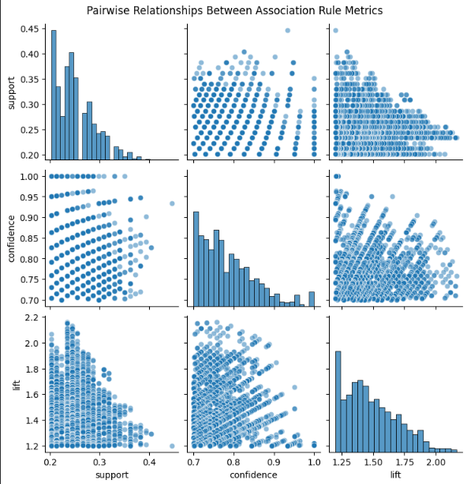
Figure 4
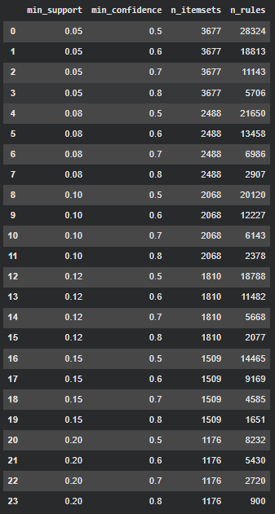

Figure 5
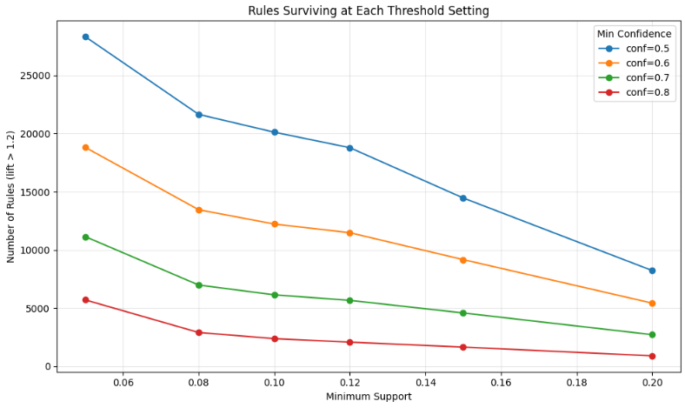
Figure 6
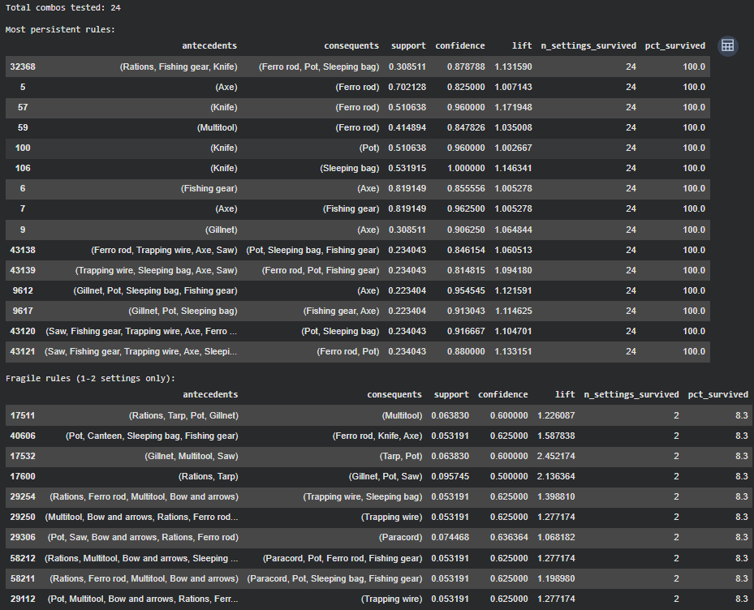

Figure 7
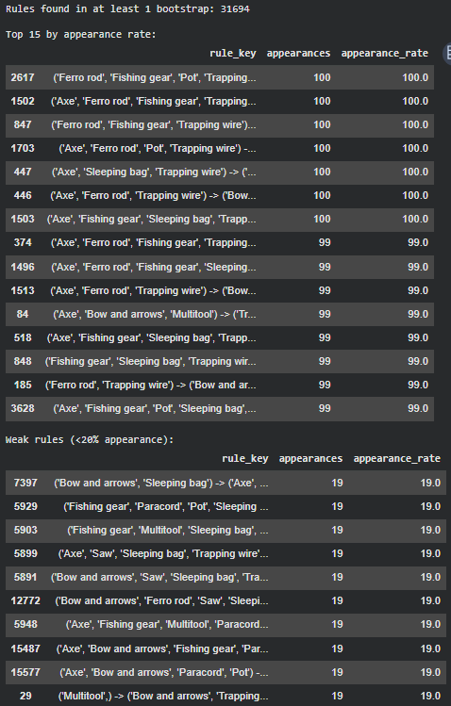
Figure 8
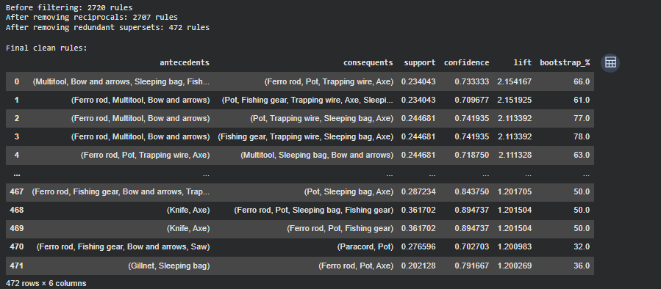
Figure 9
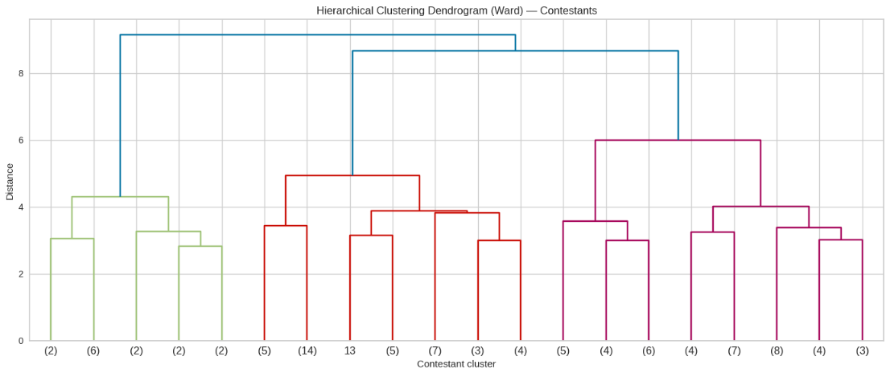
Figure 10
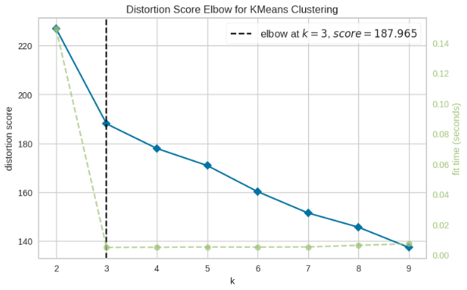

Figure 11
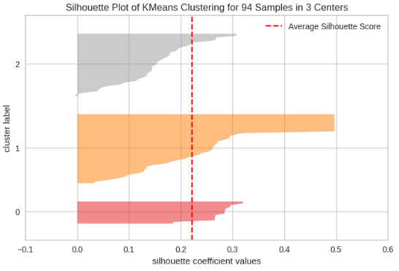
Figure 12
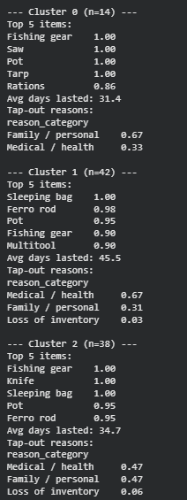
Figure 13
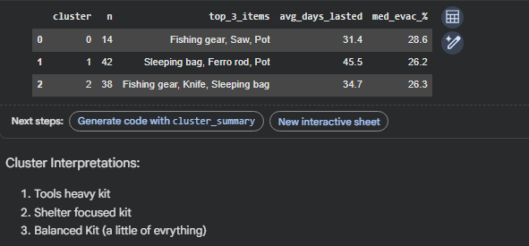
Process Overview
Use of Generative AI Tools
M4 Brainstorming Roadmap: https://chatgpt.com/share/699bbeab-c890-8002-bcd3-b3303da341df
Fixing Output Error Flood from M2: https://chatgpt.com/share/69953332-299c-8002-b36c-9735a07c215f
Association Rule Refresher and Examples: https://chatgpt.com/g/g-p-698396323be081919aca2e41c018df31/c/699bed8b-63ac-832f-9edc-1016000dec7a
Fixing part of the code where sorting was missing: https://chatgpt.com/share/699d1964-ab90-8002-bc0c-1f9e610368dc

Gemini fixed indent issue with the for loop:
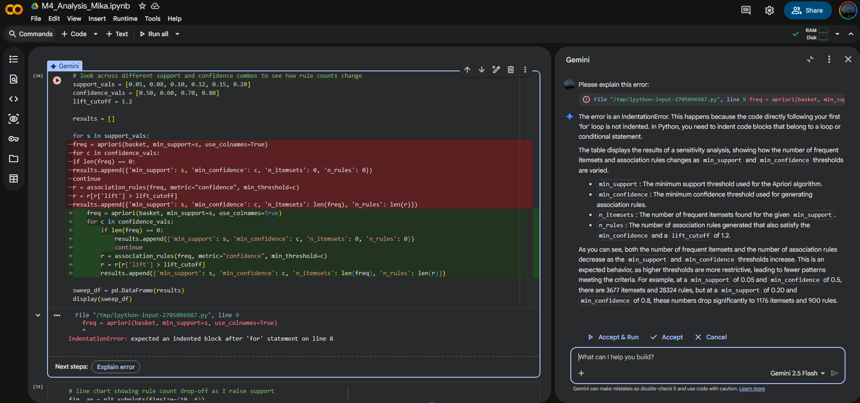
Non-binary column in the basket fix
