PRN232 Report
-Github repository link: https://github.com/MikaJariki/QE180151.git
-Deploy website link: https://qe-180151.vercel.app/
-Short report:
– Full-stack Movie Watchlist app with ASP.NET Core 9 + PostgreSQL backend and React/Vite/Ant Design frontend. Supports listing movies (poster, genre, rating) with search/filter/sort, add/edit forms with validation, delete confirmation, Swagger API docs, and Docker-friendly deployment (Render backend + Vercel frontend).

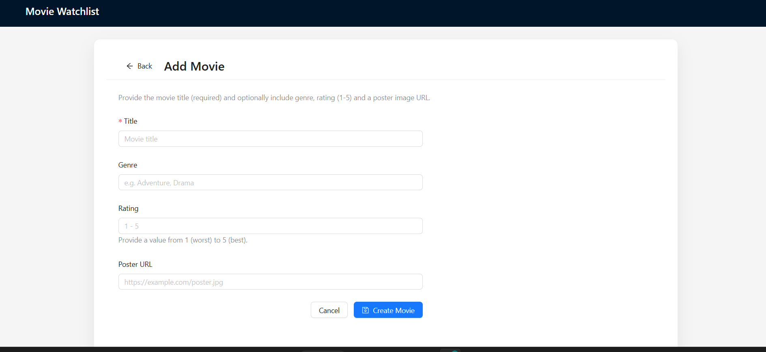
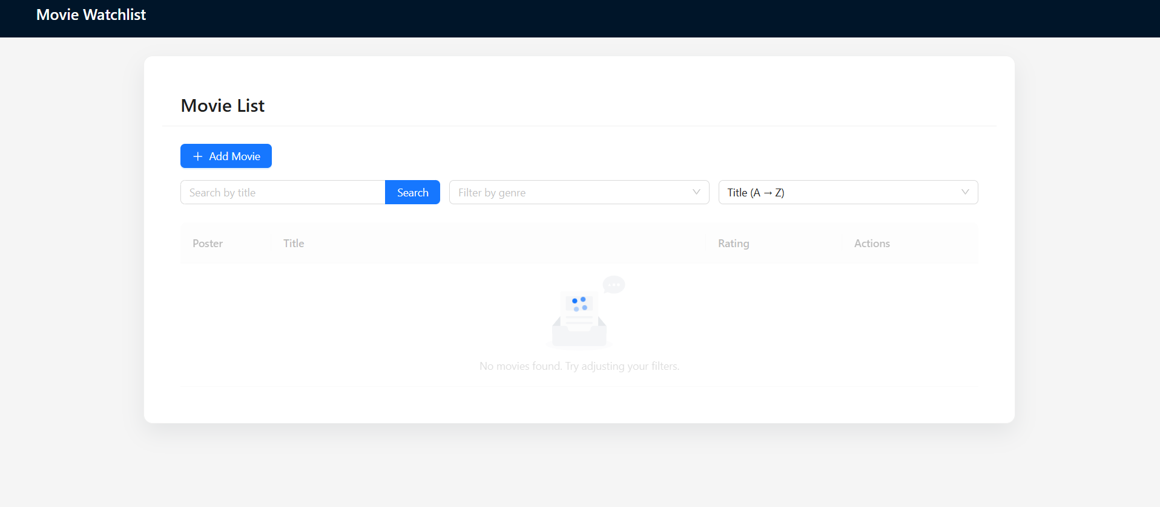
-Step to run locally:
- Backend: cd BE/MovieManager.Api && dotnet restore && dotnet ef database update && dotnet run (defaults to http://localhost:5119; update appsettings.Development.json if your Postgres creds differ).
- Frontend: cd FE && npm install && npm run dev; ensure FE/.env has VITE_API_BASE_URL=http://localhost (line 5119) (or whatever port the API uses).
- Open http://localhost:5173, use the UI to add/edit/delete movies, and confirm data persists in PostgreSQL.

