Circuitos

Desligado

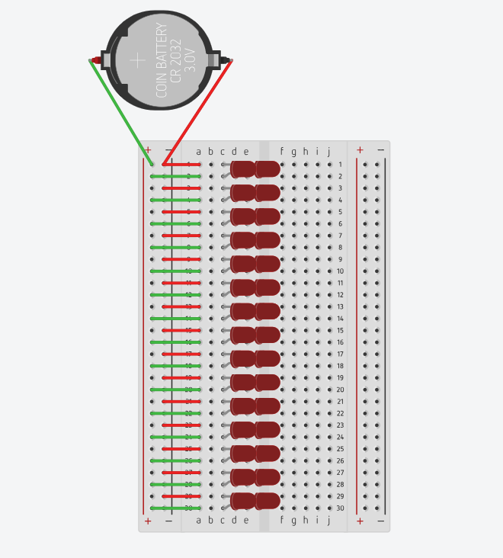

Ligado

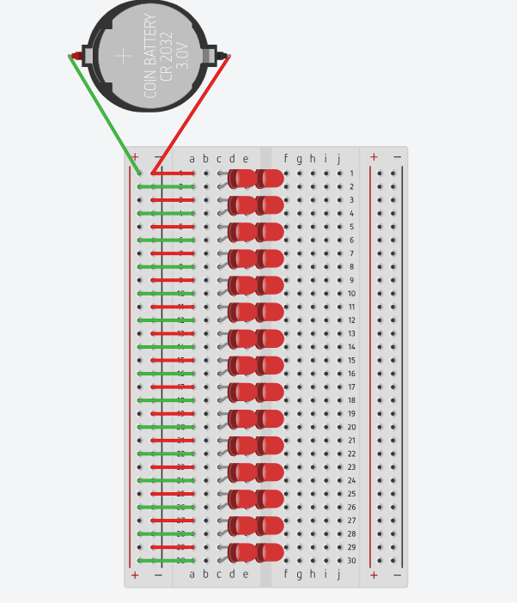

Desligado

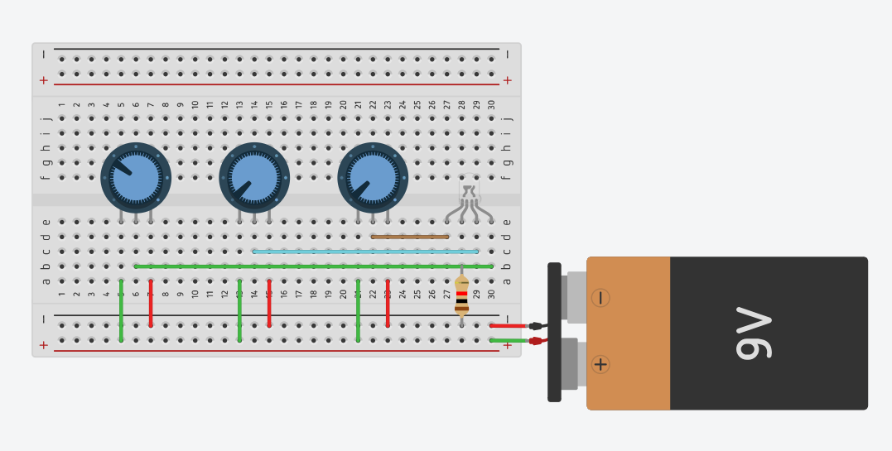

Ligado

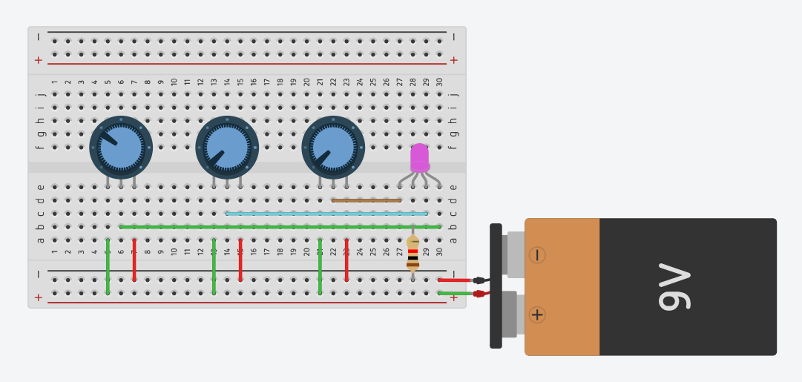

Desligado c/ código 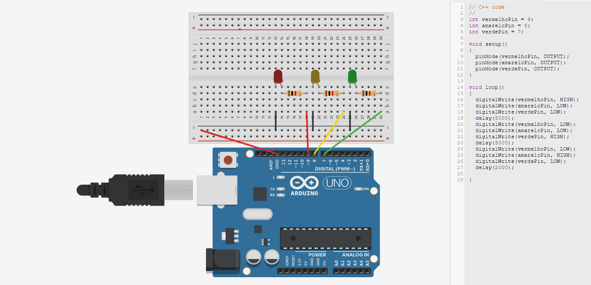

Ligado c/ código

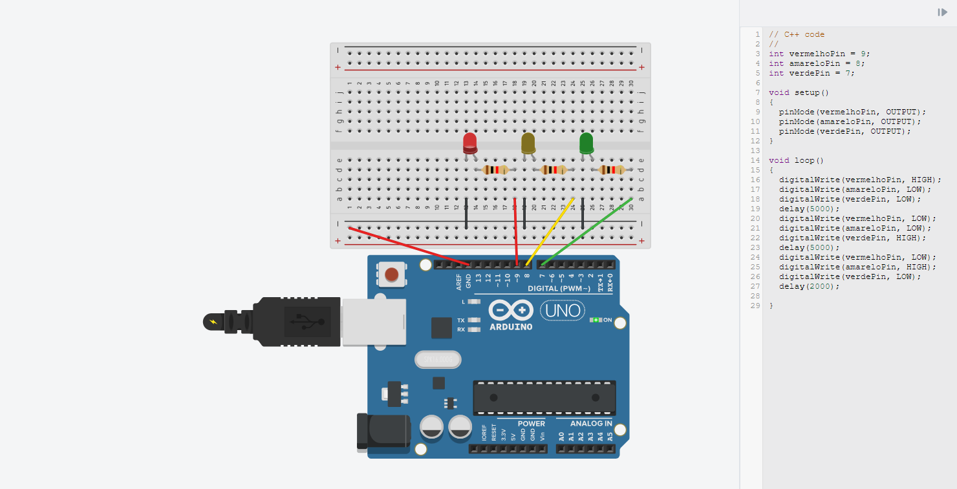

ASCENDER 15 LED’S

CÓD

// C++ code

//

int vermelhoPin = 9;

int laranjaPin = 8;

int amareloPin = 7;

int verdePin = 6;

void setup()

{

pinMode(vermelhoPin, OUTPUT);

pinMode(laranjaPin, OUTPUT);

pinMode(amareloPin, OUTPUT);

pinMode(verdePin, OUTPUT);

}

void loop()

{

digitalWrite(vermelhoPin, LOW);

digitalWrite(laranjaPin, LOW);

digitalWrite(amareloPin, LOW);

digitalWrite(verdePin, HIGH);

delay(2000);

digitalWrite(vermelhoPin, LOW);

digitalWrite(laranjaPin, LOW);

digitalWrite(amareloPin, HIGH);

digitalWrite(verdePin, LOW);

delay(2000);

digitalWrite(vermelhoPin, LOW);

digitalWrite(laranjaPin, LOW);

digitalWrite(amareloPin, HIGH);

digitalWrite(verdePin, HIGH);

delay(2000);

digitalWrite(vermelhoPin, LOW);

digitalWrite(laranjaPin, HIGH);

digitalWrite(amareloPin, LOW);

digitalWrite(verdePin, LOW);

delay(2000);

digitalWrite(vermelhoPin, LOW);

digitalWrite(laranjaPin, HIGH);

digitalWrite(amareloPin, LOW);

digitalWrite(verdePin, HIGH);

delay(2000);

digitalWrite(vermelhoPin, LOW);

digitalWrite(laranjaPin, HIGH);

digitalWrite(amareloPin, HIGH);

digitalWrite(verdePin, LOW);

delay(2000);

digitalWrite(vermelhoPin, LOW);

digitalWrite(laranjaPin, HIGH);

digitalWrite(amareloPin, HIGH);

digitalWrite(verdePin, HIGH);

delay(2000);

digitalWrite(vermelhoPin, HIGH);

digitalWrite(laranjaPin, LOW);

digitalWrite(amareloPin, LOW);

digitalWrite(verdePin, LOW);

delay(2000);

digitalWrite(vermelhoPin, HIGH);

digitalWrite(laranjaPin, LOW);

digitalWrite(amareloPin, LOW);

digitalWrite(verdePin, HIGH);

delay(2000);

digitalWrite(vermelhoPin, HIGH);

digitalWrite(laranjaPin, LOW);

digitalWrite(amareloPin, HIGH);

digitalWrite(verdePin, LOW);

delay(2000);

digitalWrite(vermelhoPin, HIGH);

digitalWrite(laranjaPin, LOW);

digitalWrite(amareloPin, HIGH);

digitalWrite(verdePin, HIGH);

delay(2000);

digitalWrite(vermelhoPin, HIGH);

digitalWrite(laranjaPin, HIGH);

digitalWrite(amareloPin, LOW);

digitalWrite(verdePin, LOW);

delay(2000);

digitalWrite(vermelhoPin, HIGH);

digitalWrite(laranjaPin, HIGH);

digitalWrite(amareloPin, LOW);

digitalWrite(verdePin, HIGH);

delay(2000);

digitalWrite(vermelhoPin, HIGH);

digitalWrite(laranjaPin, HIGH);

digitalWrite(amareloPin, HIGH);

digitalWrite(verdePin, LOW);

delay(2000);

digitalWrite(vermelhoPin, HIGH);

digitalWrite(laranjaPin, HIGH);

digitalWrite(amareloPin, HIGH);

digitalWrite(verdePin, HIGH);

delay(2000);

}

TESTES = CONCLUIDOS

