Understanding and Reducing Customer Churn: A Data-Driven Retention Strategy
Final Stage 1 — Data Analytics Competition

Team: DataWizards
[EDIT: Member 1 — Member 2]
[EDIT: University]

Executive Summary
Customer churn is a direct threat to the premium income and profitability of a Texas auto insurer. Using data on 160,000 customers (overall churn rate 11.5%), we combined statistical driver analysis, survival analysis, interpretable regression and gradient-boosted machine learning to explain why and when customers leave and whom to prioritise. Churn risk is highest in tenure interval [90, 180) days. Our final model reaches an out-of-fold ROC-AUC of 0.706 (95% CI 0.701–0.710); targeting the 20% highest-risk customers captures 52% of all churners. Expected annual premium at risk is 17.50M USD (11.6% of the premium base). We recommend: (1) First-year onboarding programme; (2) Life-stage tailored engagement; (3) Investigate and act on 'cust orig date days since'. A campaign simulation suggests that targeting the top 10% of customers by expected loss yields a net benefit of 600.86K USD (ROI 1.5x) under our stated assumptions.
[EDIT: tambahkan 1 kalimat konteks spesifik dari soal (produk, pasar, tujuan manajemen) dan rapikan ringkasan ini maks. ½ halaman.]

1. Introduction and Business Problem
[EDIT: 1 paragraf konteks pasar & perusahaan dari soal. Untuk konteks industri Indonesia (penetrasi OJK, klaim surrender AAJI, regulasi PAYDI) pakai paragraf siap pakai di BAHAN_LATAR_BELAKANG.md §C.1.]
For a Texas auto insurer, every customer who leaves takes future premium income with them. The economics of retention are well documented: Reichheld and Sasser (1990) reported that reducing customer defections by 5% raised profits by 25%–85% across several service businesses, and in insurance the effect is sharper because acquisition costs are concentrated at the start of the contract, so policies that exit early often never recover them. Lapse also affects pricing and risk management, because products are priced under persistency assumptions (Eling & Kochanski, 2013). Not every exit is equally avoidable: Gottlieb and Smetters (2021) found that forgetting to pay explained 37.8% of recent life-insurance lapses, which suggests that part of churn can be addressed through process design rather than price.
This study answers four questions: (RQ1) Which customer, policy and service factors are associated with churn, and how strongly after controlling for the others? (RQ2) When during the customer lifecycle is churn risk highest? (RQ3) How accurately can churn be predicted, and which customers should be prioritised? (RQ4) Which interventions are most likely to reduce churn, and what is their expected economic value?

2. Data and Methodology

2.1 Data
The dataset contains 160,000 customers (plus 40,000 customers to be scored) and 20 original variables covering [EDIT: demographics, policy characteristics, premium & payment behaviour, claims and service interactions]. The target is Churn (churn = 1); the overall churn rate is 11.5%.

2.2 Data preparation
Data preparation included automatic type correction (e.g. numbers stored as text and date parsing), harmonisation of inconsistent category labels, removal of 0 duplicate records and treatment of impossible values. We engineered 12 domain features, including tenure (years), tenure band, new customer (<12 months), age band, premium-to-income ratio, cust orig date days since. Variables recorded only after churn (acct suspd date year, acct suspd date month, acct suspd date days since, acct suspd date) were excluded from modelling to prevent target leakage.

2.3 Analytical framework
Our framework has five layers (Figure 1): (1) univariate driver analysis with χ² and Mann-Whitney tests, effect sizes (Cramér's V, rank-biserial r), Information Value and Benjamini-Hochberg correction; (2) survival analysis (Kaplan-Meier, log-rank tests and Cox proportional hazards) to capture when churn occurs; (3) a multivariate logistic regression for interpretable odds ratios; (4) predictive machine learning (catboost, hgb, lgbm, logreg, xgb) evaluated with stratified 5-fold cross-validation, tuned with Bayesian optimisation (Optuna) and combined via ensemble selection, with model behaviour explained by SHAP values and partial dependence; and (5) doubly robust causal estimation (AIPW) to quantify the effect of controllable levers. Results were translated into business value with lift analysis, customer lifetime value, a risk–value matrix, a retention-campaign ROI simulation and what-if scenarios.
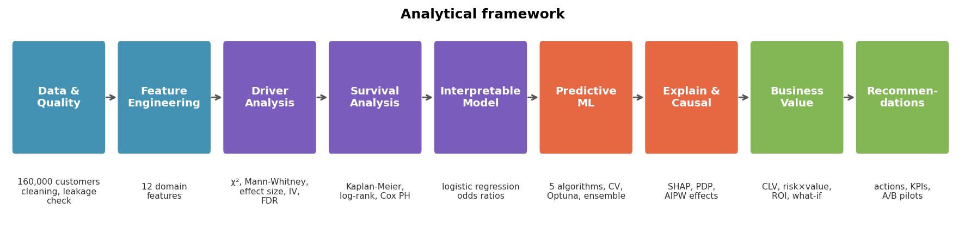
Figure 1. Analytical framework: from data preparation to evidence-based retention recommendations.

2.4 Validation
All performance figures are out-of-fold estimates. Target-dependent encodings were fitted inside each training fold. Sanity checks confirmed the absence of leakage (ROC-AUC with shuffled labels ≈ 0.5) and similar train/test distributions (adversarial validation AUC = 0.50). Uncertainty is reported with bootstrap 95% confidence intervals.

3. Findings

3.1 Churn overview
11.5% of customers churned, i.e. a [EDIT: moderate/severe] class imbalance; we therefore evaluate models with ROC-AUC and precision–recall rather than accuracy.

3.2 Key churn drivers
tenure band: customers in '0-6m' churn at 49.2% (4.3x the overall rate of 11.5%) versus 6.9% for '2-5y' (χ² p <0.001, Cramér's V = 0.39, IV = 0.93).
cust orig date month: churned customers have a median of 8.00 vs 9.00 for retained customers (weak/non-monotonic; rank-biserial r = -0.04, negligible effect, IV = 0.10). Highest-risk bin 6–7 churns at 20.5% (1.8x the average).
age band: customers in '25-34' churn at 13.9% (1.2x the overall rate of 11.5%) versus 8.0% for '65+' (χ² p <0.001, Cramér's V = 0.06, IV = 0.04).
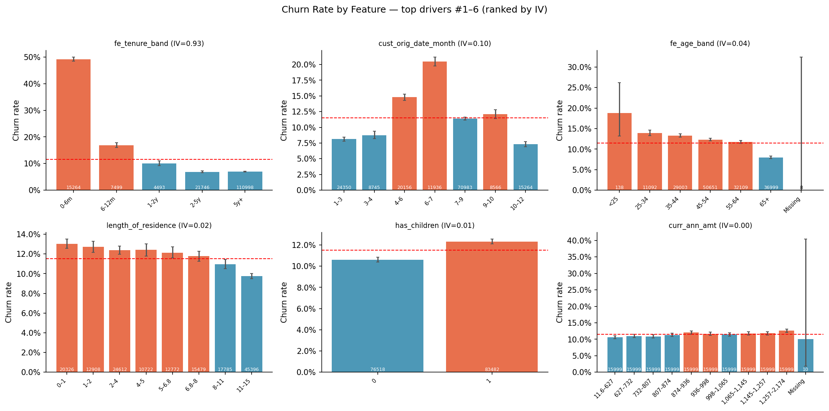
Figure 2. Churn rate by the strongest drivers (bars: churn rate with 95% CI; dashed line: overall churn rate).
Table 1. Driver evidence matrix (univariate, multivariate, survival and SHAP evidence).
Driver | High-risk group | Churn % (group) | Lift | IV | OR | HR | SHAP rank
tenure band | 0-6m | 49.20 | 4.27 | 0.93 | 12.63 |  | 10
age band | 25-34 | 13.90 | 1.21 | 0.04 | 0.88 | 0.44 | 22
days tenure | 22–191 | 47.70 | 4.14 | 0.89 |  |  | 1
tenure (years) | 0.0602–0.523 | 47.70 | 4.14 | 0.89 |  |  | 2
cust orig date days since | 22–191 | 47.70 | 4.14 | 0.89 |  |  | 3
length of residence | 0–1 | 13.00 | 1.13 | 0.02 |  |  | 4

[EDIT: jelaskan 2–3 driver utama dengan bahasa bisnis — kenapa masuk akal di industri asuransi (lihat PLAYBOOK §D2).]

Multivariate evidence
Holding other factors constant, tenure band = 0-6m (vs '5y+') changes the odds of churn by +1163% (OR = 12.63, 95% CI 12.12–13.15, p <0.001; average marginal effect +21.9 pp).
Holding other factors constant, age band = 65+ (vs '45-54') changes the odds of churn by -12% (OR = 0.88, 95% CI 0.84–0.93, p <0.001; average marginal effect -1.1 pp).

3.3 When do customers churn?
Estimated probability of retaining a customer beyond 90 days: 98.6% (Kaplan-Meier).
Estimated probability of retaining a customer beyond 180 days: 95.2% (Kaplan-Meier).
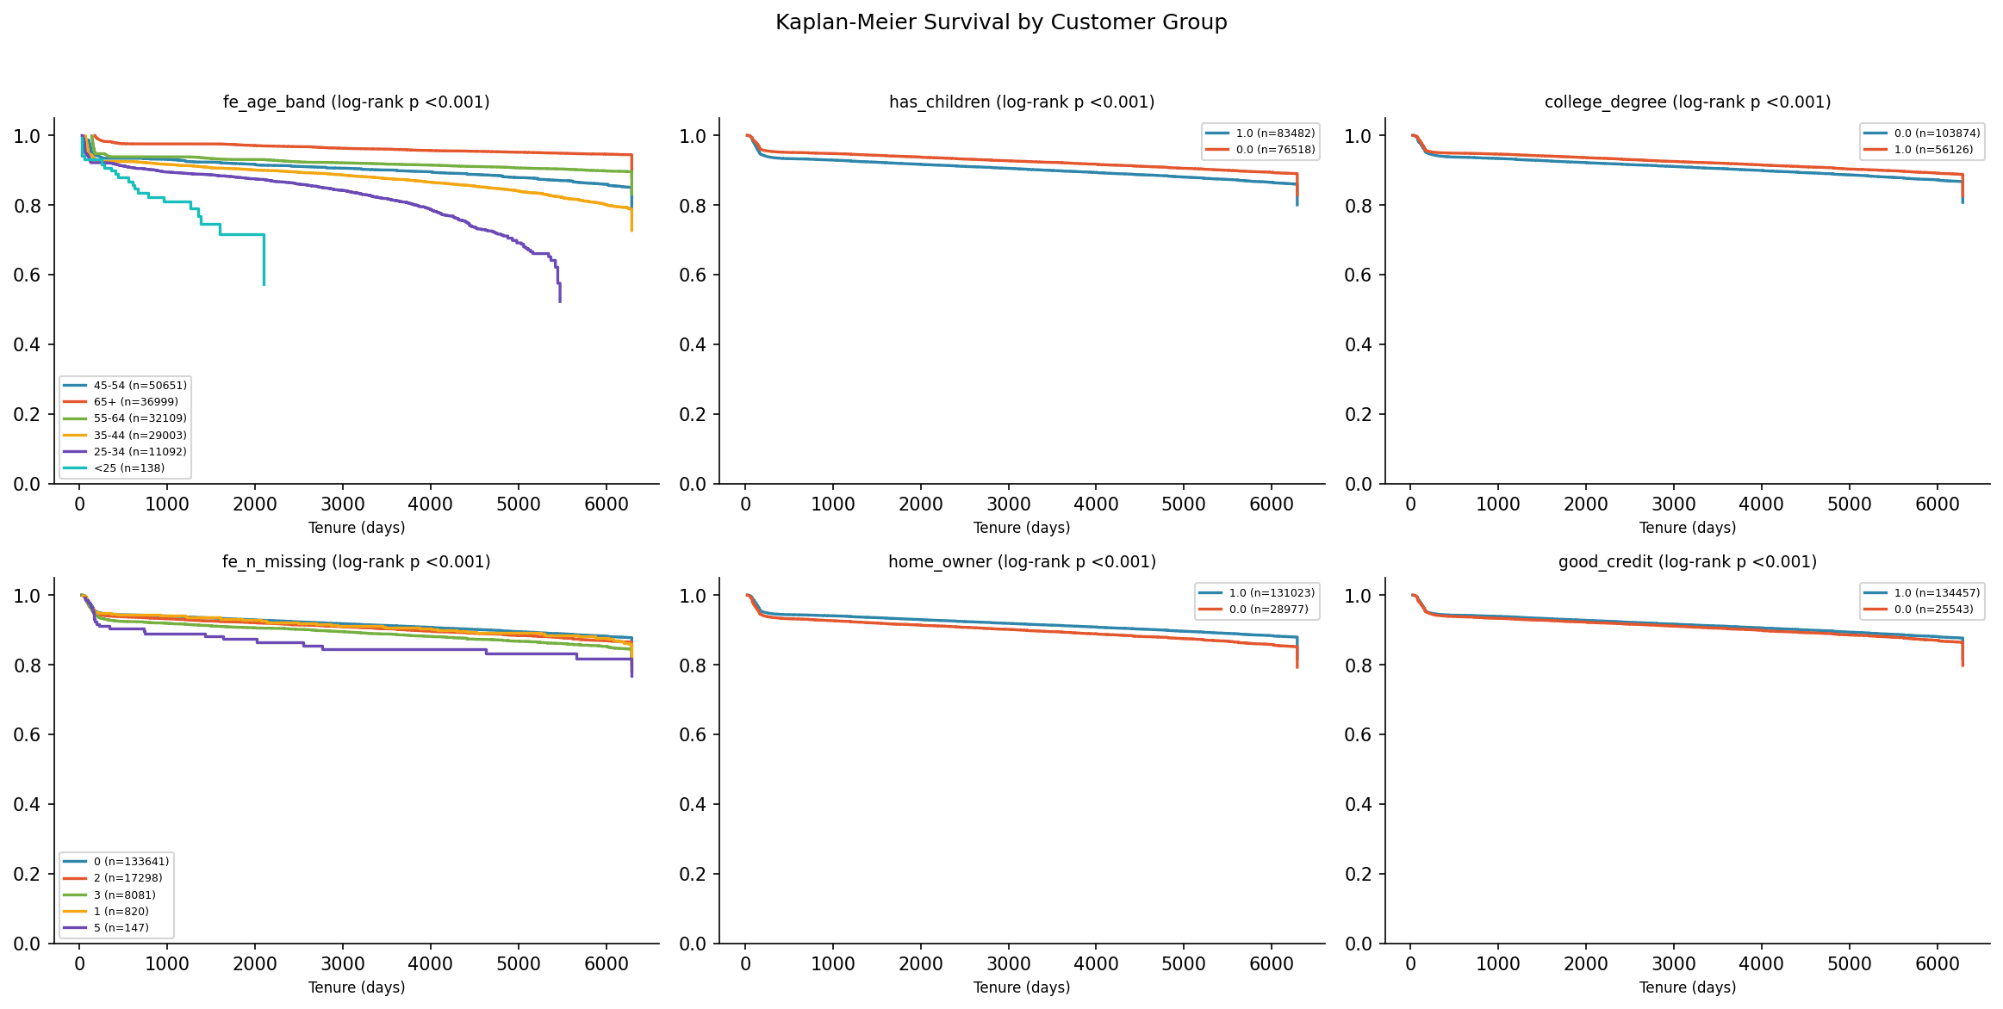
Figure 3. Kaplan-Meier survival curves by key customer groups (log-rank p-values in titles).
[EDIT: interpretasi — kapan momen kritis (onboarding? renewal pertama?) dan implikasinya untuk timing intervensi.]

3.4 High-risk segments
High-risk segment: IF tenure band = 0-6m AND length of residence ≤ 10.50 AND has children = 1 AND premium-to-income ratio ≤ 0.01 THEN churn rate = 52.8% (4.6x average; 3,258 customers, 2.0% of base, capturing 9.3% of all churners).
Table 2. Highest-risk and most loyal segments identified by a shallow decision tree.
Segment (decision-tree rule) | Customers | Churn % | Lift
tenure band = 0-6m AND length of residence ≤ 10.50 AND has children = 1 AND premium-to-income ratio ≤ 0.01 | 3258 | 52.80 | 4.58
tenure band = 0-6m AND length of residence ≤ 10.50 AND has children = 1 AND premium-to-income ratio > 0.01 | 3403 | 51.00 | 4.44
tenure band ≠ 0-6m AND tenure band ≠ 6-12m AND tenure band ≠ 1-2y AND latitude ≤ 33.13 | 122559 | 6.90 | 0.60

3.5 Predictive model
The final model (mean_top3) achieves a cross-validated roc_auc of 0.7056 (ROC-AUC 0.7056) versus 0.50 for a random baseline.
At the selected threshold (0.23) the model identifies 44.9% of churners (recall) with a precision of 49.3%, i.e. 4.3x better targeting than random selection.
Final model ROC-AUC = 0.706 (95% bootstrap CI 0.701–0.710).
Table 3. Cross-validated model comparison.
Model | OOF roc_auc | CV std | ROC-AUC | PR-AUC
lgbm | 0.70 | 0.00 | 0.70 | 0.34
lgbm_multiseed | 0.70 | 0.00 | 0.70 | 0.33
xgb_tuned | 0.70 | 0.00 | 0.70 | 0.33
lgbm_tuned | 0.70 | 0.00 | 0.70 | 0.33

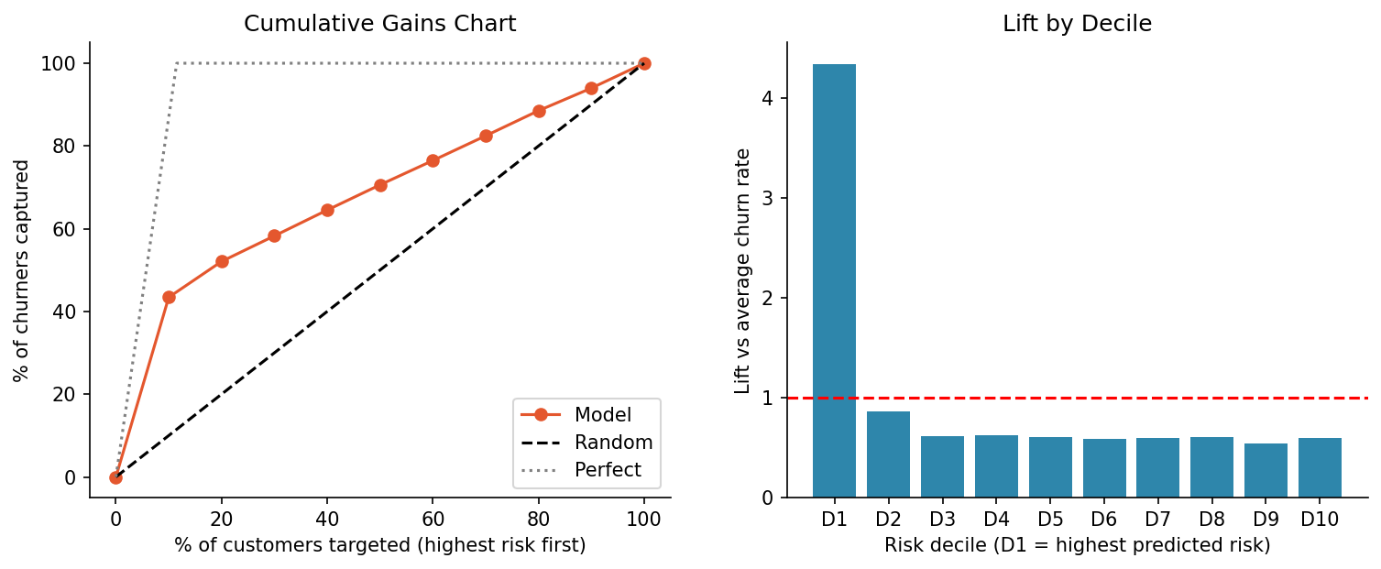
Figure 4. Cumulative gains and lift by risk decile: the model concentrates churners in the highest-risk deciles.

3.6 Explaining churn risk
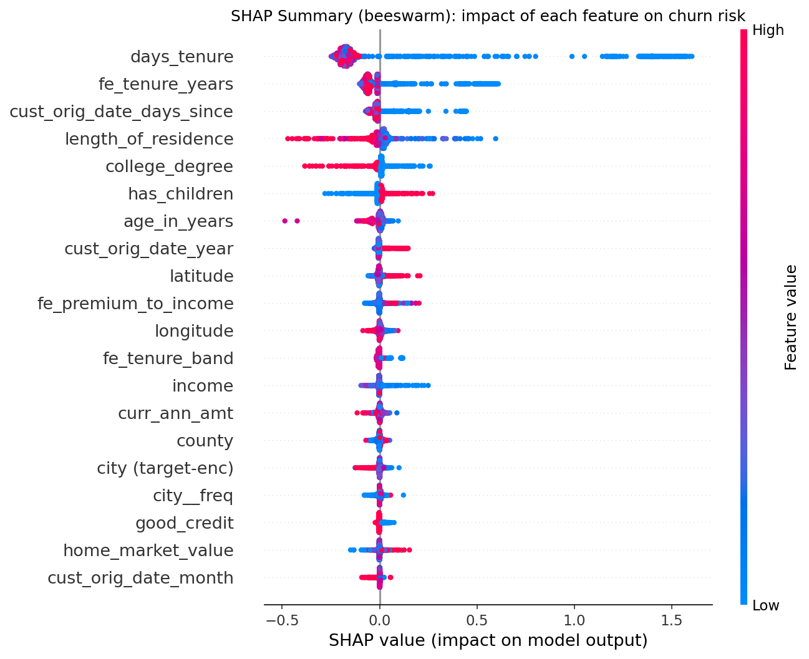
Figure 5. SHAP summary: each dot is a customer; positive values increase churn risk (colour = feature value).
Partial dependence: moving days tenure from 119.00 to 6.29K changes average predicted churn from 30.9% to 7.9%.
Partial dependence: moving tenure (years) from 0.33 to 17.22 changes average predicted churn from 14.4% to 10.0%.
[EDIT: hubungkan SHAP dengan temuan statistik — driver mana yang konsisten di semua metode (robust).]

4. Business Impact and Recommendations

4.1 Value at risk and prioritisation
Targeting the top 20% highest-risk customers captures 52.1% of all churners (2.6x lift over random targeting); the top decile churns at 50.0% vs 6.9% in the bottom decile. KS = 0.40.
The High-risk tier (20% of customers, p ≥ 0.08) has an actual churn rate of 30.0% and contains 52.1% of all churners.
Expected annual premium at risk from churn is 17.50M USD (11.6% of the annual premium base); the High-risk tier alone accounts for 49.8% of it.
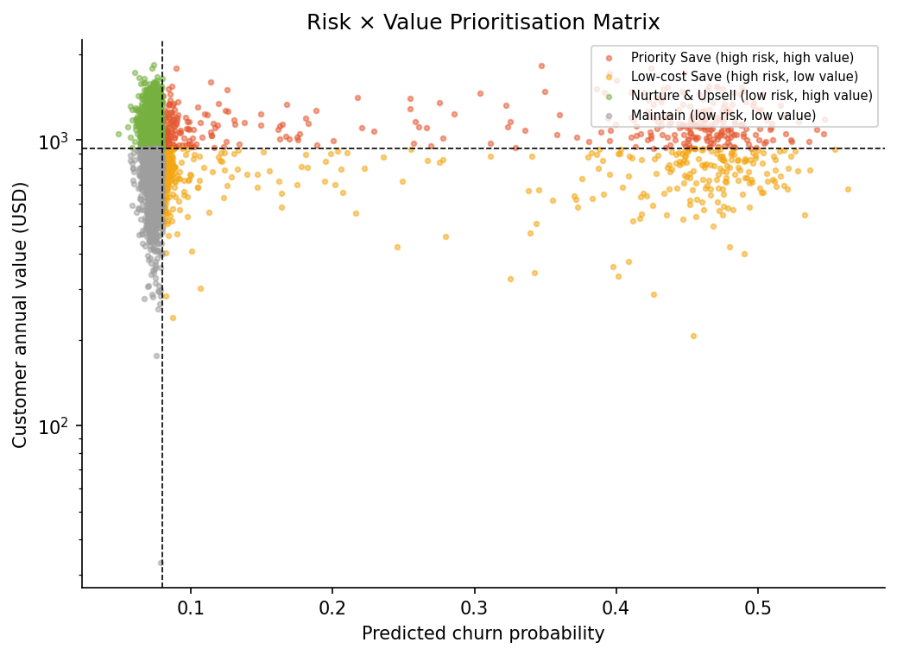
Figure 6. Risk × value matrix: 'Priority Save' customers combine high churn risk with above-median value.

4.2 Retention campaign simulation
Simulated retention campaign (assumed success rate 25%, cost 25.00 USD per contact): targeting the top 10% ranked by 'Model: expected loss (p × value)' maximises net profit at 600.86K (ROI 1.5x), versus -178.30K for random targeting of the same size.
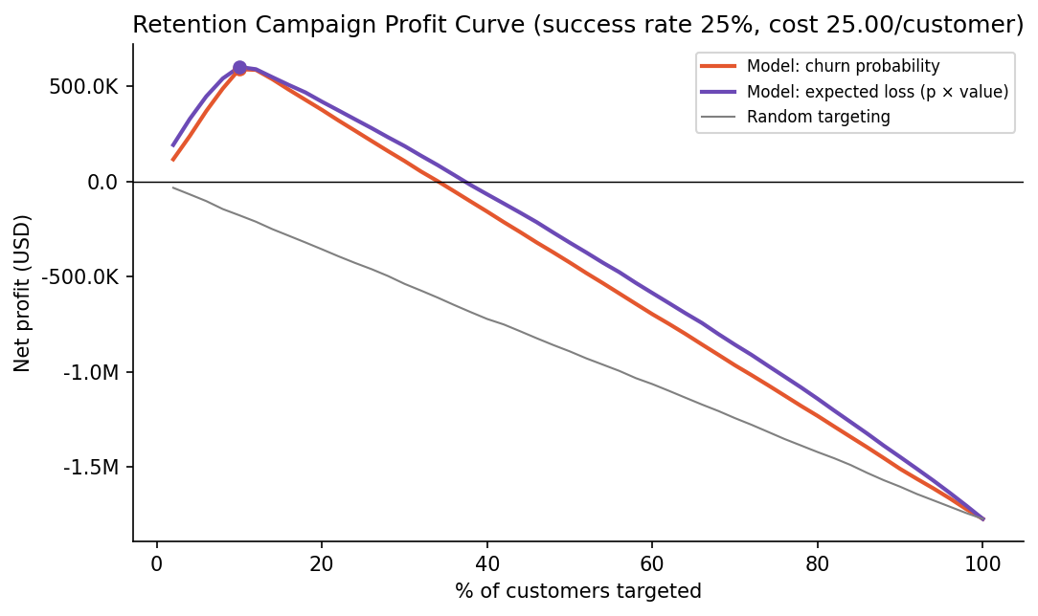
Figure 7. Net profit of a retention campaign by share of customers targeted (model vs random targeting).
[EDIT: sebutkan asumsi bisnis — margin 15%, cost per contact 25.00 USD, success rate 25% — dan sumbernya (soal / asumsi wajar); rujuk tabel sensitivity di Appendix.]

4.5 Churn personas
Persona P2 (82% of at-risk customers, actual churn 7.2%): risk driven mainly by no dominant driver (moderate, diffuse risk).
Persona P1 (18% of at-risk customers, actual churn 46.0%): risk driven mainly by days tenure (+1.34); tenure (years) (+0.39); cust orig date days since (+0.19).
[EDIT: beri nama tiap persona (misal 'Price-shocked renewers', 'Service-frustrated claimants') + 1 intervensi khusus per persona.]

4.6 Recommendations
Table 4. Evidence-based retention recommendations.
# | Recommendation | Evidence | Expected impact | KPI
1 | First-year onboarding programme | '0-6m' churns at 49.2% (4.3x avg); IV 0.93; OR 12.63; SHAP rank #10 |  | 13th-month persistency ratio; first-year churn rate
2 | Life-stage tailored engagement | '25-34' churns at 13.9% (1.2x avg); IV 0.04; OR 0.88; HR 0.44; SHAP rank #22 |  | Churn rate by age band; adoption of tailored offers
3 | Investigate and act on 'cust orig date days since' | '22–191' churns at 47.7% (4.1x avg); IV 0.89; SHAP rank #3 |  | Churn rate of the 'cust orig date days since' high-risk group
4 | Household-based cross-sell and life-event triggers | '0–1' churns at 13.0% (1.1x avg); IV 0.02; SHAP rank #4 |  | Products per household; churn after life events
5 | Deploy a churn early-warning system | Model ROC-AUC 0.706; top-20% captures 52% of churners | optimal campaign: target top 10% → net 600.86K | Precision/recall of alerts; retained revenue vs control group
6 | Validate with controlled pilots (A/B tests) | What-if results are associational |  | Uplift in retention rate (treated − control)

1. First-year onboarding programme. Welcome call, policy walkthrough, app activation and 90-day check-in for new customers; first renewal treated as a critical moment.
2. Life-stage tailored engagement. Tailor products, pricing communication and service channels to the highest-risk age groups (e.g. digital-first onboarding and flexible payment for younger customers; loyalty recognition for long-standing older customers).
3. Investigate and act on 'cust orig date days since'. Customers with high-risk values of 'cust orig date days since' churn more; design a targeted intervention and test it in a pilot.
[EDIT: tambahkan roadmap — Quick wins (0–3 bulan), Medium (3–6 bulan), Long term (6–12 bulan) — dan rencana pengukuran (A/B test dengan control group).]

5. Conclusion and Limitations
Churn at a Texas auto insurer is driven primarily by [EDIT], and is concentrated in identifiable segments and lifecycle stages. A validated predictive model (ROC-AUC of 0.706 (95% CI 0.701–0.710)) enables proactive, value-based retention targeting. [EDIT: 1 kalimat jawaban langsung untuk tiap RQ1–RQ4, dan kaitkan 1–2 temuan dengan literatur — pilih kalimat dari BAHAN_LATAR_BELAKANG.md §C.5 yang sesuai temuanmu.]
Limitations: (i) the data are a single snapshot, so relationships are associational rather than causal; (ii) the ROI simulation relies on assumed costs and success rates (see sensitivity analysis); (iii) potentially important factors such as competitor offers and life events are not observed. Future work should validate interventions through randomised pilots and enrich the data with [EDIT: interaction logs / stated reasons for leaving].

References
Akiba, T., Sano, S., Yanase, T., Ohta, T., & Koyama, M. (2019). Optuna: A next-generation hyperparameter optimization framework. In Proceedings of the 25th ACM SIGKDD International Conference on Knowledge Discovery & Data Mining (pp. 2623–2631). https://doi.org/10.1145/3292500.3330701
Ascarza, E. (2018). Retention futility: Targeting high-risk customers might be ineffective. Journal of Marketing Research, 55(1), 80–98. https://doi.org/10.1509/jmr.16.0163
Benjamini, Y., & Hochberg, Y. (1995). Controlling the false discovery rate: A practical and powerful approach to multiple testing. Journal of the Royal Statistical Society: Series B, 57(1), 289–300. https://doi.org/10.1111/j.2517-6161.1995.tb02031.x
Brockett, P. L., Golden, L. L., Guillén, M., Nielsen, J. P., Parner, J., & Pérez-Marín, A. M. (2008). Survival analysis of a household portfolio of insurance policies: How much time do you have to stop total customer defection? Journal of Risk and Insurance, 75(3), 713–737. https://doi.org/10.1111/j.1539-6975.2008.00281.x
Chernozhukov, V., Chetverikov, D., Demirer, M., Duflo, E., Hansen, C., Newey, W., & Robins, J. (2018). Double/debiased machine learning for treatment and structural parameters. The Econometrics Journal, 21(1), C1–C68. https://doi.org/10.1111/ectj.12097
Cox, D. R. (1972). Regression models and life-tables. Journal of the Royal Statistical Society: Series B, 34(2), 187–202. https://doi.org/10.1111/j.2517-6161.1972.tb00899.x
Eling, M., & Kochanski, M. (2013). Research on lapse in life insurance: What has been done and what needs to be done? The Journal of Risk Finance, 14(4), 392–413. https://doi.org/10.1108/JRF-12-2012-0088
Gottlieb, D., & Smetters, K. (2021). Lapse-based insurance. American Economic Review, 111(8), 2377–2416. https://doi.org/10.1257/aer.20160868
Guelman, L., & Guillén, M. (2014). A causal inference approach to measure price elasticity in automobile insurance. Expert Systems with Applications, 41(2), 387–396. https://doi.org/10.1016/j.eswa.2013.07.059
Hein, K. Z. P. W., Keovilay, J., Adinegoro, W., & Ko, B. (2020). Analisis empiris perilaku lapse pada nasabah asuransi jiwa di Indonesia. Jurnal Statistika dan Aplikasinya, 4(2), 73–81. https://doi.org/10.21009/JSA.04202
Kaplan, E. L., & Meier, P. (1958). Nonparametric estimation from incomplete observations. Journal of the American Statistical Association, 53(282), 457–481. https://doi.org/10.1080/01621459.1958.10501452
Ke, G., Meng, Q., Finley, T., Wang, T., Chen, W., Ma, W., Ye, Q., & Liu, T.-Y. (2017). LightGBM: A highly efficient gradient boosting decision tree. In Advances in Neural Information Processing Systems 30.
Lundberg, S. M., & Lee, S.-I. (2017). A unified approach to interpreting model predictions. In Advances in Neural Information Processing Systems 30.
Prokhorenkova, L., Gusev, G., Vorobev, A., Dorogush, A. V., & Gulin, A. (2018). CatBoost: Unbiased boosting with categorical features. In Advances in Neural Information Processing Systems 31.
Reichheld, F. F., & Sasser, W. E., Jr. (1990). Zero defections: Quality comes to services. Harvard Business Review, 68(5), 105–111.
Robins, J. M., Rotnitzky, A., & Zhao, L. P. (1994). Estimation of regression coefficients when some regressors are not always observed. Journal of the American Statistical Association, 89(427), 846–866. https://doi.org/10.1080/01621459.1994.10476818
Siddiqi, N. (2006). Credit risk scorecards: Developing and implementing intelligent credit scoring. John Wiley & Sons.
Verbeke, W., Dejaeger, K., Martens, D., Hur, J., & Baesens, B. (2012). New insights into churn prediction in the telecommunication sector: A profit driven data mining approach. European Journal of Operational Research, 218(1), 211–229. https://doi.org/10.1016/j.ejor.2011.09.031

Appendix (not counted in the page limit)
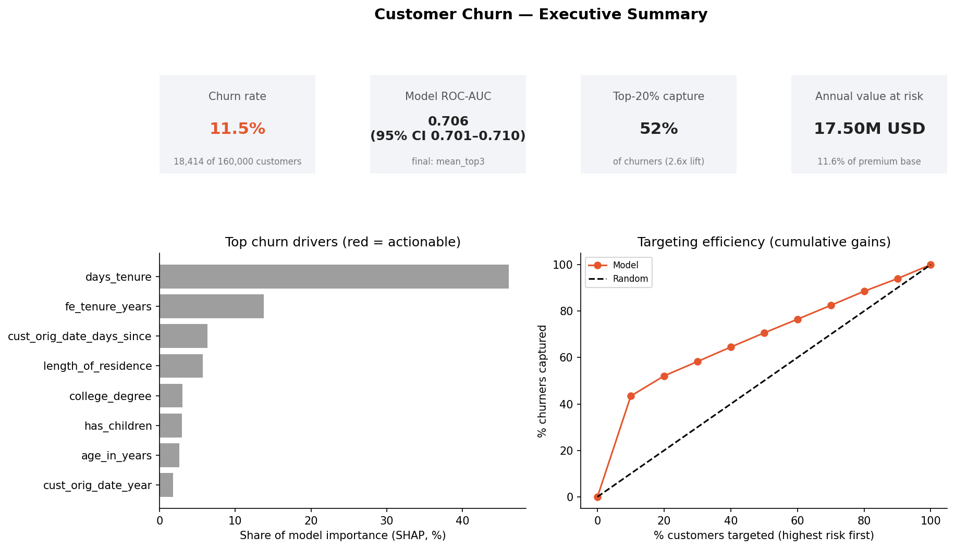
Figure 8. Executive summary dashboard.
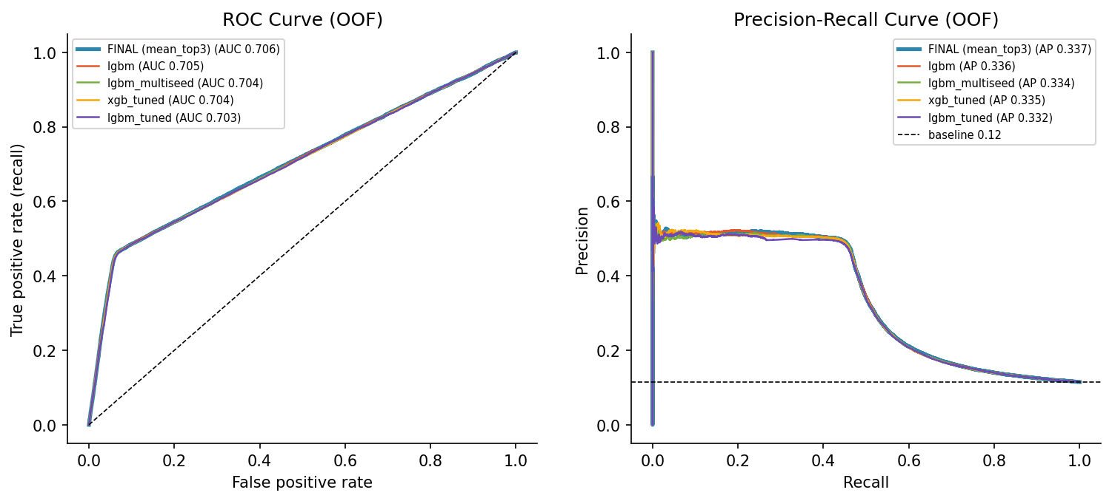
Figure 9. ROC and precision–recall curves (out-of-fold).
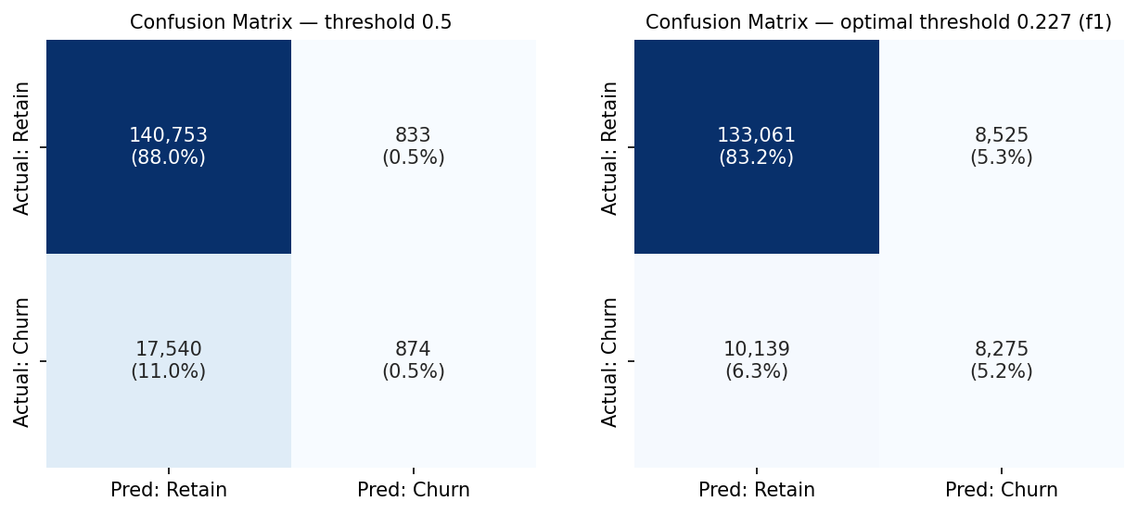
Figure 10. Confusion matrices at 0.5 and at the optimised threshold.
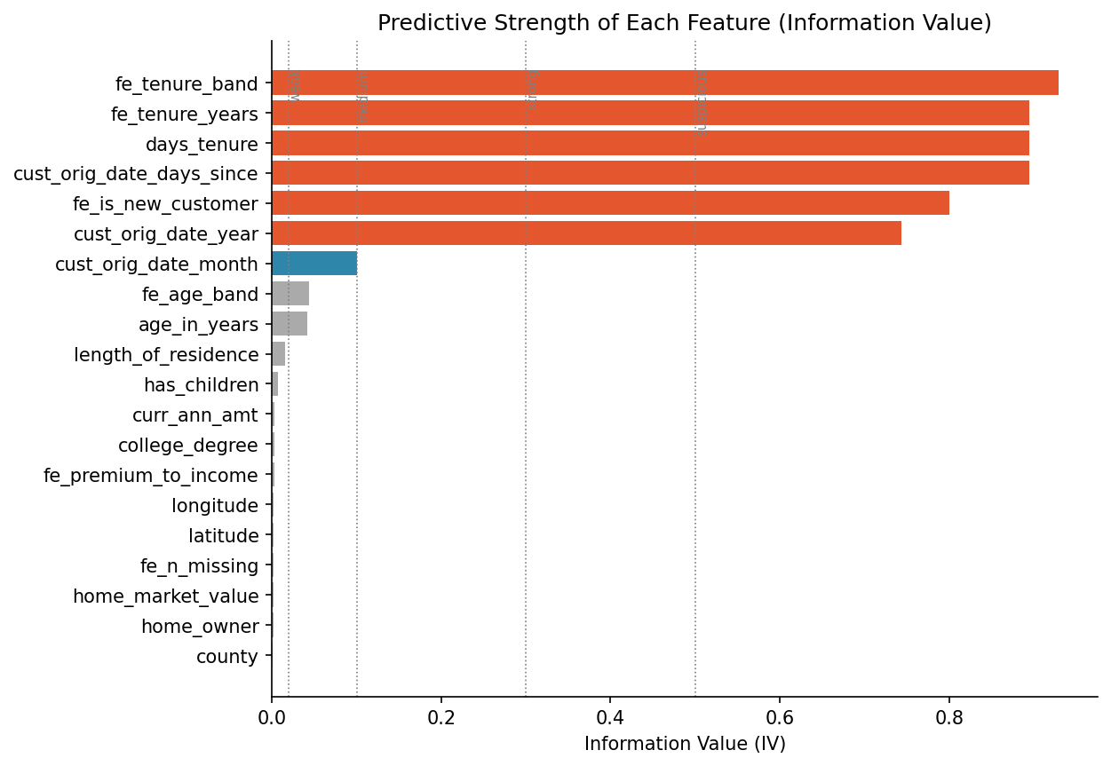
Figure 11. Information Value of each feature.
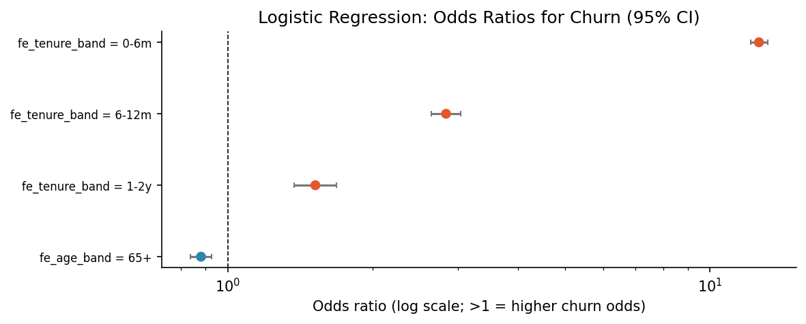
Figure 12. Logistic regression odds ratios (95% CI).
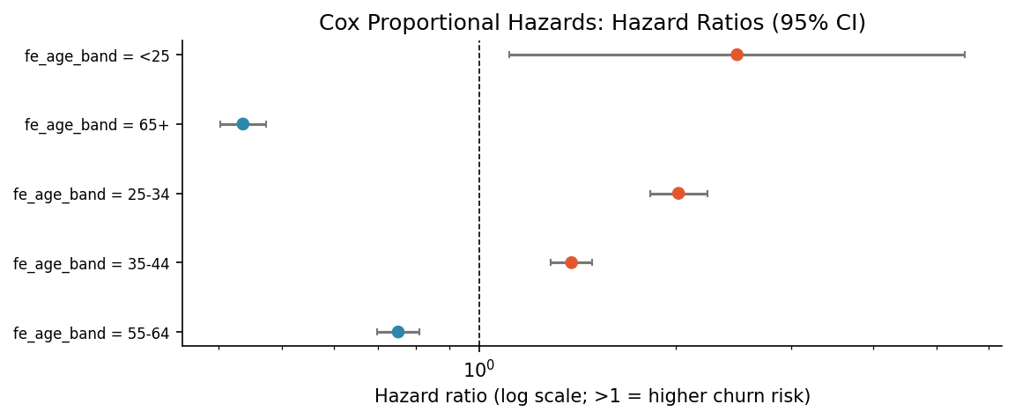
Figure 13. Cox proportional hazards: hazard ratios (95% CI).
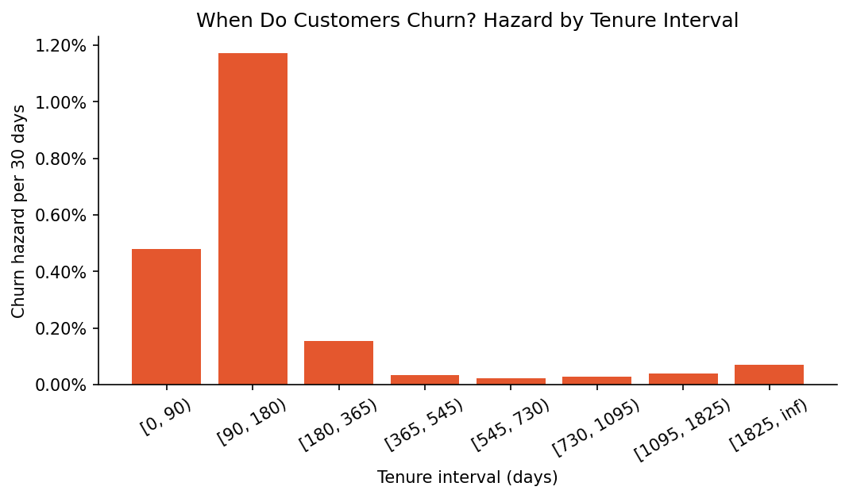
Figure 14. Churn hazard by tenure interval.
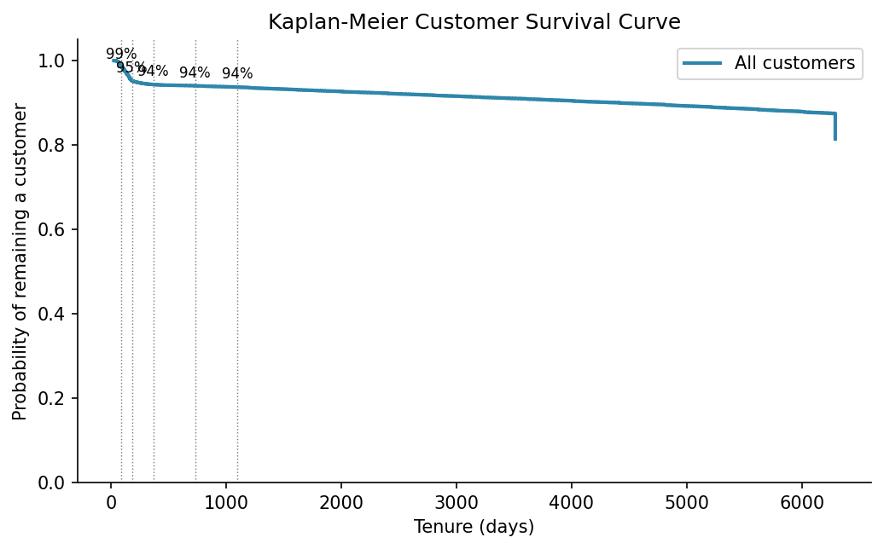
Figure 15. Overall Kaplan-Meier curve.
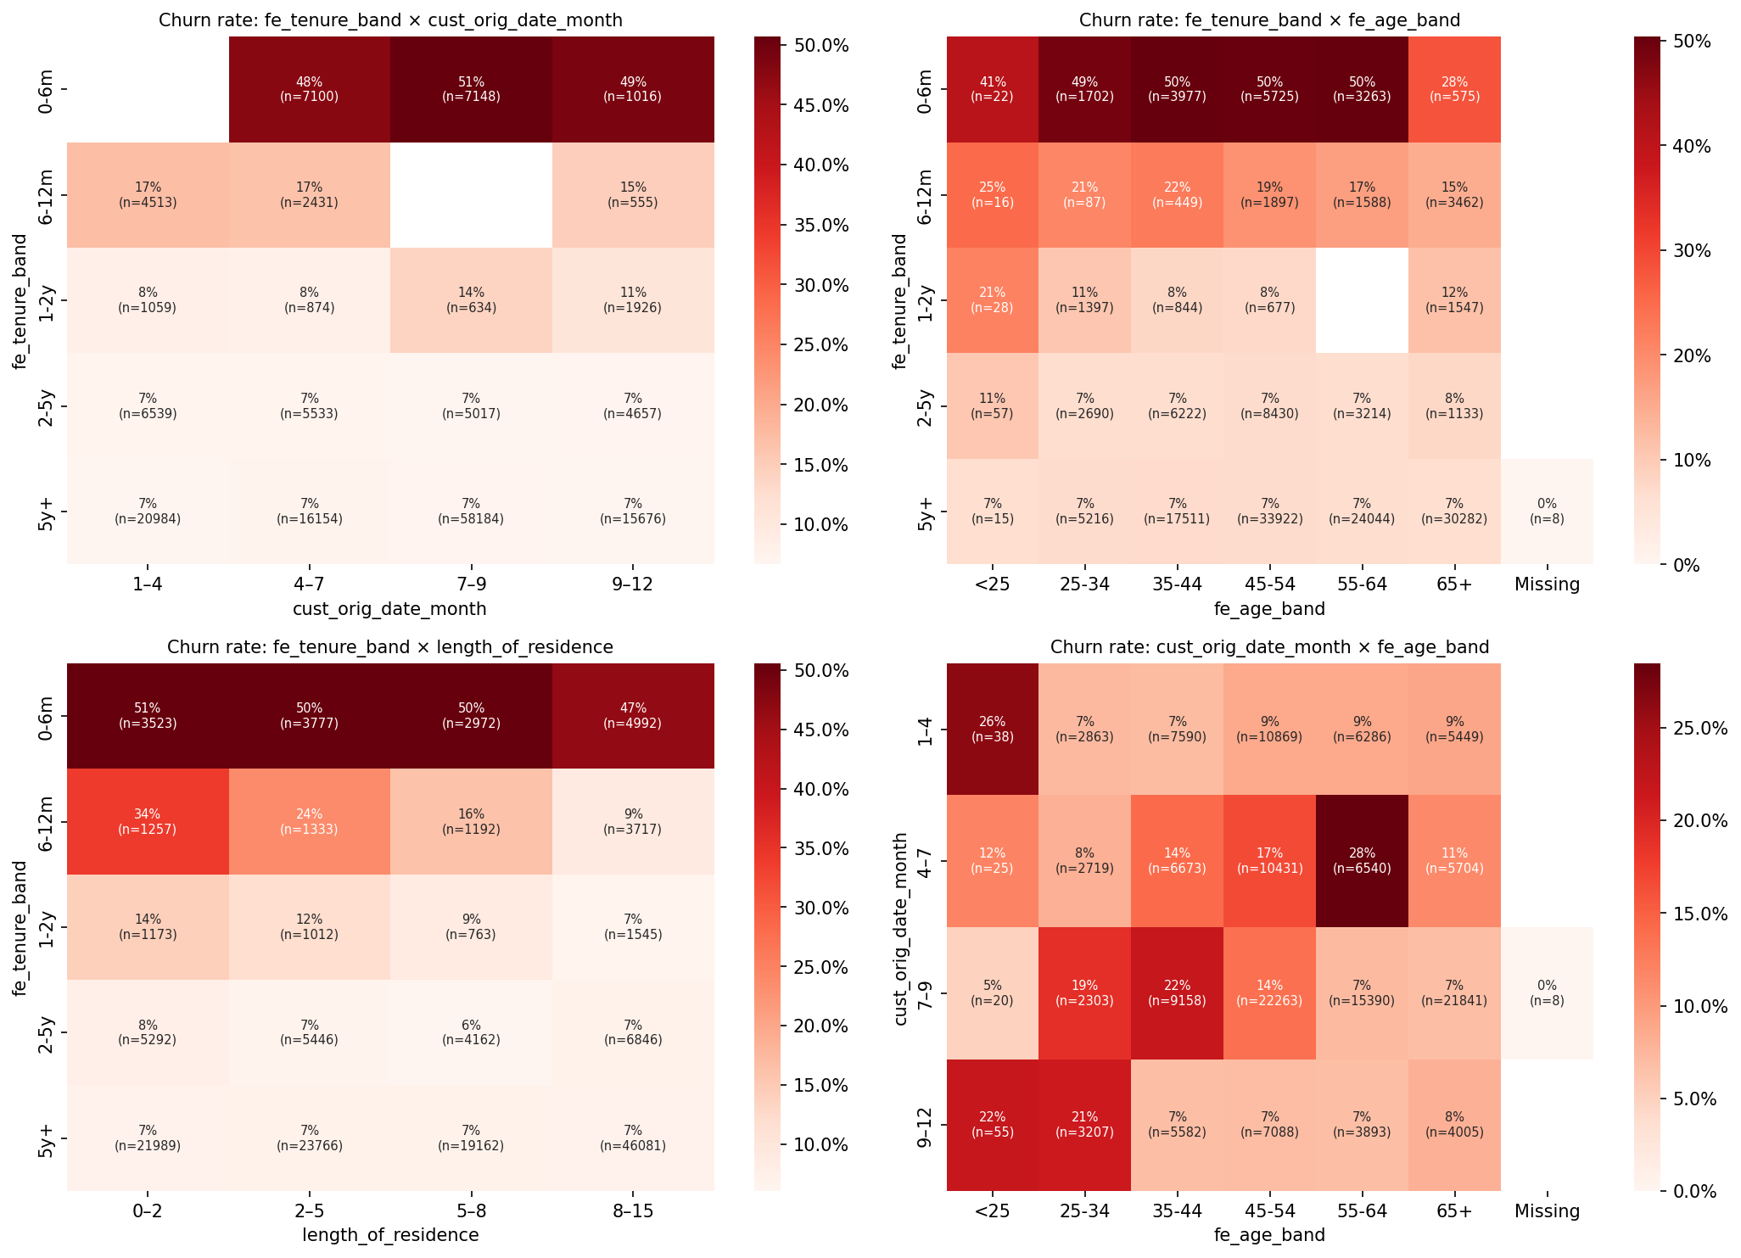
Figure 16. Two-way churn-rate heatmaps.
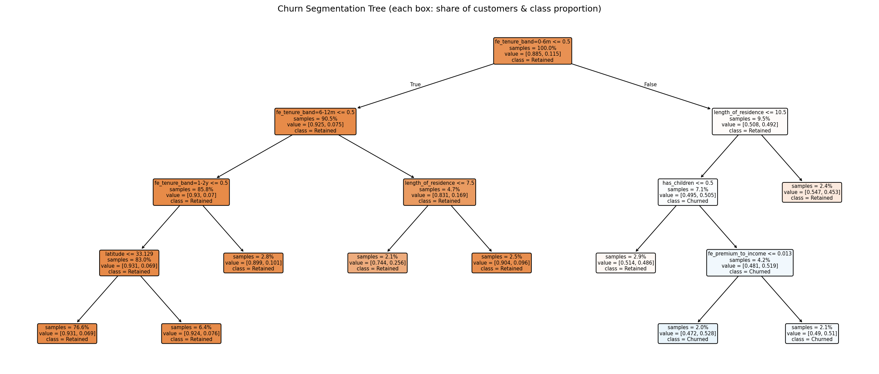
Figure 17. Churn segmentation tree.
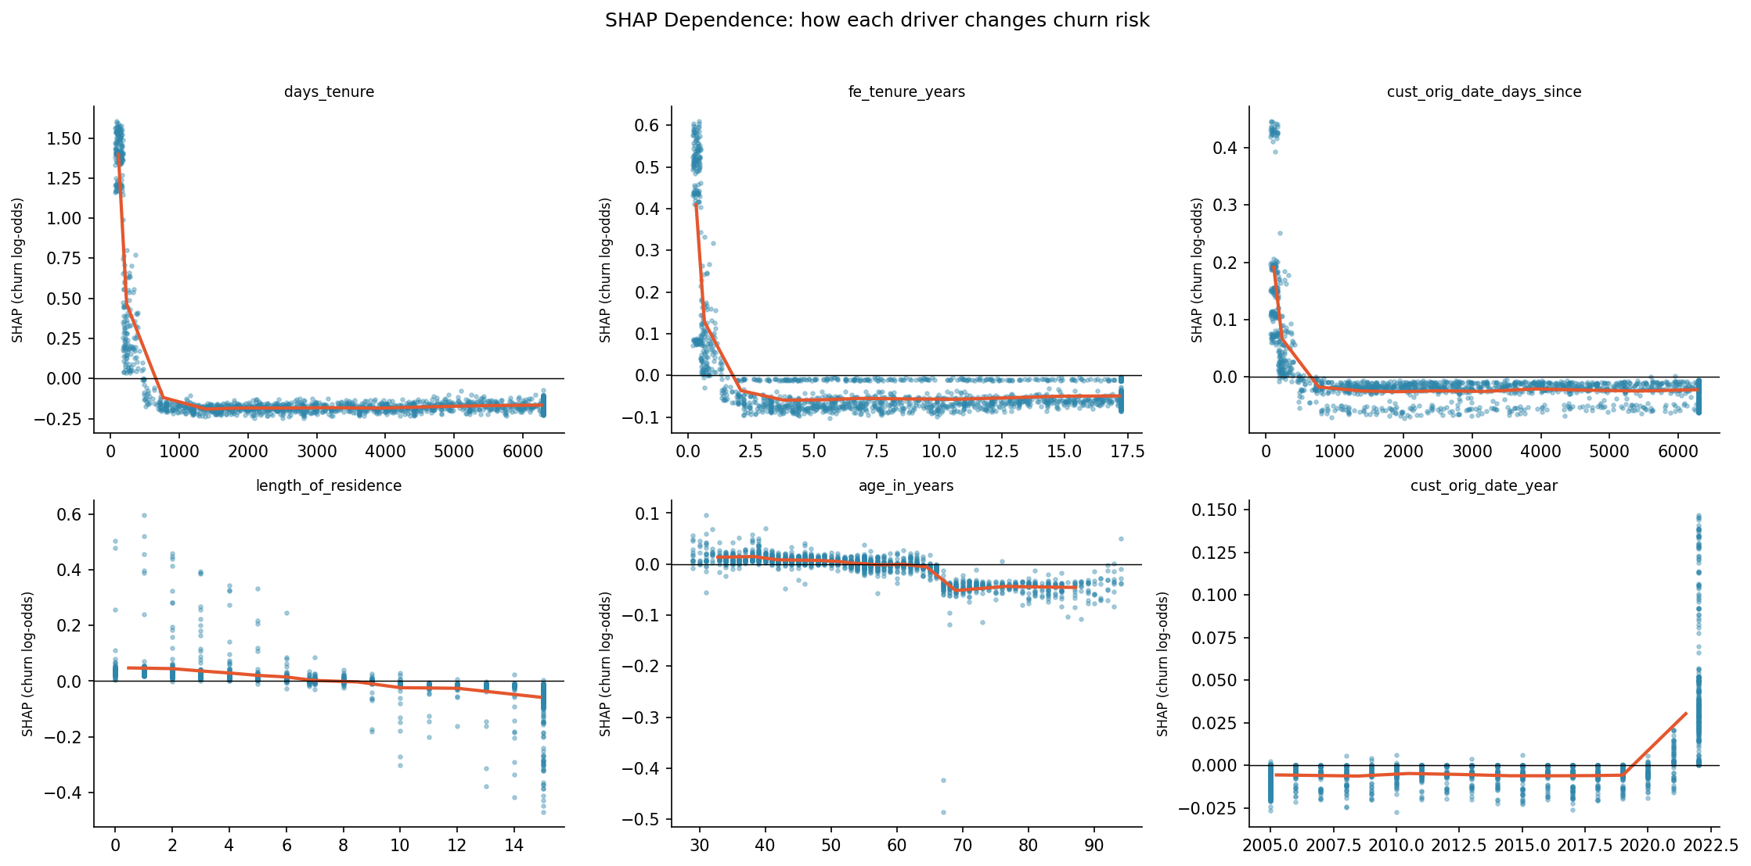
Figure 18. SHAP dependence plots.
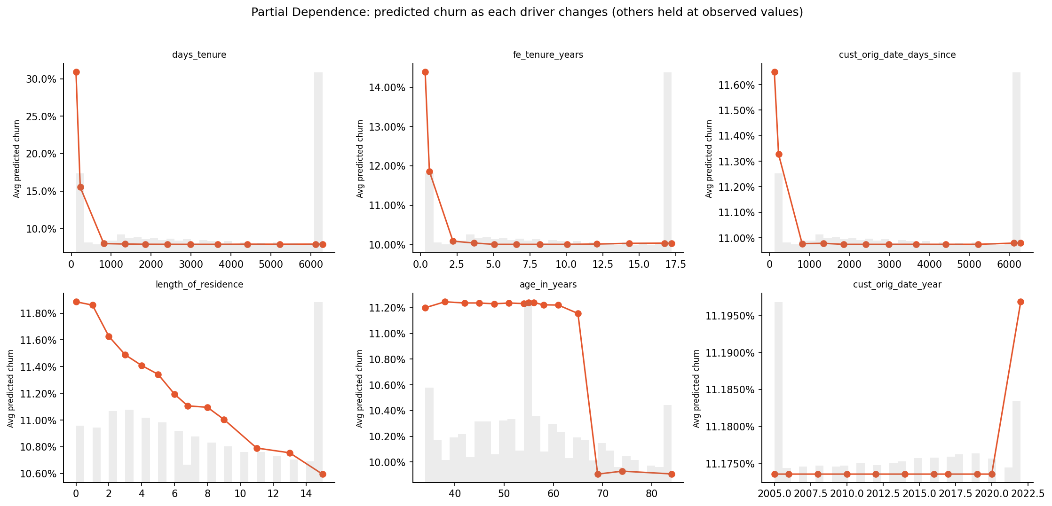
Figure 19. Partial dependence plots.
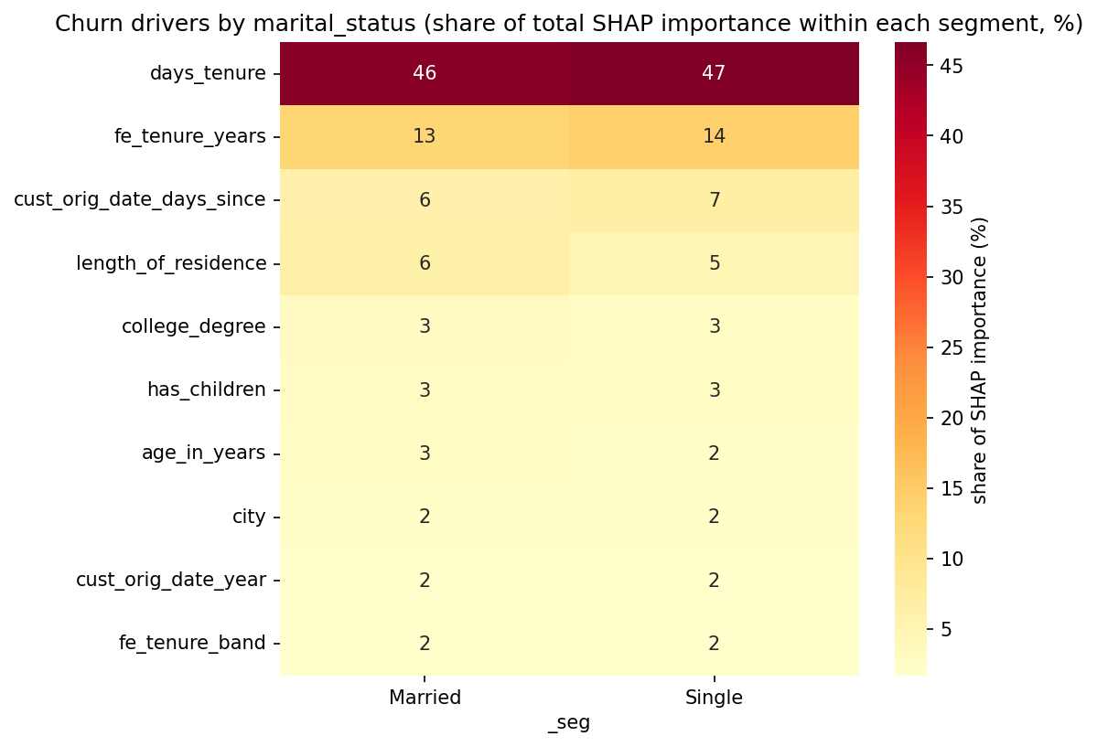
Figure 20. Driver importance by segment.
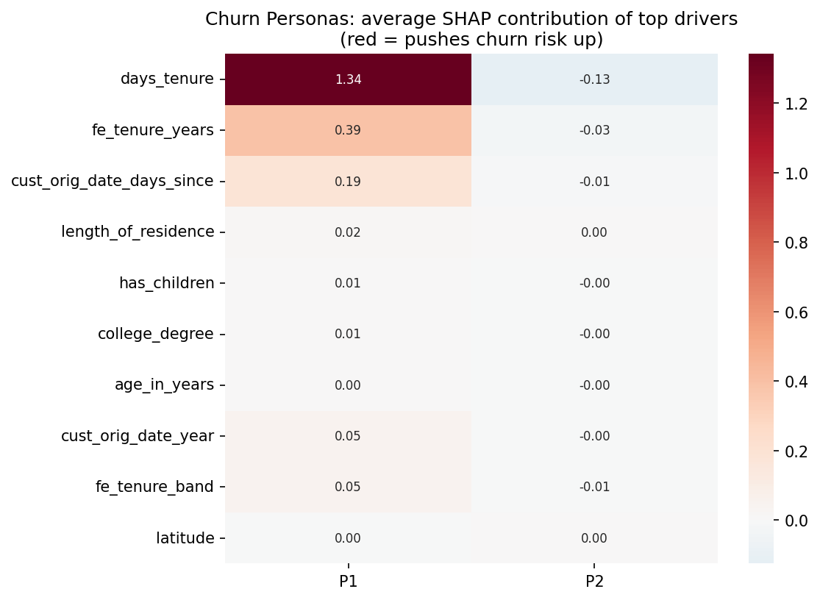
Figure 21. Churn personas (SHAP clustering).
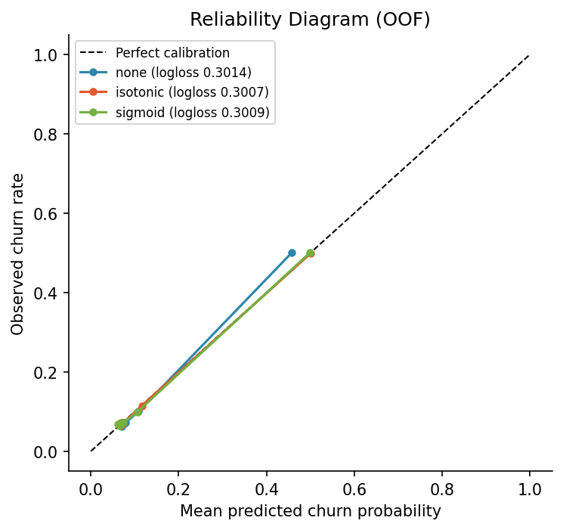
Figure 22. Calibration (reliability) diagram.
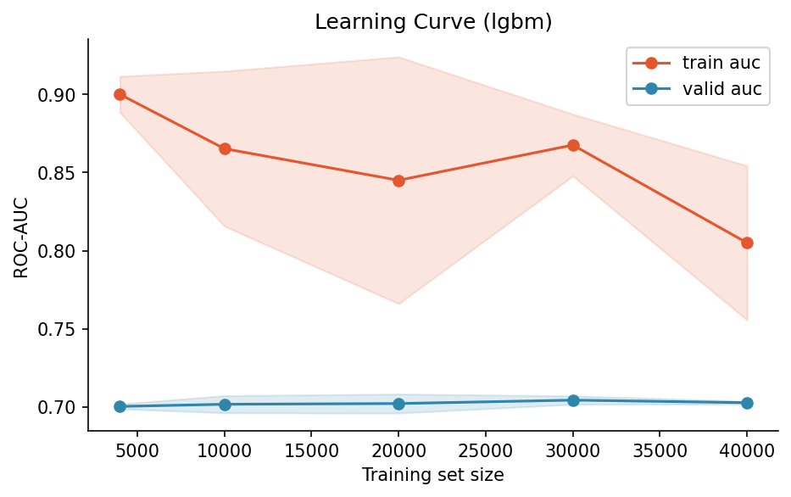
Figure 23. Learning curve.
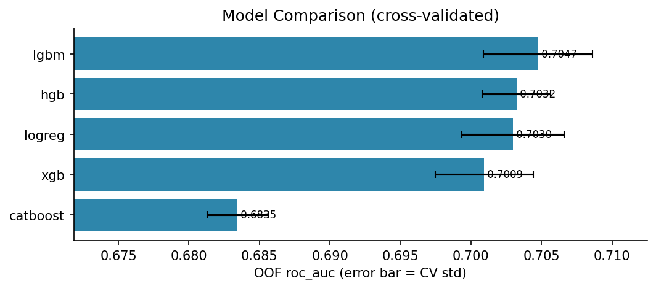
Figure 24. Model comparison chart.
Table 5. Risk tiers.
tier | n_train | actual_churn_rate | avg_predicted | share_churners_% | n_test
High | 32000 | 0.30 | 0.28 | 52.09 | 7054
Medium | 48000 | 0.07 | 0.08 | 18.52 | 10468
Low | 80000 | 0.07 | 0.07 | 29.40 | 22478

Table 6. Campaign sensitivity analysis.
success_rate | cost_per_contact | optimal_target_% | max_net_profit | roi
0.12 | 12.50 | 10.17 | 301,878.61 | 1.49
0.12 | 25.00 | 6.08 | 103,021.31 | 0.42
0.12 | 50.00 | 2.00 | -24,358.09 | -0.15
0.25 | 12.50 | 14.25 | 827,143.43 | 2.90
0.25 | 25.00 | 10.17 | 603,757.23 | 1.49
0.25 | 50.00 | 6.08 | 206,042.63 | 0.42
0.38 | 12.50 | 55.08 | 1.52M | 1.38
0.38 | 25.00 | 10.17 | 1.11M | 2.73
0.38 | 50.00 | 10.17 | 702,310.84 | 0.86

Table 7. Churn persona profiles.
persona | n_in_sample | share_of_at_risk_% | avg_pred_churn | actual_churn_rate | top_drivers | tenure band | age band
P2 | 851 | 81.83 | 0.08 | 0.07 | no dominant driver (moderate, diffuse risk) | 5y+ | 45-54
P1 | 189 | 18.17 | 0.45 | 0.46 | days tenure (+1.34); tenure (years) (+0.39); cust orig date days since (+0.19) | 0-6m | 45-54

Table 8. Paired bootstrap comparison of models.
final_vs | diff_roc_auc | ci_low | ci_high | p_value_one_sided | significant
lgbm | 0.00 | -0.00 | 0.00 | 0.23 | False
lgbm_multiseed | 0.00 | -0.00 | 0.00 | 0.12 | False
xgb_tuned | 0.00 | -0.00 | 0.00 | 0.07 | False
lgbm_tuned | 0.00 | -0.00 | 0.01 | 0.10 | False
logreg | 0.00 | -0.00 | 0.01 | 0.09 | False

