A landing page

a landing page has a 4C:
- clear proposition value
-clean design (high design standards)
-call to action (form to gather info. e.g. mail)
-CRM first milestone. (engage with your audience)

the three languages that are understood by your web browser.
- HTML [structure the content of the webpage, content scaffolding]
-CSS [design your content]
-Javascript [animate your content]

H.
T.
M. Markup
L.

2 main css libraries
-bootstrap
-material design, by google.

The browser interprets the HTML code.
The text editor helps you develop (code).

HTML is the most important part. Good structure is essential!

HTML (similar to human skeleton)
-use tags to identify contents. (h1 = main header, h2 = secondary header, p = paragraph text)
-Largest, most global tag = html. (the code is in-between the tags)
-<html>
<head>
#intelligence (meta-data)
<head>
<body>
#stuff to display
<body>
<html>
#end of file

Meta-data: is not the content that will be displayed on the page.
The ‘intelligence’ of the page, the link to the design files, the content to be displayed by third party websites like google (in searches) and media platforms (in sharing posts, automatic titles and images.)
Body: actual content of the page.

Meta-data ex:
<head>
<title>Landing</title>
<meta charset=“utf-8”>
<head>
ex (for facebook):
<head>
<meta property = “og:title” content=“le Wagon – the...”>
<meta property = “og:title” image=“facebook-card.jpg”>
<head>

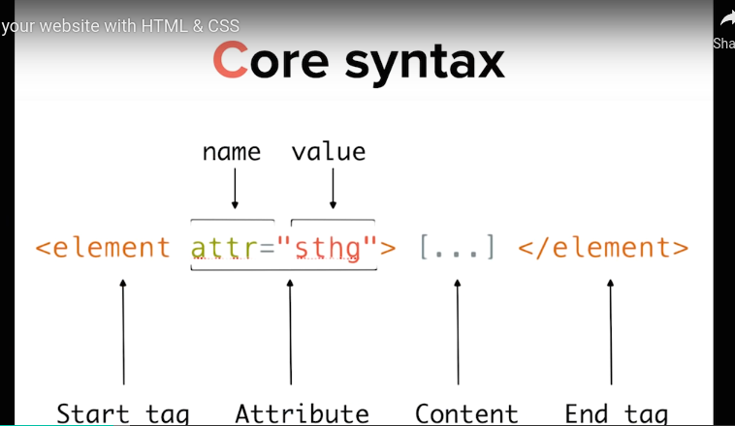
The body

tags encapsulate the content.

With starting tags you can find attributes (attr= “sthg”)

start tag here :
<element attr= “sthg”>
attribute here:
attr=“sthg”

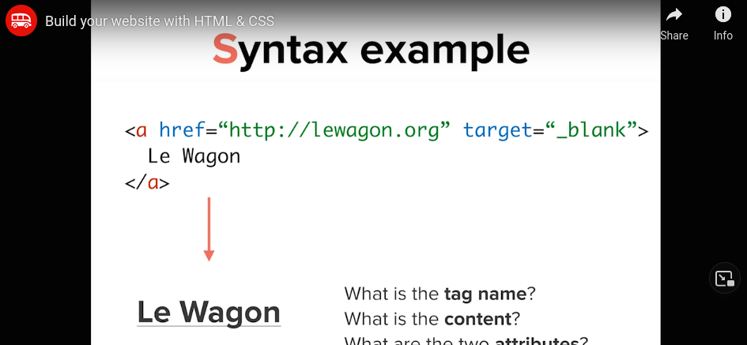
Tag for a link <a
attribute for the link:
href=“http://lewagon” target= “_blank”>

puts Le Wagon, with link, and open new tab if clicked.

Headers : <h1>...</h1>...</h6>
Paragraphs: <p>...</p>
emphasize: <em>...</em>
bold: <strong>
unordered lists (bullet points): <ul>
List item: <il>
ordered list (numbered): <ol>
image: <img …..> *Special

Images

thenounproject.com # for design project images.
Nucleoapp.com # for design project images. Find free app.

.png is static.
.svg can be animated. Is dynamic.

CSS

Cascading
Style
Sheets

know. Selector, style rule and css properties

inspecting a page (shift-ctl +i), you can see the html and css.

You can cut piece of the website in the inspector. See what it would look like without that part of the code.

A navigation part of a website is just a list <ul>, listing links <a
href=“http://lewagon”>.

Linking stylesheets

<head>
<link rel=“stylesheet” href=“style.css”
<head>

style.css:

h1 {
color: red;
}

CSS syntax (easiest to understand)

selector #selection of one or more elements of the page {
property: value;
property: value;
property: value; .. on which we define style rules
}

the selector selects the element of the page that you want to design.
Between brackets {}, we specify the rules of design.

Ex:

h2 {
color: red;
font-size:20px;
font-family: arial;
}

to design, start with color theme and font. Nothing complex.

Colors

h2 {
color: orange; #one method for primary colors, but ugly
color: #FF530D; #Hexadecimal system
color: rgb(255, 83, 13); #red green blue system, max quantity is 255, mixing)
color: rgba(255, 83, 13, 1.0); red green blue system, with transparency. 0.0 is completely transparent
}

As designer, your best friend is the grey scale! Just apply shades of grey to start.

RGB tips

In rgb scale, if rgb has same value, you will obtain grey.
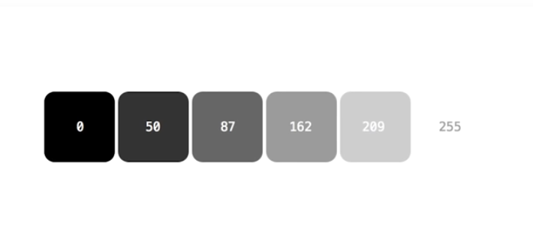
For background color.

Body {
color: orange;
background-color: yellow;
}
Fonts
- font-family
- font-size
- line-height
- font-weight (close to 25 - ultra light is like iOS, 95 – more bold than bold)
- letter-spacing
- color
- text-decoration (underline)
- text-align (center)
- font-style
- text-transform

font-family: serif, sans-serif, monospace.
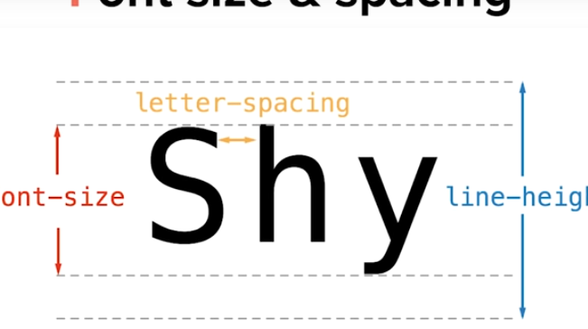

Tip: use small h2, around 17px.

See style.css in landing for examples.

Coolors service (coolors.co, colorhunt.co)

it gives you color schemes with hexadecimal value.
You can lock a color that you like, and it will suggest complementary colors.

OR color picker plugin. Hover over a color and the plugin tells you exactly what color it is in hexadecimal. Strong stuff.

Google fonts

like the amazon of fonts.
open sans, for the buddy, is the most used webpage font. 99%.

its nice to have a contrast between the header and text (bold vs thin fonts)
Ex : Montserrat, robotto.
Click en use to “checkout”.

In file, load the fonts before your own design lines. EX:

<head>
<title>Landing page</title>
#google link <link href=“https://fonts.googleapis.com/cas?family=open….>
<link rel= “personal stylesheet” href= “style.css”>
<head>

*Loading them first, allows you to write the google foots in your style.css locally.

DIV & box model

With div, wrap all the similar content together. Grouping, different design boxes.

EX: a div for the navbar, a div for the map, the div for the any result of the search.

When divised. You can play with content in boxes. Play with the width and height of the content of the box, not the box itself. Width/height of the content of the box.

The space between the content and the edge of the box is called margin.
The space between the content of the box and the edge of the content of the box is called padding.

Marging is external space.
Padding is internal space.

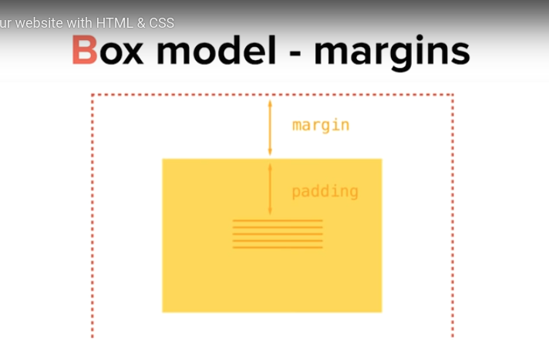

Border

width of the border
color of the border
and style of the border. (solid/dashed/ dotted)

h2 {
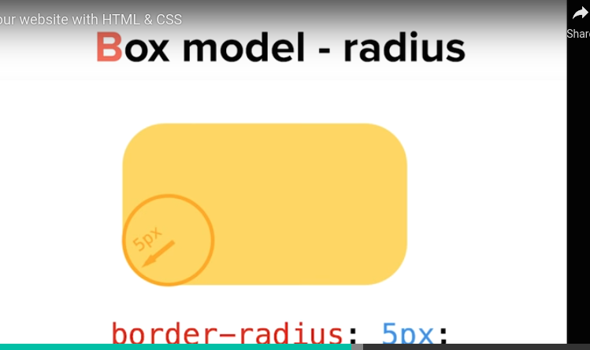
border: 1px solid green;
border: 2px dashed #FF530D;
}

Radius

rounded corners.
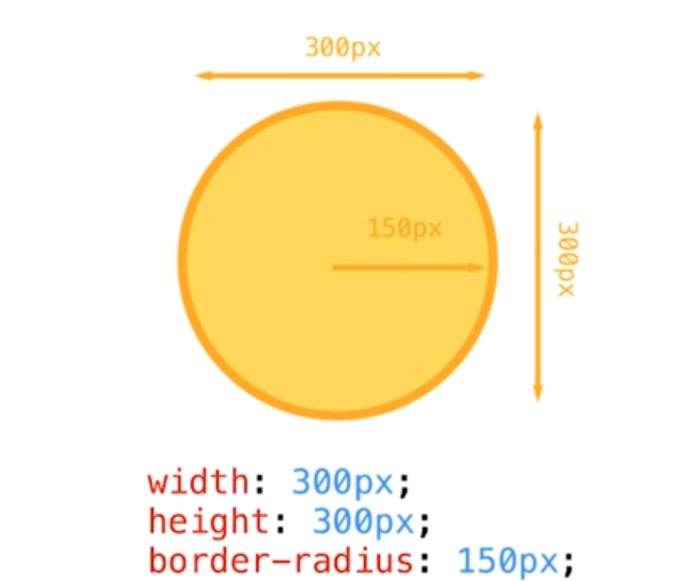
Creating a circle.

The box shadow
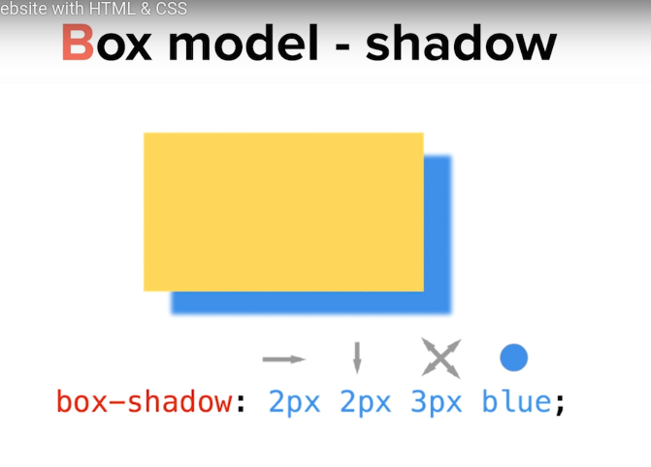

horizontal and vertical shifts, blur effect.

Wrap with div.

You have to div all the different features of your page. If you want a box to play with margins, padding, shadows, radius, etc. you need a div.

It just give you more options, it makes your css richer, without necessarely changing your page. It gives you more power on your page.

Tip for shadows.
Small horixontal and vertical shift, small blur, and use the color plugin to pick a bit darker than your background color.
In design, you have to be so suddle that you don’t really see it.

Id & class

To select different divs independently on your page, you need ids and classes.
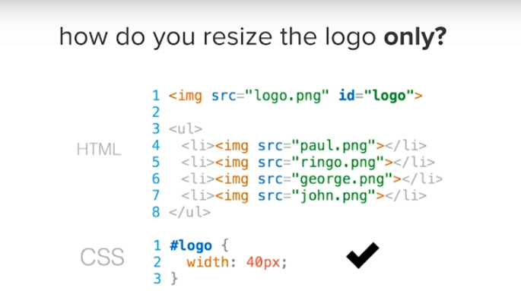
Naming your element as ID in the html file,
allows you to use it as selector in your css file.

The selector needs a #. #logo.
ID are for individual items, not a box. Unique thing.

If you want to reuse the design on multiple items of your website, you need to create a class.
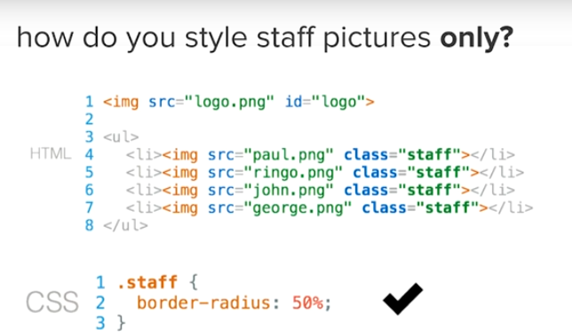

The class selector need a . Ex: .staff {

ID when unique element. The ID is more precise than the class.

The class is recurrent, across many images for example.

For ideal results, combine classes.

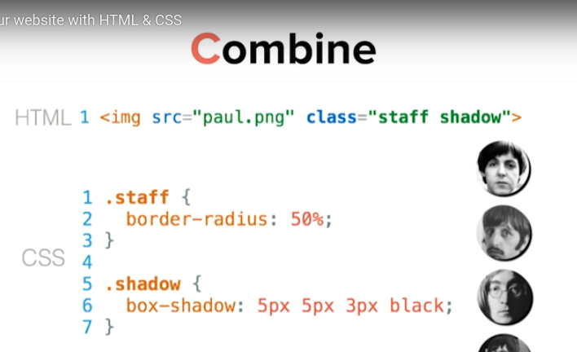
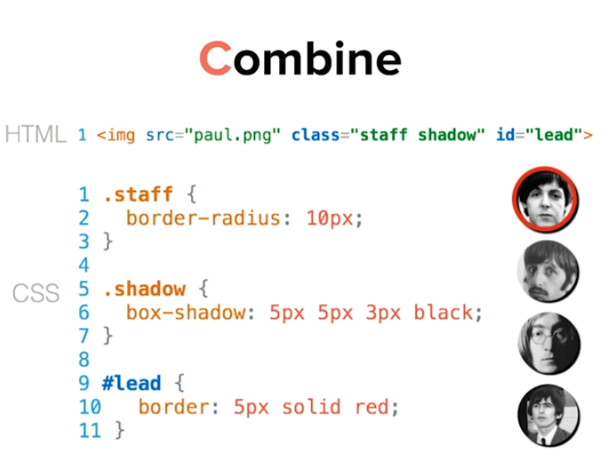

Banners

use unsplash.it to prototype with images. Image provider for fast dev.

Padding

Ex:
#banner {
padding: 10px #specifies 10px on all sides, left, right, top, bottom.
Padding: 150px 0; #specifies 150px for top and bottom, and 0 for left and right.
}

Background

keyword,
{
background-size: cover; # covers the div entirely.
}
great start examples

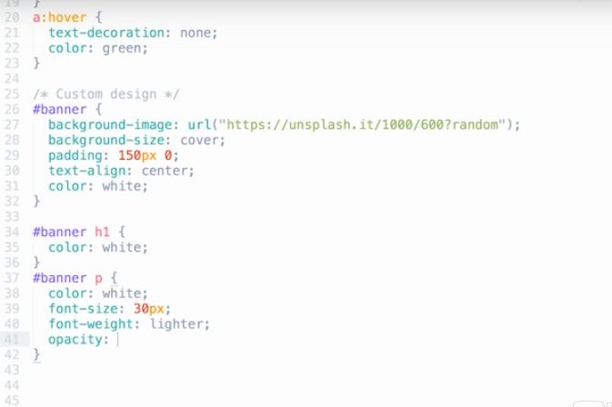
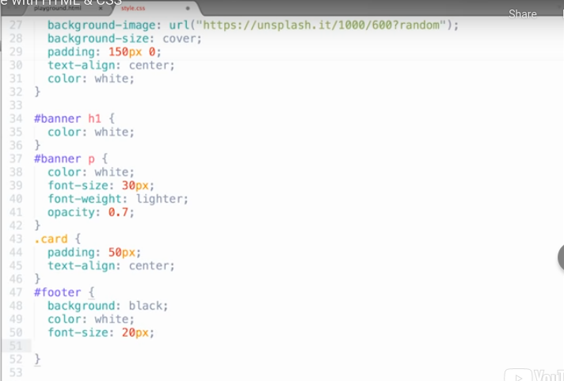

For utility icons

Use Font Awesome. It is a font of icons. The most straightforward thing for utility icons.
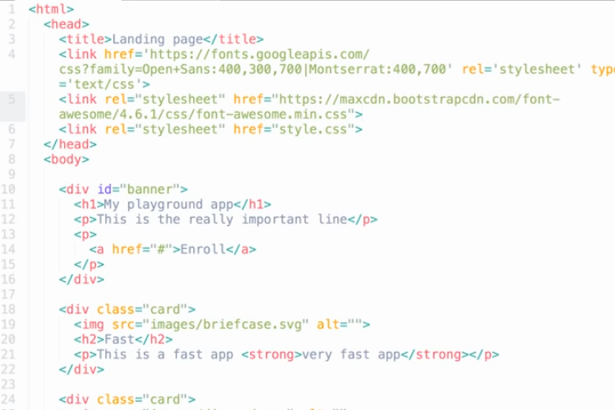

A great footer example
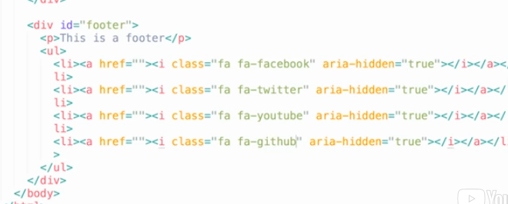

fontawesome logos behave like text.
In style.css, just specify font-size and color, and it will work!
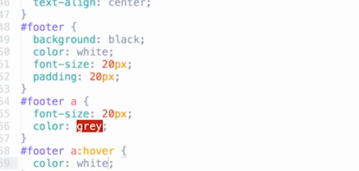

Bootstrap

It’s a css file already coded. They have all the class already coded, that you can use in your html.

Create an index.html, insert the bootstrap css link in your head.

Semantic scheme

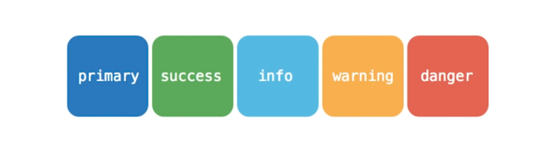

with bootstrap, you don’t have to write the css!!

all you have to write in your html is:
<div class=‘text-justify’></div>
<div class=‘text-left’></div>
<div class=‘text-center’></div>
<div class=‘text-right’></div>

because the class is already created by bootstrap.

Buttons are programmed in the csv already as well!!
all you have to write
<a class= ‘btn btn-primary’ href= ‘#’>TextOnButton</a>
<a class= ‘btn btn-warning’ href= ‘#’>TextOnButton</a>
<a class= ‘btn btn-danger’ href= ‘#’>TextOnButton</a>
<a class= ‘btn btn-info’ href= ‘#’>TextOnButton</a>
<a class= ‘btn btn-success’ href= ‘#’>TextOnButton</a>

same for list classes.
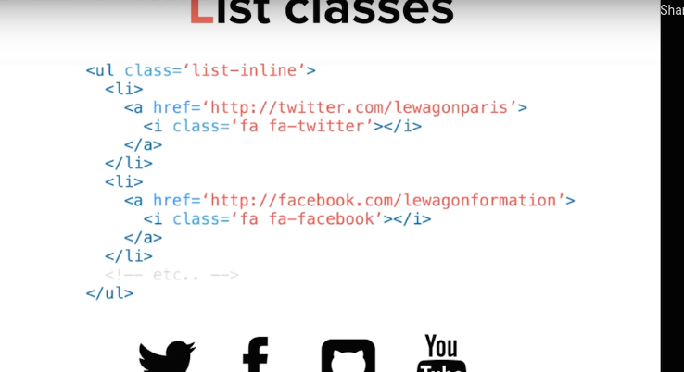

Bootstrap structure.

Component-design

btn btn-danger
list-inline

Bootstrap gridsystem

the grid system is:
- responsive (adapts on device accessing the webpage) think about mobile first, then imagine it bigger!

Always start with a container
<div class=“container”>
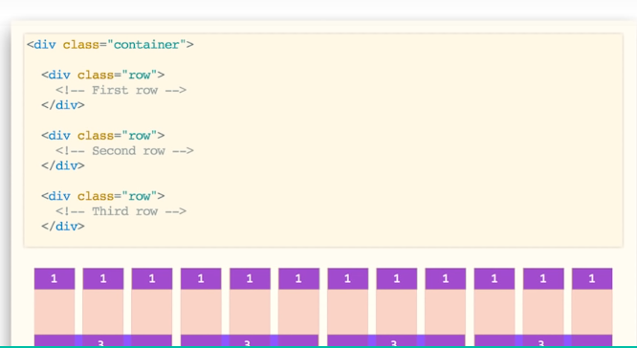
------define container ---------
</div>

then, insert rows.
<div class=“container”>
<div class= “row”>
<!--first row →
</div>
</div>

the structure is based on 12 columns.

You can push pieces inside rows.
The row is divided in 12 columns.

If I want 12 blocks, Each block will take one space.

If I want 4 blocks, Each block will take 3 columns of space!

If I want 3 blocks, each block will take 4 columns of space.

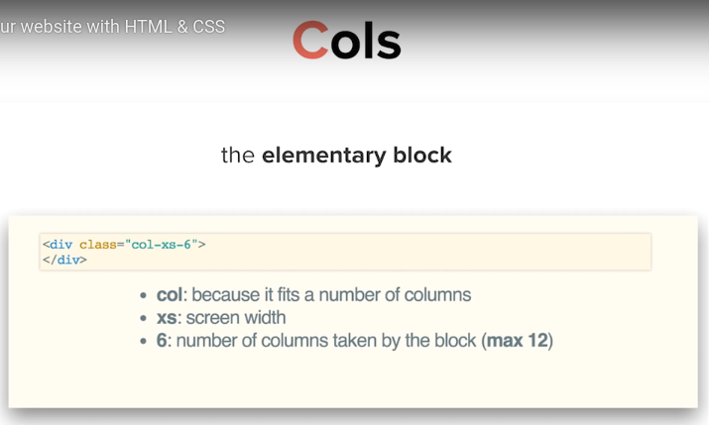

Xs means extra-small, mobile devices.

In this example: “I am an element”, taking 6 colomn of space on mobiles only!

Xs: extra small devices (phones <768px>)
sm: Small devices (tablets >768px)
md: Medium devices (>992px)
lg: Large devices (Desktops >1200px)

Tip about grids.

Always code the grids from scratch, without content. Then, insert content.

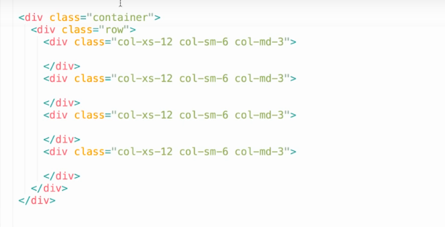

Order to design fonts and colors.

- Star with fonts and colors for body
- set fonts and colors for headers
- set fonts and colors for links.

To center a div

.card {
width:700px;
margin: 0 auto;
}

