 

**Cover Page**

**Academic Integrity statement signed by all team members:**

“In preparing this assignment our team has observed the requirements of the UNCC Code of Student Academic Integrity. The submitted deliverables are entirely the work of our team.”

| **Names** | **Roles & Responsibilities** | **Sign here to show that you have read have complied to the UNCC Academic Integrity** |
| --- | --- | --- |
| Mikaela Olaya | Project Manager |  |
| Sara Gassew | Database Administrator |  |
| Alec Carpenter | Database Designer |  |
| Cole Bloomer | Data Analyst |  |
| Samra Kanwal | Database Designer |  |
| Joseph Reinhart | Data Analyst |  |

Relevant files:

| File Name | Description |
| --- | --- |
| [file name] | Access database |
| [file name] | Visio or ER Assistant diagrams |
| Optional |  |

Version control:

| Version | Changes |
| --- | --- |
| 10/17/2022 | Updating Part 1. (Initial Study and Problems and Constriants)-collaborative amongst team |
| 11/4/2022 | Revisions made prior to submission for Deliverable 2 |
| 11/14/2022 | Deliverable 3 responsibilities assigned |
| 11/25/2022 | Deliverable 3 final revisions before submission |
| 11/30/2022 | Deliverable 4 responsibilities assigned |

Contents

Part I. Database Initial Study 3

About the Model Company 3

Problems and Constraints 3

Project Objectives and Business Needs 4

Scope and Boundaries 5

Part II. Database Design 3

Business Rules 3

Normalized ERD 3

Simplified Data Dictionary 3

Nots explaining design decisions and assumptions 3

Part III. Implementation and Loading 4

Appendices 4

Business Forms 4

Business Reports 4

# Part I. Database Initial Study

## About the Model Company

The Charlotte Swingers® are a professional baseball team based in Charlotte, North Carolina. The club is one of a few expansion teams added into the MLB. The team seeks to use data analytics to record next-gen stats in order to improve decision making within the organization, and they plan on accomplishing this by creating their own database. The database will collect information on players, in-game stats, team inventory, and on all other facets which make up the Charlotte Swingers® organization as well as their home stadium amenities.

## Problems and Constraints

There are numerous constraints and problems affecting the Swingers. Firstly, food sanitation within the stadium is a problem. Due to an inefficient system for tracking food expiration dates and monitoring kitchen hygiene, the Swingers stadium has served fans moldy and unhygienic food, failing to meet food processing standards. This not only negatively impacts the Swingers overall brand and media profile, it also threatens to cause problems with the health department and other health protocols enforced by the league.

A second major problem for the Swingers is that many of the players that they signed on large contracts have faced injuries rendering them unable to play. These players are on guaranteed contracts, and as such the Swingers are wasting money due to player injuries. The Swingers do not currently have a system to actively monitor, keep track of, and analyze players health and playtimes. As such, they cannot accelerate injury recovery time and actively prevent injuries.

An additional issue the Swingers face, if a player gets drafted to another team, the player information does not automatically get removed from the database. There could be a new player on the team that has the number as someone who was just drafted which could cause issues when trying to look up a certain player. If they are injured and cannot play for the season or indefinitely that could also cause problems when it comes to their playing statistics (as they would not be playing so the information would be skewed).

Moving on to business constraints, one major constraint for the team is that games will get canceled due to unfavorable weather conditions. Heavy rain, lightning, snow, or fog can be the cause of a game being canceled. If the weather is not severe enough for the game to be canceled, it can still be a factor towards lower than average ticket sales. Less people will come out to games if there are less favorable weather conditions.

Another key constraint to consider is the stadium capacity. The Charlotte Swingers’ stadium has a seat capacity of 40,000 for fans to come and watch a game. The stadium can also fit up to 100 outside vendors for selling food and merchandise. If the number of ticket sales and vendors exceed these limits, then the stadium becomes overcrowded and also becomes a safety and health hazard to everyone inside.

In addition to stadium capacity, we should also mention roster capacity. MLB rosters are limited to 26 active players per game, which includes a cap of 13 pitchers as well.

Lastly, one of the most important constraints the Charlotte Swingers’ have to consider is the budget for their player payroll. Since the Swingers are an expansion MLB team, their budget is going to be significantly smaller compared to lots of other teams who have been established for decades and who have larger fan bases. The Charlotte Swingers’ payroll is set to be $50,000,000, which is a lot of money to be fair. But if you compare this budget to a team like the Yankees, our payroll is dwarfed by the Yankees’ $250,000,000 payroll. Smaller teams like ourselves have to be a lot more creative and efficient with our budget to stand any kind of fighting chance against these bigger teams. Teams with the smallest budgets are often the same teams who innovate and create game changing strategies that ultimately become the golden standard for every other team to follow.

## 

## Project Objectives and Business Needs

The main goal of the Swingers, and any MLB team, is to operate each season with the highest level of efficiency and effectiveness. While the Charlotte Swingers® have all the right athletes and staff to be a top MLB team, they are missing a database (or databases for that matter) for their season statistics. Baseball has a vast amount of statistics that need to be monitored almost daily, whether it be for player performance or staff efficiency. Users of this new database would be able to see player injuries, drafts for each season, performance statistics for each game, and much more in relation to players. They can also use it to see stadium specific statistics such as sanitation ratings for each concession stand, the seating options, merchandise options, and entertainment for each game just to name a few.

Of course, to make these goals possible we need to have substantial data and information collected specific to the Charlotte Swingers® in order to have the most accurate databases. This is where our staff can be of importance, to record the statistics for each player and for the vendors of the concession stands to stay up to date with their specific data. Another major factor in our objectives is the fans of this baseball team. The ability for a fan to also easily look up all the information on said team will help bring up overall income and increase the amount of tickets and merchandise sold per season.

## Scope and Boundaries

In order to accomplish our objectives, we need to capture player statistics for each game. Each player's hitting and/or pitching statistics will be recorded. This data will be utilized to compute season averages for each players’ statistics. Our various entities will encompass strategic information that will improve the performance of the Swingers and their other related stadium staff, food, vendors, and entertainment.

The purpose of exploring and recording the specific data mentioned is to measure the value of each game in relation to the fans satisfaction, the expected overall success of the firm as well as the depth of data collection. We aim to structure our database in such a way that we can obtain a wide array of data regarding each facet. Our target is to expand the scope of information accessible that influences the potential for the team to thrive and be its most profitable.

Some of the boundaries that our databases face include having such a large amount of data to record and maintain for each player for any given season. These databases are also holding data on players from previous seasons that are no longer part of the Charlotte Swingers. There is a large abundance of possibilities that could be influencing fan attendance at home games, therefore limiting the team’s financial success. These databases should assist in determining what factors may be having an influence.

We are attempting to collect comprehensive data and information on the groups and subgroups that we selected. The scope and depth is determined by the entities and attributes of the various topics relating to both on and off the field Swinger activities and information. We want to structure our databases to cover all of the topics concerned with the Charlotte Swingers® organization and its incorporated entertainment. The table groupings we have are as follows:

# Part II. Database Design

## Business Rules-SARA AND MIKAELA

*[Talk about who is doing what, the relationship among main entities.]*

The Charlotte Swingers® would not be able to function at its highest level without the help of both the team members and the staff. The records managers (who are included in the coaching staff for the team) are responsible for maintaining the player statistics for each game of the season and importing them into the database.

In order to evaluate the team’s success and popularity, we have created a table to take account the number of tickets sold in comparison to the number of seats occupied. Another key indicator of the Charlotte Swingers® success are the sales of team merchandise. When it comes to this merchandise, the booths tend to be operated by the arena staff, thus the managers of each booth/store would be in charge of the inventory on hand before and after each game. The types of merchandise we have in our database would be jerseys, hats, shirts, and baseball cards.

Another way to entice fans into joining us live at our stadium to cheer on the Charlotte Swingers® is with the wide variety of food and entertainment that the stadium has to offer. Although our various entertainment factors vary from game to game, keeping track of the revenue that our food and beverages bring allows the organization to see what is selling best so that we can continue to give our fans more of what they enjoy. Being able to track our special guests and performers appearances in comparison with our fan attendance also helps the organization to understand our fan’s preferences.

Within our database there are 15 main tables, three of which have three subtype tables within them. Those subtypes are the coaching, equipment, and merchandise tables. All of the main tables have some type of relationship that connects them to one another. These relationships are as followed:

* Many players play on one baseball team, and one baseball team has many players on it.
* One player has many player statistics while there are many statistics that belong to a single player.
* A player can have many types of equipment, and many pieces of equipment belong to many players.
* Within the equipment there are three main subtypes: bats, gloves, and miscellaneous.
  + There are different bat types and bat weights.
  + There are different glove types.
* A baseball team can have many coaches but a coach can only coach one baseball team.
* Within the coaching staff there are three main types of coaches: pitching, batting, and fielding coaches.
* A department can have many staff members and each staff member can be assigned to one department.
* Many customers can have one piece of merchandise and many types of merchandise can be bought by many customers.
  + The merchandise products can be jerseys, hats, shirts, and baseball cards.
  + The merchandise ID, merchandise type, and merchandise price is stored for all merchandise.
  + For jerseys, the size, style, and color are stored.
  + For hats, the type and color are stored.
  + For shirts, shirt size, type, and sleeve size are stored.
  + for baseball cards, the pack number and brand are stored.

## Normalized ERD- SAMRA AND ALEC

*[see description in the instructions] needs to be at least 15 tables (from deliverable 1)*   
 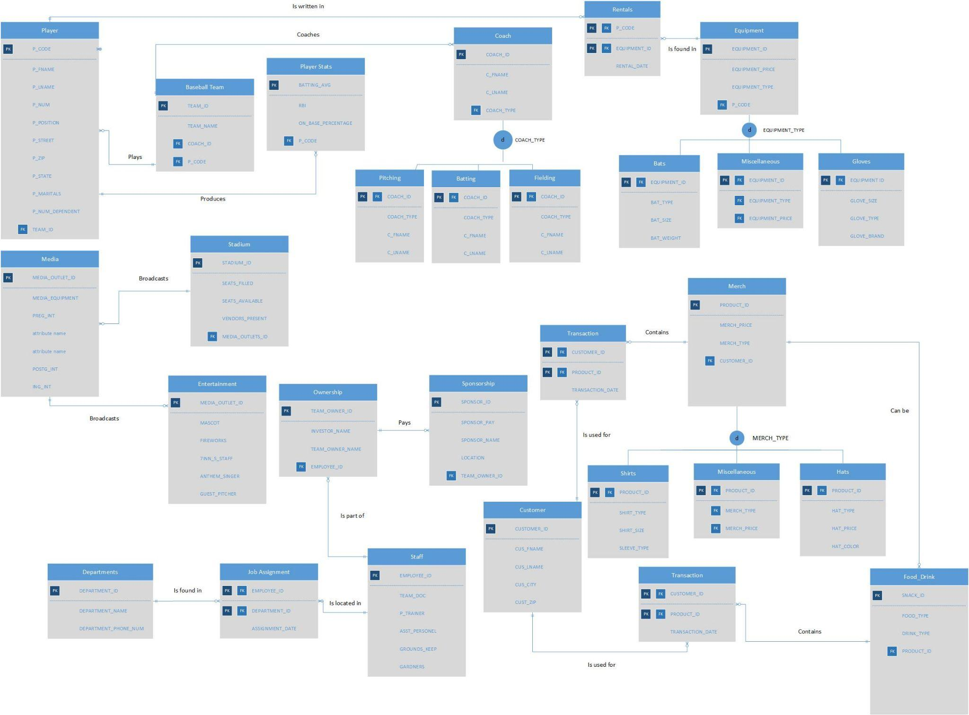

## Simplified Data DictionaryJOSEPH AND COLE

*[see description in the instructions]*

*NEW LINK TO EDIT* <https://docs.google.com/spreadsheets/d/1r3sZhcwawIsubek9_AnnmUZ8sw-ECyMOASB9Efuu-hM/edit?usp=sharing>

## Notes explaining design decisions and assumptions- SARA AND MIKAELA

*[For example, you decided to use supertype-subtype for loan application because there are a few types of mortgage loans and their attributes a slightly different.]*

Within our database we have three subtypes, those being for coaching structure, equipment, and merchandise. Each of these subtypes consist of three tables to better break down the extensive information being stored.

We decided to use a supertype-subtype to better explain the breakdown of the coaching structure between head coaches, pitching coaches, batting coaches, and coaches for other specific positions. Equipment, with the various types of equipment such as bats, gloves, and other miscellaneous equipment are recorded and kept track of while the equipment is assigned to each player. Finally, merchandise is broken down into jerseys, hats, shirts, and baseball cards.

Each player of the Charlotte Swingers® has their own PlayerID, but within the history of the organization there are some repetitive jersey numbers. Current and past players statistics are recorded for each game and are organized by season in order to track progress or growth in a particular skill stored in the player statistics table. In the Player Identification table, we will also hold the player’s personal information such as full name, address, marital status, and number of dependents. In addition to keeping track of Charlotte Swingers® statistics.

All stadium staff are grouped together and organized by their EmployeeID, but are more specifically separated by Department. This table is utilized to keep track of length of time that each employee has been with the organization and which merchants or kiosks that a given employee falls under.

# Part III. Implementation and Loading

This part is done in MS Access. Please see the relevant file.

# Appendices

## Business Forms

*[used currently for data capture/entry]*

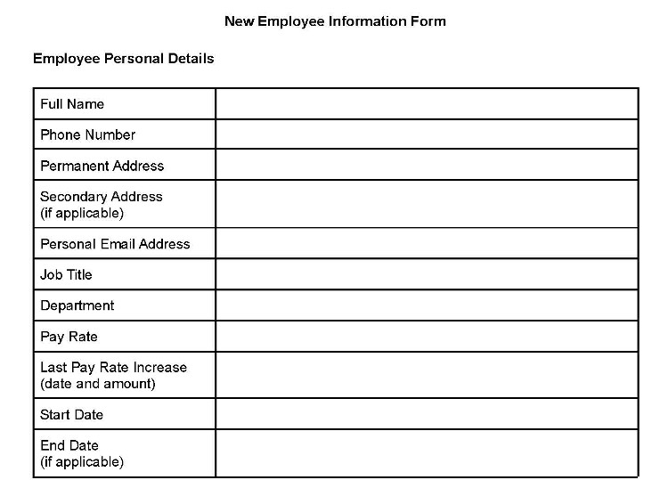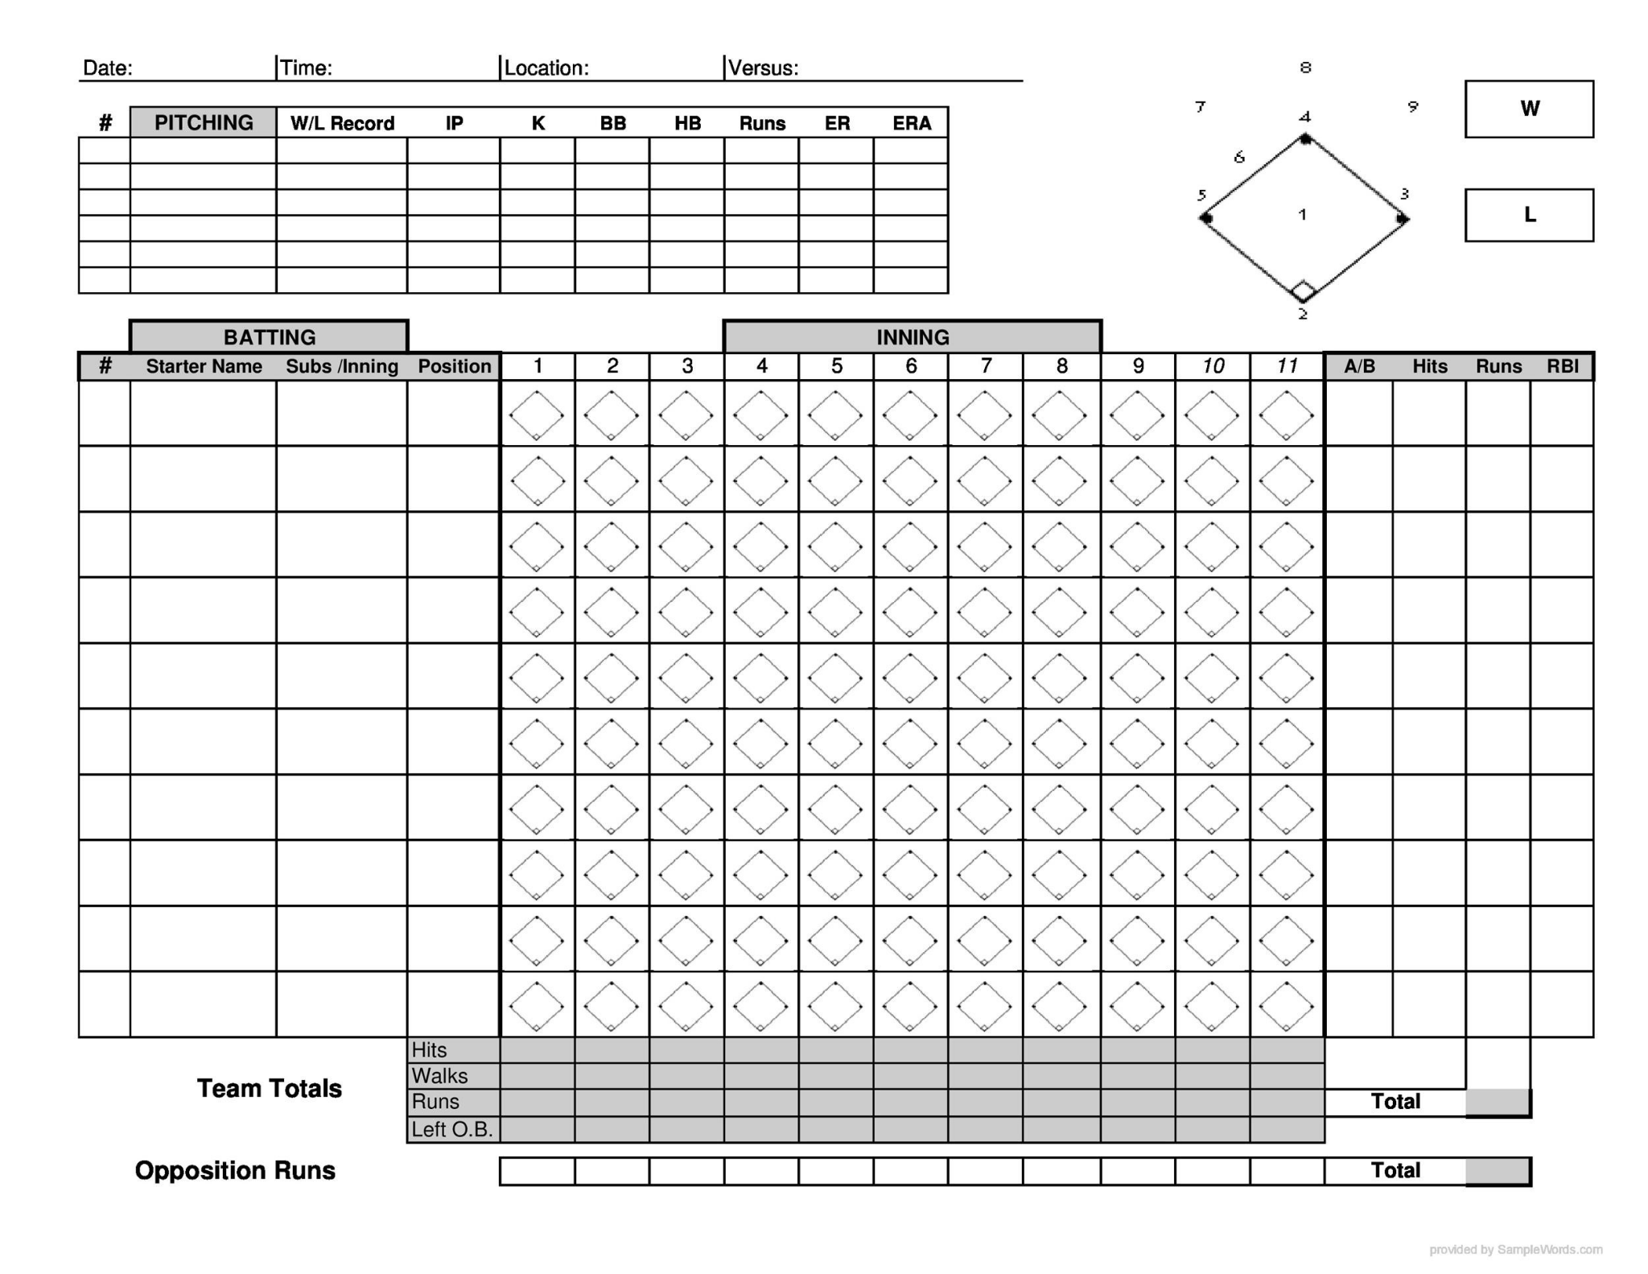

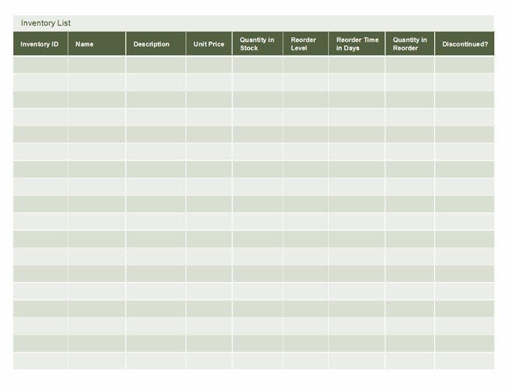

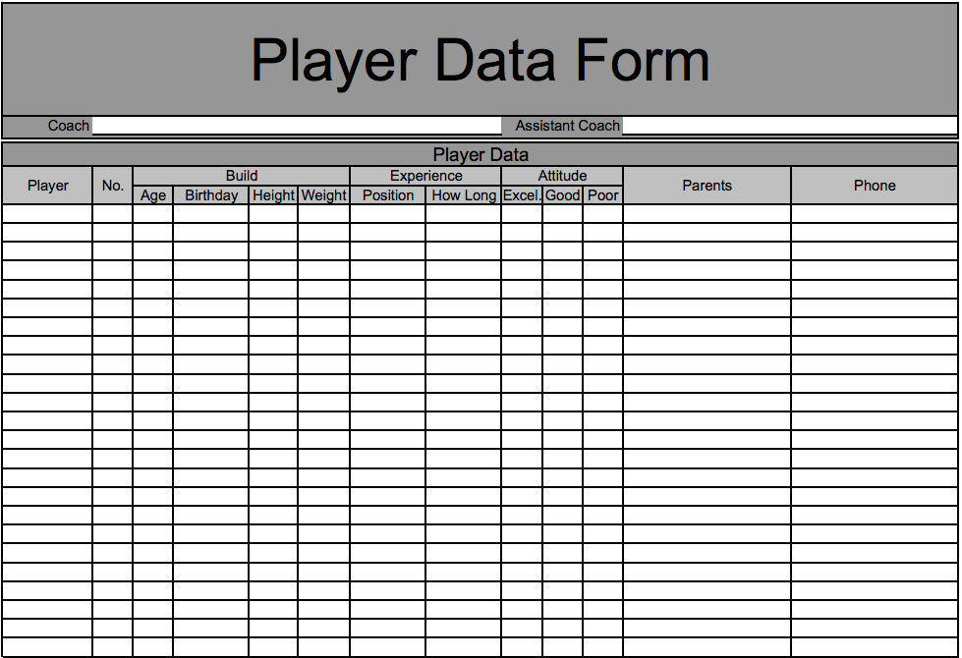

## Business Reports

*[Think about the need for data retrieval or questions that needed answer regularly. Translate those into queries, and then reports. For example, People Bank of Greensboro need to generate of approved loan applications report by date. Your job is translate that into query and then report on top of it.]*

Presentation

1. About
   1. Samra
2. business rules
   1. Mikaela and Sara
3. Entities
   1. Alec
4. Form
   1. Joey
5. Reports
   1. Cole