HW(1) Project

Mikaela Olaya

2/5/2022

# Run this code first

# Q1. Replace the author name with your name in YAML part above.

# Q2. Find Position Adjustments section from the cheat sheet and apply one of its methods with your comment

q2 <- ggplot(mpg, aes(fl, fill = drv)) # creating my variable `q2` # Do not modify this line

q2 + geom_bar(position= "dodge")

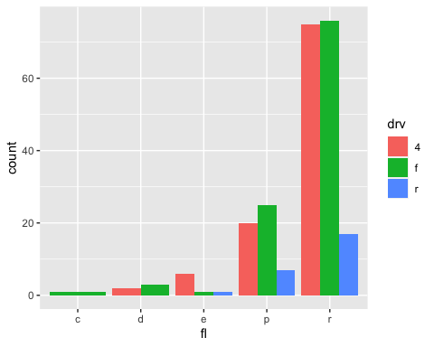

# Q3. Find ONE VARIABLE continuous section and apply one of its methods with your comment

q3 <- ggplot(mpg, aes(hwy)) # creating my variable `q3` # Do not modify this line

q3 + geom_freqpoly()

## `stat_bin()` using `bins = 30`. Pick better value with `binwidth`.

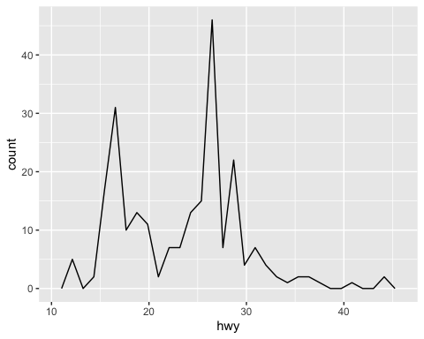

# Q4. Find COLOR AND FILL SCALES (CONTINUOUS) section and apply one of its methods with your comment

q4 <- q3 + geom_dotplot(aes(fill = ..x..)) # Creating my variable `q4` # Do not modify this line

q4 +scale_fill_gradient2(low= "red", high= "blue", mid= "white", midpoint=25)

## Bin width defaults to 1/30 of the range of the data. Pick better value with `binwidth`.

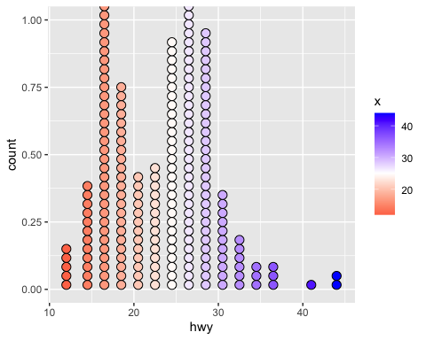

# Q5. Find both discrete section and apply one of its methods with your comment

q5 <- ggplot(mpg, aes(cyl, hwy)) # Creating my variable `q5` # Do not modify this line

q5 +geom_jitter()

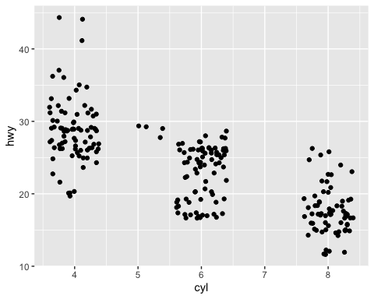

### *End of document*