This is a restaurant application that is able to help waiter/waitress to submit orders, keep track of what has been ordered by which table and what items has been ordered.

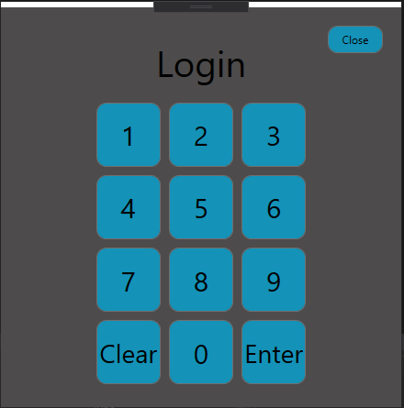  
This is the login page for any employees who work at the restaurant. They will be required to enter their employee number to access the application.

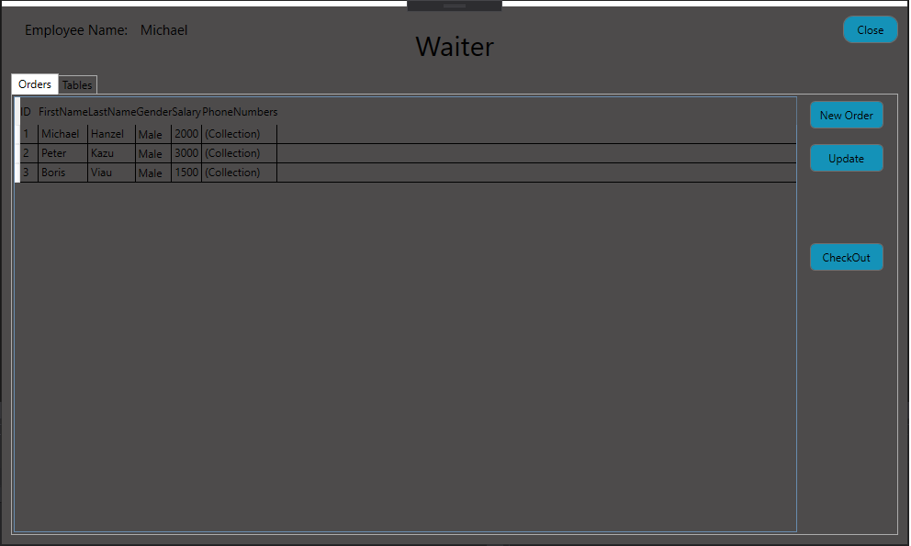

Once Logged in the user will able to see all the orders in datagrid view table. They will be able to Create new order, update existing order, and checkout order to terminate.

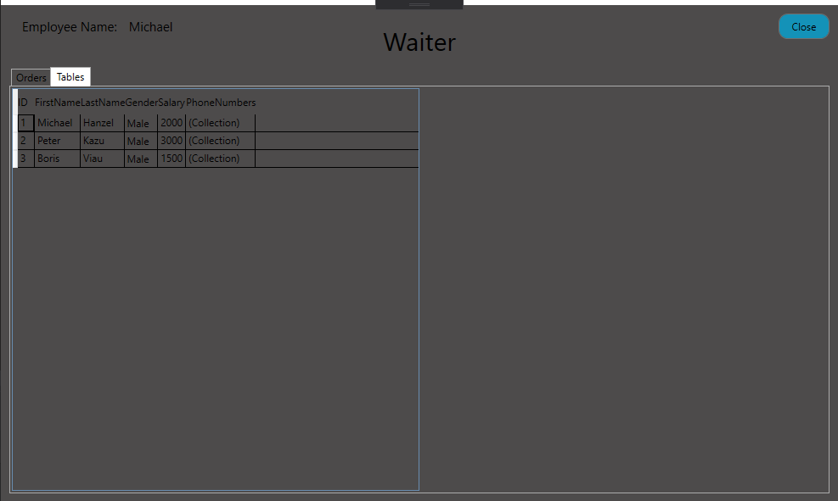

They will also be able to view tables that are either available or occupied.

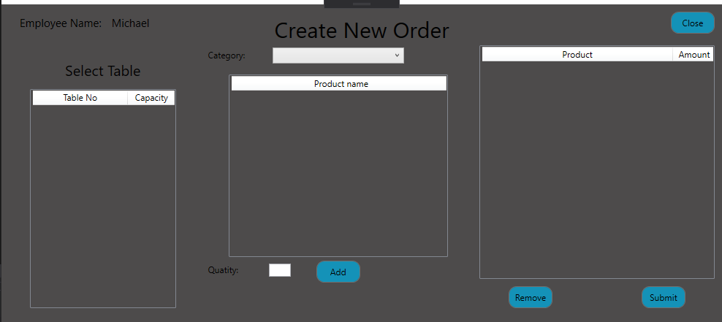

This is the Create New Order page that will allow users to select any available restaurant tables, then choose category of food, product name, specify quantity, then add the order.

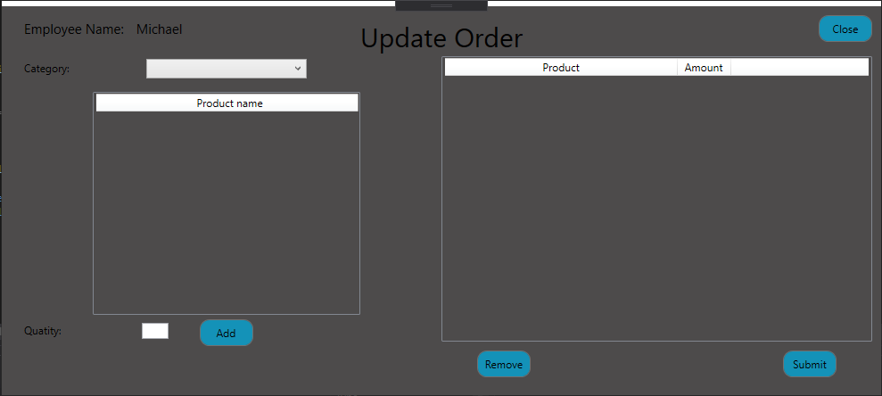

This page will allow the users to update existing order.

