Requirements to run our Project: Group 16  
  
Install/Open Visual Studio Code IDE



Open and expand the folder “mysite”.



Open the terminal if it not already open and ensure that you are within the “mysite” directory like this:



Within the terminal pip install Flask onto your computer if not already installed



After installing flask install the other requirements necessary to create the environment to run the command: pip install -r mysite/requirements.txt

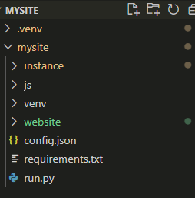



Locate the python file called “run.py” and run the file

Click that button

Then after running the “run.py” within terminal you will see “WARNING: This is a development server. Do not use it in a production deployment. Use a production WSGI server instead” right below this are 2 link addresses click on the second link it should look like this \* Running on <http://127.0.0.1:80>

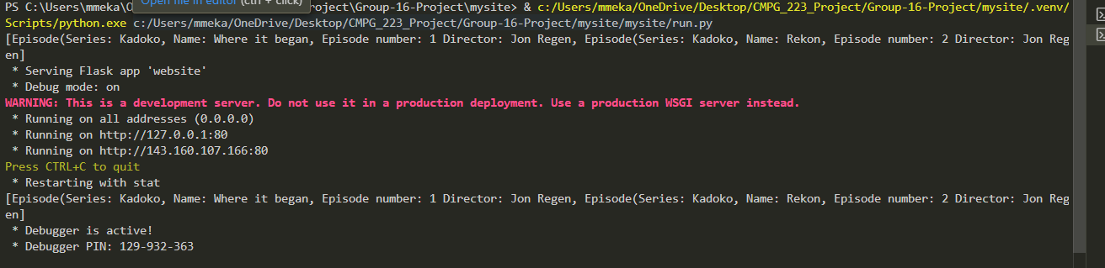

After clicking that link it should take you straight to your browser and you will see this website.