Mikaila Steinbrugge

Assignment 6.2

June 30, 2024

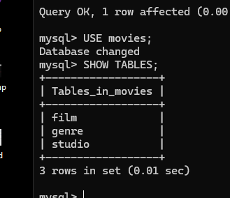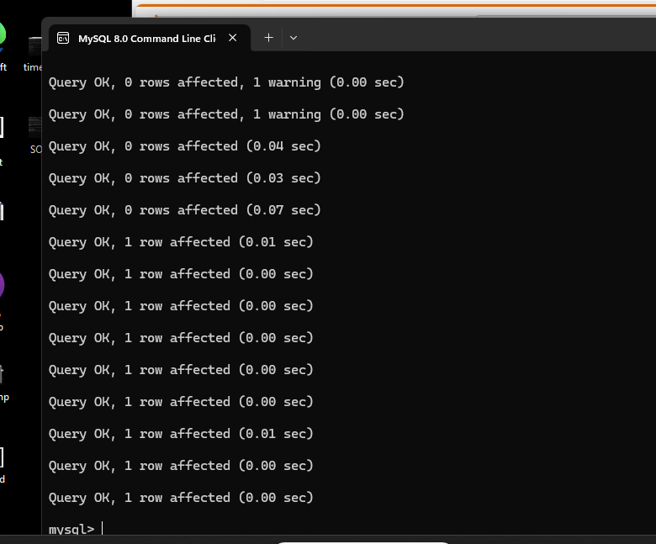

For step 8 I cannot connect mysql to python I have downloaded multiple different versions of python and types of connectors an all I get is an error message. I’m not sure what I am doing wrong.

