**Color scheme**

**Sketch/Wireframe**

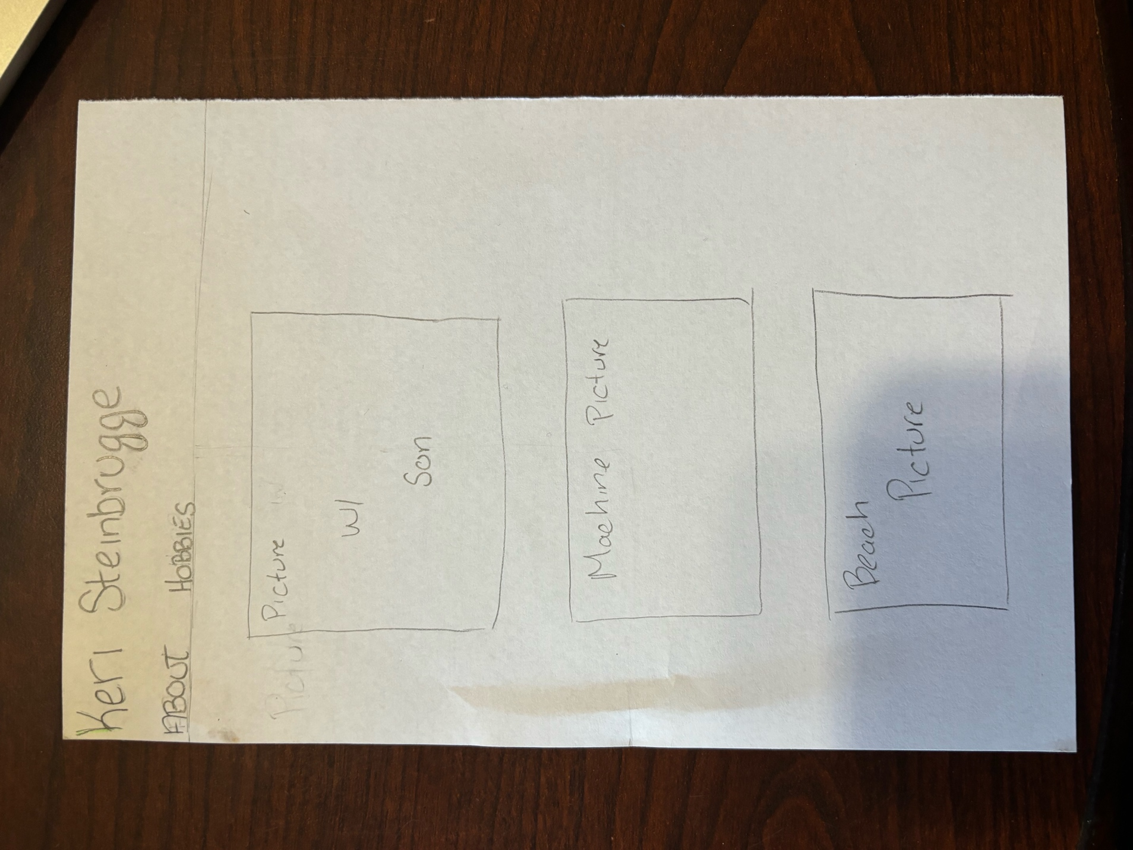

**Interview**

1. **Tell us about your background and how you got started in your field.**

Originally, I wanted to go into the medical filed, I had gone to school for nursing at the career center I was at in high school. When it came to going to college, I was going to go to medical school, but I knew that I wanted to have kids, and I didn’t want to put off having them for years, so I changed my mind on what I wanted to do. I still wanted to stick with science so switched my major to biological science. This way I was still involved in the medical field in some way.

1. **What do you currently do for work?**

I am a shift supervisor for a DNA testing facility. I have four employees that work directly under me on third shift. DNA testing is not the only thing that we do where I work, we also do blood typing and a few other things.

1. **What are some of your hobbies?**

Recently I have gotten into crocheting more, its nice to be able to work with my hands in a creative fashion. I am currently working on making trivets to give to both my workers and family form Christmas. I also enjoy going to concerts whenever I get the chance to, as well as reading.

1. **What is the best concert you have been to?**

I have been to a lot of concerts in my life, but one of the best concerts that I have ever been to would have to be either be Jon Bellion. I hadn’t gone into the concert thinking much of him, I had only known one song at the time. The venue that we went to was sold out, and the crowd knew every word to every song that he played. He also sounded exactly like he did on record which is rare to see.

1. **What is your favorite book or series that you have read?**

One series that I love and can always reread if I was bored would have to be Harry Potter, I remember waiting in the lines for the midnight releases of the later books. You just get to relive everything that you felt as a child that magic was possible.

1. **What are your most significant achievements?**

I don’t want to sound cliché and say that my kids are my greatest achievements, but I do honestly feel that way. If I had to say anything else it would have to be that I was the first person in my family immediate to get a college degree. I knew that I wanted to do what I could to help others.

1. **Who has been a significant influence on your hobbies?**

I learned to crochet when I was younger from my mom, she would make all kinds of things like doll clothes for us, which as a young child you think is amazing that you can make pretty clothes with just some yarn. My kids have gotten me back into going to concerts in the past six years, it is something that we do together.

1. **What are your future goals?**

I don’t really have future goals in mind, I just like to go with whatever is going on around me without thinking too much about the future. I do know that I want to be able to take an extended vacation to the beach or somewhere warm without having to worry about my employees or the people in my family.

1. **How do you stay current with trends in your field or hobbies?**

I try to keep up the best I can with any new science news by reading articles that come out to see if it is anything that may be useful in my field. Even if it isn’t directly connected to my field of work, I like to read about all of the scientific advancements.

1. **Can you share a memorable experience related to your work or hobbies?**

One of the most memorable experiences I have from going to concerts is once last year me and my daughter were at a Nickelback concert in Indiana, just having a good time. When a lady a few rows back came up to us and told us how much she enjoyed seeing us together having fun. She has taken a couple videos of us and wanted to send them to us just to have the memories for the future to look back on.

**Bio**

Keri Steinbrugge is a fifty-two year old mother of two. She has lived in Ohio her whole life studying Biological science at Wright State University. She was the first person in her immediate family to graduate from college. She has used her degree to work for a company that does DNA testing and had risen through the ranks to become a shift supervisor. She enjoys going to concerts with her kids, crocheting and reading.

Keri got into crocheting more after she decided to quit smoking to give her something to distract herself with. Saying that with the money she is saving she can buy as much yarn as she wants to. Her favorite things to make are trivets since they are quick to make even with a pattern on them. She has been trying to make some for everyone in her family for Christmas with some of their favorite things in them. She has made other things such as tops, blankets, coasters and hats. She likes to joke that she should sell what she has made but would never actually go thought with it without major assistance.

In the future she would like to be able to have more free time without having to stress about her employees lives or about the people in her family being healthy. Being able to just relax without having anything else going on, to be able to read books on the beach.

**Images**

Keri Steinbrugge

Some of the Trivets that Keri has made recently.

Keri with her daughter Mikaila and the lead singer of Games we Play.

Keri with her Son Josh.

Thomas Rhett concert from this week.

Machines used in DNA testing,

A beach in Aruba where she wants to go on vacation =.