ADS INTEGRATION DOCUMENTATION :

Everything is done for you :

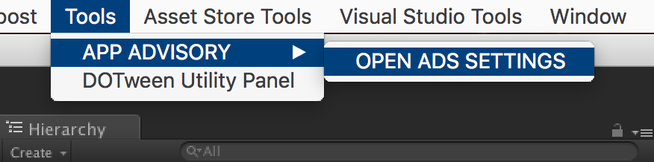

And Select the networks you want (don’t forget to get the SDKs if needed) :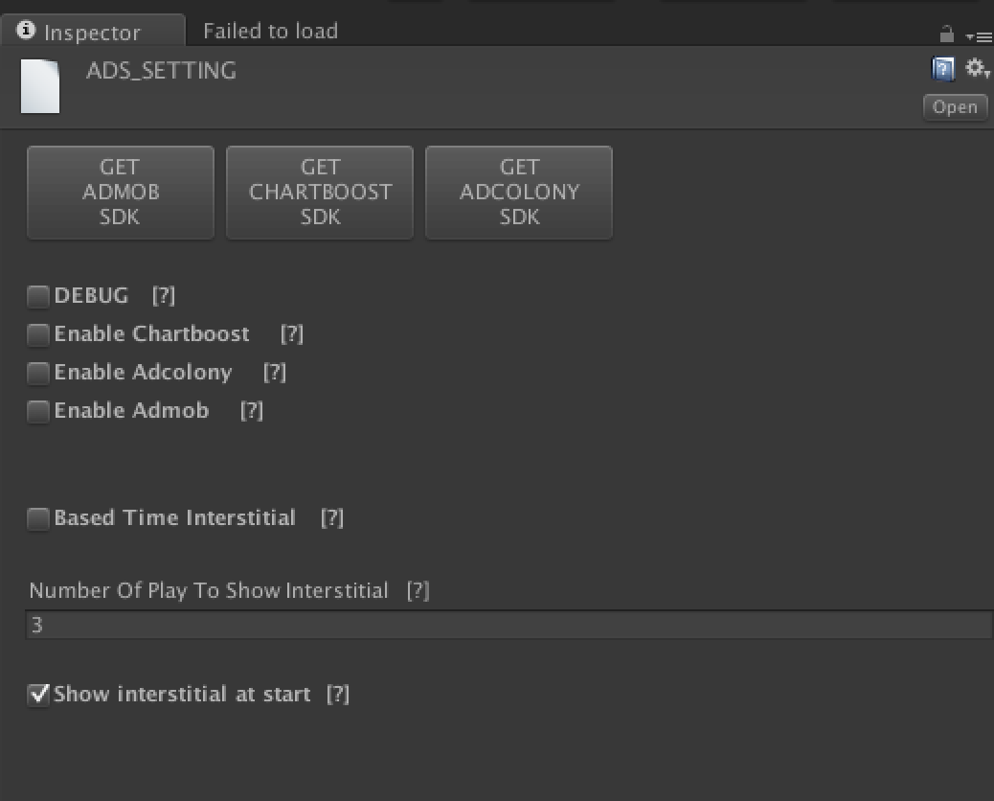

For Unity Ads, please visit my website :

<https://appadvisory.zendesk.com/hc/en-us>

You should have a GameObject named « AdsInit » in the hierarchy view :

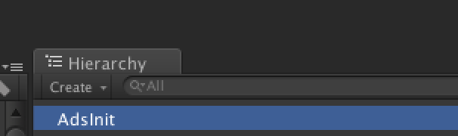

If not, please do a right click on the hierarchy view and :

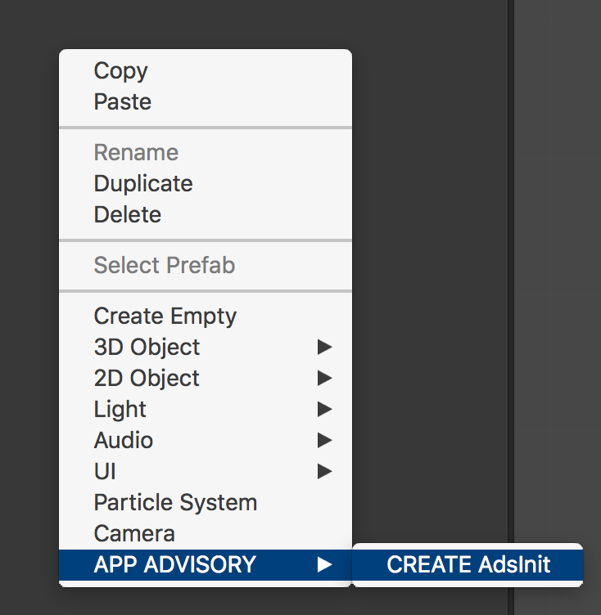

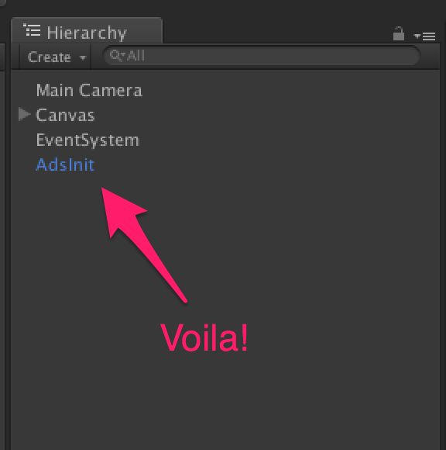

How to check :

* If an interstitial is available ?

*AdsManager.instance.IsReadyInterstitial()*

Return a boolean : true if ready, false if not.

* If a video ad is available ?

*AdsManager.instance.IsReadyVideoAds()*

Return a boolean : true if ready, false if not.

* If a rewarded video is available ?

*AdsManager.instance.IsReadyRewardedVideo()*

Return a boolean : true if ready, false if not.

How to show :

* An interstitial ?

*AdsManager.instance.ShowInterstitial()*

* A video ad?

*AdsManager.instance.ShowVideoAds()*

* A rewarded video?

*AdsManager.instance.ShowRewardedVideo( () => {*

*If(success)*

*{*

*//give a reward to the player*

*}*

*else*

*{*

*//the player do not complete the video*

*}*

*})*

OR

*AdsManager.instance.ShowRewardedVideo(Method) ;*

And the method called is like this :

*Void Method(bool success)*

*{*

*If(success)*

*{*

*//give a reward to the player*

*}*

*else*

*{*

*//the player do not complete the video*

*}*

*}*

**How to add a loading page to load ads before to start the game ?**

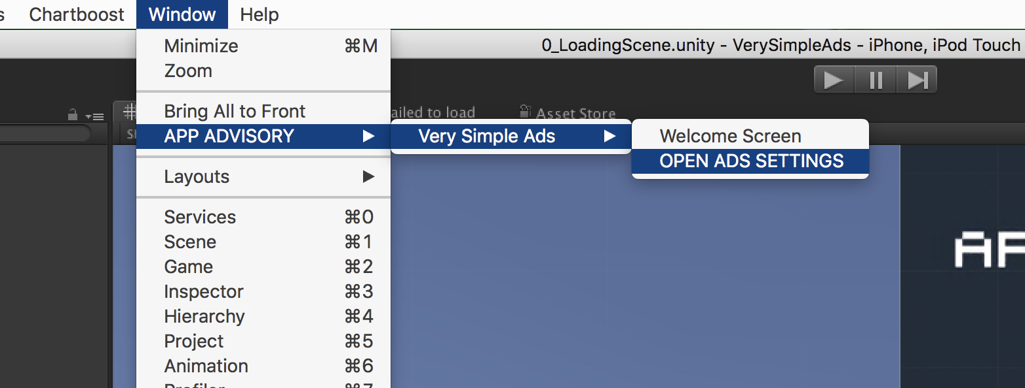

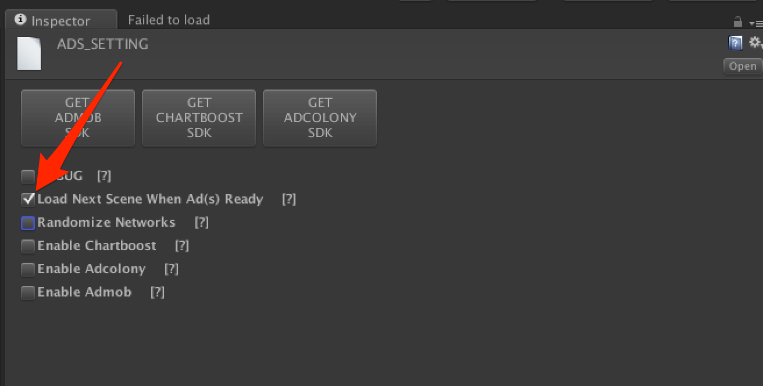

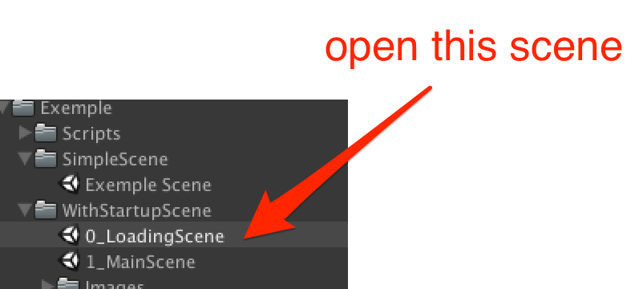

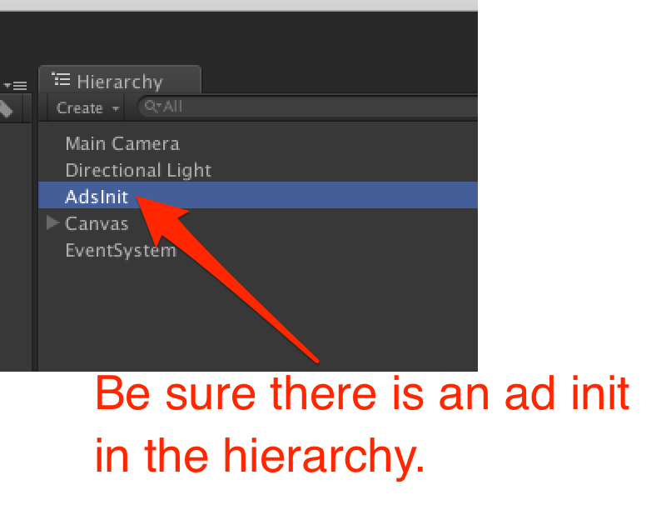

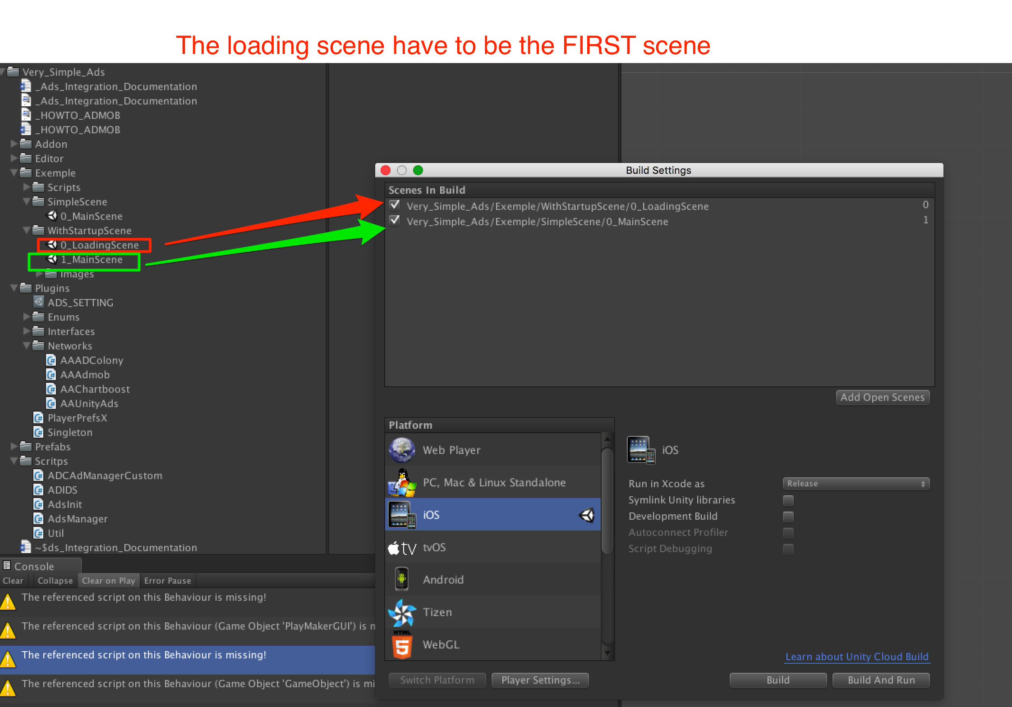

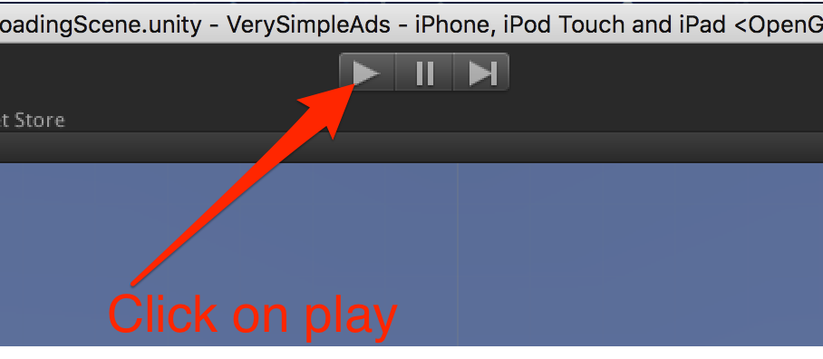

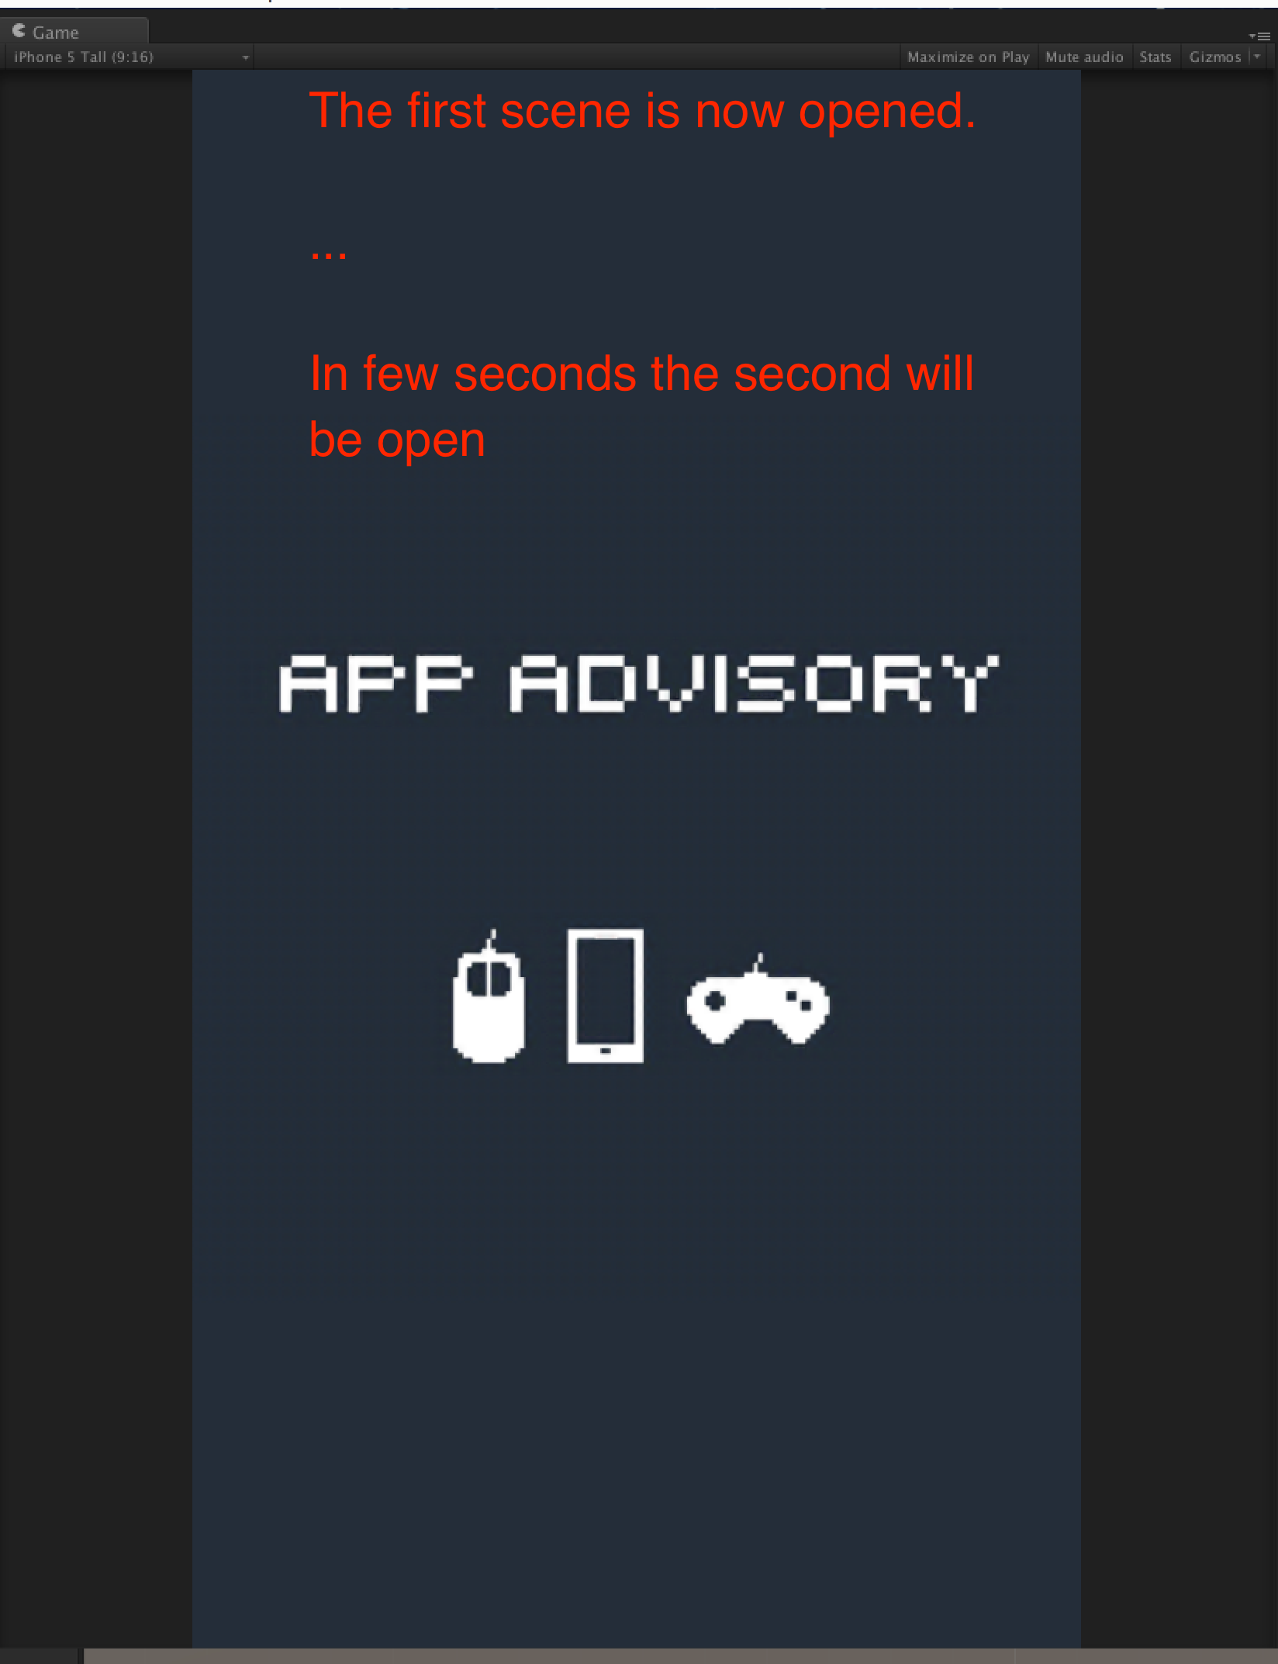

**Subscribe to events :**

Be notified when static interstitial is opened :

../../../../../../var/folders/3d/_68g_lwn0zb4d4rm9spylztm0000gn/T/com.skitch.skitch/DMD03B3E611-1BA1-4A00-AF4C-B4EF388820A0/Assembly-CSharp_-_Very_Simple_Ads_Exemple_Scripts_Scene_ButtonReloadScene_cs_-_Mono

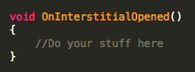

Be notified when static interstitial is closed:

../../../../../../var/folders/3d/_68g_lwn0zb4d4rm9spylztm0000gn/T/com.skitch.skitch/DMD7A27B5C9-F247-4610-9A2D-BECE96E5EBA2/Assembly-CSharp_-_Very_Simple_Ads_Exemple_Scripts_Scene_ButtonReloadScene_cs_-_Mono

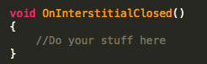

Be notified when video interstitial is opened:

../../../../../../var/folders/3d/_68g_lwn0zb4d4rm9spylztm0000gn/T/com.skitch.skitch/DMD055BCA59-DE6A-42E8-9070-5A0FC991CC27/Assembly-CSharp_-_Very_Simple_Ads_Exemple_Scripts_Scene_ButtonReloadScene_cs_-_Mono

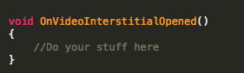

Be notified when video interstitial is closed:

../../../../../../var/folders/3d/_68g_lwn0zb4d4rm9spylztm0000gn/T/com.skitch.skitch/DMD64F12E3D-8595-4BAC-B7A6-A913C27A7B62/Assembly-CSharp_-_Very_Simple_Ads_Exemple_Scripts_Scene_ButtonReloadScene_cs_-_Mono

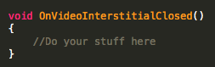

Thanks !

Our other assets : <http://u3d.as/9cs>

Contact : [contact@app-advisory.com](mailto:contact@app-advisory.com)