Artillery 3  
High Distinction Project

**COS20007 – Object Oriented Programming**

artillery.nekox.net

|  |  |
| --- | --- |
| Submission Date: | XX/XX/XX |
| Tutor: Student: | Medhi  Jimmy Trac  101624964 |

This page is mostly blank.

The purpose of this page is to separate the cover page from the report when printed double-sided.

# Artillery 3: Object Oriented Programming High Distinction Project

Written by Jimmy Trac, ID: 101624964, Mikanwolfe of nekox.net

## 1. Design Overview for Artillery 3

**Artillery 3** is a 2D physics-based shooter where players take turns controlling vehicles on a map of varying elevation. Players will be able to move their artillery pieces across the map and fire in long arcs towards enemy players, with the explicit goal of destroying all other players. The game will be turn-based, with players selecting a weapon (if not multiple) and select an angle to fire at. The “force” behind each shot will be a rough estimate at best and the fired projectiles of varying properties and physical interactions will both damage players’ health, armour, and stats, along with the terrain itself. Figure 1 is illustrative of the initial-initial concept for Artillery (the original version!)

Artillery 3 is a complete re-write of the original Artillery 2 project found [here](https://github.com/Mikanwolfe/artillery).

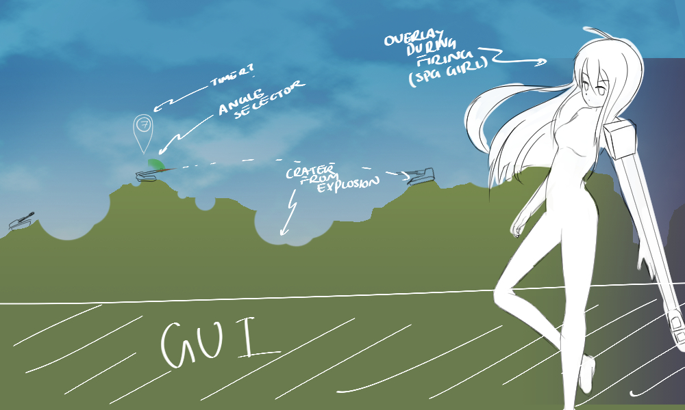

Figure 1 – Example Game Sketch

**Features:**

* Object Oriented Programming Design Pattern Festival!
  + Singleton for Physics Engine and Entity Manager
  + Strategy/Abstract Factory for Terrain Generation
  + Abstract Factory for various UIs!
  + Composites for Entities
  + Command for all player input
  + Favouring composition (extensively) over inheritance (according to the GoF)
  + Game-State and Finite State Machine Pushdown Automata!
  + Flyweight Terrain Tiles!
* Did I mention a Physics Engine???
  + Hopefully a particle engine too!
* Multiple vehicles (now Characters) with art!!!
* Improved projectile physics (projectiles have different dynamics such as lift)
  + Improved wind calculations that consider the new physics!
  + Projectiles will be able to home and later their flight paths
* Variable Terrain Generation!
  + Fractal Terrain generation using the Midpoint Displacement Algorithm
  + Other terrain generation methods such as a tonne of sine graphs super-positioned on each other
  + Fully adjustable variables and dynamics for terrain generation in the menu
  + Destructible terrain!
  + Possibly tile-based map!
* Aiming assistance (finally)
* Improved graphics and possibly animations! (Terrain textures and character animations)
* Saving character stats
* Multiplayer networking support, eventually!

##### Why is it called Artillery 3?

Artillery 1 and Artillery 2 are the same game/project under the domain of the *Artillery Project*, however, Artillery 1 was designed to satisfy the requirements of the HD task. On the other hand, Artillery 2 was a major extension of the original game that focused on playability and improved upon the original project in a such a meaningful way that it was eventually submitted instead.

On the other hand, Artillery 3 is a complete redesign and re-writing of the Artillery concept though the look and feel of the programs will be similar. Under the hood, they are completely different programs.

### 1.1 Required Roles

There’s quite a lot to go through here, otherwise, it’s all good.