

|  |
| --- |
| Orchestra O/S |
| Music Experience Operating System |
| Experience One Corporation |

Contents

Background on the Invention 8

Current process 8

Summary of Invention 10

System Tenants 11

System Overview 12

Key Scenarios 18

Track Production 19

Primary Personas 19

Applications 19

Devices 20

Process 20

Congregated SuperTrack Production 21

Primary Personas 21

Applications 22

Devices 22

Process 22

Live Broadcast SuperTrack Production 23

Primary Personas 23

Applications 23

Devices 23

Process 24

Promotional SuperTrack Production 25

Primary Personas 25

Applications 25

Devices 25

Process 26

UltraTrack Production 27

Primary Personas 27

Applications 27

Devices 28

Process 28

Portable Music Experience 31

Primary Personas 31

Applications 31

Devices 31

Process 31

Mood Matrix 32

Before 32

After 33

Research Implications 34

Patentable Concepts 34

Corporate Entities and Structure 35

Glossary 36

Auditory Advertising Placement Locations 36

Dreamcatcher Movement Analysis Gear (D-Mag) 36

Feedback Application 36

Feedback Device 36

Gatekeeper Ticket Processing System 36

(Virtual) Instrument 36

(Virtual) Instrument Producer 36

(Virtual) Instrument Library 36

Instrument Production Application Provider 36

Interactive Advertising Station 37

Layer 37

Listener 37

Media Capture Application 37

Music Experience Device 37

Music Experience Generator 37

Music Source File 37

Network Location 37

Note 37

Performance Area 37

Performance Area Video Capturing Device 37

Performance Area Sound Capturing Device 38

Personal Media Capturing Device 38

Personal Preference Profile Application 38

Personal Track Library Device 38

Sponsor 38

SuperTrack 38

SuperTrack Archival Device 38

SuperTrack Producer 38

SuperTrack Production Application 38

SuperTrack Production Application Producer 38

SuperTrack Production Editor 38

SuperTrack Production Workstation 38

SuperTrack Production Viewer Application 38

SuperTrack Viewing Device 39

Track 39

Track Management Application 39

Track Production Editor 39

Track Production Manager 39

Track Producer 39

Track Production Application 39

Track Production Application Producer 39

Track Production Editing Application 39

Track Production Editing Application Producer 39

Track Production Editor 39

Track Production Workstation 39

Track Provision Device 40

Track Selection Device 40

Track Selection Management Application 40

UltraTrack 40

UltraTrack Production Manager 40

UltraTrack Production Viewer Application 40

UltraTrack Performer 40

Venue Owner 40

USB-Enabled CDJ 40

Claims 41

Abstract 41

Music Experience Operating System

# Background on the Invention

Digital music has changed the notion of how art is distributed throughout the world. When this medium was introduced over a decade ago, existing establishments scrambled to deal with the new perceived threat. Unfortunately, the system as a whole remains unbalanced, and billions of dollars continue to be realized as a loss due to piracy and a broken understanding of the entire paradigm. This invention aims to fully and holistically capture the music experience process, restoring balance to the entire system, and ensuring that all parties involved with the entire process are compensated fairly and appropriately.

## Current process

Currently, music is created and distributed to the market by the following process:

1. Music authors create music, with Production Applications and instruments provided from external providers. These pieces of music are compiled into layers of instruments and effects and packaged as songs or tracks.
2. Music is converted to MP3’s and placed into a promotional vehicle such as a website.
3. Authors market these tracks to friends and organizations such as record labels (or “label”) so that they can get signed.
4. Labels sift through hundreds of thousands of sampled tracks to find those that resonate with their image and sound.
5. Once a label finds an author that they like, they begin negotiations with the author to secure a distribution and marketing deal. The label agrees to handle all of the author’s distribution and marketing efforts for a percentage of profits derived from any retail and online sales, and royalty fees acquired from public performances through establishments such as restaurants and nightclubs.
6. Label manages distribution of signed author’s music to market.
7. Label manages royalty fees with organizations such as ASCAP/BMI/SESAC.
   1. Public broadcasting mediums such as radio stations, restaurants and nightclubs pay royalty fees for “public performances” of music.
8. Labels pay authors any royalties and a percentage of profits from sales in the marketplace.
9. From these sales, all SoundScan-enabled point-of-sale locations provide data to Nielson SoundScan to compile the Billboard Top 40 charts.
10. Radio Air Play. Program managers from radio stations consult with Billboard Top 40/100 Lists to create their programming and track selections.
11. “Public Performances.” Public locations such as restaurants and coffee houses play music from radio stations, satellite radio or other sources, and pay monthly fees to royalty organizations for the “privilege” of doing so.

#### Identified Issues

This process creates the following issues in the marketplace.

1. Piracy. Above all, music is treated as a physical commodity in a digital marketplace. As such, millions of music lovers easily trade music through peer-to-peer networks, resulting in billions of dollars in lost revenue.
   1. [Piracy accounts for $12.5 Billion every year in music sales.](http://www.riaa.com/physicalpiracy.php)
   2. Due to business practices and policies, music software companies will not release actual figures, but from interviews with music producers, it is estimated that 70%-90% of recording studio and virtual instrument software is pirated.
2. Inorganic promotional cycle. Labels promote their acts which in turn generate sales, which in turn generate airplay. Airplay, in turn, generates more sales. As a result, Top 40 lists are created in a very coerced and unnatural manner.
3. Public resentment. Restaurants and public businesses do not like having to pay a monthly fee for providing music for their clientele. Listeners as a whole do not like the royalty payment system as it exists currently and openly express anger and resentment towards the current process.
4. Fragmentation. Every restaurant, nightclub, and radio station use different methods to retrieve, track and play their music.
5. Inaccurate market analysis. Most nightclubs don’t even track at all. The Billboard Top 100 is compiled by a handful of “Billboard-enabled” clubs, meaning 100,000s of songs every week go unaccounted for.
6. Confusion and inaccurate record-keeping. Due to the fragmented nature of this system, different sets of contracts exist between all parties, leading to miscommunication and misinformed expectations between individuals, especially where live performances are concerned. Inaccurate record-keeping, antiquated book-keeping and just plain corruption (due to a lack of a monitored paper-trail) creates an imbalanced environment where parties lend themselves to anger and resentment.

# Summary of Invention

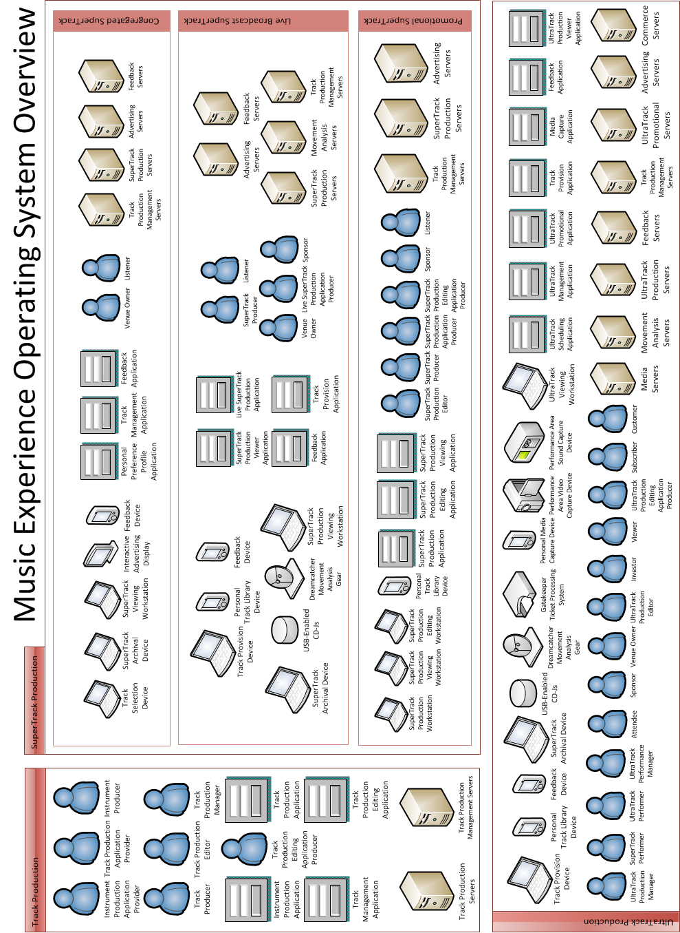

## System Tenants

The system identified in this invention is driven by the following tenants:

1. **The true Value of music is the Experience it creates.**
2. The process of creating this Experience involves many parties that together comprise a holistic system (hereafter known as the System).
3. The process of creating music is free.
4. The process of experiencing music is free, until an exchange of currency in relation to this experience occurs.
5. Whenever an exchange of currency occurs, all parties involved in the creation of the Music Experience should be compensated appropriately.
6. Music promotion is an organic process. E.g. listeners should be providing the industry great acts to promote, not the other way around.
7. As such, the dance floor (hereafter known as the “Performance Area”) is the true promotional marketplace.
8. Public venues are Music Experience Generators and are paid for providing music.

## System Overview

The System fulfills these tenants by:

1. Accurately identifying domain entities. Known as the Sonic Entity Hierarchy, these are:

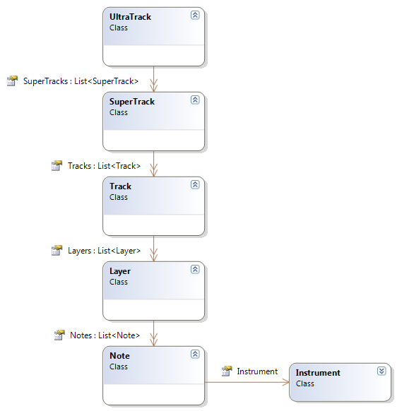

* 1. Notes
     1. Instruments
  2. Layers
  3. Tracks
  4. SuperTracks
  5. UltraTracks

1. Accurately identifying Music Experience Creation. These are experiences created from this system and are identified by the following:
   1. Congregated SuperTrack Broadcasting (formerly public performance broadcasting)
   2. Live SuperTrack Broadcasting (formerly radio or internet broadcasting)
   3. UltraTrack Production
2. Accurately identifying Commodities. These are:
   1. SuperTracks, of types which include:
      1. Congregated
      2. Live Broadcast
      3. Promotional
   2. UltraTracks
3. Accurately identifying Commodity Chains. These are:
   1. Congregated SuperTrack Commodity Chain
      1. Instrument Producer
      2. Instrument Production Application Provider
      3. Track Production Application Producer
      4. Track Producer
      5. Track Production Editor
      6. Track Production Editing Application Producer
      7. Track Production Manager
      8. Venue Owner
   2. Live SuperTrack Commodity Chain
      1. Instrument Producer
      2. Instrument Production Application Provider
      3. Track Production Application Producer
      4. Track Producer
      5. Track Production Editor
      6. Track Production Editing Application Producer
      7. Track Production Manager
      8. Live SuperTrack Production Application Producer
      9. SuperTrack Producer
      10. Venue Owner
   3. Promotional SuperTrack Commodity Chain
      1. Instrument Producer
      2. Instrument Production Application Provider
      3. Track Production Application Producer
      4. Track Producer
      5. Track Production Editor
      6. Track Production Editing Application Producer
      7. Track Production Manager
      8. SuperTrack Production Application Producer
      9. SuperTrack Producer
      10. SuperTrack Production Editor
      11. SuperTrack Production Editing Application Producer
   4. UltraTrack Commodity Chain
      1. Instrument Producer
      2. Instrument Production Application Provider
      3. Track Production Application Producer
      4. Track Producer
      5. Track Production Editor
      6. Track Production Editing Application Producer
      7. Track Production Manager
      8. Live SuperTrack Production Application Producer
      9. UltraTrack Production Manager
      10. UltraTrack Performance Manager
      11. SuperTrack Producer
      12. UltraTrack Performer
      13. Venue Owner
4. Accurately identifying Music Experience Generators. These are:
   1. FM Broadcast stations (approximately 6,000 in the United States)
   2. Nightclubs (approximately 4,000 in the United States)
   3. Restaurants (approximately 500,000 in the United States, with an estimated 10% of them who play music as public performances, with a guaranteed 100% of those not happy with having to pay monthly fees for music)
5. Establishing a common file format that captures all known aspects of a Track, including notes, layers, instruments, authors, the Track Production Application used to create it and the Track Production Editing Application used to create it. This file is known as the Music Source File.
6. Establishing a network whereby all links of the commodity chain can register, connect, communicate and collaborate with each other in one centralized location. This network enables:
   1. Instrument Providers to register their Instruments in a Virtual Instrument Library. This is accessed from Track Production Applications during Track Production.
   2. Production Application Producers to register their Production Applications for use by Track Producers.
   3. Negotiations to occur between Track Producers, Production Application Producers and Virtual Instrument Producers.
   4. Track Producers to register their Music Source Files (or Tracks) and share with the world.
   5. Track Production Managers to listen/rank/rate to Tracks, and to negotiate with Track Producers when a Track Production Manager finds a Track they’d like to sign.
   6. Track Production Managers to promote or recommend Tracks to SuperTrack Producers for use in SuperTrack Productions.
   7. SuperTrack Producers to create and register SuperTracks within the system.
   8. UltraTrack Production Managers, UltraTrack Performance Managers, SuperTrack Producers, UltraTrack Performers, Venue Owners, Investors and UltraTrack Production Editors to collaborate and negotiate on UltraTracks.
   9. Publishing SuperTrack Productions and UltraTrack Productions for use in broadcasting and marketplace transactions.
   10. Sponsors to manage advertising campaigns that consist of both interactive advertisements and audio advertisements. Interactive advertisements are displayed on devices during live performances and playback of SuperTracks. Audio advertisements are played during Live Broadcasting and Congregated Broadcasting.
7. Capture the workflow required to create a music experience, by providing a cohesive and unified contractual framework.
8. Provide a unified advertising network, and enable Track Producers and Track Production Managers to provide Auditory Advertising Placement Locations within Tracks for Sponsors to provide audio advertising.
9. Provide a commerce solution that tracks currency exchange – whether through advertising, subscriptions, donations or purchases, and then distributes it accordingly to appropriate Commodity Chain responsible for the Music Experience.
10. Provide a feedback system for listeners to give their feedback to SuperTrack Productions and UltraTrack Productions, whether it’s during a real-time performance, or during a broadcast.

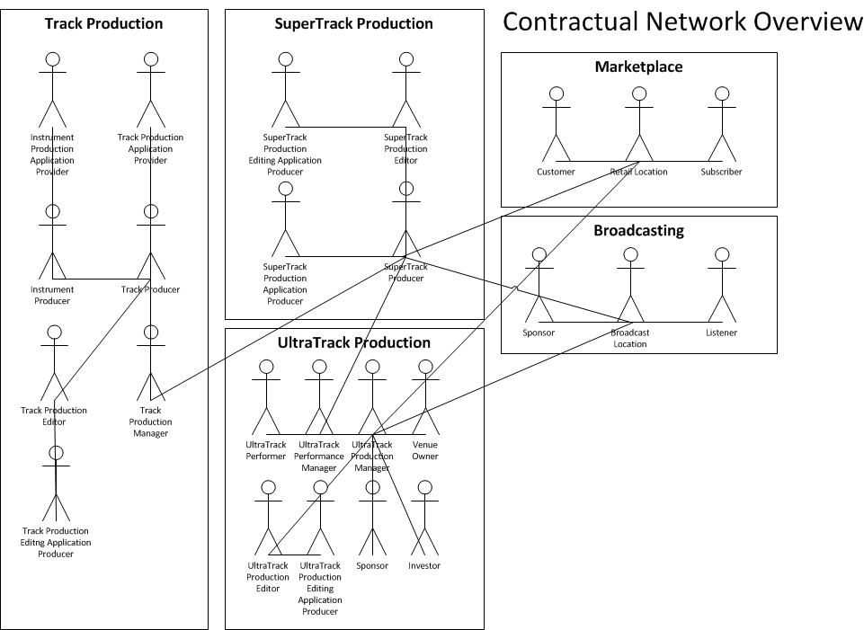

# Key Scenarios

The System addresses five key scenarios. They are:

1. Track Production Process
2. Congregated SuperTrack Production Process
3. Live Broadcast SuperTrack Production Process
4. Promotional SuperTrack Production Process
5. UltraTrack Production Process

## Track Production

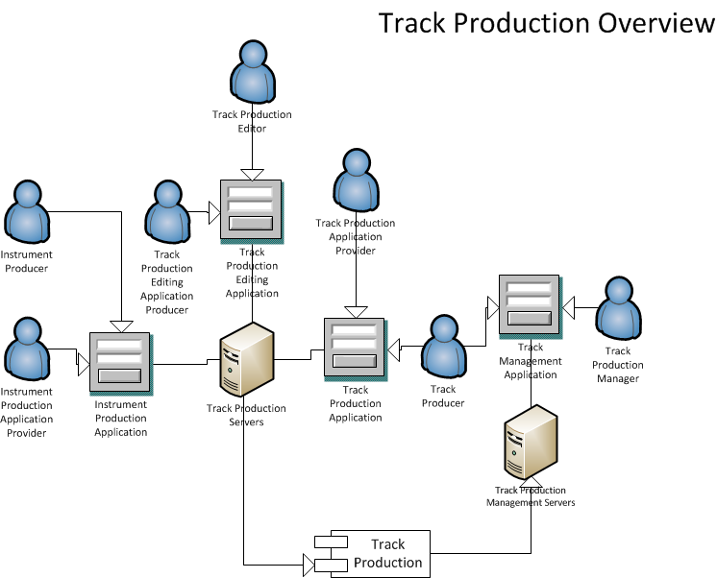

### Primary Personas

1. Instrument Producer
2. Instrument Production Application Provider
3. Track Production Application Producer
4. Track Producer
5. Track Production Editor
6. Track Production Editing Application Producer
7. Track Production Manager

### Applications

1. Instrument Production Application
2. Track Production Application
3. Track Management Application
4. Track Production Editing Application

### Devices

1. Instrument Production Workstation
2. Track Production Workstation
3. Track Production Editing Workstation

### **Process**

1. Instrument Production Application Provider registers with System.
2. Instrument Production Application Provider registers Instrument Production Application with System.
3. **Instrument Producer registers with System.**
4. **Instrument Producer creates Instrument with** Instrument Production Application**.**
5. **Instrument Producer registers Instrument with System, adding the Instrument into the Virtual Instrument Library.**
6. Track Production Application Producer **registers with System.**
7. Track Production Application Producer **registers** Track Production Application **with System.**
8. **Track Production Editor registers with System.**
9. **Track Production Editing Application Producer registers with System.**
10. **Track Production Editing Application Producer registers Track Production Editing Application with System.**
11. Track Production Application Producer **enables access to Virtual Instrument Library within the registered** Track Production Application**.**
12. **Track Producer accesses** Track Production Application **from System and produces Track, selecting various Virtual Instruments from the Virtual Instrument Library.**
13. **Track Producer submits Track into Editing Repository.**
14. **Track Producer collaborates with Track Production Editor to edit and master finished Track.**
15. **If desired, Track Producer adds Auditory Advertising Placement Locations within Track for sponsored track placement during Sponsored Broadcasting.**
16. **Track Producer submits Track into Track Gallery.**
17. **Track Producer recommends Track to Track Production Manager.**
18. **Track Production Manager listens to Track and:**
    1. **Provides feedback.**
    2. **Begins negotiations to sign Track Producer.**
19. **Once signed, Track Production Manager ensures Track contains sufficient Auditory Advertising Placement Locations within the song, according to Track Production Manager’s policy.**

## Congregated SuperTrack Production

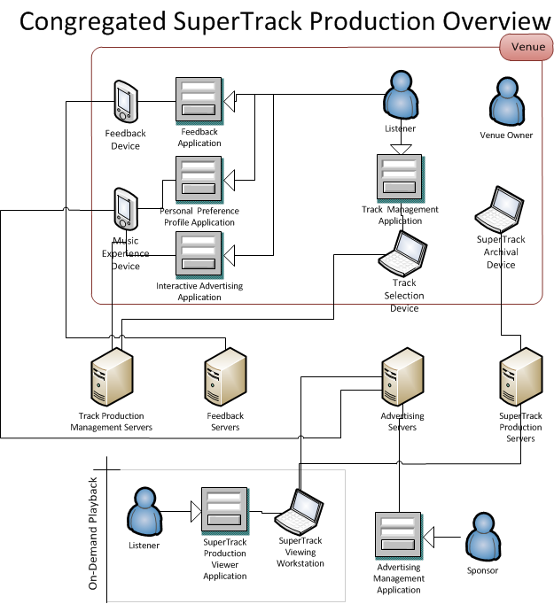

### Primary Personas

1. Track Producer
2. Track Production Manager
3. Listener
4. Venue Owner

### Applications

1. Track Selection Management Application
2. Personal Preference Profile Application
3. Feedback Application

### Devices

1. Music Experience Device
2. Track Selection Device
3. SuperTrack Archival Device

### **Process**

1. Track Producer registers with System.
2. Track Manager registers with System.
3. Sponsor registers with System.
4. Sponsor creates ad-campaign within system, and submits payment into System for a specified number of audio advertisements and/or visual advertisements.
5. Venue Owner registers with System.
6. Track Producer or Track Manager configures marketplace policy on Track Production to specify when a Track Production is allowed to play in a congregated setting.
7. Listener registers with system. Over time, a personal preference profile emerges. Personal preference profile includes statistics such as:
   1. Favorite Tracks of all time.
   2. List of current favorite Tracks.
8. Listener installs system application on Music Experience Device. Application downloads personal preference profile.
9. Listener enters venue with other Listeners.
10. Track Selection Device detects listeners and connects to system to access all detected Listeners’ personal preference profiles. This creates a Suggested Track List that consists of Listeners’ current favorite Tracks as well as “recommended” tracks from the system. Finally, these Tracks are filtered against the corresponding marketplace policies defined by Track Producers and Track Managers.
11. Track Selection Device selects a song based on the Suggested Track List and plays it.
12. Listener provides Feedback through Music Experience Device. Furthermore, Listener makes Track selections for Track Selection Device to play.
13. Over time, a SuperTrack is created, by the hour.
14. The SuperTrack is sent back to the System through the SuperTrack Archival Device.
15. Listener accesses the system to playback SuperTrack on-demand.
16. Listener submits donation to the System for the Music Experience generated from SuperTrack Production. Proceeds from donation are sent to the Congregated SuperTrack Production Commodity Chain.

## Live Broadcast SuperTrack Production

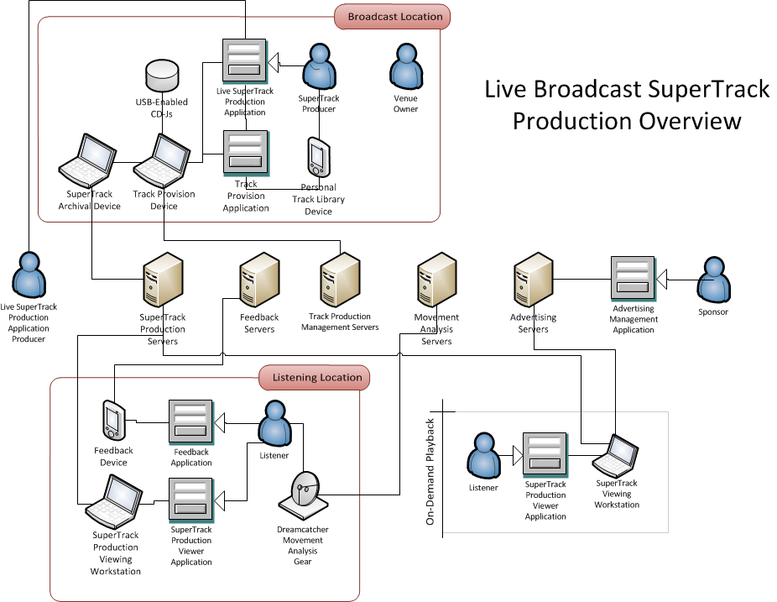

### Primary Personas

1. SuperTrack Producer
2. Live SuperTrack Production Application Producer
3. Venue Owner
4. Listener
5. Sponsor

### Applications

1. Live SuperTrack Production Application
2. Feedback Application
3. SuperTrack Production Viewer Application

### Devices

1. Track Provision Device
2. Microphone
3. Personal Track Library Device
4. 1 or more USB-Enabled CDJs
5. SuperTrack Archival Device
6. Feedback Device
7. Dreamcatcher Movement Analysis Gear

### Process

1. Sponsor registers with System.
2. Sponsor creates ad-campaign within system, and submits payment into System for a specified number of audio advertisements and/or visual advertisements.
3. SuperTrack Producer registers with system.
4. Live SuperTrack Production Application Producer registers with System.
5. Live SuperTrack Production Application Producer registers Live SuperTrack Production Application with System.
6. SuperTrack Producer creates Personal Track Library within System. This is synchronized to their Personal Track Library Device.
7. SuperTrack Producer approaches Track Provision Device. This has the Live SuperTrack Production Application installed on it.
8. The Live SuperTrack Production Application prompts for command control, asking if the user is the expected SuperTrack Producer.
9. SuperTrack Producer answers prompt. If yes, continues.
10. Live SuperTrack Production Application downloads Tracks from SuperTrack Producer’s Personal Track Library Device to the Track Provision Device.
11. Track Provision Device presents SuperTrack Producer with analysis and compiled charts based off the Personal Preference Profiles from listeners tuned into SuperTrack Production.
12. SuperTrack Producer selects Tracks to play. These Tracks are then provided to CDJ’s connected to the Track Provision Device via USB.
13. SuperTrack Producer compiles a SuperTrack from selected Tracks, and provides voice-over with microphone.
14. SuperTrack is delivered to System through the SuperTrack Archival Device.
15. During SuperTrack production, interactive advertisements from Sponsor display on Listeners’ Music Experience Devices, audio advertisements from Sponsor play at specified Auditory Advertising Placement Locations assigned by Track Producer and Track Manager. Revenue from this advertising is sent to the Live Broadcast SuperTrack Production Commodity Chain.
16. Listener provides Feedback through Music Experience Device.
17. Listener provides Feedback through Dreamcatcher Movement Analysis Gear.
18. Listener accesses the System to playback SuperTrack on-demand at later date.
19. Listener submits donation to System for the Music Experience generated from SuperTrack Production. Proceeds from donation are sent to the Live Broadcast SuperTrack Production Commodity Chain.

## Promotional SuperTrack Production

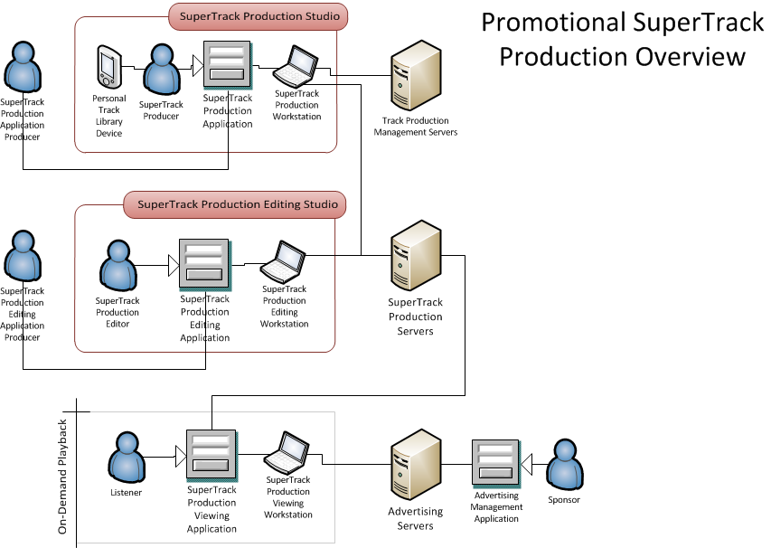

### Primary Personas

1. Track Producer
2. Track Production Manager
3. SuperTrack Producer
4. SuperTrack Production Application Producer
5. SuperTrack Production Editor
6. SuperTrack Production Editing Application Producer
7. Listener
8. Sponsor

### Applications

1. SuperTrack Production Application
2. SuperTrack Viewer Application
3. SuperTrack Production Editing Application

### Devices

1. Personal Track Library Device
2. SuperTrack Production Workstation
3. SuperTrack Viewing Device
4. SuperTrack Production Editing Workstation

### **Process**

1. Sponsor registers with System.
2. Sponsor creates ad-campaign within System, and submits payment into System for a specified number of audio advertisements and/or interactive advertisements.
3. SuperTrack Producer registers with System.
4. SuperTrack Production Application Producer registers with System and registers Production Application with System.
5. SuperTrack Production Editor registers with System.
6. SuperTrack Production Editing Application Producer registers with System.
7. SuperTrack Production Editing Application Producer registers SuperTrack Production Editing Application with System.
8. SuperTrack Producer subscribes to:
   1. Recommendations from Track Production Managers.
   2. Track releases from (unsigned and favorite) Track Producers.
9. From Track subscriptions, the SuperTrack Producer assembles a personal library that is stored on SuperTrack Producer’s Personal Track Library Device.
10. SuperTrack Producer uses SuperTrack Production Application to select list of Tracks from personal library and produces a SuperTrack.
11. **SuperTrack Producer submits Track into SuperTrack Editing Repository.**
12. **SuperTrack Producer collaborates with SuperTrack Production Editor to master finished SuperTrack.**
13. SuperTrack Producer submits SuperTrack into Broadcast Gallery. This creates a Network Location for SuperTrack Producer to promote the SuperTrack to listeners.
14. SuperTrack Producer promotes SuperTrack.
15. Listener visits SuperTrack Network Location and listens with a SuperTrack player.
16. While Listener listens through player, interactive advertisements from Sponsor display, and audio advertisements from Sponsor play at specified Auditory Advertising Placement Locations assigned by Track Producer and Track Manager. Revenue from this advertising is sent to the Promotional SuperTrack Commodity Production Chain.
17. Listener provides feedback for SuperTrack.
18. Listener submits donation to the System for the Music Experience generated from SuperTrack Production. Proceeds from donation are sent to the Promotional SuperTrack Production Commodity Chain.

## UltraTrack Production

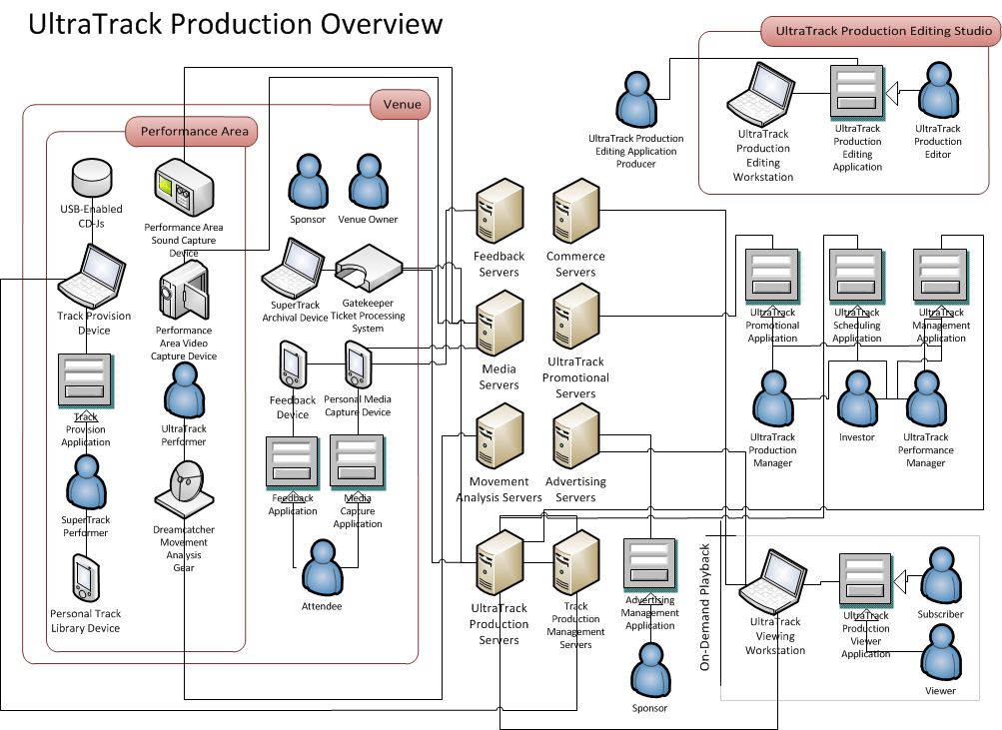

### Primary Personas

1. Venue Owner
2. UltraTrack Production Manager
3. UltraTrack Performance Manager
4. SuperTrack Producer
5. UltraTrack Performer
6. UltraTrack Production Editor
7. UltraTrack Production Editing Application Producer
8. Sponsor
9. Investor
10. Attendee
11. Viewer

### Applications

1. UltraTrack Scheduling Application
2. UltraTrack Management Application
3. UltraTrack Promotional Application
4. Track Provision Application
5. Feedback Application
6. Media Capture Application
7. UltraTrack Production Viewer Application

### Devices

1. Track Provision Device
2. SuperTrack Archival Device
3. Performance Area Sound Capturing Device
4. Performance Area Video Capturing Device
5. Personal Media Capturing Device
6. Feedback Device
7. Dreamcatcher Movement Analysis Gear
8. Gatekeeper Ticket Processing System

### Process

1. Venue Owner registers with System.
2. Sponsor registers with System.
3. Sponsor creates ad-campaign within System, and submits payment into System for a specified number of interactive advertisements displayed during UltraTrack Production playback.
4. UltraTrack Production Manager registers with System.
5. SuperTrack Production Manager registers with System.
6. SuperTrack Producer registers with System.
7. UltraTrack Production Manager registers with System.
8. UltraTrack Performer registers with System.
9. UltraTrack Production Editor registers with System.
10. Investor registers with System.
11. Attendee registers with System.
12. UltraTrack Production Manager uses the UltraTrack Scheduling Application to find an available date and venue to produce an UltraTrack Production.
    1. UltraTrack Scheduling Application lists all possible shows available based on current SuperTrack Producer and Venue availability.
13. Venue Owner and UltraTrack Production Manager negotiate terms of lease for event.
14. UltraTrack Production Manager places deposit to Venue Owner to secure venue on specified date.
15. UltraTrack Production Manager negotiates with Investors in System.
16. Investors place investments in System.
    1. Money is placed in escrow until needed.
17. UltraTrack Production Manager negotiates with UltraTrack Performance Managers to secure SuperTrack Producers and UltraTrack Performers for the UltraTrack Production.
18. UltraTrack Production Manager pays any deposits to SuperTrack Production Managers to secure SuperTrack Producers and UltraTrack Performers.
19. UltraTrack Production Manager secures Sponsor for UltraTrack Production.
20. With all parties in agreement, UltraTrack Production Manager formalizes UltraTrack Production in System and publishes its profile. This generates a Network Location for promotional and commerce purposes.
21. Attendee visits Network Location for UltraTrack Production.
22. Attendee purchases tickets from the Network Location of the UltraTrack Production.
23. Attendee participates in community feedback and discussion about UltraTrack Production.
24. UltraTrack Production Manager uses UltraTrack Promotional Application to promote UltraTrack Production.
25. Attendee attends UltraTrack Production. Approaches the entrance where Gatekeeper Ticket Processing System unit is located.
26. Attendee scans ticket through Gatekeeper Ticket Processing System. Ticket is either physical or read from Attendee’s Music Experience Device.
27. SuperTrack Producer produces SuperTrack in the same manner as a Live Broadcast SuperTrack Production.
28. UltraTrack Performers in and around Performance Area wearing Dreamcatcher Movement Analysis Gear.
29. Video of Performance Area is captured with one or more Performance Area Video Capturing Devices.
30. Sound of Performance Area is captured with one or more Performance Area Sound Capturing Devices.
31. Attendee provides feedback with the Feedback Application installed on their Personal Feedback Device.
32. Attendee moves in and around Performance Area wearing Dreamcatcher Movement Analysis Gear.
33. Attendee captures media with Media Capture Application installed on their Personal Media Capturing Device.
34. All media and data are sent to the SuperTrack Archival Device, which is then sent back to the System.
35. UltraTrack Production Manager negotiates with UltraTrack Production Editor to create a mastered UltraTrack Production.
36. UltraTrack Production Editor creates UltraTrack Production and submits it to the System.
37. UltraTrack Production Manager configures the marketplace policy of the UltraTrack Production.
38. UltraTrack Production Manager submits the UltraTrack Production into the System for marketplace commerce transactions. This is added to the UltraTrack Production’s Network Location.
39. UltraTrack Production Manager configures the broadcasting policy of the UltraTrack Production.
40. UltraTrack Production Manager submits the UltraTrack Production into the System for general broadcasting.
41. Attendee visits Network Location of UltraTrack Production to playback UltraTrack Production.
42. Attendee pays System required currency to access UltraTrack Production as defined by the UltraTrack Production’s marketplace policy. Revenue from transaction is sent to the UltraTrack Production Commodity Chain.
43. Viewer views UltraTrack Production through UltraTrack Production Viewer Application.
44. While Viewer views UltraTrack Production through the UltraTrack Production Viewer Application, interactive advertisements from Sponsor display. Revenue from this advertising is sent to the UltraTrack Production Commodity Chain.
45. Listener provides donation for the Music Experience generated from UltraTrack Production. Proceeds from donation are sent to the UltraTrack Production Commodity Chain.

## Portable Music Experience

### Primary Personas

1. Sponsor
2. Viewer

### Applications

1. Music Experience Viewer Application

### Devices

1. Music Experience Device
2. Bluetooth-enabled Speaker System

### Process

1. Sponsor registers with System.
2. Sponsor creates ad-campaign within System, and submits payment into System for a specified number of interactive advertisements displayed during UltraTrack Production playback.
3. Listener registers with System.
4. Listener pairs Music Experience Device with Bluetooth-enabled Speaker System. Bluetooth-enabled Speaker System can be in a location such as a house, workplace or automobile.
5. Listener plays Music Experiences via Music Experience Viewer Application on the Music Experience Device.
6. While Listener listens through player, interactive advertisements from Sponsor display, and audio advertisements from Sponsor play at specified Auditory Advertising Placement Locations assigned by Track Producer and Track Manager. Revenue from this advertising is sent to the appropriate Commodity Production Chain.
7. Listener provides feedback for the Music Experience.
8. Listener submits donation to the System for the Music Experience generated from production. Proceeds from donation are sent to the appropriate Commodity Chain.

# Mood Matrix

The following matrices show the major groups within the music industry before and after the System’s implementation.

## Before

|  |  |
| --- | --- |
| **The Big Four** | C:\Users\MichaelD\Documents\DragonSpark Studios\PulseNation\Images\Devilish.pngC:\Users\MichaelD\Documents\DragonSpark Studios\PulseNation\Images\Devious.pngC:\Users\MichaelD\Documents\DragonSpark Studios\PulseNation\Images\Angry.png |
| **RIAA** | C:\Users\MichaelD\Documents\DragonSpark Studios\PulseNation\Images\Confused.pngC:\Users\MichaelD\Documents\DragonSpark Studios\PulseNation\Images\Angry.png |
| **Labels** | C:\Users\MichaelD\Documents\DragonSpark Studios\PulseNation\Images\Sad.png |
| **Ticket Master** | C:\Users\MichaelD\Documents\DragonSpark Studios\PulseNation\Images\Devilish.pngC:\Users\MichaelD\Documents\DragonSpark Studios\PulseNation\Images\Delighted.png |
| **Live Nation** | C:\Users\MichaelD\Documents\DragonSpark Studios\PulseNation\Images\Devilish.pngC:\Users\MichaelD\Documents\DragonSpark Studios\PulseNation\Images\Delighted.png |
| **Restaurants** | C:\Users\MichaelD\Documents\DragonSpark Studios\PulseNation\Images\Angry.pngC:\Users\MichaelD\Documents\DragonSpark Studios\PulseNation\Images\Sad.png |
| **Artists** | C:\Users\MichaelD\Documents\DragonSpark Studios\PulseNation\Images\Sad.png |
| **Instrument Producers** | C:\Users\MichaelD\Documents\DragonSpark Studios\PulseNation\Images\Sad.png |
| **Track Production Application Producers** | C:\Users\MichaelD\Documents\DragonSpark Studios\PulseNation\Images\Sad.pngC:\Users\MichaelD\Documents\DragonSpark Studios\PulseNation\Images\Angry.png |
| **Track Producers** | C:\Users\MichaelD\Documents\DragonSpark Studios\PulseNation\Images\Sad.png |
| **Track Production Editors** | C:\Users\MichaelD\Documents\DragonSpark Studios\PulseNation\Images\Sad.png |
| **Track Production Managers** | C:\Users\MichaelD\Documents\DragonSpark Studios\PulseNation\Images\Confused.png |
| **SuperTrack Production Application Producers** | C:\Users\MichaelD\Documents\DragonSpark Studios\PulseNation\Images\Dazed.png |
| **SuperTrack Producers** | C:\Users\MichaelD\Documents\DragonSpark Studios\PulseNation\Images\Dazed.png |
| **SuperTrack Production Editors** | C:\Users\MichaelD\Documents\DragonSpark Studios\PulseNation\Images\Dazed.png |
| **UltraTrack Performance Managers** | C:\Users\MichaelD\Documents\DragonSpark Studios\PulseNation\Images\Dazed.png |
| **UltraTrack Producers** | C:\Users\MichaelD\Documents\DragonSpark Studios\PulseNation\Images\Dazed.pngC:\Users\MichaelD\Documents\DragonSpark Studios\PulseNation\Images\Angry.png |
| **Venue Owner** | C:\Users\MichaelD\Documents\DragonSpark Studios\PulseNation\Images\Dazed.pngC:\Users\MichaelD\Documents\DragonSpark Studios\PulseNation\Images\Angry.png |
| **Radio Stations** | C:\Users\MichaelD\Documents\DragonSpark Studios\PulseNation\Images\Dazed.pngC:\Users\MichaelD\Documents\DragonSpark Studios\PulseNation\Images\Confused.png |
| **Internet Broadcast Stations** | C:\Users\MichaelD\Documents\DragonSpark Studios\PulseNation\Images\Sad.pngC:\Users\MichaelD\Documents\DragonSpark Studios\PulseNation\Images\Dazed.pngC:\Users\MichaelD\Documents\DragonSpark Studios\PulseNation\Images\Confused.png |
| **Listeners** | C:\Users\MichaelD\Documents\DragonSpark Studios\PulseNation\Images\Angry.png C:\Users\MichaelD\Documents\DragonSpark Studios\PulseNation\Images\Sad.png |
| **Music Industry** | C:\Users\MichaelD\Documents\DragonSpark Studios\PulseNation\Images\Sad.pngC:\Users\MichaelD\Documents\DragonSpark Studios\PulseNation\Images\Confused.png |
| **Global Economy** | C:\Users\MichaelD\Documents\DragonSpark Studios\PulseNation\Images\Sad.png |

## After

|  |  |
| --- | --- |
| **The Big Four** | C:\Users\MichaelD\Documents\DragonSpark Studios\PulseNation\Images\Shocked.png |
| **RIAA** | C:\Users\MichaelD\Documents\DragonSpark Studios\PulseNation\Images\Dazed.png |
| **Labels** | C:\Users\MichaelD\Documents\DragonSpark Studios\PulseNation\Images\Shocked.pngC:\Users\MichaelD\Documents\DragonSpark Studios\PulseNation\Images\Happy.png |
| **Ticket Master** | C:\Users\MichaelD\Documents\DragonSpark Studios\PulseNation\Images\Shocked.png |
| **Live Nation** | C:\Users\MichaelD\Documents\DragonSpark Studios\PulseNation\Images\Shocked.png |
| **Restaurants** | C:\Users\MichaelD\Documents\DragonSpark Studios\PulseNation\Images\Delighted.png |
| **Artists** | C:\Users\MichaelD\Documents\DragonSpark Studios\PulseNation\Images\Delighted.png |
| **Instrument Producers** | C:\Users\MichaelD\Documents\DragonSpark Studios\PulseNation\Images\Delighted.png |
| **Track Production Application Producers** | C:\Users\MichaelD\Documents\DragonSpark Studios\PulseNation\Images\Delighted.png |
| **Track Producers** | C:\Users\MichaelD\Documents\DragonSpark Studios\PulseNation\Images\Delighted.png |
| **Track Production Editors** | C:\Users\MichaelD\Documents\DragonSpark Studios\PulseNation\Images\Delighted.png |
| **Track Production Managers** | C:\Users\MichaelD\Documents\DragonSpark Studios\PulseNation\Images\Delighted.png |
| **SuperTrack Production Application Producers** | C:\Users\MichaelD\Documents\DragonSpark Studios\PulseNation\Images\Shocked.pngC:\Users\MichaelD\Documents\DragonSpark Studios\PulseNation\Images\Delighted.png |
| **SuperTrack Producers** | C:\Users\MichaelD\Documents\DragonSpark Studios\PulseNation\Images\Shocked.pngC:\Users\MichaelD\Documents\DragonSpark Studios\PulseNation\Images\Delighted.png |
| **SuperTrack Production Editors** | C:\Users\MichaelD\Documents\DragonSpark Studios\PulseNation\Images\Shocked.pngC:\Users\MichaelD\Documents\DragonSpark Studios\PulseNation\Images\Delighted.png |
| **UltraTrack Performance Managers** | C:\Users\MichaelD\Documents\DragonSpark Studios\PulseNation\Images\Shocked.pngC:\Users\MichaelD\Documents\DragonSpark Studios\PulseNation\Images\Delighted.png |
| **UltraTrack Producers** | C:\Users\MichaelD\Documents\DragonSpark Studios\PulseNation\Images\Shocked.pngC:\Users\MichaelD\Documents\DragonSpark Studios\PulseNation\Images\Delighted.png |
| **Venue Owner** | C:\Users\MichaelD\Documents\DragonSpark Studios\PulseNation\Images\Shocked.pngC:\Users\MichaelD\Documents\DragonSpark Studios\PulseNation\Images\Delighted.png |
| **Radio Stations** | C:\Users\MichaelD\Documents\DragonSpark Studios\PulseNation\Images\Shocked.pngC:\Users\MichaelD\Documents\DragonSpark Studios\PulseNation\Images\Delighted.png |
| **Internet Broadcast Stations** | C:\Users\MichaelD\Documents\DragonSpark Studios\PulseNation\Images\Shocked.pngC:\Users\MichaelD\Documents\DragonSpark Studios\PulseNation\Images\Delighted.png |
| **Listeners** | C:\Users\MichaelD\Documents\DragonSpark Studios\PulseNation\Images\Shocked.pngC:\Users\MichaelD\Documents\DragonSpark Studios\PulseNation\Images\Delighted.png |
| **Music Industry** | C:\Users\MichaelD\Documents\DragonSpark Studios\PulseNation\Images\Shocked.png |
| **Global Economy** | ?!... C:\Users\MichaelD\Documents\DragonSpark Studios\PulseNation\Images\Shocked.png …?! |

# Research Implications

Since this System captures a great deal of data, starting from the creation of the note to the response on the dance floor and in the marketplace, it is possible to embark on significant research possibilities. Here are a few questions that could possibly be addressed and answered by this System.

* What is this notion of *resonance*?
* How is music created?
* Does each person have a "sound"?
* What is this "sound"?
* Does each person represent a sound (or vice versa)?
* Does a person share the same "sound" with their friends and family?
* Does a person play a "song"?
* Does an individual’s “song” resonate with particular people in the past?
* Does a person find themselves attracted to other people with like or different sounds?
* Does a person purchase items from other corporations/entities with a certain type of sound?
* Does our species play a "song" collectively?
* Can collective "notes" be tied to certain events in history?
* Is there a "code" to music?
* If so, **is there some Higher Entity (God/Universe/Earth) talking to our species through music or vice versa?**

# Patentable Concepts

The following identified concepts are candidates for patents.

1. The System (Music Experience Operating System)
2. Auditory Advertising Placement Location Framework
3. Gatekeeper Ticket Tracking System
4. Track Production Process
5. Congregated SuperTrack Process
6. SuperTrack Production Process
7. UltraTrack Production Process
8. Congregated Auditory Response Analysis
9. Congregated Music Composition
10. Portable Music Experience

# Corporate Entities and Structure

The following outlines the different corporate entities involved with The System.

* SonicPlanet Corporation
  + Technology Division
    - Orchestra O/S
  + Hardware Division
    - Music Experience Device
    - Dreamcatcher Movement Analysis Gear
    - Track Provision Device
    - Music Experience Archival Device
  + Food & Entertainment
    - UltraTrack Productions
    - Soundhouses
    - Broadcasting
      * Live
      * On-demand
* Gaialect Research International
  + Scientific non-profit
  + Analytics and research

# Glossary

## Auditory Advertising Placement Locations

These are areas within Tracks specified by Track Producers and Track Production Managers to enable Sponsors to play audio advertisements during Promotional SuperTrack playback and during Live Broadcast SuperTrack Productions.

## Dreamcatcher Movement Analysis Gear (D-Mag)

Equipment that an UltraTrack Performer or UltraTrack Attendee wears during an UltraTrack performance. This equipment consists of Bluetooth-enabled set of bands that the user wears and pairs with their Music Experience Device. The bands cover the forehead, neck (to measure vibrations from yelling), wrists, ankles and knees. An application on the Music Experience Device tracks movement incurred by the bands and sends movement data to the System.

## Feedback Application

Application installed on a Feedback device to enable a Listener or UltraTrack Attendee to provide feedback in real-time about a SuperTrack Producer’s performance. Metrics for feedback include user to relay how much they like the current set or transition, and other metrics. Additionally, the user can request songs from this application.

## Feedback Device

This device is used by a Listener or UltraTrack Attendee to enable the user to provide feedback about a performance.

## Gatekeeper Ticket Processing System

This system tracks Attendees that attend an UltraTrack Production. This system is connected to the System and processes tickets provided by the System (purchased by the attendee).

## (Virtual) Instrument

Instrument is an entity that produces a sound when combined with a Note.

## (Virtual) Instrument Producer

This is a person who produces Instruments.

## (Virtual) Instrument Library

This is a library of Instruments used by the System. Track Producers use this library while creating Track Productions.

## Instrument Production Application Provider

This is a person or organization that creates an application to create Instruments with and registers it with the System. Instrument Producers use this application to create Instruments.

## Interactive Advertising Station

A station used in a Venue to display interactive advertisements by Sponsors. Listeners can interact with the station to engage with the advertising or request Tracks for the Track Selection Device to play.

## Layer

This is a Sonic Entity. A collection of Layers comprise a Track. A collection of Notes comprise a Layer.

## Listener

This is a user of the system that views a SuperTrack Production with a SuperTrack Production Viewer Application.

## Media Capture Application

This is an application installed on an UltraTrack Production Attendee’s Music Experience Device. This application enables an Attendee to capture photos and video of an UltraTrack while it is occurring and send it to the System.

## Music Experience Device

This is a device that is carried by a Listener or UltraTrack Attendee. This device can install applications that are used by the user. An example of this device in application is a smartphone.

## Music Experience Generator

This is used to describe a location that provides music experiences. The System recognizes restaurants, radio stations and night clubs as Music Experience Generators.

## Music Source File

This is a file that contains all known data of a Track Production, including Instruments, Notes, Layers, Auditory Advertising Placement Locations, Track Production Application used, Track Production Editing Application used, Track Producer, Track Production Editor and Track Production Manager.

## Network Location

This is created when a SuperTrack Production is published, or when an UltraTrack Production Profile is created. This is accessible through a URL for promotional and commerce purposes.

## Note

This is a Sonic Entity. A collection of Notes comprise a Layer.

## Performance Area

This is an area of a Venue that is dedicated to UltraTrack Performers and Attendees. From here Feedback, Movement Metrics and Media are captured from Attendees and UltraTrack Performers.

## Performance Area Video Capturing Device

This is a device that captures video from a Performance Area and sends it to the System.

## Performance Area Sound Capturing Device

This is a device that captures audio from a Performance Area and sends it to the System.

## Personal Media Capturing Device

This is a device that’s used during an UltraTrack Production by an Attendee to capture media such as photographs and video and send them to the System.

## Personal Preference Profile Application

This application is responsible for keeping track of a System User’s list of preferred and favorite SuperTracks, Tracks and UltraTracks. This data is then used by the System whenever a Congregated SuperTrack Production is produced.

## Personal Track Library Device

This device is used by SuperTrack Producers to store their current library of most used and preferred Tracks. This device interfaces with the Track Provision Device to provide Tracks to USB-Enabled CDJs.

## Sponsor

This is an entity that has a message to promote through an advertising campaign in the System.

## SuperTrack

This is a Sonic Entity. A SuperTrack is comprised of a collection of Tracks. A collection of SuperTracks comprises an UltraTrack.

## SuperTrack Archival Device

This device is used to send SuperTrack data to the System.

## SuperTrack Producer

This is a person who produces SuperTracks.

## SuperTrack Production Application

This is an application that is used to create SuperTracks.

## SuperTrack Production Application Producer

This is a person or organization that creates an application that is used to create SuperTracks with. The person or organization then registers the application with the System.

## SuperTrack Production Editor

This is a person who edits a SuperTrack to create a finalized and mastered version of the SuperTrack.

## SuperTrack Production Workstation

This is a workstation where a SuperTrack Producer creates a SuperTrack Production.

## SuperTrack Production Viewer Application

This is an application that is used by a Listener to view a SuperTrack Production.

## SuperTrack Viewing Device

This is a device that is used to view a SuperTrack Production. This could be a Music Experience Device or Personal Workstation.

## Track

This is a Sonic Entity. A collection of Layers comprise a Track. A collection of Tracks comprise a SuperTrack.

## Track Management Application

This is an application that is used by Track Production Managers and Track Producers to collaborate, communication and negotiate with each other.

## Track Production Editor

This is a person who edits a Track Production.

## Track Production Manager

This is a person or organization that managers Track Producers and recommends Tracks to SuperTrack Producers. This could also be thought of as a traditional record label.

## Track Producer

This is a person who produces a Track.

## Track Production Application

This is an application that enables a Track Producer to create a Track Production.

## Track Production Application Producer

This is a person or organization that creates an application that enables a Track Producer to create a Track Production.

## Track Production Editing Application

This is an application that enables a Track Production Editor to edit a Track Production to a finalized (or mastered) state.

## Track Production Editing Application Producer

This is a person or organization that creates an application that enables a Track Production Editor to edit a Track Production.

## Track Production Editor

This is a person who edits a Track Production so that it is in a final (or mastered) state.

## Track Production Workstation

This is a workstation that a Track Producer uses to create a Track Production.

## Track Provision Device

This is a device that provides tracks to a SuperTrack Producer during Promotional SuperTrack Productions, Live Broadcast SuperTrack Productions and UltraTrack Productions.

## Track Selection Device

This is a device that is used during Congregated SuperTrack Productions to select Tracks based on the aggregate Track profile that is comprised from all Listeners detected in the area.

## Track Selection Management Application

This is an application that is used at a Congregated SuperTrack Production that enables Listeners in the area to request Tracks to play for the SuperTrack Production.

## UltraTrack

This is the highest Sonic Entity in the Sonic Entity Hierarchy. An UltraTrack is comprised of a collection of SuperTracks.

## UltraTrack Production Manager

This is a person who manages all parties responsible for an UltraTrack Production.

## UltraTrack Production Viewer Application

This is an application that enables an UltraTrack Attendee to view an UltraTrack after it’s been produced.

## UltraTrack Performer

This is a person who performs during an UltraTrack production.

## Venue Owner

This is someone who owns a venue that is used to produce an UltraTrack performance in, as well as host a Congregated SuperTrack Production.

## USB-Enabled CDJ

This device interfaces with a Track Provision Device to play Track Productions during Live Broadcast SuperTrack Productions and UltraTrack Productions.

# Claims

1. Process to Track Production as described herein.
2. Process for Promotional SuperTrack Production as described herein.
3. Process for Congregated SuperTrack Production as described herein.
4. Process for Live Broadcast SuperTrack Production as described herein.
5. Process for UltraTrack Production as described herein.

# Abstract

Describes a Music Experience Operating System, which is a networked system of components that enables music experiences to be produced, broadcasted, and sponsored in a holistic manner, ensuring that all parties who are responsible for generating the experience are compensated appropriately.