A bad Network:

This is an example of a bad network, design. It works, but, what if the connection between switch one and Switch2 is broken? If this happens, then everything that is bellow Switch two won’t get any connection, to the internet, or locally.

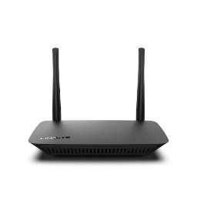

Router

Computers

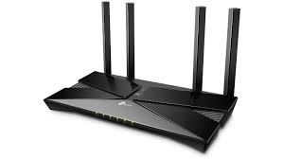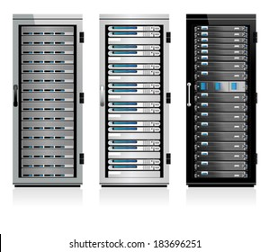

Phone

WAP

Switch # 1

Server

Switch # 2

Computers

Switch # 3

Computers

**IMPORTANT**

As we can see, if one of the cables, or one of the Switches goes down all the network that follows that device will fall. Those points are called **Single Points of Failure**, and you want to eliminate as many of those as you can. The goal here is being **Redundant**, which means exactly that, eliminate the **SPF’s**

A good Connection:

There are two kind of Good network design we are going to study from Cisco. The **Two-Tier Network Design Model** and the **Three-Tier Network Design Model**. Of course, the Three-Tier is better since it adds more power and more redundancy.

Connection philosophy:

Here we are dividing the connections by Layers. The number of layers will depend of the Design type, if is the **Two-Tier Network Design Model**, it has two layers; and of course if is the **Three-Tier Network Design Model** it has three layers.

Layers:

* Core Layer (3)

-----Three-Tier Model----- -----Two-Tier Model-----

* Distribution Layer (2) or Collapsed Core Layer in (2)
* Access Layer (1)

What’s New?

Here we are introducing a new device which is not new at all but a better-bigger-faster version of it. Here we introduce a **Multilayer Switch**.

**Multilayer Switch:**

This device as its name indicates, is a switch that can read IP addresses and MAC addresses alike. This is a device that has an enormous capacity of load, with a really big number of ports for a really big number of devices, that require a really big amount of traffic.

We connect all of our devices to this Switches and also, to another Multilayer Switch at the same height in the Layers (Layer 2) as is described above.

Why not just use a Router?

The router is a great idea if what we want is to connect to the internet, but if we want our data flow to go only locally without going through the internet, we are going to need a switch to connect the devices and not a router. Then, the router comes after whatever happens to be the last layer in our Network Design.