Ethernet Cables and custom links:

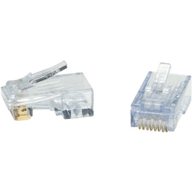Sometimes we face the fact that our ethernet cable broke or someone cut it. The less expensive way of getting one is by making one for yourself but…how does it works?

Sometimes this can be as easy as putting an ethernet cable head at the end of the ethernet cable, but this can be a bit tricky.

Frist we have to remove at least half inch of the outer cable.

Once we remove the outer cable this is what we see:

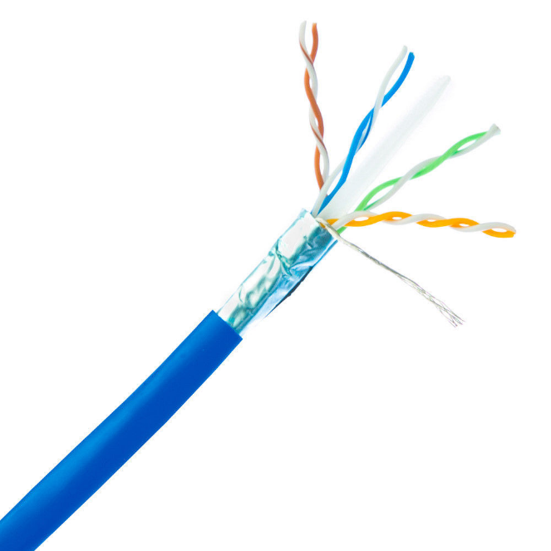 **STP-Shielded Twisted Pair () Outer**

**UTP-Unshielded Twisted Pair () Outer (This one is used in places with less interference)**

**Orange**

**White - Orange**

**Blue**

**White - Blue**

**Green**

**White - Green**

**Brown**

**White - Brown**

The ethernet cables depend on electrons to take the signal from one place to another, and as we know an electrical signal can be affected by another electrical signal, and sometimes by itself. That’s why we use an external coverture, to protect it from damages and from the electromagnetic field coming from other electrical signals.

Why are they Twisted?

As we said before, even the internal structure of the ethernet cable can create EMI (Electromagnetic Interference) so what we do is that we twist them so the force’s vector can’t interfere with the other cables electromagnetic fields.

Also, is important to point out that the pairs describe a closed circuit, in, and out. This means that the signal comes in through one of the pair’s cables and then it goes out through the other one.

What are the wires made of?

The answer is cupper, old boring amazing electric connectivity cable of cupper. There are four pairs, the pairs represent let’s say siblings, and each pair contains the main color, let’s say blue, and a white and blue cable.

This structure is known as a Category-5e Cable or **Cat5e-Ethernet cable** **.**

Fun Fact:

Before this structure we use to have a structure of only 4 cables, this structure is known as the 10base-T (10-mbps T-twisted). In 1995 we introduced the 100BASE-TX (100mbps T-twisted). There are other notations like LX and S, but that’s fiver.

We still had 4 cables, but the speed went up 10 times. What happened?

We went from Cat3 to Cat5, the difference here is the type of cable we are using. What we are doing now to send and receive signals is that we change the voltage, let’s say for example 2.5v and -2.5v. Being 2.5v a “1” and -2.5v a “0”.

This has a loophole, because then this would only be useful for receiving or transmitting, not both. Well, we have two pairs of cables so…One pair for RC and one pair for TX.

Now let’s talk about how we connect our cable to the head of the ethernet cable.

There are 8 pins in an ethernet cable’s head, and only the **first** **two** are used to send data. When you want to receive anything, you will receive it in pins **three** and **six**. Now this is only the case for a device that often sends data, like a PC or something like that, not a switch because let’s remember that at the end of this cable, there is a switch. Well, the switch is going to receive data and send data on the exact contrary way as the PC sends it because the ethernet cable used is going to be the same

|  |  |  |  |  |  |  |  |  |  |  |  |  |  |  |  |  |
| --- | --- | --- | --- | --- | --- | --- | --- | --- | --- | --- | --- | --- | --- | --- | --- | --- |
| 1 | |  | 2 |  | 3 | |  | 4 |  | 5 |  | 6 |  | 7 |  | 8 |
|  |  |  |  |  |  |  |  |  |  |
| 1 | | 2 | 3 | | 4 | 5 | 6 | 7 | 8 |

How do we use to connect to sender devices?

We can’t connect two sender devices this way, like a raspberry pi and a computer, or two computers, for example, so what’s the solution?

The solution is quite simple, because here, one device’s mouth is talking to the other device’s mouth instead of it hears. So, what we do is that we just match ears and mouths.

|  |  |  |  |  |  |  |  |  |  |
| --- | --- | --- | --- | --- | --- | --- | --- | --- | --- |
|  |  |  |  |  |  |  |  |  |  |

|  |  |  |  |  |  |  |  |  |  |
| --- | --- | --- | --- | --- | --- | --- | --- | --- | --- |
|  |  |  |  |  |  |  |  |  |  |

With the new distribution don’t need to worry about sending and receiving data between different types of devices. This means that if we are going to build a PC to Switch ethernet cable, the distribution is the one described In the New Distribution table. If is a sender device to sender device, then we have to **cross the cables** as we did before with the 4 cables set. It doesn’t matter about the new cables inserted, those remain the same

New Distribution:

|  |  |  |  |  |  |  |  |  |  |  |  |  |  |  |  |  |  |  |
| --- | --- | --- | --- | --- | --- | --- | --- | --- | --- | --- | --- | --- | --- | --- | --- | --- | --- | --- |
| 1 | |  | 2 |  | 3 | |  | 4 |  | 5 | |  | 6 |  | 7 | |  | 8 |
|  |  |  |  |  |  |  |  |  |  |  |  |
| 1 | | 2 | 3 | | 4 | 5 | | 6 | 7 | | 8 |

Switches Connected:

When we connect a switch with another switch, we’d think that we must create this new type of connection to make sure the data is transmitted, but no. The switch can automatically detect from where the data is coming and adapt to receive and send data on those pings according to the distribution of the pings that we set.

PoE ( Power over Ethernet ):

Power over internet is a term that refers to give power to a device, like a phone through the Ethernet cable. Why do in mean by that?

Devices like phones to work, need two main things, an internet connection an a power source. This means two cables. But what if we could have them both in just one cable? This very question was what brough Power over ethernet to life.

*There are two types of PoE:*

**Active** and **Passive**.

**Active**: Negotiates with the receiving part how much power does it needs. There is a process before the receiver device gets the power. In that process the sender device (Switch in this case) determines how much power does the receiver device (camera or phone) needs.

This way if we connect a computer to a Switch, which doesn’t need any power because is a PC it already has power, the switch wont sent any power to it because of the protocol we established before.

**Passive**: Is always ON, is always active. Even if we connect a device which already has power the switch will give power to the device.

Fiver:

Fiver is another way of connecting devices. The mayor difference between fiver and an ethernet cable is the speed. Since the speed of an electron depends on the voltage applied, and the speed of light doesn’t vary I mean…is the only universal constant. We can use light to transmit signals because electrons and photons are able to react with each other, making light perfect to long distance transport, and electricity to run the devices.

We are talking here about 100Tbs per second.

How does it work:

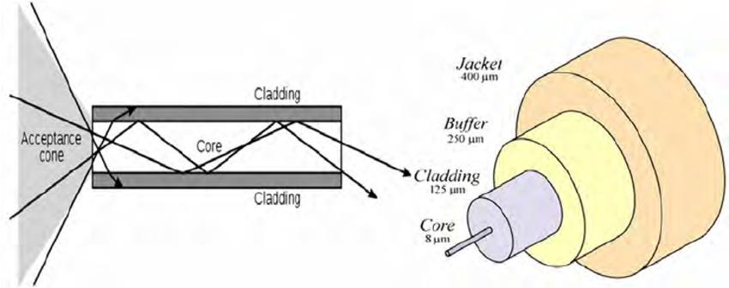

What we want to do here is to get to the critical angle. The critical angle is what happens when we are in the road and is hot. This produces a similar effect because we get two different media (even being the same its density is different is different places because of the temperature).

Normally when we have two different densities some of the light is reflected, and some of the light is refracted. Here happens the contrary to the hot road’s example because there we get Total reflection, meaning that no light gets in, all the light gets reflected.

What we are trying to accomplish here is that the light stays trapped inside the inner media or core. So, we try to get the critical angle for **Total Internal Refraction**.

Single mode and Multimode: Depending on how big is the core, it will be the speed, the quality and the price. Single mode is the same cable but 5-9 nanometers, which means that light now wastes less energy to get to the same distance because the bouncing becomes infinitesimal, meaning, is almost as if the light goes straight.

Pros and Cons:

Pros: We already mentioned before that the speed is an expected Pro since the beginning, but there is more of it. Since the photons can’t interfere with the electromagnetic field like the electros, they cause no interference in the signal. If our fiver cable is straight, we can extend it for long distances ( 100km ), while with the ethernet wire, we couldn’t.

Cons: They’re expensive and difficult to manage.