Mike Gao
260915701

Question 1

1 a)
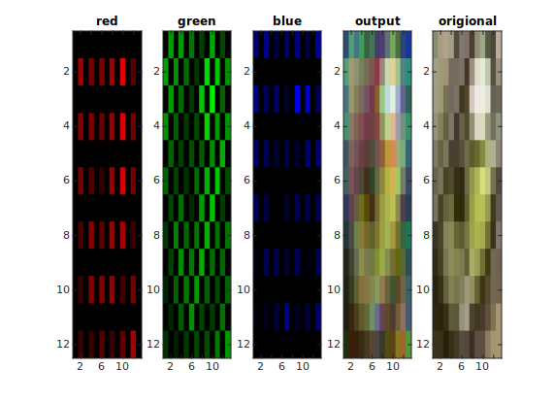

1 b)
Red / Blue Filter [0.25 0.5 0.25;0.5 1 0.5;0.25 0.5 0.25]
Green Filter [0 0.25 0;0.25 1 0.25;0 0.25 0]

1 c)
You’re essentially losing information because of your Bayer pattern sample so the output is not very sharp anymore. When you average the color, you might get some color that is not in the original picture resulting in some artifact. Because of the use of linear interpolation, the image is still smooth.
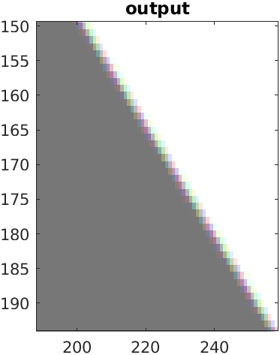

Question 2

2 a)
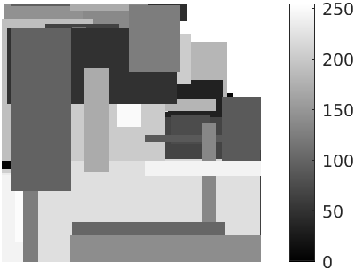
2 b)
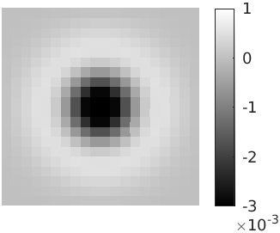
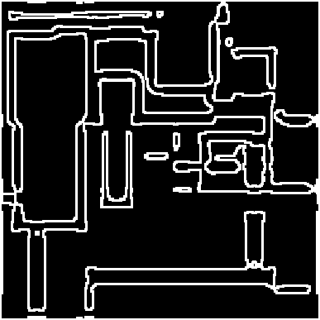
2 c)

2 d)
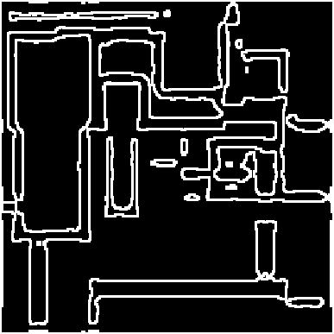
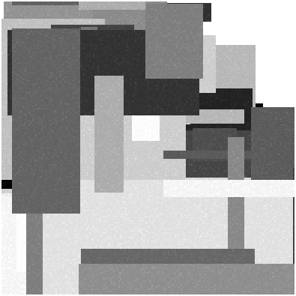
2 e)
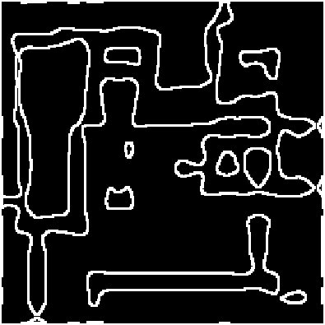

Straight lines became more curve like. Density of zero crossings decreased with the new filter, because we’re now more tolerant to noises thanks to the larger filter. The corner of the shapes are more curved due to the fact that Laplacian of Gaussian is symmetric.

Question 3

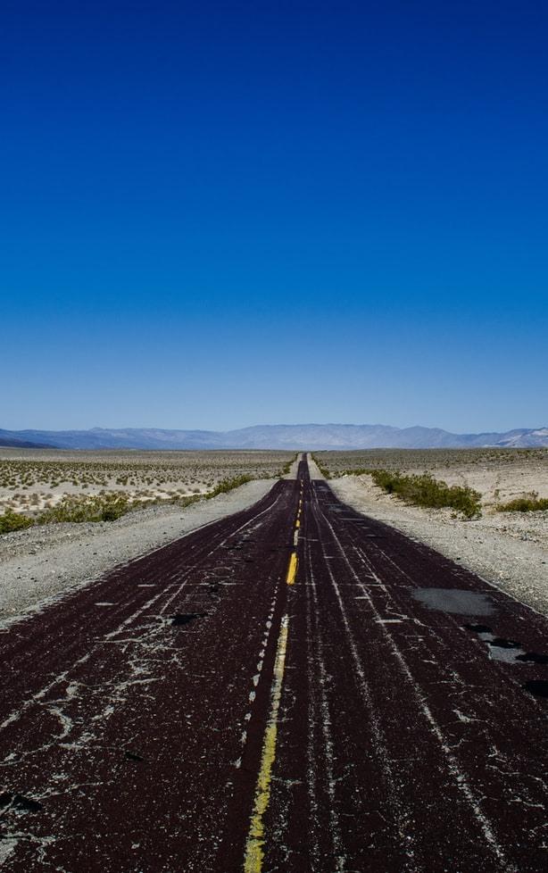
3 a)
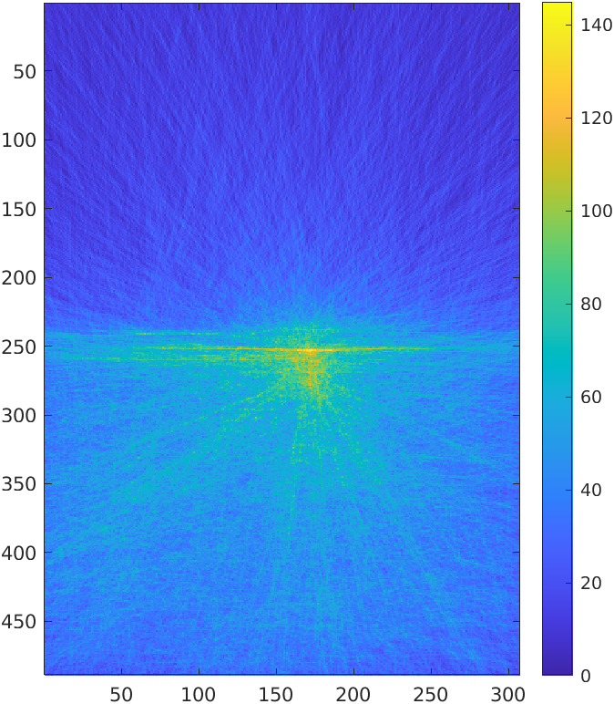
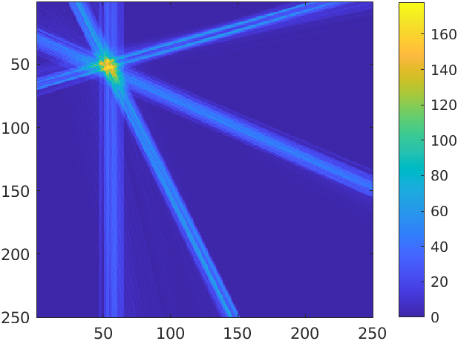
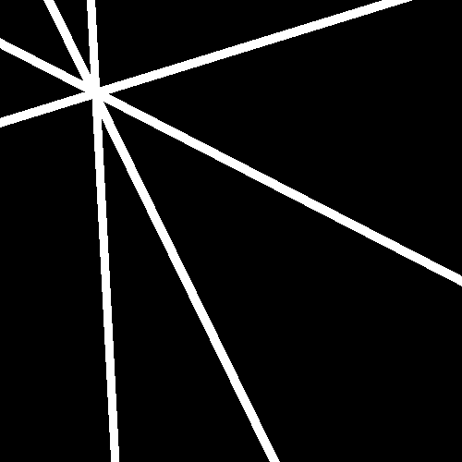

3 b)
Our Algorithm: O(NE) since we have O(N) operation for every edge, there are E edges so the complexity is O(NE).
For the proposed method, there are E^2 edges. The computation of the intersection is O(1). We do it for each pair of edge, resulting in the computational complexity of O(E^2)
So for an image with greater number of edges, our method is better, whereas for an image with a smaller number of edges, the proposed method is better.

