Mike Gao
260915701

Q1
Gaussian Scale Space
Synthetic
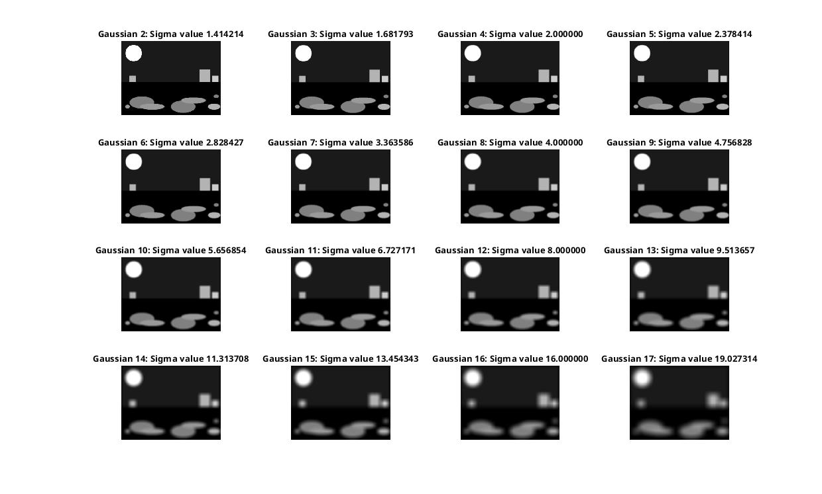
Natural
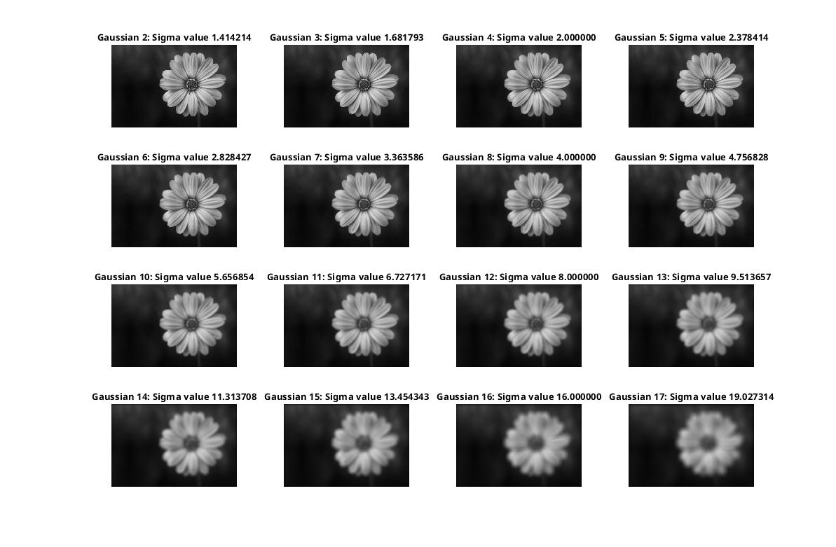

Q2
Harris-Stevens
Synthetic
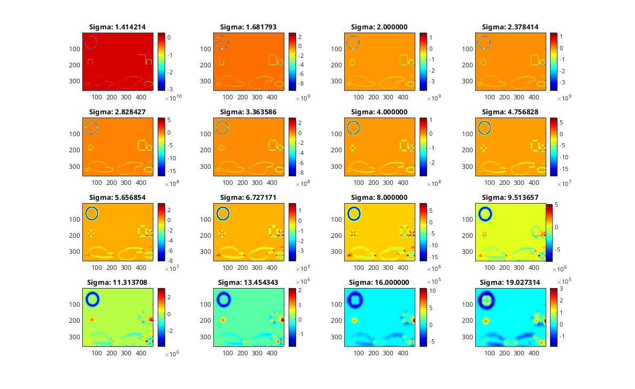
Natural
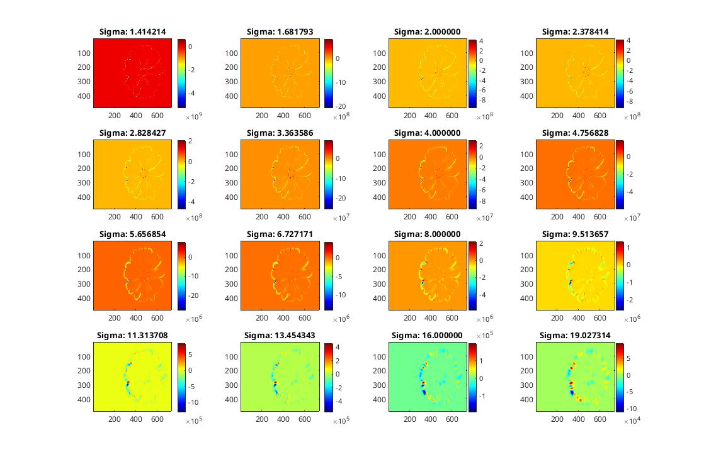

Q3
Difference of Gaussian
Synthetic
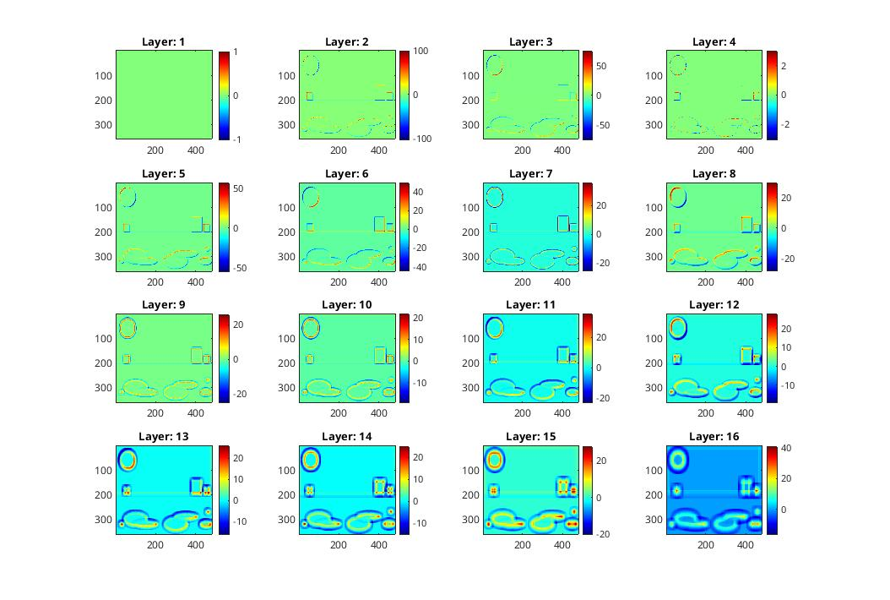
Natural

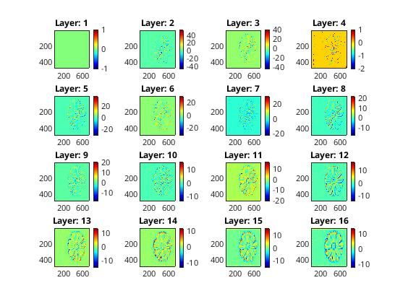
Discussion:
Difference of Gaussian highlights the edges in the images. At higher scale space levels zero crossings became thicker. That is because the blurred image has less pronounced edges.
Q4
SIFT Keypoint Detection
Synthetic
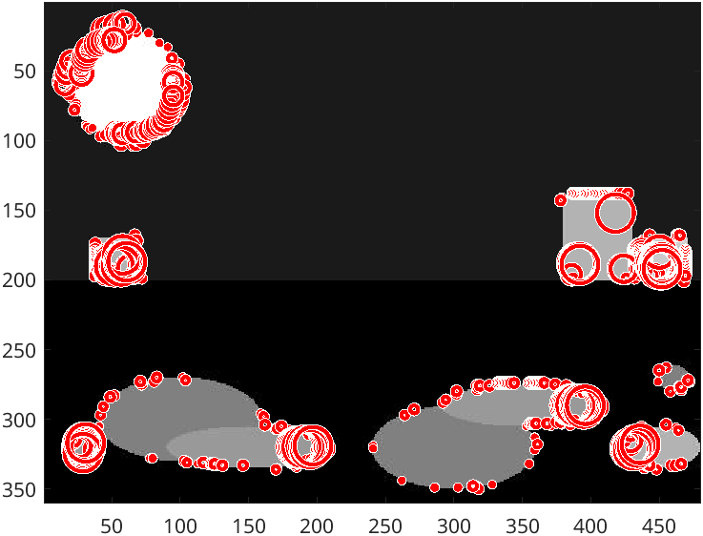
Natural
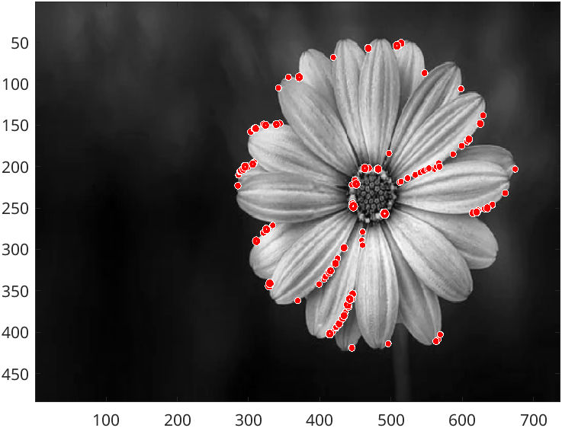

Q5
Hessian Constraint
Synthetic
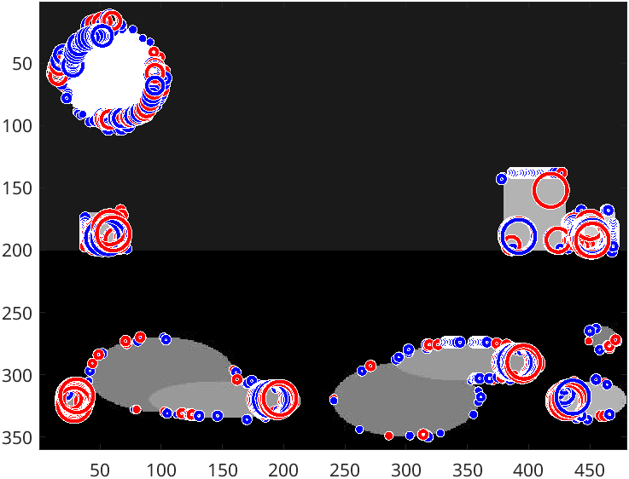

Natural
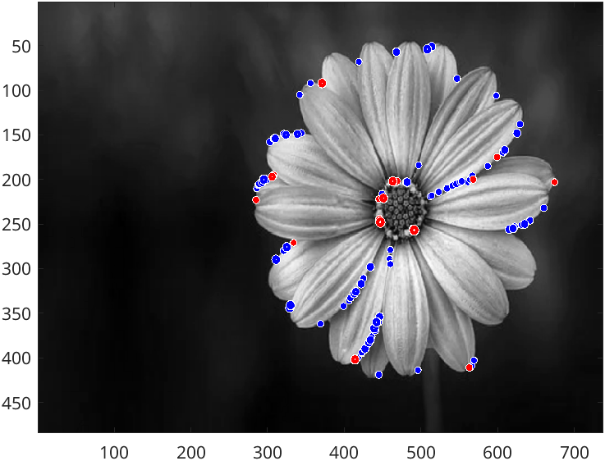
Approximating hessian by getting a neighborhood, and computing the gradient of x y in order to obtain the hessian matrix.

Q6
Synthetic

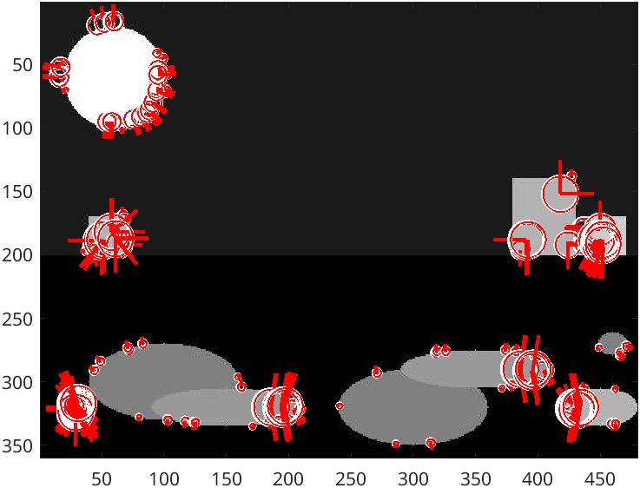
Natural
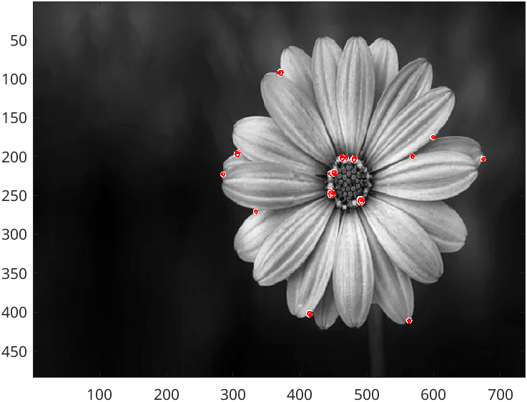

Q7
Key points in the newly re-scaled images correspond in the expected way with the key points in the original images. See below for a scaled version of the synthetic image and natural image.
