COVID-19 outbreaks in Australian residential aged care homes

# National snapshot

As at 8:00 am 10 October 2024, there are 709 active COVID-19 cases reported in 121 active outbreaks in residential aged care homes (RACHs) across Australia. There have been 53 new outbreaks, 7 new resident deaths and 615 combined new resident and staff cases reported since 3 October 2024.  
  
**Table 1: Aged Care COVID-19 data as at 8.00am 10 October 2024[1]**

| Category | Active*[2]* | Change in active (7 days) | Cumulative  Total | Cumulative increase (7 days) |
| --- | --- | --- | --- | --- |
| **Outbreaks[3]** | 121 | 11 | 23,152 | 53 |
| **RACHs affected** | 121 | 11 | 2,898 | 0 |
| **Resident cases[4]** | 525 | -50 | 225,457 | 460 |
| **Resident deaths** |  |  | 7,019 | 7 |
| **Staff cases** | 184 | -11 | 121,338 | 155 |

Residential aged care homes with active outbreaks are included in Appendix.  
  
Table 2: Overview of active outbreaks in Australia

|  |  |  |  |  |  |  |  |  |  |
| --- | --- | --- | --- | --- | --- | --- | --- | --- | --- |
|  | ACT | NSW | NT | QLD | SA | TAS | VIC | WA | Total |
| Total RACHs with outbreaks | 0 | 36 | 0 | 10 | 9 | 3 | 56 | 7 | **121** |
| *Total number of active resident cases* | 0 | 148 | 0 | 70 | 38 | 24 | 226 | 19 | **525** |
| *Total number of active staff cases* | 0 | 44 | 0 | 24 | 10 | 15 | 82 | 9 | **184** |
| Total outbreaks opened in previous 7 days | 0 | 11 | 0 | 0 | 5 | 2 | 31 | 4 | **53** |
| Total outbreaks closed in previous 7 days | 0 | 13 | 0 | 4 | 2 | 0 | 21 | 1 | **41** |

**Figure 1: National outbreak trends in aged care**

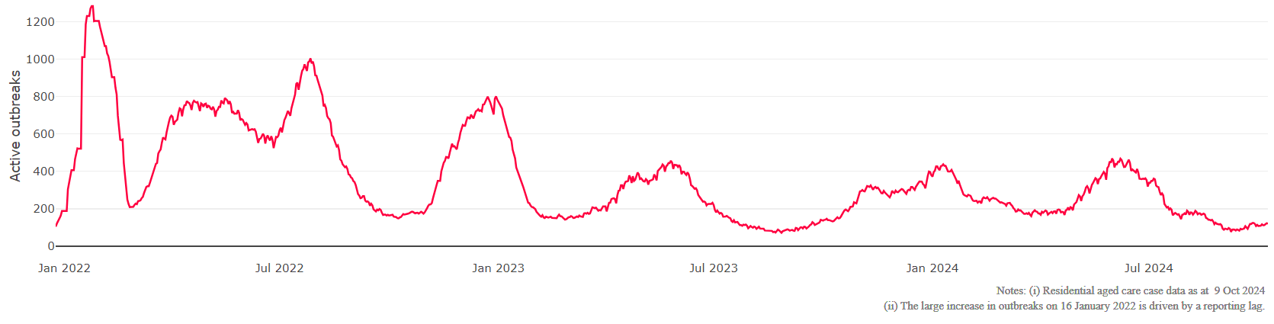

**Figure 2: Trends in aged care cases – December 2021 to present**

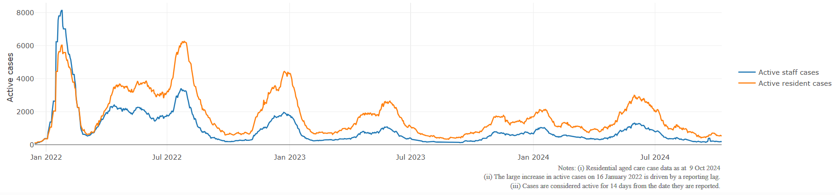

## Mortality

For the period of 1 July 2024 to 10 October 2024, COVID-19 is recorded as the cause of death in 1.6% of all deaths in permanent residents in aged care homes.

Since the beginning of the Omicron outbreak in mid-December[5] 2021, there have been 166,804 deaths in residential aged care from all causes (report period from 15 December 2021 to 24 September 2024)[6]. COVID-19 deaths account for 3.7% of this figure.

There has been a decrease year on year for the rate of case fatality[7], from a 33% case fatality rate in resident COVID-19 cases in 2020 to 3.3% in 2022 and 1.9% since   
1 July 2024.

Over the course of the pandemic, all-cause excess mortality in residential aged care was below expected numbers in 2020, and within expected range in 2021. In the first half of 2022, all-cause excess mortality in residential aged care was above the expected range. Excess mortality for the second half of the 2022 is yet to be finalised.

**Figure 3: COVID-19 deaths in RACHs overlaid with community deaths**

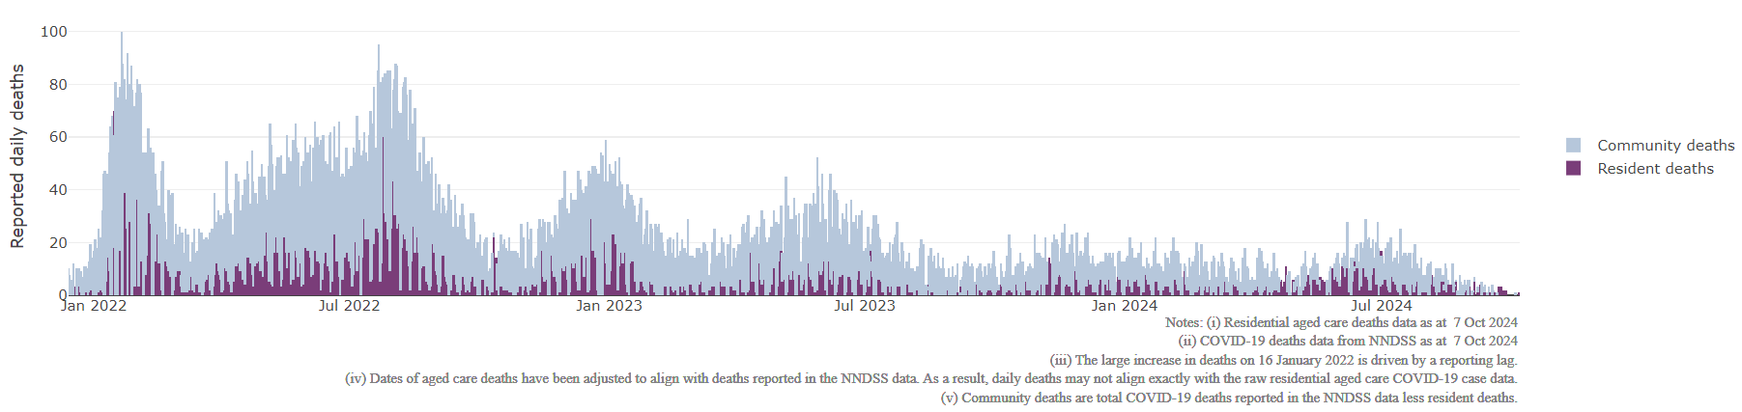

## Workforce in active residential aged care outbreaks

As at 9 October 2024, surge workforce providers report a total of 198,496 shifts delivered in aged care services impacted by COVID-19. These shifts include roles for GPs, nurses, care workers, allied health workers, executive and ancillary staff. In the past week surge workforce providers have reported assisting 9 residential aged care homes and filled 207 shifts in aged care services.

Table 3: Workforce resources supplied to RACHs

| Workforce provider | Total shifts | Previous 7 days | |
| --- | --- | --- | --- |
| Aspen Medical8 | 32,106 | 81 |
| HealthX9 | 36,768 | 126 |
| Randstad10 | 878 | 0 |
| Previous contracted providers11 | 128,744 | N/A |
| **Total** | **198,496** | **207** |

8Aspen Medical shift data as at 9 October 2024, reported fortnightly.

9HealthX shift data as at 9 October 2024, reported weekly.

10Randstad shift data as at 9 October 2024, reported weekly.

11Previous contracted providers include RCSA, HealthCare Australia, Mable and Torrens.

## Oral antiviral treatments

Distribution of the oral anti-viral Lagevrio (Molnupiravir) commenced on 6 February 2022 to all RACHs with outbreak sites prioritised for delivery. The National Medical Stockpile has deployed 48,269 treatment courses of Lagevrio (Molnupiravir) to RACHs.

138,624 prescriptions for Lagevrio (Molnupiravir) have been issued to residents in RACHs, with a further 18,329 prescriptions for Paxlovid (nirmatrelvir + ritonavir) also issued since 28 February 2022 and up to 30 September 2024.­

*\*Note: Oral antiviral data is only being updated monthly.*

**Vaccination in RACHs**

On 29 February 2024, recommendations for 2024 COVID-19 vaccinations were released. Recommended doses for the program in 2024 are based on an individual's age and level of severe immunocompromise.

In 2024, those aged 75 years and over are recommended to get a COVID-19 vaccine dose every 6 months. Those aged over 65 years of age, and adults with severe immunocompromise are recommended to receive a COVID-19 vaccine dose every 12 months and are eligible to receive a COVID-19 vaccine dose every 6 months based on individual risk-benefit assessments. All other adults can receive a single dose this year.

Recommendations can be found on the Department of Health and Aged Care (department) website at:   
  
<https://www.health.gov.au/our-work/covid-19-vaccines/getting-your-vaccination/booster-doses>.   
  
People are encouraged to seek vaccination advice from their healthcare providers, specific to their circumstances.

People living in residential aged care are a high priority for the Government’s COVID-19 vaccination program.

Older age remains the biggest risk factor for severe COVID-19 disease. Vaccination offers added protection to help reduce the risk of severe illness or hospitalisation of aged care residents.

The department is working with both the aged care and primary care sectors to ensure residents have access to the COVID-19 vaccine. The department continues to target support for RACHs to arrange COVID-19 vaccinations with local primary care providers such as GPs, community pharmacists and Aboriginal Community Controlled Health Services.

As at 9 October 2024:

* 71.9% of aged care residents have received a booster dose in the last 12 months.
* For residents over the age of 75:
  + 86,426 (52.4%) aged care residents received a booster dose in the last 6 months.
* 6,892 aged care residents have received a vaccination in the last 28 days (compared to 14,477 in the 28 days prior).

**Table 4: Aged care COVID-19 Booster Doses (data as at 9 October 2024)**

| Jurisdiction | 75+ with booster in last 6 months | |
| --- | --- | --- |
| Residents vaccinated | % of residents vaccinated |
| **National** | **86,426** | **52.4%** |
| NSW | 27,602 | 51.9% |
| VIC | 22,920 | 53.7% |
| QLD | 16,824 | 50.8% |
| WA | 8,097 | 52.8% |
| SA | 7,631 | 53.0% |
| TAS | 1,833 | 49.2% |
| ACT | 1,330 | 62.8% |
| NT | <200 | 51.6% |

*Data in this report is sourced from Australian Immunisation Register (AIR) data of residents in permanent residential aged care homes.*

*An updated data methodology was implemented on 7 August 2024. Aged Care AIR data as at 9 October 2024; Matched AIR data uses a snapshot of permanent residents in residential aged care homes as at 31 May 2024. The Residential Aged Care Home {RACH) Recipient ID to Medicare PIN linkage file was loaded into Health Enterprise Data Warehouse on 11 July 2024 which linked Medicare Consumer Directory data as at 11 October 2023 and RACH recipient data as at 31 January 2024.*

*Note: Booster doses in this report refer to any dose 2 or above administered to an individual.*

## Infection control and audit

The Aged Care Quality and Safety Commission (Commission) conducts site audits and assessment contacts (site and non-site) to monitor and assess residential aged care services against the Aged Care Quality Standards (see Table 5 below). This may include conducting infection control monitoring (ICM) spot checks.

An ICM spot check involves an on-site visit to residential aged care services, without an outbreak, to observe infection control practices, to ensure that staff, management, and visitors are adhering to safe personal protective equipment protocols and to safe infection control arrangements, as required under the Quality Standards.

As at 10 October 2024, the Commission had conducted 6,068 ICM spot checks to observe infection control practices and PPE protocols in RACHs.

Table 5: Total quality assessment and monitoring activities with residential services (including IPC), by type and month 1 March 2020 to 10 October 2024

|  |  |  |  |  |  |  |  |
| --- | --- | --- | --- | --- | --- | --- | --- |
| Regulatory Activities | 2019-20  (1 Mar - 30 Jun 2020) | 2020-21 | 2021-22 | 2022-23 | 2023-24 | 2024-25 (to 10 Oct 2024) | Total |
| ****Site visits**** | 318 | 3,452 | 1,732 | 3,814 | 2,840 | 729 | **12,885** |
| ****Non-site activities**** | 3,704 | 8,396 | 6,665 | 1,413 | 487 | 168 | **20,833** |
| Total activities | 4,022 | 11,848 | 8,397 | 5,227 | 3,327 | 887 | **33,718** |

# Appendix: National residential aged care homes (RACHs) with active outbreaks COVID-19

Please note, information reported in this table has been directly reported to the department by RACHs.   
‘Total cases’ refers to all staff and resident cases associated with the active outbreak and may not reflect the count of currently active cases. Where numbers have been incorrectly reported, RACHs are able to correct these in the COVID-19 Support Portal through My Aged Care.   
Where a RACH is reporting less than six resident or staff cases or less than six deaths, data has been suppressed to protect the privacy of affected individuals (note that “n/p” indicates data is not provided to protect privacy).   
Data below for individual services is as at 10 October 2024.

| Service Name | State | Resident Deaths | Resident Cases | Staff  Cases | Total Cases |
| --- | --- | --- | --- | --- | --- |
| Anglican Care Jesmond Grove | New South Wales | <6 | 23 | <6 | n/p |
| Anglicare Donington Court | New South Wales | 0 | <6 | <6 | <6 |
| Anglicare Elizabeth Lodge | New South Wales | 0 | 9 | <6 | n/p |
| Anglicare Mary Andrews Village | New South Wales | 0 | <6 | 0 | <6 |
| Arcare Oatlands | New South Wales | 0 | <6 | <6 | 6 |
| Ascott Gardens | New South Wales | 0 | <6 | <6 | 6 |
| Avondale House | New South Wales | 0 | 21 | 12 | 33 |
| Bolton Clarke Cabrini | New South Wales | 0 | <6 | 0 | <6 |
| Calvary Mt Carmel Retirement Community | New South Wales | 0 | <6 | <6 | <6 |
| Calvary St Joseph's Retirement Community | New South Wales | 0 | <6 | 0 | <6 |
| Carino Care at Russell Lea | New South Wales | 0 | 30 | 9 | 39 |
| Casa Mia Aged Care Centre | New South Wales | 0 | 29 | <6 | n/p |
| Catholic Healthcare Macquarie Care Centre | New South Wales | 0 | <6 | <6 | 8 |
| Columbia Aged Care Services - Oberon Village | New South Wales | 0 | 11 | 11 | 22 |
| Constitution Hill Aged Care | New South Wales | 0 | <6 | 0 | <6 |
| Cooinda | New South Wales | 0 | <6 | 0 | <6 |
| Dellacourt | New South Wales | 0 | <6 | 0 | <6 |
| Dubbo Homestead Care Community | New South Wales | 0 | 11 | <6 | n/p |
| Frank And Jess Kennett Home | New South Wales | 0 | <6 | <6 | 7 |
| Genista Aged Care Facility | New South Wales | 0 | 16 | <6 | n/p |
| HammondCare - Horsley | New South Wales | 0 | <6 | <6 | <6 |
| IRT Macarthur | New South Wales | 0 | <6 | <6 | 7 |
| Paling Court Residential Aged Care | New South Wales | 0 | 14 | <6 | n/p |
| Pembroke Lodge | New South Wales | 0 | 17 | <6 | n/p |
| Randwick Montefiore Home | New South Wales | 0 | 0 | <6 | <6 |
| RFBI Cessnock Masonic Village | New South Wales | 0 | 15 | <6 | n/p |
| St Vincent's Care Services Yennora | New South Wales | <6 | 9 | <6 | n/p |
| The Whiddon Group - Grafton | New South Wales | 0 | <6 | 7 | n/p |
| Toongabbie Terrace Care Community | New South Wales | 0 | 14 | <6 | n/p |
| Uniting Aldersgate Lilyfield | New South Wales | 0 | 15 | 6 | 21 |
| Uniting Elanora Shellharbour | New South Wales | 0 | <6 | 0 | <6 |
| Uniting Kamilaroi Lane Cove | New South Wales | 0 | <6 | <6 | <6 |
| Uniting Mullauna Blacktown | New South Wales | 0 | <6 | 0 | <6 |
| Uniting Nunyara Peakhurst | New South Wales | 0 | 25 | <6 | n/p |
| Uniting Osborne Nowra | New South Wales | 0 | 30 | 6 | 36 |
| Wagga Wagga Community Aged Care | New South Wales | 0 | <6 | 0 | <6 |
| Blue Care Capricorn Aged Care Facility | Queensland | 0 | 22 | 9 | 31 |
| Blue Care Kenmore Aged Care Facility | Queensland | 0 | 11 | 6 | 17 |
| Blue Care Lowood Glenwood Aged Care Facility | Queensland | 0 | 19 | 10 | 29 |
| Blue Care Mackay Homefield Aged Care Facility | Queensland | 0 | 21 | 14 | 35 |
| Bolton Clarke Baycrest | Queensland | 0 | 7 | <6 | n/p |
| Kerrisdale Gardens | Queensland | 0 | 10 | 10 | 20 |
| Ozcare Innisfail | Queensland | <6 | 30 | 17 | 47 |
| Regis Maroochydore | Queensland | 0 | <6 | 0 | <6 |
| Sinnamon Village - Knowles Court | Queensland | 0 | 19 | <6 | n/p |
| St Paul de Chartres Residential Aged Care | Queensland | 0 | <6 | 0 | <6 |
| ACH Group Residential Care - Perry Park (high care) | South Australia | 0 | <6 | 0 | <6 |
| Bonney Lodge | South Australia | 0 | <6 | <6 | 7 |
| Carmelite Residential Care | South Australia | 0 | 8 | <6 | n/p |
| Ceduna MPS | South Australia | 0 | <6 | 0 | <6 |
| Estia Health Salisbury East | South Australia | 0 | 11 | <6 | n/p |
| Longridge Aged Care | South Australia | 0 | <6 | 0 | <6 |
| Ridleyton Greek Home for the Aged | South Australia | 0 | 27 | 7 | 34 |
| St Louis Nursing Home | South Australia | 0 | <6 | 0 | <6 |
| Warrina Park Residential Aged Care Service | South Australia | 0 | <6 | <6 | 6 |
| May Shaw Residential Aged Care | Tasmania | 0 | <6 | <6 | 6 |
| The Queen Victoria Home | Tasmania | 0 | 20 | 13 | 33 |
| Tyler Village | Tasmania | 0 | <6 | <6 | <6 |
| Anzac Lodge Private Nursing Home | Victoria | 0 | 6 | 0 | 6 |
| Arcare Carnegie | Victoria | 0 | <6 | 0 | <6 |
| Arcare Cheltenham | Victoria | 0 | <6 | 0 | <6 |
| Arcare Portarlington | Victoria | 0 | <6 | <6 | <6 |
| Aurrum Plenty | Victoria | 0 | 13 | 0 | 13 |
| Banksia Lodge Residential Aged Care Service | Victoria | 0 | <6 | 0 | <6 |
| Baptcare Peninsula View Community | Victoria | 0 | <6 | <6 | <6 |
| Baptcare Wyndham Lodge Community | Victoria | 0 | 12 | <6 | n/p |
| Beechworth Health Service Residential Care Program | Victoria | 0 | 11 | <6 | n/p |
| Bentons Lodge - Residential Aged Service | Victoria | 0 | <6 | <6 | 7 |
| BlueCross Baradine | Victoria | 0 | <6 | <6 | <6 |
| BlueCross Scotchmans Creek | Victoria | 0 | 20 | <6 | n/p |
| Bolton Clarke Glendale (VIC) | Victoria | <6 | 60 | 12 | 72 |
| Bolton Clarke Newmans on the Park | Victoria | 0 | <6 | 0 | <6 |
| Boronia Residential Aged Care | Victoria | 0 | <6 | <6 | <6 |
| Bupa Clayton | Victoria | 0 | 7 | <6 | n/p |
| Bupa Coburg | Victoria | 0 | 10 | <6 | n/p |
| Bupa Croydon | Victoria | 0 | 7 | 0 | 7 |
| Bupa Templestowe | Victoria | 0 | 13 | <6 | n/p |
| Calvary Elouera | Victoria | 0 | 6 | <6 | n/p |
| Calvary Sandhurst | Victoria | 0 | <6 | <6 | 6 |
| Carshalton House Hostel | Victoria | <6 | 22 | <6 | n/p |
| Casterton Memorial Hospital Nursing Home | Victoria | 0 | <6 | <6 | <6 |
| Charles Brownlow Retirement Village | Victoria | 0 | 9 | <6 | n/p |
| Chelsea Lodge Hostel | Victoria | 0 | <6 | 0 | <6 |
| Coppin Centre | Victoria | 0 | <6 | <6 | 8 |
| Creswick District Nursing Home | Victoria | 0 | <6 | 10 | n/p |
| Diamond Creek Care Community | Victoria | 0 | 6 | <6 | n/p |
| Dianella Hostel | Victoria | 0 | <6 | <6 | 8 |
| Drysdale Grove | Victoria | 0 | <6 | <6 | 7 |
| Embracia in Reservoir | Victoria | 0 | 20 | <6 | n/p |
| Estia Health Bentleigh | Victoria | 0 | <6 | <6 | <6 |
| Heritage Gardens | Victoria | 0 | <6 | 0 | <6 |
| Johnson-Goodwin Memorial Homes | Victoria | 0 | 27 | 17 | 44 |
| Kardinia Parkside Care Community | Victoria | 0 | <6 | 0 | <6 |
| Lakeview Nursing Home | Victoria | 0 | <6 | <6 | <6 |
| Lifeview Argyle Court | Victoria | 0 | <6 | 0 | <6 |
| Lifeview Emerald Glades | Victoria | 0 | 27 | <6 | n/p |
| mecwacare Annie's Court | Victoria | 0 | <6 | <6 | 7 |
| mecwacare Calwell Manor | Victoria | 0 | 9 | 6 | 15 |
| mecwacare Simon Price Centre | Victoria | 0 | 14 | <6 | n/p |
| Mercy Place Lynbrook | Victoria | 0 | 14 | <6 | n/p |
| Mercy Place Parkville | Victoria | <6 | 22 | 9 | 31 |
| Olivet Aged Persons Home | Victoria | 0 | <6 | <6 | <6 |
| Rathdowne Place | Victoria | 0 | 8 | <6 | n/p |
| Regis Shenley Manor | Victoria | 0 | <6 | 0 | <6 |
| Shepparton Aged Care | Victoria | 0 | 18 | <6 | n/p |
| Sheridan Aged Care | Victoria | 0 | 6 | 8 | 14 |
| St Vincent's Care Services Hawthorn | Victoria | 0 | <6 | <6 | <6 |
| Trinity Manor | Victoria | 0 | 23 | 6 | 29 |
| Twin Parks Aged Care Centre | Victoria | 0 | <6 | <6 | <6 |
| Uniting AgeWell Hawthorn Community | Victoria | 0 | 13 | <6 | n/p |
| Vasey RSL Care Bundoora | Victoria | 0 | <6 | 0 | <6 |
| Victoria Grange Residential Aged Care Facility | Victoria | 0 | <6 | <6 | <6 |
| Village Baxter - Manor | Victoria | 0 | <6 | <6 | 7 |
| Wannon Court Hostel | Victoria | 0 | <6 | <6 | <6 |
| Armadale Place Care Community | Western Australia | 0 | 26 | 14 | 40 |
| Baptistcare Gracewood | Western Australia | 0 | <6 | 0 | <6 |
| Brightwater Birralee | Western Australia | 0 | 13 | 0 | 13 |
| Juniper Numbala Nunga | Western Australia | 0 | <6 | 0 | <6 |
| Lady McCusker Home | Western Australia | 0 | <6 | 0 | <6 |
| MercyCare Maddington | Western Australia | 0 | <6 | <6 | <6 |
| Michael Lee Centre | Western Australia | 0 | <6 | 0 | <6 |

1. Outbreak opening and closure includes changes in the status of exposure sites to outbreaks (and vice versa), which are applied retrospectively to facility records. New case information can also change the status of a recovered site back to an active outbreak site. As a result, changes in active outbreak status may not align with day-on-day variations to active totals. These adjustments will also affect the number of cases in staff and residents reported each week.
2. Active residents and staff cases are the total currently positive cases in active outbreaks
3. An outbreak is considered to be active pending advice from the relevant Public Health Unit. An outbreak is defined as at least 1 (one) positive case in a resident or 2+ cases in staff.
4. Case numbers and numbers of deaths are dependent upon reporting from RACHs. This is subject to change as further information is provided.
5. The Omicron outbreak start date has been redefined from late November 2021 to mid-December 2021. Changes have been made to align reporting with the start date of Omicron published in the department’s external facing Epidemiology report.
6. The department is now accessing aged care deaths data from the SIEBEL dataset. Figures are live and subject to change. Source: Department of Health and Aged Care unpublished data / SIEBEL dataset.
7. Case fatality calculated as total reported resident COVID-19 deaths divided by total resident COVID-19 cases.