This is my first time to submit a dashboard to Figure Friday. My dashboarding skills are barely past the Hello World level; I hope to improve them in the coming weeks.

I enhanced the solution offered for this week’s exercise which included a line plot and dash AG table. I added a histogram, changed changed the currency units from billions of US dollars to millions of US dollars, changed the graph template to ‘simple_white’, and updated axis labels and graph titles. A pulldown selects the spending category, then updates the data in the line plot, histogram and the table.

This screen shot has selected IAP-USAID. The line plot matches the plot given in this week’s exercise.

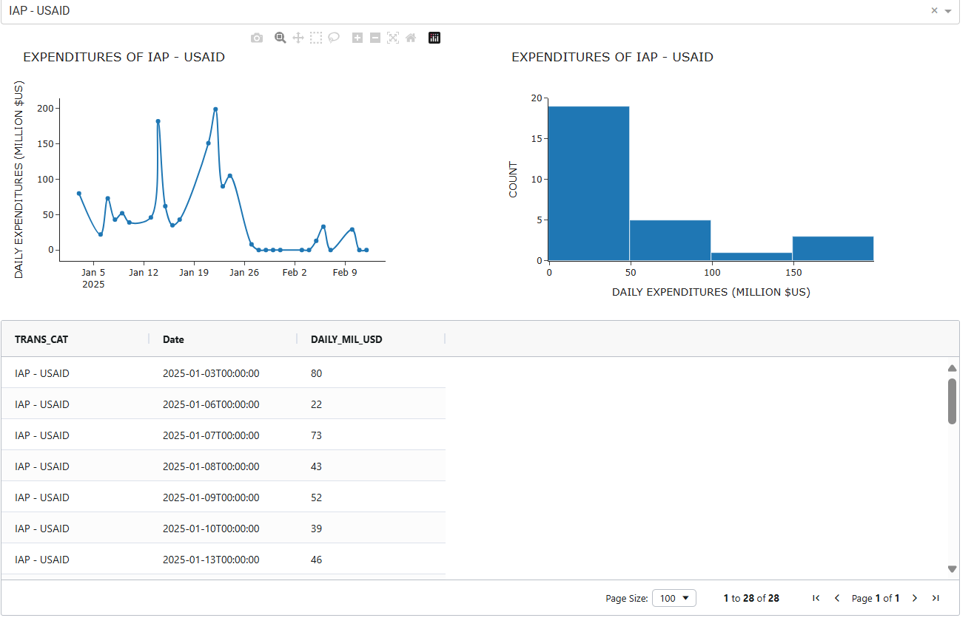

This screen shots show federal salary payment. I assume from the peaks that federal employees are paid every other Friday, with payday in January on January 3 and January 17.

Here is the code: