Procedural Modeling Project Notes for a Chinese Dragon
Project Topic | Procedural Modeling of a Chinese Dragon | Modeling Tool | OpenSCAD

1. Project Goal and Personal Responsibility
My main responsibility within the group was to complete the model structure design, code implementation, detail refinement, and STL file export.
The final modeling solution followed a modular approach, dividing the model into the head, body, front legs, and back legs so that the parts could be exported separately and reused later.
- Model Structure Description
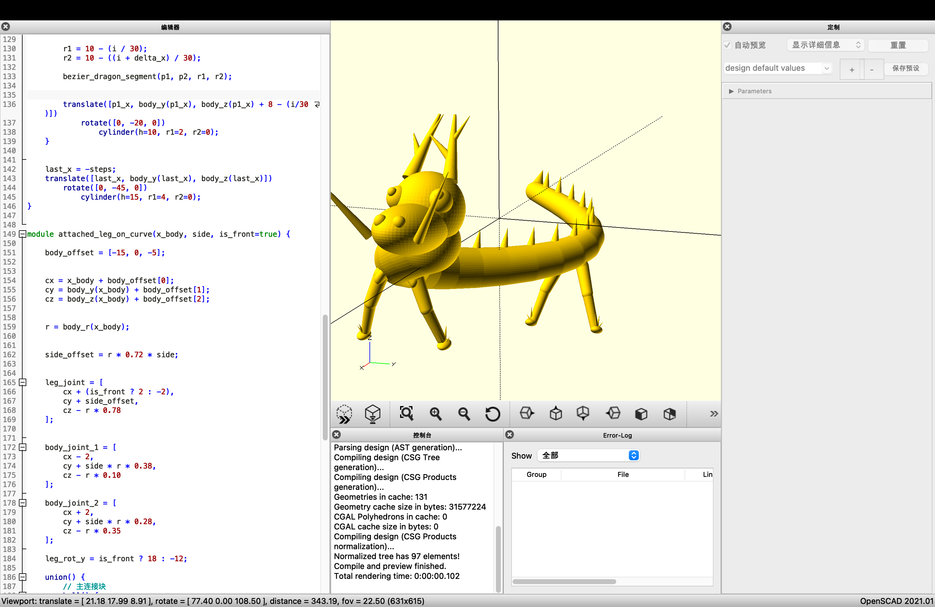
Since the code is too long, I’ve put it separately in a text file named code.txt.
Component | Main Technique | Implementation Notes
Head | sphere / cylinder / translate / rotate | The snout, back of the head, and brow ridge are formed by combining spheres, then horns, whiskers, and nostril details are added to make the model more recognizable as a Chinese dragon.
Body | Curve functions + hull() | Cross-sections are placed along a non-linear curve, and hull is used to smoothly connect adjacent segments to form a winding continuous body.
Limbs | Modular leg component | The front and back legs are generated from a shared module, with parameters used to distinguish their length, angle, and foot position.
Attachment logic | Body-curve binding | The legs are no longer attached using fixed straight-line coordinates. Instead, their attachment points are computed automatically from the body’s y / z / radius at the corresponding x position.
Export | Switch variables + STL | Boolean switches such as SHOW_HEAD and SHOW_BODY are used to control visible parts, and the currently visible geometry is then exported.
When previewing the model, the preview speed is accelerated by reducing the value of $fn. After confirming that the model is error-free, the value is reset to 60 for the final export to produce a smoother result.
Subsequently, toggle parameters are used to control the display and export of individual modeling components, such as the head, body, front legs, and hind legs. The entire model is set to gold to facilitate the observation of the model’s outline and structural relationships within OpenSCAD.
The bending direction of the body is controlled using sine functions: body_y(x) governs lateral sway, and body_z(x) controls vertical undulation, creating a continuous, winding trajectory for the dragon’s body. The body radius tapers gradually along its length, resulting in a thicker front section and a thinner tail, which conforms to the natural form of a dragon’s body.
In terms of specific implementation, the body is not constructed from a single cylinder; instead, multiple spheres are arranged along a curved path, and adjacent segments are smoothly connected using the hull() function. Dorsal spines are added along the top of the body to enhance its outline characteristics and decorative effect.
The head is composed of a combination of multiple spheres and cylinders. The dragon horns are coded as an independent module, consisting of one main horn and two branched protrusions.
The legs were the key focus of adjustments in the later stage. Initially, the leg positions were hard-coded, meaning that although the front and hind legs were present, they did not actually follow the curved body. This was later revised to calculate the attachment positions of the legs based on the body’s curve functions, allowing the legs to be distributed naturally along the body’s contour instead of being aligned in a straight line. To create a more natural connection between the legs and the body, additional connection reference points were added between the body and the leg bases, and the hull() function was applied to achieve a smooth transition. This ensures that the legs do not look like separately inserted parts, but rather like integral parts growing out of the body. The leg structures themselves are also generated using a combination of spheres and the hull() function.
The entire model adopts a modular modeling method, with the head, body, and legs coded separately. This enables the export of individual STL files, providing convenience for subsequent animation, coloring, and presentation.

3. Problems Encountered and How They Were Solved
No. | Problem Encountered | Solution
1 | At first, I placed JavaScript-style OpenJSCAD code into OpenSCAD, which caused a parser error on line 1 immediately. | After confirming that the two systems use different syntax, I rewrote the code in true .scad syntax using native OpenSCAD constructs such as sphere, cylinder, module, and hull.
2 | The first version of the model had only a body similar to a bent tube, so the dragon was not visually recognizable enough. | I strengthened the head features and added horns, whiskers, eyes, nostrils, dorsal spikes, and claws so that the outline and visual symbols matched a Chinese dragon more closely.
3 | Rendering was very slow, and F6 caused OpenSCAD to handle too much computation. | I lowered $fn during preview, used a low subdivision level for testing, and restored a higher subdivision level only before STL export. I also avoided unnecessary high-complexity debugging.
4 | At the beginning, the legs were not truly connected to the body and were only placed near it. | I added a connection module and used hull to generate a smooth transition between the body attachment point and the leg root, so the legs and torso became one continuous structure.
5 | Although the legs were later connected, the relationship still looked unnatural, and the front and back legs still seemed to lie on one straight line. | I restructured the binding logic. Instead of hanging the legs using fixed world coordinates, I reused the body-curve functions and automatically computed the leg attachment points from the body’s y, z, and radius at the corresponding position.
6 | At first, I was not sure whether the STL exported by OpenSCAD represented the full model or only a partial model. | I added the SHOW_HEAD, SHOW_BODY, SHOW_FRONT_LEGS, and SHOW_BACK_LEGS switches, then controlled what was visible first and exported only the currently visible STL.

