Q3:

.globl map

.text

main:

jal ra, create_default_list

add s0, a0, x0 # a0 = s0 is head of node list

#print the list

add a0, s0, x0

jal ra, print_list

# print a newline

jal ra, print_newline

# load your args

add a0, s0, x0 # load the address of the first node into a0

# load the address of the function in question into a1 (check out la on the green sheet)

### YOUR CODE HERE ###

la a1, square

# issue the call to map

jal ra, map

# print the list

add a0, s0, x0

jal ra, print_list

# print another newline

jal ra, print_newline

addi a0, x0, 10

ecall #Terminate the program

map:

# Prologue: Make space on the stack and back-up registers

### YOUR CODE HERE ###

addi sp sp -12

sw s0, 8(sp)

sw s1, 4(sp)

sw ra, 0(sp)

beq a0, x0, done # If we were given a null pointer (address 0), we're done.

mv s0, a0 # Save address of this node in s0

mv s1, a1 # Save address of function in s1

# Remember that each node is 8 bytes long: 4 for the value followed by 4 for the pointer to next.

# What does this tell you about how you access the value and how you access the pointer to next?

# load the value of the current node into a0

# THINK: why a0?

### YOUR CODE HERE ###

lw a0, 0(s0)

# Call the function in question on that value. DO NOT use a label (be prepared to answer why).

# What function? Recall the parameters of "map"

### YOUR CODE HERE ###

jalr s1

# store the returned value back into the node

# Where can you assume the returned value is?

### YOUR CODE HERE ###

sw a0, 0(s0)

# Load the address of the next node into a0

# The Address of the next node is an attribute of the current node.

# Think about how structs are organized in memory.

### YOUR CODE HERE ###

lw a0, 4(s0)

# Put the address of the function back into a1 to prepare for the recursion

# THINK: why a1? What about a0?

### YOUR CODE HERE ###

mv a1, s1

# recurse

### YOUR CODE HERE ###

jal ra, map

done:

# Epilogue: Restore register values and free space from the stack

### YOUR CODE HERE ###

lw s0, 8(sp)

lw s1, 4(sp)

lw ra, 0(sp)

addi sp sp 12

jr ra # Return to caller

square:

mul a0 ,a0, a0

jr ra

create_default_list:

addi sp, sp, -12

sw ra, 0(sp)

sw s0, 4(sp)

sw s1, 8(sp)

li s0, 0 # pointer to the last node we handled

li s1, 0 # number of nodes handled

loop: #do...

li a0, 8

jal ra, malloc # get memory for the next node

sw s1, 0(a0) # node->value = i

sw s0, 4(a0) # node->next = last

add s0, a0, x0 # last = node

addi s1, s1, 1 # i++

addi t0, x0, 10

bne s1, t0, loop # ... while i!= 10

lw ra, 0(sp)

lw s0, 4(sp)

lw s1, 8(sp)

addi sp, sp, 12

jr ra

print_list:

bne a0, x0, printMeAndRecurse

jr ra # nothing to print

printMeAndRecurse:

add t0, a0, x0 # t0 gets current node address

lw a1, 0(t0) # a1 gets value in current node

addi a0, x0, 1 # prepare for print integer ecall

ecall

addi a1, x0, ' ' # a0 gets address of string containing space

addi a0, x0, 11 # prepare for print string syscall

ecall

lw a0, 4(t0) # a0 gets address of next node

jal x0, print_list # recurse. We don't have to use jal because we already have where we want to return to in ra

print_newline:

addi a1, x0, '\n' # Load in ascii code for newline

addi a0, x0, 11

ecall

jr ra

malloc:

addi a1, a0, 0

addi a0, x0 9

ecall

jr ra

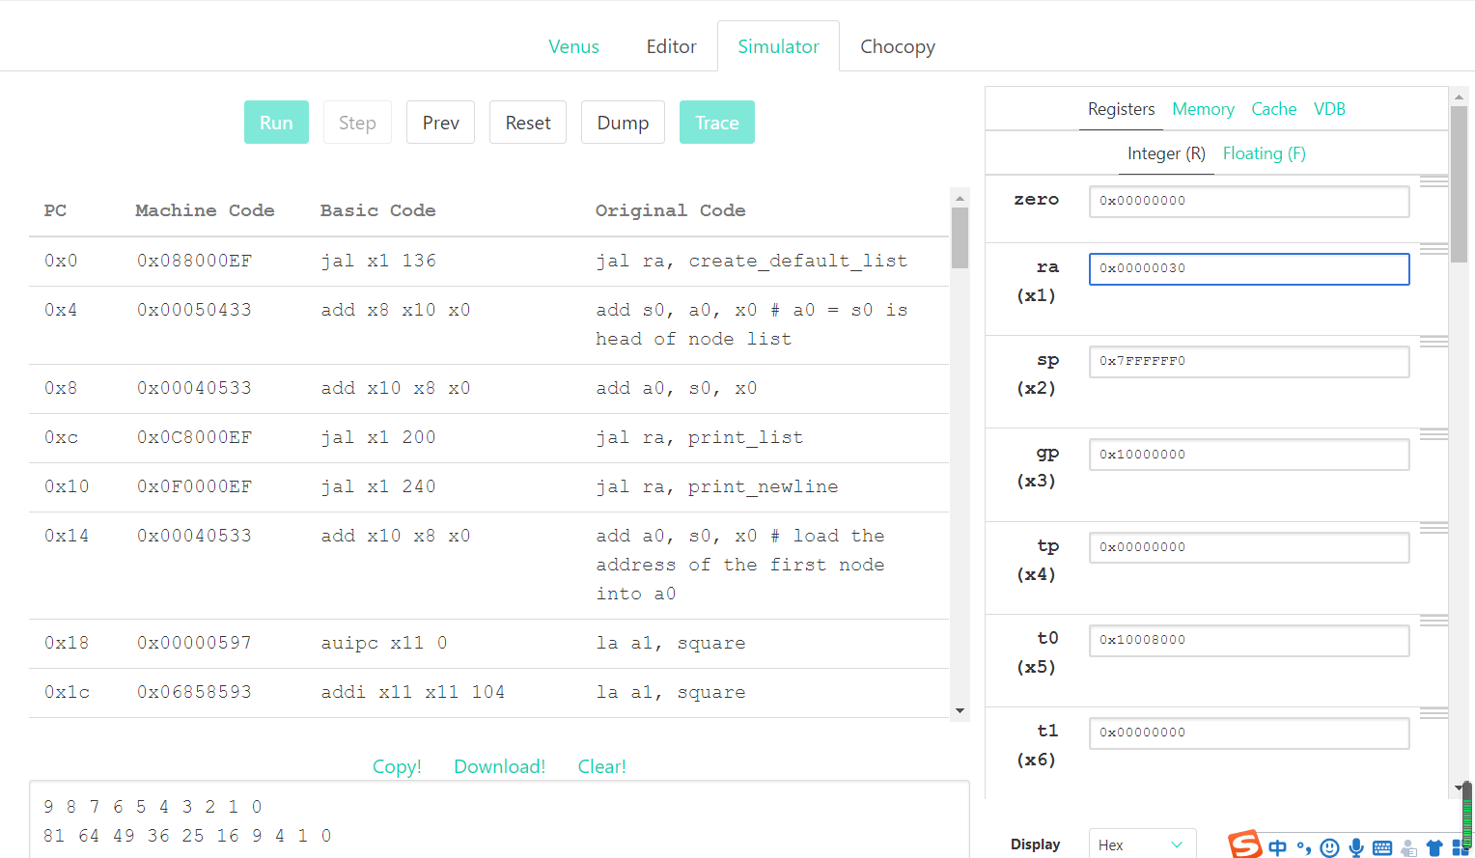

Q4:

.globl map

.data

arrays: .word 5, 6, 7, 8, 9

.word 1, 2, 3, 4, 7

.word 5, 2, 7, 4, 3

.word 1, 6, 3, 8, 4

.word 5, 2, 7, 8, 1

start_msg: .asciiz "Lists before: \n"

end_msg: .asciiz "Lists after: \n"

.text

main:

jal create_default_list

mv s0, a0 # v0 = s0 is head of node list

#print "lists before: "

la a1, start_msg

li a0, 4

ecall

#print the list

add a0, s0, x0

jal print_list

# print a newline

jal print_newline

# issue the map call

add a0, s0, x0 # load the address of the first node into a0

la a1, mystery # load the address of the function into a1

jal ra, map

# print "lists after: "

la a1, end_msg

li a0, 4

ecall

# print the list

add a0, s0, x0

jal print_list

li a0, 10

ecall

map:

addi sp, sp, -12

sw ra, 0(sp)

sw s1, 4(sp)

sw s0, 8(sp)

beq a0, x0, done # if we were given a null pointer, we're done.

add s0, a0, x0 # save address of this node in s0

add s1, a1, x0 # save address of function in s1

add t0, x0, x0 # t0 is a counter

# remember that each node is 12 bytes long:

# - 4 for the array pointer

# - 4 for the size of the array

# - 4 more for the pointer to the next node

# also keep in mind that we should not make ANY assumption on which registers

# are modified by the callees, even when we know the content inside the functions

# we call. this is to enforce the abstraction barrier of calling convention.

mapLoop:

lw t1, 0(s0) # load the address of the array of current node into t1

lw t2, 4(s0) # load the size of the node's array into t2

slli t3, t0, 2

add t1, t1, t3 # offset the array address by the count

lw a0, 0(t1) # load the value at that address into a0

mv t4, t1

jalr s1 # call the function on that value.

mv t1, t4

sw a0, 0(t1) # store the returned value back into the array

addi t0, t0, 1 # increment the count

bne t0, t2, mapLoop # repeat if we haven't reached the array size yet

lw a0, 8(s0) # load the address of the next node into a0

mv a1, s1 # put the address of the function back into a1 to prepare for the recursion

jal ra, map # recurse

done:

lw s0, 8(sp)

lw s1, 4(sp)

lw ra, 0(sp)

addi sp, sp, 12

jr ra

mystery:

mul t1, a0, a0

add a0, t1, a0

jr ra

create_default_list:

addi sp, sp, -4

sw ra, 0(sp)

li s0, 0 # pointer to the last node we handled

li s1, 0 # number of nodes handled

li s2, 5 # size

la s3, arrays

loop: #do...

li a0, 12

jal malloc # get memory for the next node

mv s4, a0

li a0, 20

jal malloc # get memory for this array

sw a0, 0(s4) # node->arr = malloc

lw a0, 0(s4)

mv a1, s3

jal fillArray # copy ints over to node->arr

sw s2, 4(s4) # node->size = size (4)

sw s0, 8(s4) # node-> next = previously created node

add s0, x0, s4 # last = node

addi s1, s1, 1 # i++

addi s3, s3, 20 # s3 points at next set of ints

li t6 5

bne s1, t6, loop # ... while i!= 5

mv a0, s4

lw ra, 0(sp)

addi sp, sp, 4

jr ra

fillArray: lw t0, 0(a1) #t0 gets array element

sw t0, 0(a0) #node->arr gets array element

lw t0, 4(a1)

sw t0, 4(a0)

lw t0, 8(a1)

sw t0, 8(a0)

lw t0, 12(a1)

sw t0, 12(a0)

lw t0, 16(a1)

sw t0, 16(a0)

jr ra

print_list:

bne a0, x0, printMeAndRecurse

jr ra # nothing to print

printMeAndRecurse:

mv t0, a0 # t0 gets address of current node

lw t3, 0(a0) # t3 gets array of current node

li t1, 0 # t1 is index into array

printLoop:

slli t2, t1, 2

add t4, t3, t2

lw a1, 0(t4) # a0 gets value in current node's array at index t1

li a0, 1 # preparte for print integer ecall

ecall

li a1, ' ' # a0 gets address of string containing space

li a0, 11 # prepare for print string ecall

ecall

addi t1, t1, 1

li t6 5

bne t1, t6, printLoop # ... while i!= 5

li a1, '\n'

li a0, 11

ecall

lw a0, 8(t0) # a0 gets address of next node

j print_list # recurse. We don't have to use jal because we already have where we want to return to in ra

print_newline:

li a1, '\n'

li a0, 11

ecall

jr ra

malloc:

mv a1, a0 # Move a0 into a1 so that we can do the syscall correctly

li a0, 9

ecall

jr ra

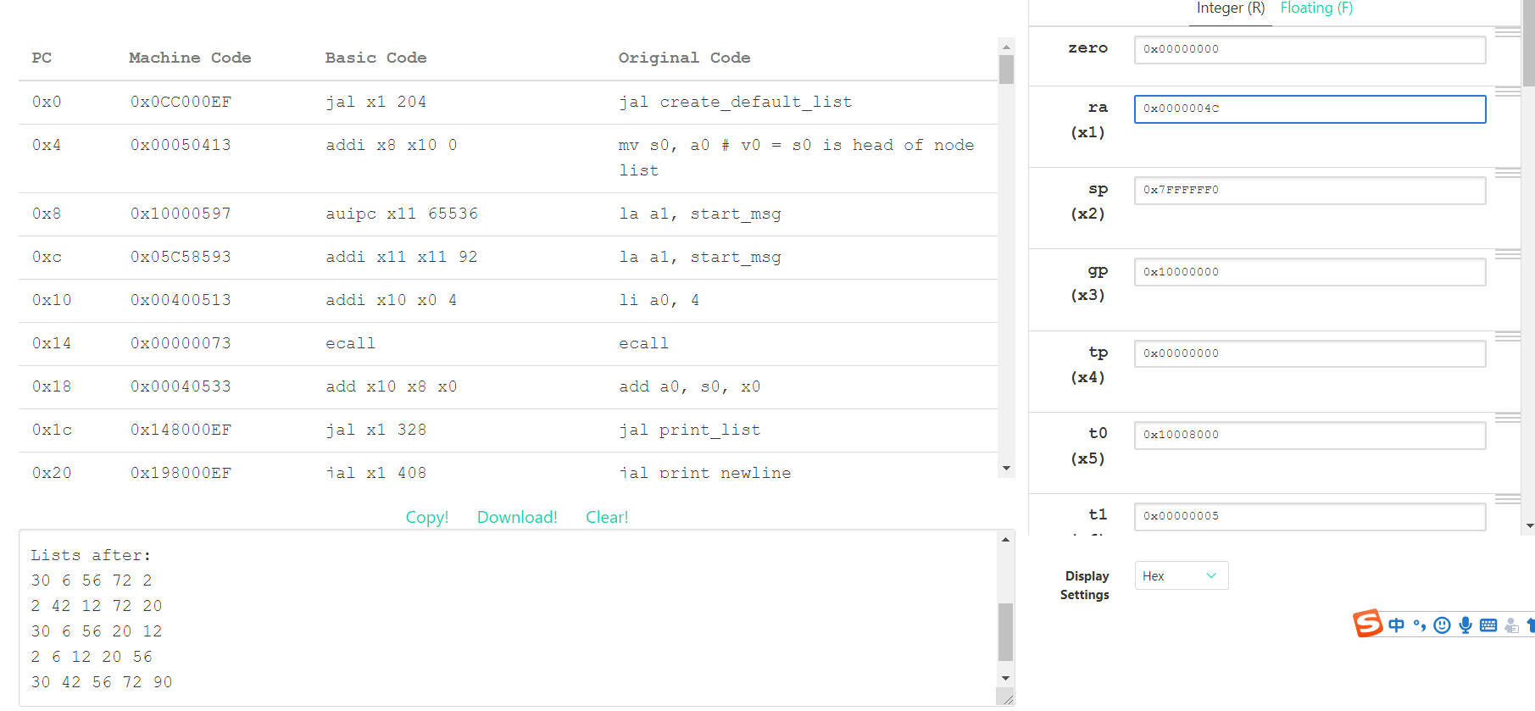

Q5:

.globl f

.data

neg3: .asciiz "f(-3) should be 6, and it is: "

neg2: .asciiz "f(-2) should be 61, and it is: "

neg1: .asciiz "f(-1) should be 17, and it is: "

zero: .asciiz "f(0) should be -38, and it is: "

pos1: .asciiz "f(1) should be 19, and it is: "

pos2: .asciiz "f(2) should be 42, and it is: "

pos3: .asciiz "f(3) should be 5, and it is: "

output: .word 6, 61, 17, -38, 19, 42, 5

.text

main:

la a0, neg3

jal print_str

li a0, -3

la a1, output

jal f # evaluate f(-3); should be 6

jal print_int

jal print_newline

la a0, neg2

jal print_str

li a0, -2

la a1, output

jal f # evaluate f(-2); should be 61

jal print_int

jal print_newline

la a0, neg1

jal print_str

li a0, -1

la a1, output

jal f # evaluate f(-1); should be 17

jal print_int

jal print_newline

la a0, zero

jal print_str

li a0, 0

la a1, output

jal f # evaluate f(0); should be -38

jal print_int

jal print_newline

la a0, pos1

jal print_str

li a0, 1

la a1, output

jal f # evaluate f(1); should be 19

jal print_int

jal print_newline

la a0, pos2

jal print_str

li a0, 2

la a1, output

jal f # evaluate f(2); should be 42

jal print_int

jal print_newline

la a0, pos3

jal print_str

li a0, 3

la a1, output

jal f # evaluate f(3); should be 5

jal print_int

jal print_newline

li a0, 10

ecall

# f takes in two arguments:

# a0 is the value we want to evaluate f at

# a1 is the address of the "output" array (defined above).

# Think: why might having a1 be useful?

f:

# YOUR CODE GOES HERE!

addi t0, a0, 3 # index

slli t0, t0, 2

add t0 a1, t0

lw a0, 0(t0)

jr ra # Always remember to jr ra after your function!

print_int:

mv a1, a0

li a0, 1

ecall

jr ra

print_str:

mv a1, a0

li a0, 4

ecall

jr ra

print_newline:

li a1, '\n'

li a0, 11

ecall

jr ra

