**Comp9331 lab5 answer**

**Exercise 1: Understanding TCP Congestion Control using ns-2 (4 Marks)**

**Question 1：**

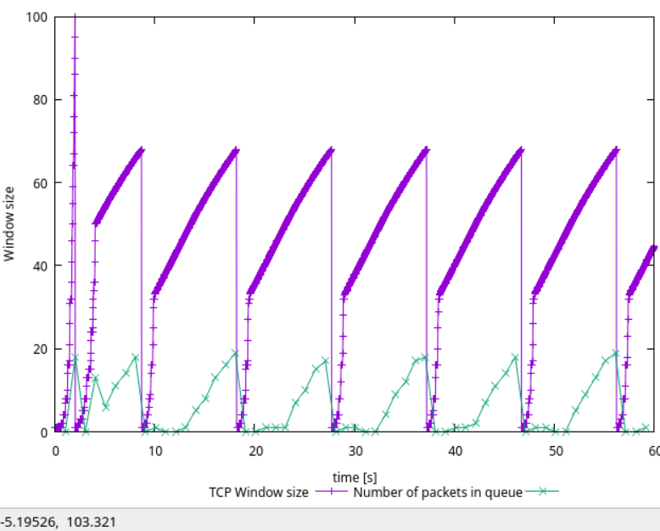

1. In this case, what is the maximum size of the congestion window that the TCP flow reaches?

The maximum size of congestion window is 100.

1. What does the TCP flow do when the congestion window reaches this value? Why?

when the congestion window reaches this value, the TCP flow will reset the window size which cause the window size equal to 1 because receiver knows the congestion happened (packet time out).

1. What happens next?

Then the congestion window size will exponentially increase to 50 which is the half of the max window size (100). When the congestion window size reaches a certain value, TCP flow enters the congestion avoidance phase, where the congestion window increases linearly until packet loss occurs.

**Question 2: From the simulation script we used, we know that the packet's payload is 500 Bytes. Keep in mind that the size of the IP and TCP headers is 20 Bytes each. Neglect any other headers. What is the average throughput of TCP in this case? (both in number of packets per second and bps)**

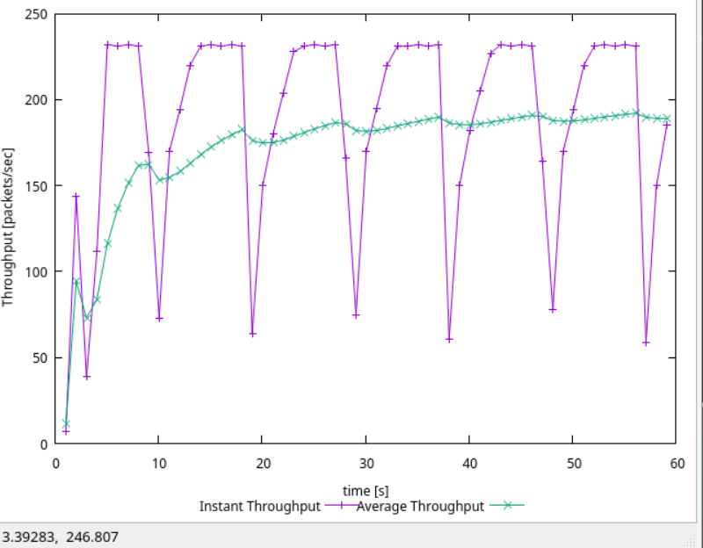

The average throughput is about 190.667 packet/ second.

Therefore, the packet length = (500+20+20) bytes

The Tcp average throughput (include header and payload data) = 540*8 *190 = 820800 bps.

For throughput (Only payload data) = 190 * 500 * 8 = 95000 = 760000 bps.

**Question 3: Repeat the steps outlined in Questions 1 and 2 but for TCP Reno. Compare the graphs for the two implementations and explain the differences. (Hint: compare the number of times the congestion window returns to zero in each case). How does the average throughput differ in both implementations?**

For question1, Reno TCP congestion control algorithm experiences a decrease in window size by half and skips the slow-start stage when it encounters three duplicate ACKs, following a congestion event. The number of times it returns to zero is only 1. This process repeats until the occurrence of the next three duplicate ACKs. In contrast, Tahoe TCP, upon encountering a congestion event, reduces the window size to 1 and enters the slow-start stage.

For question2, Reno's average throughput (200 packets/sec) exceeds that of Tahoe (190 packets/sec) because Reno bypasses the slow-start stage when encountering three duplicate ACKs, whereas Tahoe sets its window size to 1 and undergoes slow start

### Exercise 2: Setting up NS2 simulation for measuring TCP throughput (3.5 marks)

### 

### **Question 1:**Why is the throughput achieved by flow tcp2 higher than tcp1 between 6 sec to 8 sec?

### the throughput achieved by flow tcp2 higher than tcp1 between 6 sec to 8 sec because the round-trip time and the number of flows competing for link bandwidth, TCP1 competes with TCP4 on link n1-n2, while also contending with TCP2 on link n2-n4. Since TCP2 has a lower RTT compared to TCP1, it acquires a larger share of the bandwidth on link n2-n4. Consequently, the final throughput is higher.

### **Question 2:**Why does the throughput for flow tcp1 fluctuate between a time span of 0.5 sec to 2 sec?

### The throughput for flow tcp1 fluctuates between 0.5-2 seconds because tcp1 is initiating at a slow start phase which is a slow-start stage.

### Exercise 3: Understanding the Impact of Network Dynamics on Routing (2.5 marks)

### **Question 1:**Which nodes communicate with which other nodes? Which route do the packets follow? Does it change over time?

Node0 communicate with node5 and the route is 0-1-4-5.

Node2 communicate with node5 and the route is 2-3-5.

No, it does not change over time.

**Question 2: What happens at time 1.0 and time 1.2? Does the route between the communicating nodes change as a result?**

At time 1.0, the link between node 1 and node 4 goes down. As a result, Node 0 loses connectivity to node 5, and packets queue up at node 1. However, node 2 still maintains connectivity to node 5.

At time 1.2, the link between node 1 and node 4 goes back up. Now, node 0 can again reach node 5, and node 1 can reach node 4. There is no impact on node 2 and node 5.

**Question 3: Did you observe additional traffic compared to Step 3 above? How does the network react to the changes that take place at time 1.0 and time 1.2 now?**

Yes, a small packet was transmitted in the network before time 1.0. If the n1 - n4 link goes down, Node 0 to node 5 will use another path 0-1-2-3-5 and if n1- n4 goes up, it will use path 0-1-4-5.

**Question 4: How does this change affect the routing? Explain why.**

The cost of node1 to node4 will increase to 3.and the new route 0-1-2-3-5 will cost 4 which is the lower cost route. Therefore, the route 0-1-2-3-5 will be the route for node 0 to 5.

**Question 5: Describe what happens and deduce the effect of the line you just uncommented.**

For nodes 0 to 5, the route 0-1-4-5 remains the lower-cost option with a cost of 4. However, for nodes 2 to 5, both routes 2-3-5 and 2-1-4-5 have the same cost of 4. The effect is that the traffic between these two routes is equal.