**COMP9331 lab4 answer**

Exercise 1: Understanding TCP using Wireshark

***Question 1***. What is the IP address of gaia.cs.umass.edu? On what port number is it sending and receiving TCP segments for this connection? What are the IP address and TCP port numbers used by the client computer (source) that is transferring the file to gaia.cs.umass.edu?

****The IP address of gaia.cs.umass.edu is **128.119.245.12**, on port number **80.**

The client(source) IP address is **192.168.1.102** and the TCP port numbers is **1161**.

***Question 2.*What is the sequence number of the TCP segment containing the HTTP POST command?**

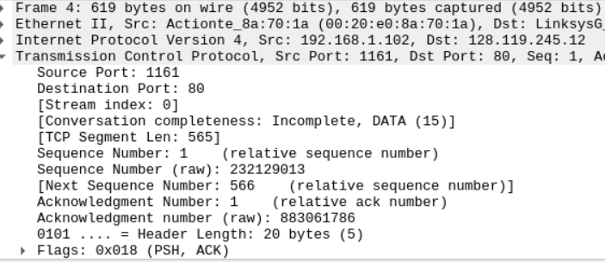The sequence number is **232129013**.

***Question 3.***

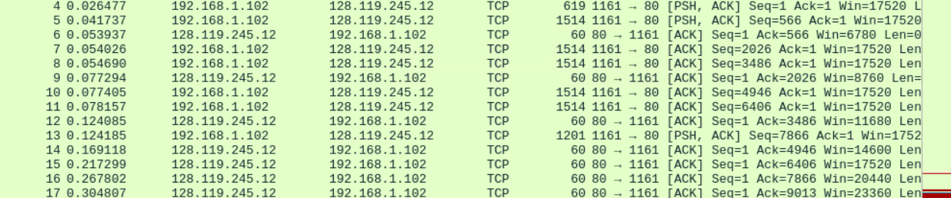

|  |  |  |  |  |  |
| --- | --- | --- | --- | --- | --- |
| Segment | Sequence | Send time(sec) | Received time (se c) | Sample  RTT (sec) | Estimated RTT (sec) |
| 4 | 232129013 | 0.026477 | 0.053937 | 0.02746 | 0.02746 |
| 5 | 232129578 | 0.041737 | 0.077294 | 0.035557 | 0.028472 |
| 7 | 232131038 | 0.054026 | 0.124085 | 0.070059 | 0.03367 |
| 8 | 232132498 | 0.054690 | 0.169118 | 0.114428 | 0.043765 |
| 10 | 232133958 | 0.077405 | 0.217299 | 0.139894 | 0.055781 |
| 11 | 232135418 | 0.078157 | 0.267802 | 0.189645 | 0.072514 |

This is the information for question a b c.

*(d)*What is the length of each of the first six TCP segments?

The length of first Tcp segment is 565 bytes and others are 1460 bytes.

***Question 4.***What is the minimum amount of available buffer space advertised at the receiver for the entire trace? Does the lack of receiver buffer space ever throttle the sender?

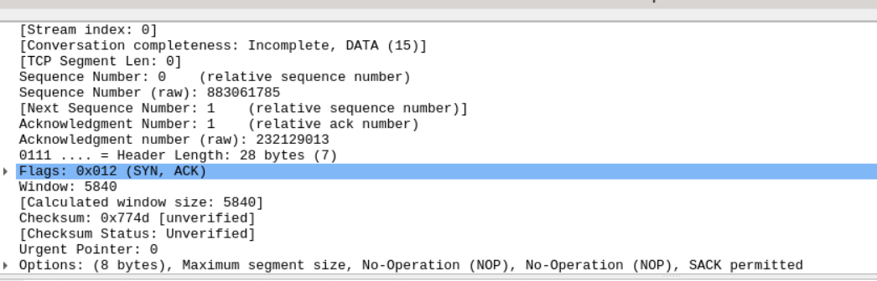

The minimum amount of available buffer space is 5840 bytes. No, the lack of receiver buffer space does not throttle the sender. This is because the sliding window mechanism in the TCP protocol allows the sender to continue sending data without waiting for confirmation until the data it sends reaches the receiver's window size.

***Question 5.***Are there any retransmitted segments in the trace file? To answer this question, what did you check for (in the trace)?

No, there are no retransmitted segments. To find this, I used tcp.analysis.retransmission and tcp.analysis.fast_retransmission and they did not show the output. We can also find this by checking the sequence number.

***Question 6.***How much data does the receiver typically acknowledge in an ACK? Can you identify cases where the receiver is ACKing every other received segment (recall the discussion about delayed acks from the lecture notes or Section 3.5 of the text)?

The receiver typically acknowledges **1460 bytes** data in an ACK.

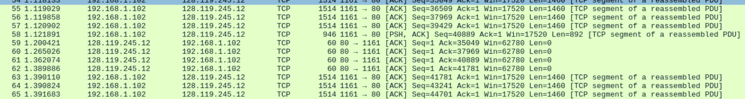

the time between segments #59 and #60 is short, so the receiver might employ delayed acknowledgment. In this scenario, the receiver waits for a certain duration (typically a few hundred milliseconds) to see if additional packets arrive before sending an acknowledgment. Then, it sends a cumulative acknowledgment that includes the sequence numbers of all sequentially received packets, rather than sending individual acknowledgments for each packet.

***Question 7.***What is the TCP connection's throughput (bytes transferred per unit of time during the connection)?

Explain how you calculated this value.



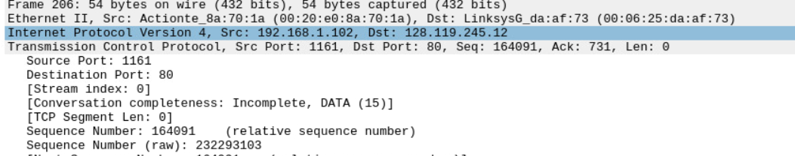

Throughput = total amount data (bytes) /total transmission time (seconds) data

total amount data (bytes) = = 232293103 (bytes) – 232129013 (bytes) = 164090 (bytes)

total transmission time (seconds) data = 5.45583 (seconds) – 0.026477 (seconds) = 5.429353 (seconds)

Throughput = 164090 (bytes) / 5.429353 (seconds) = 30222.75 (bytes/second)

### Exercise 2: TCP Connection Management

### 

### *****Question 1*.****What is the sequence number of the TCP SYN segment that is used to initiate the TCP connection between the client computer and server?

### The sequence number is 2818463618.

***Question 2.***What is the sequence number of the SYNACK segment sent by the server to the client computer in reply to the SYN? What is the value of the Acknowledgement field in the SYNACK segment? How did the server determine that value?

The sequence number is: **1247095790**.

The value of the Acknowledgement field is **2818463619**.

Plus 1 to value of the previous client sequence number to determine the value.

**Question 3.**What is the sequence number of the ACK segment sent by the client computer in response to the SYNACK? What is the value of the Acknowledgment field in this ACK segment? Does this segment contain any data?

The sequence number is: **2818463619**.

The value of the Acknowledgement field is **1247095791**.

No, this segment does not contain any data because the previous ACK is equal to the sequence number.

**Question 4.**Who has done the active close? Is it the client or the server? How you have determined this? What type of closure has been performed? 3 Segment (FIN/FINACK/ACK), 4 Segment (FIN/ACK/FIN/ACK) or Simultaneous close?

Both the client and the server complete the active close because they sent FIN ACK to each other simultaneously, meaning it was simultaneous close.

**Question 5.**How many data bytes have been transferred from the client to the server and from the server to the client during the whole duration of the connection? What relationship does this have with the Initial Sequence Number and the final ACK received from the other side?

Data transformed form the client to server = lastACK - ISN – 2 =

**2818463653 – 2818463618 -2 = 33 bytes.**

Data transformed form the server to client = lastACK - ISN – 2 =

**1247095832– 1247095790-2 = 40 bytes.**

The final acknowledgment number represents the next expected byte sequence to be received by the receiver, typically the final ACK received (ISN) plus the total data size received. Knowing the ISN and final acknowledgment number allows calculation of the total data bytes transferred. However, complexities such as packet loss, duplication, and segmentation/reassembly must be considered for accurate calculation in practical scenarios.