**COMP9336 Mobile Data Networking**

**Written by Jiayang Jiang**

**a. Task 1: Wireshark screen shot showing the filter expression, display of all beacon frames from SSID=COMP4336 (“COMP4336” should be visible) including columns for S, N, and SNR.**

Imported the trace file into Wireshark and used a filter “**wlan.ssid=="COMP4336"&& wlan.fc.type_subtype == 0x08**” to remove all other packets except the beacons from SSID=COMP4336. Add signal strength, noise level, and SNR columns to the display and the above screenshot shows part of the SSID beacon frames information.

**b&c. Task 1: 3 graphs (S, N, and SNR) and commentary on the graphs following the guidelines given under Task 1**

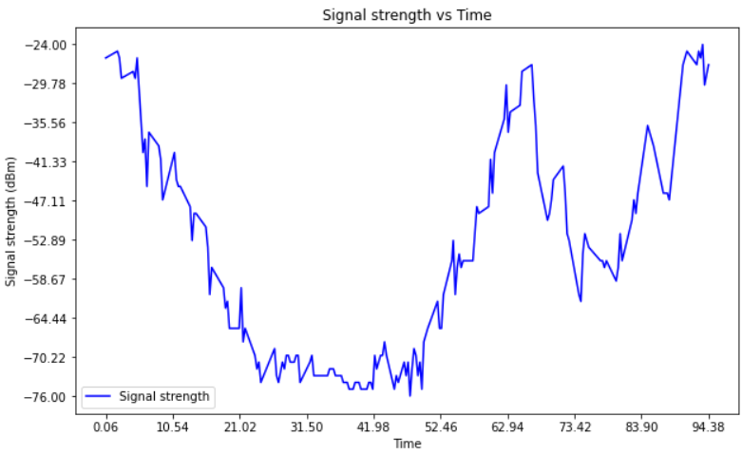

**Commentary:**

From the Signal Strength Diagram shown above, we can see that the signal strength starts from around **-25 dBm**, then gradually decreases. Around the 50-second mark, the signal strength begins to rise again, and by the end of the observation period, it returns to approximately **-25 dBm.** This is because that before the 50-second mark, the phone was moving away from the computer, causing the signal strength to drop due to the increased distance. After 50 seconds, as the phone moved closer again, the signal strength recovered. This is typical in wireless communication where signal strength changes with distance between devices and it could also be affected by obstacle such as Wall, glass and doors.

**Commentary:**

The noise level is influenced by the environment and can be affected by other devices operating on the same frequency bands, such as 2.4 GHz or 5 GHz, depending on which Wi-Fi frequency is in use. While these external signals can introduce interference, in this case, the noise level shows some fluctuations, which could be due to external factors. (devices like microwaves, fridge)

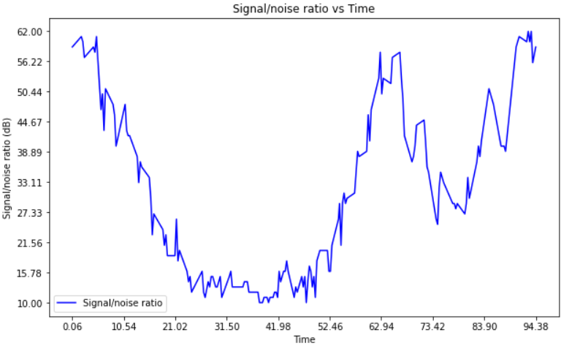

**Commentary:**

The Signal-to-Noise Ratio is determined by the relationship between signal strength and noise level. In this case, since the noise level remains relatively stable, the SNR diagram closely mirrors the signal strength diagram, resulting in minimal differences between the two. However, some minor variations may still be observed, reflecting subtle fluctuations in signal strength that occur over time.

**d. Task 2: Wireshark screen shot showing the filter expression, display of all beacon frames from SSID=” your ZID” (“your ZID” should be visible) including columns for S, N, and SNR**

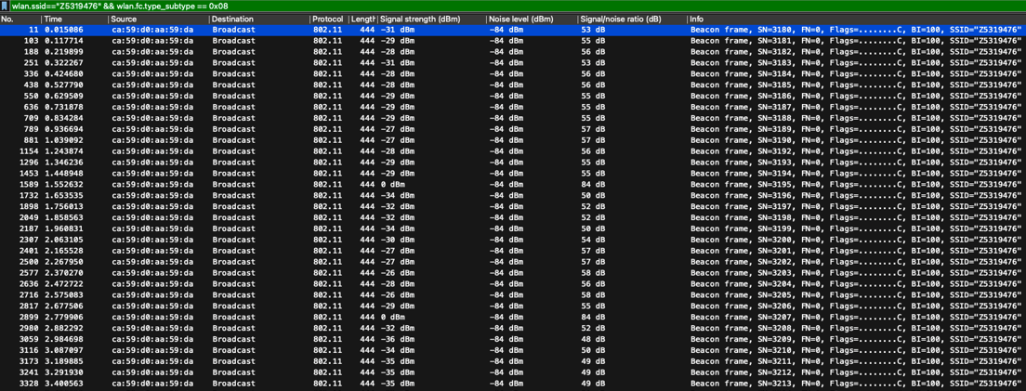

Use mac and smartphone to capture the packet.

**e&f. Task 2: 3 graphs (S, N, and SNR) and task 2: Commentary on the graphs following the guidelines given under Task 1**

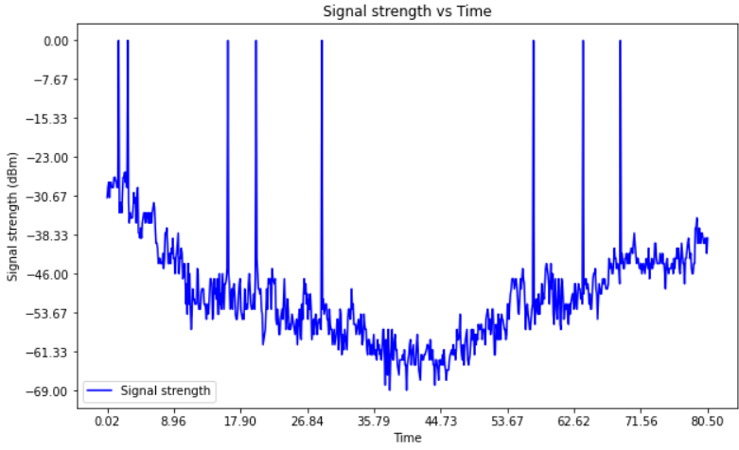

**Commentary:**

As in the first scenario from task 1, I gradually moved my phone away from the computer and then brought it closer again. I noticed that the signal strength initially decreased and then improved as the phone got closer. Additionally, in some cases, the signal strength became zero. This could be due to device or network issues, as well as physical obstacles, like a wall between the phone and the computer.

**Commentary:**

For task 2, the noise level remains the same regardless of the phone's distance from the signal source. I was simply walking around, and there were no other high-power devices nearby, which could explain why the noise level stayed consistent. The absence of significant interference from surrounding equipment shows that the environment was relatively stable, allowing the noise level to remain unchanged during the movement.

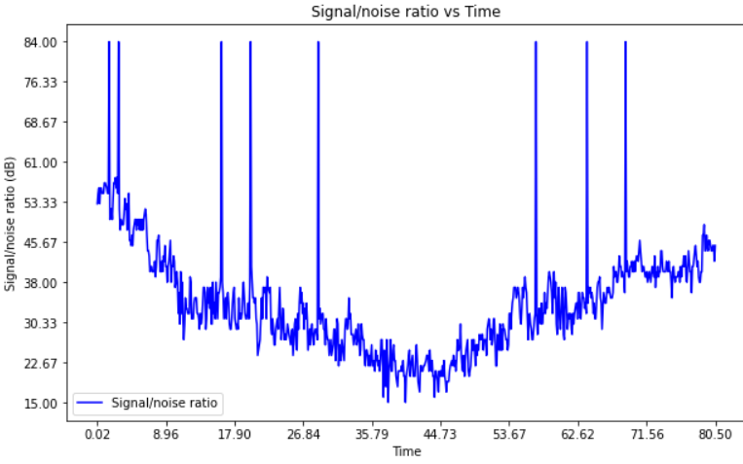

**Commentary:**

The Signal-to-Noise Ratio (SNR) diagram is almost the same as the signal strength diagram. In this case, since the noise level remains constant, any increase in signal strength directly contributes to a higher SNR. This relationship highlights the importance of a strong signal in maintaining good communication quality, even when the noise remains unchanged. However, it’s essential to consider that while the SNR follows a similar trend to signal strength, the absolute levels of signal and noise can still vary independently in different scenarios.