**COMP9336 Mobile Data Networking   
Written by Jiayang Jiang**

**Tasks1 RSS data capture**

In this experiment, I used two chairs for laptop and mobile phone to keep them at the same height and capture RSS data (indoor and outdoor) at different distances (1m to 10m).

* **Indoor RSS Data Capture**

I captured 10 files of RSS data indoors. In each data collection session, the distance between the laptop and the phone was increased by 1 meter. Starting from 1 meter in the first dataset, I incrementally increased the distance by 1 meter for each subsequent capture, up to a total of 10 meters. This experiment was conducted in the living room.

**For each trace file, I applied a filter as shown in the following image.**

**RSS data Capture Count RSS data average Signal Strength(log_Distance)**

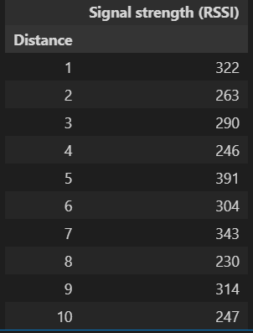

* **Outdoor RSS Data Capture**

Using the same method as the indoor experiment, I conducted the same task in an outdoor park.

**RSS data Capture Count RSS data average Signal Strength(log_Distance)**

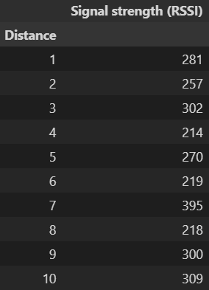

**Tasks2 Path loss exponent estimation**

* **Indoor** Raw RSS data against distance in Log Scale

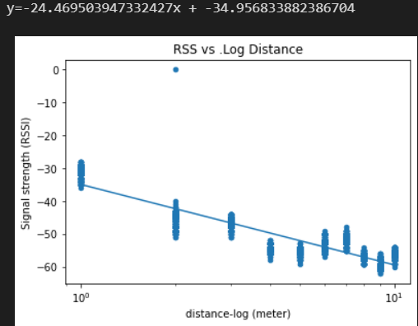

* **Indoor** average RSS values against distance in Log Scale

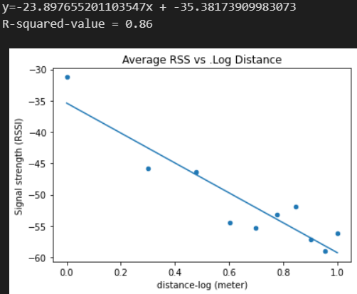

Based on my RSS measurements in the living room, the signal strength data points are scattered rather than concentrated in a specific region. Two factors likely contributed to this variation. First, I used my phone as a hotspot while there were 2-3 other Wi-Fi networks in the vicinity, along with a microwave oven operating at 2.4GHz. These factors may have caused interference, affecting the consistency of the signal strength readings. Second, I unintentionally blocked the laptop’s antennas during the experiment, which likely influenced the detection of the signals. Despite these challenges, I ensured consistency in the experiment by maintaining the same height for both devices using chairs and measuring incremental distances before taking readings. Overall, the results indicate the expected trend as the distance between the receiver and the access point increases, the average signal strength decreases due to attenuation over distance. The calculated R-squared value of 0.86 suggests a strong correlation between the distance and the signal strength, indicating that the model fits the data well.

* **Outdoor** Raw RSS data against distance in Log Scale

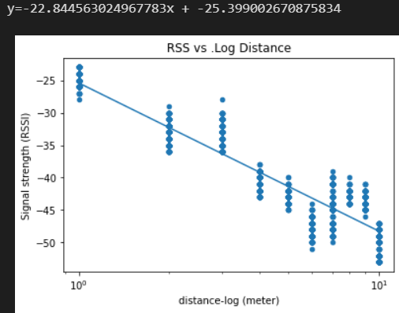

* **Outdoor** average RSS values against distance in Log Scale

In outdoor environments, signal strength measurements tend to be more dispersed across various locations compared to indoor settings. This dispersion can be attributed to several factors, including the presence of open spaces, which allow for greater signal variation influenced by environmental elements. The average slope of the signal strength in outdoor measurements is typically lower, indicating a more gradual decrease in signal strength with increasing distance. Notably, the R-squared value for outdoor measurements is higher at 0.89, reflecting a strong correlation between distance and signal strength.

This may be because outdoor environments usually have fewer physical obstacles, such as walls and furniture, resulting in less multipath interference and a clearer relationship between distance and signal strength. Additionally, the open nature of outdoor spaces leads to greater signal variation due to interactions with environmental factors.

* **Indoor** average RSS values against distance in Log Scale after removing outliers

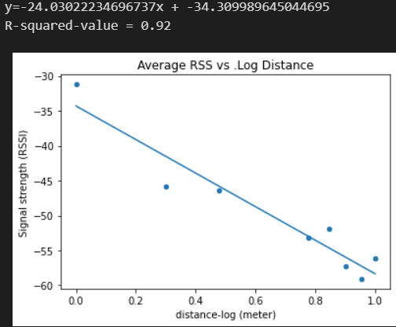

I removed the data in distance 4 and 5 (outlier) and then R squared value increased to 0.92.

* **Outdoor** average RSS values against distance in Log Scale after removing outliers

I removed the data in distance 6 (outlier) and then R squared value increased to 0.93.