**COMP9336 Mobile Data Networking   
Written by Jiayang Jiang**

**Task:**

**RSS data capture**   
In this experiment, I used two chairs to position the laptop and mobile phone at the same height, allowing me to capture RSS data from approximately 2.5 meters.

I captured 8 files of RSS data in the living room while the space was unoccupied.

I first positioned the laptop and phone within line of sight, ensuring there were no obstacles between them, and collected over 500 RSS data points. Then, I added a wall, a table, and a person sitting on a chair between the devices, and re-collected the RSS data for both 2.4GHz and 5GHz WiFi.

For each trace file, I applied a filter as shown in the following image: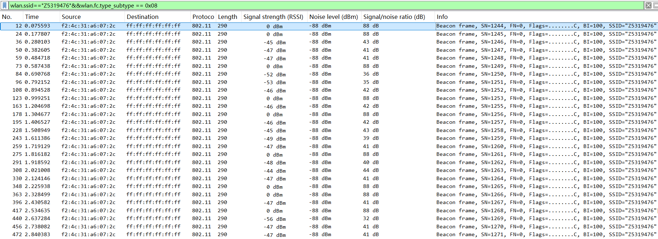

**5GHz WiFi:**

**The RSS distributions without the obstacles over time(5G) and mean value(-57.03dBm):**

**The RSS distributions with obstacle table over time(5G) and mean value(-58.20dBm):**

**The RSS distributions with obstacle wall over time(5G) and mean value(-57.88dBm):**

**The RSS distributions with obstacle people over time(5G) and mean value(-58.26dBm):**

**violin plot(5G):**

**2.4GHz WiFi:**

**The RSS distributions without the obstacles over time (2.4G) and mean value(-49.63dBm):**

**The RSS distributions without obstacle table over time (2.4G) and mean value(-50.53dBm):**

**The RSS distributions without obstacle wall over time (2.4G) and mean value(-56.52dBm):**

**The RSS distributions without obstacle people over time (2.4G) and mean value(-53.73dBm):**

**violin plot (2.4G):**

**Table1: RSS Distribution with and without Obstacles**

|  |  |  |
| --- | --- | --- |
| **Object** | **Average Rss(dBm)** | |
| **5GHz** | **2.4GHz** |
| **Nothing(los)** | **-57.03** | **-49.63** |
| **Human body with chair** | **-58.26** | **-53.73** |
| **Wall** | **-57.88** | **-56.52** |
| **Table** | **-58.20** | **-50.53** |

**Table2: Path loss (compare with no obstacle)**

|  |  |  |
| --- | --- | --- |
| **Object** | **Path loss(dBm)** | |
| **5GHz** | **2.4GHz** |
| **Human body with chair** | **1.23** | **4.1** |
| **Wall** | **0.85** | **6.89** |
| **Table** | **1.17** | **0.9** |

**Commentary:**

For the 5GHz frequency, the overall signal strength remained relatively stable within a specific range, with only minor fluctuations. After adding obstacles, there was a slight decrease in signal strength (human body: 1.23, wall: 0.85, table: 1.17). This could be due to the higher frequency of 5GHz being more susceptible to attenuation when passing through solid objects, or potential reflections and scattering of the signal off surfaces.

For the 2.4GHz frequency, after collecting the data, I observed many instances where the signal strength was recorded as 0(I removed them). This could be because of interference from other devices operating on the crowded 2.4GHz band, temporary signal loss during data collection, or limitations in the devices' ability to pick up weak signals in certain conditions. After adding obstacles, the 2.4GHz signal strength also experienced a slight drop (more on human body and wall than table). This could be due to increased absorption by obstacles, or interference caused by the proximity of obstacles.

Comparing the two frequencies, 5GHz shows better stability, but the signal strength is larger for 2.4GHz. Also, 2.4GHz shows the larger path loss on human body and wall than 5GHz. 2.4GHz experiences more interference and multi-path effects, leading to increased path loss despite its penetration advantages.