**COMP9336 Mobile Data Networking   
Written by Jiayang Jiang**

**Task-1 Frequency re-use [2 marks]**

**a.**

Therefore, when N = 9. We used **i=3, j=0.**

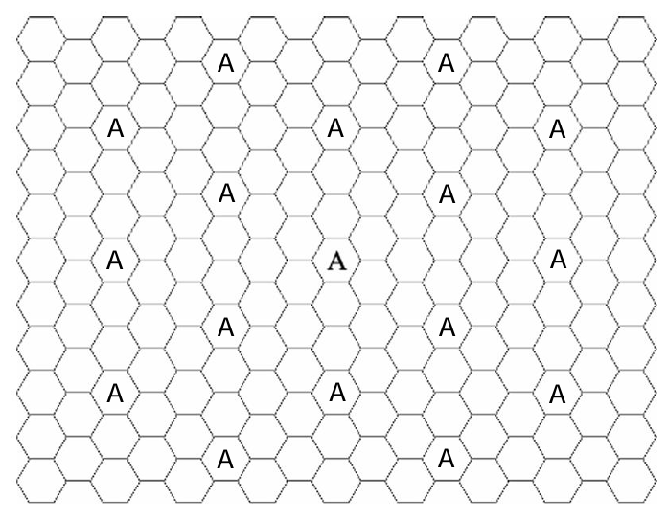

**b.**

Therefore, when N = 12. We used **i=2, j=2.**

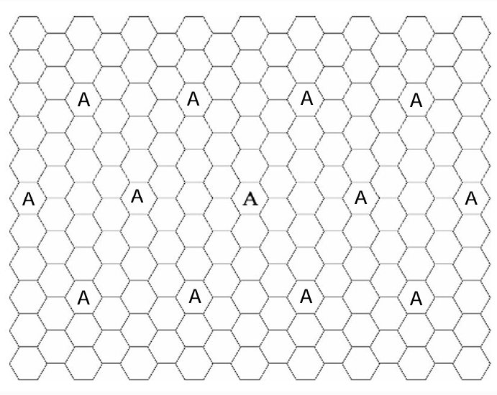

**c.**

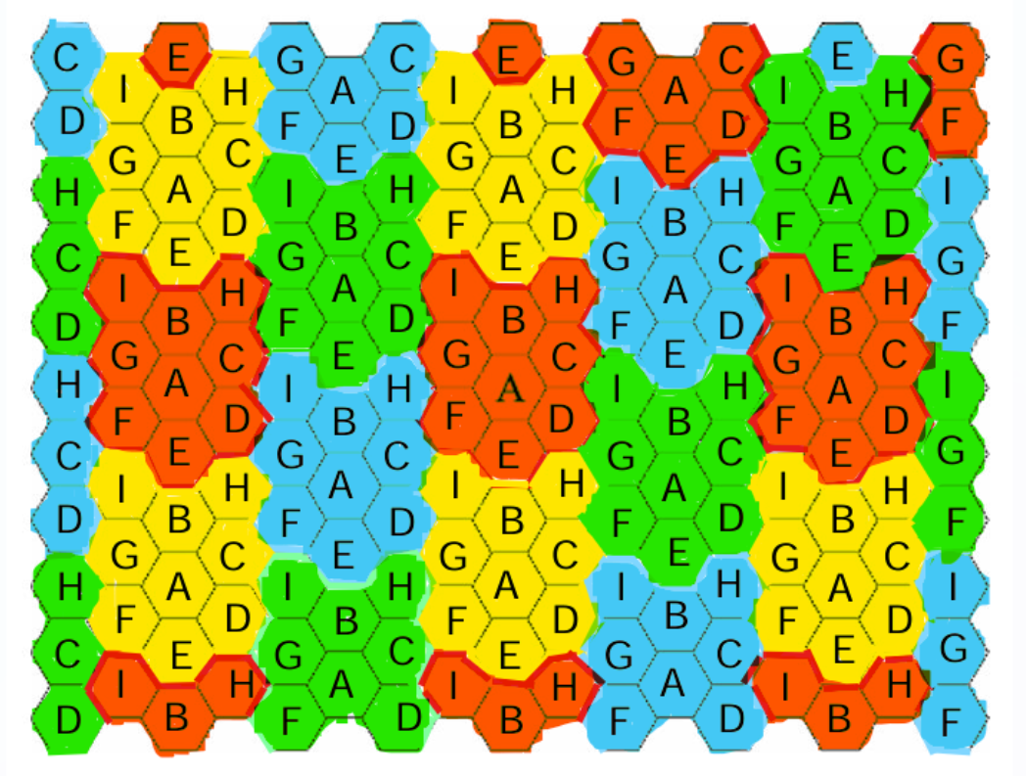

**Task-2 Measuring cellular signal strength [2 marks]**

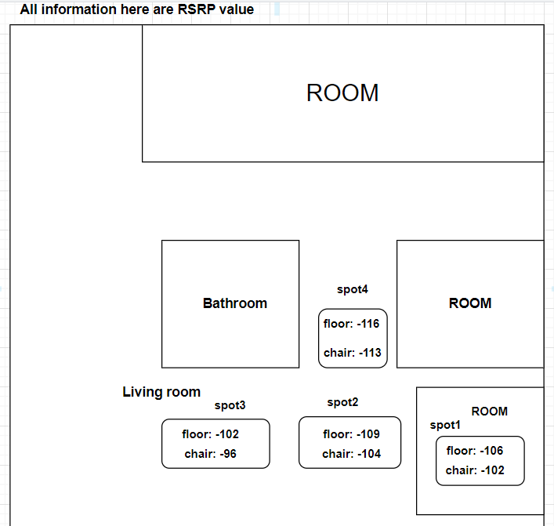

I measured the RSRP value at four different spots within my home, ensuring each spot was no more than 1 meter away (horizontally) from the nearest spot. I used two different heights: the floor and a chair. I turned off WiFi and set my phone to 4G mode. Then, I placed my phone on the floor and on the chair, holding it in position for a few seconds at each spot to collect the RSRP data.

**My screenshot:**

**RSRP value table:**

|  |  |  |  |  |
| --- | --- | --- | --- | --- |
|  | In bedroom(spot1) | Outside the bedroom (spot2) | Living room center (spot3) | Between two rooms (spot4) |
| Floor(dBm) | **-106** | **-109** | **-102** | **-116** |
| Chair(dBm) | **-102** | **-104** | **-96** | **-113** |

The RSRP data indicates expected indoor signal behavior: strongest in the living room center (fewer obstacles, direct signal path), almost similar in and near rooms (wall attenuation), lowest between rooms (multiple wall blockage causing interference and a dead zone), and higher on a chair than the floor (less ground absorption and interference).

My carrier is **optus,** this is the coverage map for my place:

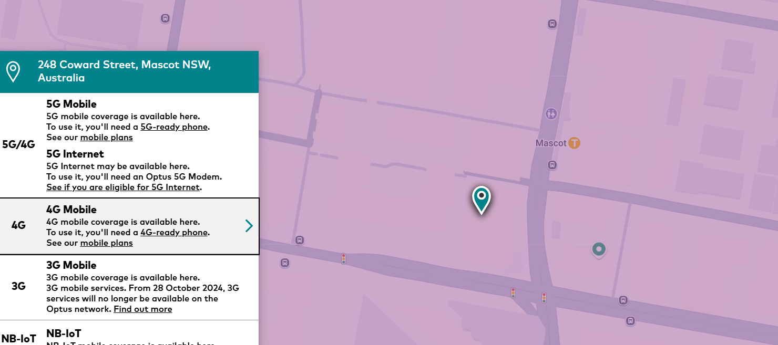

I live on the 6th floor at a street corner, this could benefit from fewer ground-level obstacles and an open corner location, improving the RSRP. However, multipath reflections from nearby buildings might affect the signal stability.