Problem #1: See code for documentation

Problem #2: We see in this problem that the amount of iterations it takes to solve by richarson greatly increases with a larger scattering term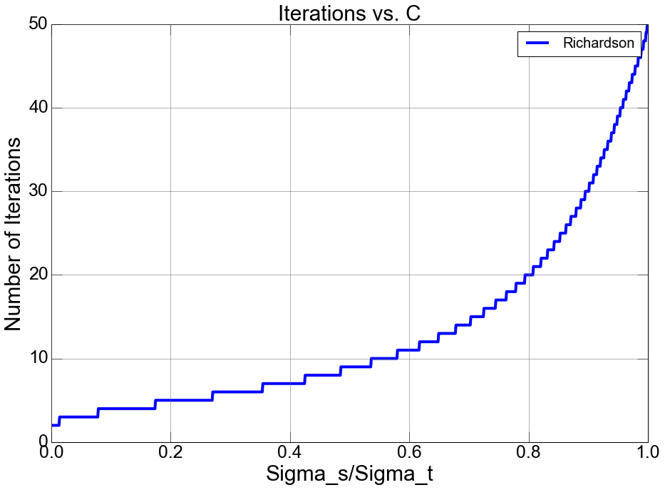

Problem #3: Solving using GMRES takes more iterations to solve than the Richardson method, especially for large scattering term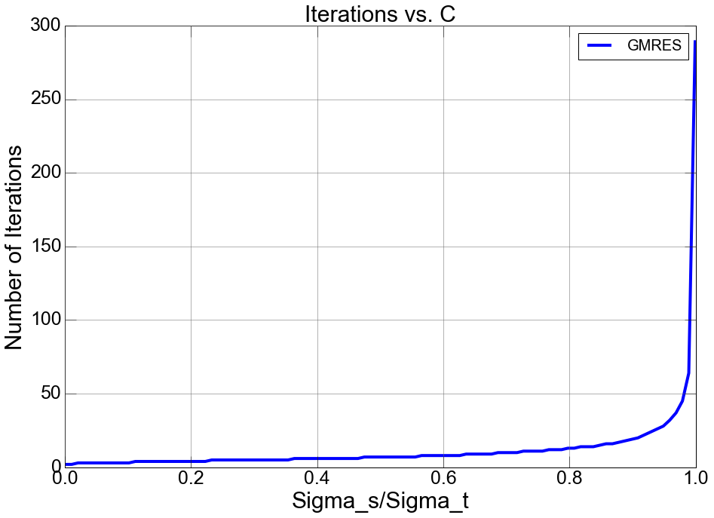

Problem #4: For large scattering terms, the maximum flux is increased and amount of iterations also increases. See code for details

