Blog 1Agile Estimation and Planning

We have been working at defining the approach to preparing and estimating user stories in one of my clients projects. Here stories are prepared through the early discovery events and progress through to the development teams. This post describes the estimations that are performed along this journey.
At the early discovery phases T-shirt sizes are used. The T–shirt sizes is a first guess. The word guess being appropriate. It is based on the feeling for size, complexity and risk in the story. This is a very early estimate and is used to provide input into the business level release planning. This is useful in providing a feeling for size and begins the initial planning at product or release level. It is a “handful” type of measure.
The next measure of story points is taken by the elaboration team during the grooming process. This includes some contribution from the Technical Lead of the scrum teams. This is useful for planning of releases. See the article about story points and hours below to explain why this is not useful in terms of commitment for an individual sprint. I would not recommend a translation between these two story point sizing techniques as the independence of the measurements is a key factor. I would however examine them and see if there are any unexpected relationships between the estimates for a story. This means a misunderstanding is present. For instance in the table from below the values assigned imply too much precision.
T-Shirt size | Story Point Size
S | 1
M | 3
L | 5
XL | 8
XXL | 13
Table 1: Too much implied precision
Anything else is too big and should be split.
The table above should be more like the range of mapping in table 2
T-Shirt size | Story Point Size
S | 1-3
M | 2-4
L | 3-6
XL | 5-11
XXL | 10-15
Table 2: This shows a range of estimation mapping
Or something like that. Note that the ranges overlap. This is because the story points are mean to be accurate in large samples and not as individual measures. See the link about use of story points in planning. When I say that we can look for misunderstandings at this level it means we can look to see if the business called a story S and the grooming calls it 15. This should now stop this story in favour of a discussion about it.
The hours at sprint planning are now about specific stories. Again are these real or ideal hours? This is something we need to learn and is why teams often apply a modifier against them. We should measure the planned hours against the real hours as we go and learn when our ideal to real factor is. It is of course crucial that a teams time is protected if they make commitments to delivery. This is an area where micro management can destroy the productivity of a team, achieving the opposite of what the good intentioned manager was trying to achieve.
So in conclusion you cannot relate story points to hours. Story points are a bell curve distribution of hours. They are useful for planning however as until a story goes into sprint planning we do not have any better estimate. Also note that a story point is up to a team to define. It should be based on relative sizes of stories with understood benchmarks from experience. Story points are useful for planning purposes in the release plan. They are good at planning how much work can be done in 6-12 sprints, for instance. But they are less good for individual stories.
Please note that if you wish to learn more about this subject the very excellent book “Agile Estimating and Planning” by Mike Cohn is recommended

Blog 2 What is Agile
We keep hearing different opinions about what is Agile. Those who understand it the least describe it as a series of processes that can be applied to the software development business as need be.
Others, more academic refer to it as a culture, and claim that the culture must be established before any processes can be established, less they prove temporary.
Having considered these points, and seeing that there is much good about them I have a somewhat different view. Agile is attitude.
- We are doing great things, but we can get even greater
- We are learning lots of stuff, but need to learn more
- We are delivering quality, but must get better
- We are connecting with our customers, but need to get closer
- We are establishing collaboration as the management method, but need to talk more
- We talk the talk, but need to walk the walk
- We are easy to approach, but must be even friendlier
- Agile is the way forward, but we must get leaner
You get the drift, add more in the comments if you agree, add even more if you don’t.
Mike

Blog 3 If you don’t know what done is you never finish
I have been working with a number of teams recently that are behind. It always seems that people believe that when they are in trouble with respect to time that Agile is the answer. Strange.
The discussion does however follow a pattern. It becomes almost automatic to go down this path.
Q: So do you have a list of stories or tasks that are being worked on in this iteration?
A: Yes, here it is.
Q: Great, tell me what is the success criteria for this one ( I randomly select one)
A: Well it isn’t written down but I feel I knew what it was when I wrote that task in the list.
Q: Do you think the developer working on it has the same understanding you had in your mind?
A: Well he should, but we don’t talk about it, we are too busy.
Q: How will you know when he is done?
A: He will come to me and ask to close the work request.
Q: And how long from now is that?
A: Don’t know
Does anyone else spot the issues here. We seem to be working on a list of tasks that have no acceptance criteria written down or even agreed. There is not enough discussion about the tasks and we simply sit back and wait. Wrong wrong wrong. Spend time to agree and write down what done means at all levels. In user stories this is the acceptance criteria. In tasks it depends on the task type, but if you cannot write it down, then it will never be finished.

Blog 4 The whole lifecycle
When we look at setting up a Agile pilot we need to do some end to end thinking. Agile trials are generally small teams set up with the Agile principles, the purpose of which is to provide evidence that Agile should be considered for a larger roll-out. So we take a group of people and train them in the principles, then set them off on some part of a project.
But how do we set their goals for them? These are the user stories that feed the team with work to do. OK Great, who writes these user stories? The team is not able to nor should they. If the team takes its requirement from the same source as the non-Agile portion of the project, then are the user stories READY? For that matter who is receiving the work that is DONE?
Agile pilots need an Agile thread from end to end. The practice of creating a pilot Agile team in the middle of a non Agile delivery project has limitations. The team is starved of good “scrum food” and often has an “impedance mismatch” for the results of their work. The pilot needs an Agile delivery team, an Agile demand (requirements) team and an Agile integration team. This is an end to end thread provided for the pilot, and it needs to exist. The implications otherwise are that the pilot spends a good deal of time on these areas and not on development, and not on clear requirements.
This will conclude Agile is slow and doesn’t deliver. So therefore if we look at the waterfall model and follow it even more carefully maybe that’s the answer….

Blog 5 Thoughts on splitting a story
There is often a desire to split stories near the end of a sprint when things are getting close and the need to be able to claim some points is strong. This need is
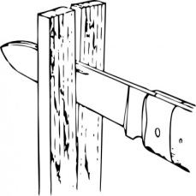
often driven by the metrics side of the team, who need to claim some points for the purpose of reporting. This doesn’t mean that splitting a story at this time is a sensible thing to do. Here are some thoughts on splitting a story.
<!-1. When splitting a story, both pieces need to be a standalone story in their own right. Note that this probably means that story should have been two to begin with. Use INVEST here.
2. It is likely that the story points for the two stories will be more than the original. This is because the act of splitting will take time and the planning of two stories will also take time. Note that you now have two different show and tell events for the story and two DONE checks. Etc. The completed story will be easy to estimate, you have actuals. The remainder piece should go through poker, or whatever your estimating technique is again, as a new story would.
3. This is a time when your waterfall instincts will hurt. If a story is tasked up such as Design, Code and Test; it cannot be split. These tasks are all or nothing and so shall the story be so. What we need to split a story is a structure such as sub-story 1, sub-story 2 and sub-story 3. Each will have a clear, independent set of acceptance criteria, and each can be demonstrated independently. Again note that these probably should have been independent stories to start.
All teams will occasionally have stories that bow-wave into the next sprint. This should be somewhat uncommon, but if it never happens the view is that they are not trying hard enough! the message is not to fear this situation, but to learn from it.
When stories are too large the points make velocity and burn downs looks inconsistent. By having smaller stories these numbers look better controlled. Splitting is a way of spreading larger stories across sprints, but is often done to cover poor planning.
Consider why a story is split. There should be a blocking event that stops the story, but which only applies to a subset of the acceptance criteria, and therefore to a sub-story or two. Events such as running out of time should not be used to split stories. These should be fed into the retrospective and used to improve the estimating process. I have noticed that the need to split is more common in new teams and projects that are adopting Agile as compared to mature teams. Treat this as part of the learning process and apply it by creating smaller, more isolated stories that avoid the waterfall traps.

A series of blogs on the subject of team building
I have been presented with a number of topics to write on, all which looked interesting. This one took my eye as a starter. Because the quick answer is to build an Agile organisation and place your team within it. This may sound flippant, but it is not. Let me explain.
An Agile development team does not live in a vacuum. They have to get their requirements from somewhere and the need to be able to deliver their valuable software to somewhere. Even in a small environment of a single team there is a need for a product owner and a customer, all who are part of the Agile release train. While we have always recognised the need for the product owner, and the product management organisation, the down stream connection to operations has become a topic lately. We need to connect with operations to the point where they work closely with our team. In a large group SAFe scaledagileframework.com/ gives us a structure to model ourselves on.
But the question being asked is not what the structure is, but how to build the team. We know that we build the structure in steps. An organisation does not go from waterfall or RUP to SAFe in a single day. But it often expects a team to do just this. A project starts, the pressure is on “Hey you lot over there, team 1, here is your backlog: GO GO GO”. This is the way I have seen it done and you know what, it doesn’t work. Teams are best when they work together and get to know how to help each other. So there is a performance curve when teams are forming. It looks like this
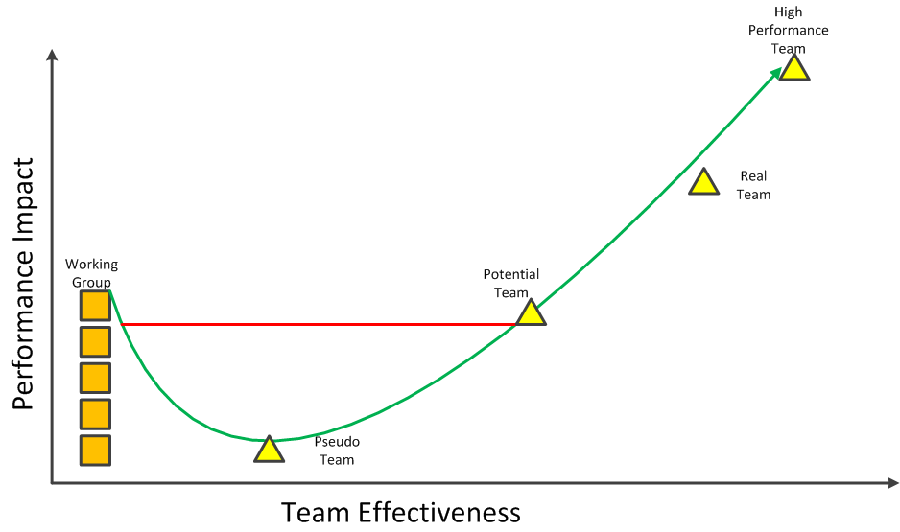
So the starting point is called the working group. This is a simple collection of people each of whom has tasks to do and they get on and do them. There is little interaction between these people other than to report to the team leader who assigns out the next tasks. There are many example of these working groups. Executive boards, traditional development teams and even parliamentary working groups. They tend to be short lived with personal changes happening frequently.
A working group can achieve a certain performance, but then it hits limits. These limits are due to the fact that the working group is a simple sum of the parts. But we want more. We want high performing teams. This means we are willing to to work our team to help them become this high performing team that they aspire to be. This will take some effort, and for a short while the team will therefore have less effort to spend on delivery. This is shown on the chart and is called the pseudo team. So how do we move from a working group to a high performing team? There are a number of activities that can be undertaken to aid this progress. Examples of these are:
- Establish Vision
- Understand the individuals
- Coaching, training and mentoring
- Create positivity
- Understand Team Health
- Understand the team strengths
- Team space
- The start-up or reset process
- The whole team
- The path ahead
I intend to cover all these aspects in subsequent blogs. For now I will consider the Vision.
I was in a call once and stated that I felt the group needed a vision. The senior person on the call rolled his eyes (I felt this through the phone) and said they haven’t got time for that. So in response I asked “What is the vision for your time from inspiration to delivery?”, “What is your vision for the defect level?” and a few other questions. Later I got a call that said he was thinking about these points after the meeting and wanted to pursue this line of thinking.
Google for bad vision statements and have a laugh. Consider something like: “To be the most successful computer company in the world at delivering the best customer experience in markets we serve.” This might sound good, but is fairly meaningless. How would we know ?
Now think about what we really do want to talk about in our vision. Think about
What’s in it for me?
- How do I want to grow?
- Where will I be in 6 months, 1 year 5 years
- What are my needs?
What’s in it for our team?
- How will we perform?
- How will we communicate?
- How will we grow?
- What do we do?
What’s in it for HP?
- How will we know?
- How will they know?
- Why does it matter?
What’s in it for the world?
- Why does it matter?
- How will it make us feel?
Vision statements are a number of things.
- They are measurable, or at least verifiable
- They are living
- They are visible, very visibly
- They are meaningful, not just words
It is important that a team agree their vision. This should be one of the first things they do when they decide they want to become a real high performing team. When they are happy with their vision, they shout about it! They will review it regularly and challenge each other to live by it.
More team building to follow. The list above will be elaborated and explained. Feel free to get in touch and explore these subjects. Just in case you are wondering, the inspiration for this blog and the entries about team building is from Lyssa Adkins. She is a great source for information about teams and making them great.

Establish the Team
So we the team has worked on the vision and has something that speaks to the Company, Team and individuals. Now picture yourself now, in a room with a bunch (7 +/- 2) of people. You have a vision of what you aspire to. But who are these people? You may know them, or think you know them. But if you are going to become a high performing group of people you really need to know each other. At this stage you may have a scrum master or maybe not. But you are going to need one. So lets say that scrum master is you. Scary. So what do you do now?
Is this the AA moment. Stand up and say “Hi everyone my name is Mike and I have been a software engineer for N years. Here is my journey line”. So tell the other team members what your career has been like and how you got to where you are now standing. Good stuff and bad stuff, its all relevant. 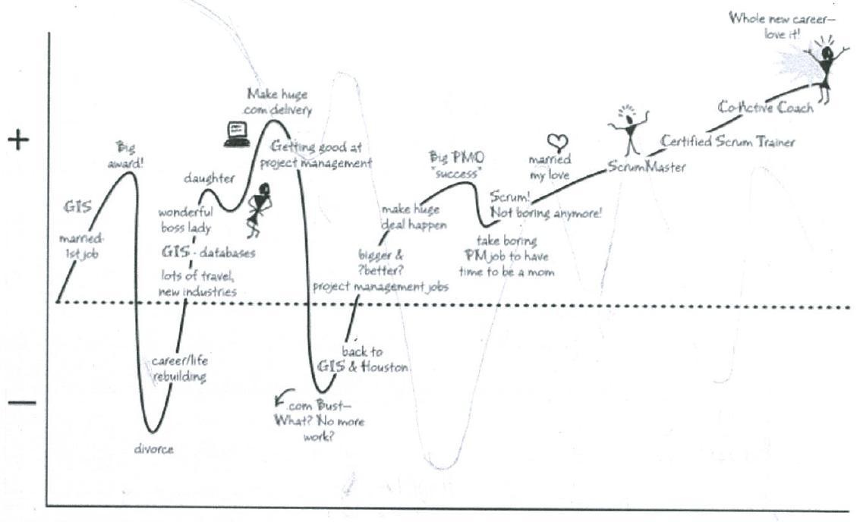
The above Journey Line is that of Lyssa Adkins and is published. But after drawing yours you now need to get the team to each stand up and draw theirs. This will give everyone some insite into who their team members are. If people chose to keep things to themselves, this is not the time to force it out of them. But let the team ask questions all they like.
Its going great, 45 minutes later and we know our teams history. But what are their skills? Next step the skills inventory. Every team needs one. Talk about not just your main skills, but your minor ones as well. Be honest but open. Also express any skills you would like to have. This would help drive future pairing opportunities.
Each member of the team should talk of their skills and how deep they are. These skill should be recorded and a team inventory of skills maintained. Later on you will use this to help when you need to solve problems that you are not getting anywhere with. Perhaps a bit of Ruby would crack this one, or something like that. Graduates need to know who the people to go to for certain skill are.
While you are here, perhaps you could also stray outside of the usual IT skills set. For instance, I am a very experienced C codes with lots of time writing shell scripts as well. I have experience with the Fitnesse tool and Eclipse. In addition I am a First Aider, Scout Leader, Martial Artist, Sports Enthusiast, Love Cooking, Gardener and Family person. In other words tell the team a little about yourself. Declaring your interests wil help them understand that you do have outside commitments that are important to you.
Let the others on your team know your aspirations as well. If you are a developer you may be looking to qualify as a architect. If you are the scrum master, may you want to develop your coaching skills. Maybe being a tester is what you have always wanted to be and just getting better at that works for you. If you don’t tell your team about yourself then they can’t help you. So this is a good time to get to know each other and work out how your are going to gel as a team.
Have you chosen you team name yet?

Coaching, Training and Mentoring
These are all different activities and each of them needs to be considered for the newly emerging team. They all can apply to the individual or the team level.
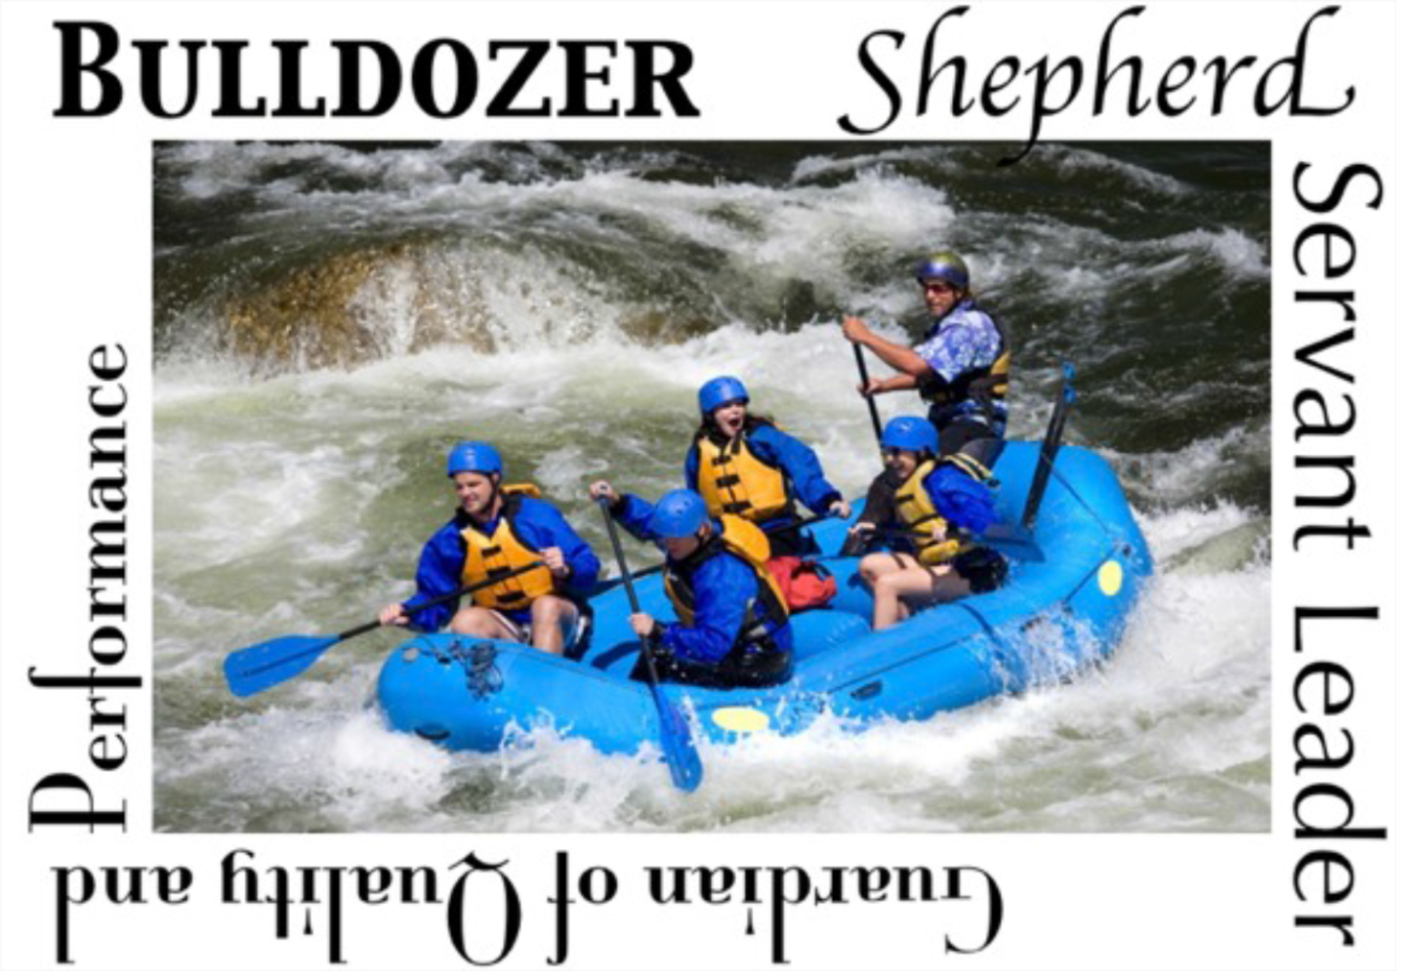

Coaching
This is an activity that considers the team or individuals and works with them for the purpose of helping them reach higher performance levels. Coaching takes place on a number of levels.
The initial level is the Team Facilitator. This is the scrum master. So we can see that the scrum master has a coaching role for the team. This is one way that the job becomes more than simply keeping the burn down chart up to date. The scrum master also is the navigator for the teams agile journey. The rest of the team help with the drive and the entire team provides the vision. In their role as team facilitator the scrum master keeps the team on course for their vision. The team facilitator can work with one or two teams.
Working at the next level up and Agile coach works with the team and the scrum master. The Agile coach also works in the ecosystem that surrounds the teams they are coaching. This role includes skills in facilitation, professional coaching, business and technical focus. The Agile coach works with teams to help keep them focused on their journeys. The coach can be a challenger to the status quo and may often find themselves having to judge how much change a team can manage at a time.
The Enterprise coach works across the enterprise. This role addresses organisation culture and leadership. The challenge is to ensure that Agile adoption is something that drive real business advantage.
In summary coaching occurs at many levels, each essential. Without coaching Agility tends to be driven by the delivery needs. This is local optimisation and these Agile adoptions tend to fail by falling back on bad habits. At all levels the coaches role is to keep the Enterprise/Company/Group/Team on the path to high performance.

Mentoring
Ok, so what is the difference between mentoring and coaching? In a nutshell, coaching have no domain knowledge. Mentors do. These roles are often mixed. For example as a coach I will work with you in the adoption of practices from XP. We can identify those which you do not do now and which would make a real difference to you. We can work out a set of objectives that would put these practices in place.
Then I change my hat. I can now help you understand a practice, for example Test Driven. I understand how it works and what tools can be used to help drive it. I can identify where the teams need some help and I can provide that help. This is mentoring. As a coach I may suggest that for certain topics we find a mentor who is not me. Sadly I am not an expert in everything, so I can coach you to adopt practices, but I may not be able to mentor you in all of them.

Training
Through the above coaching and mentoring activities we can identify where training should be applied. This is the traditional approach to learning. Individuals or teams are identified as having a training need. This could be for certification or for technical skills. Indeed it could be for a wide range of reasons, any of which support the journey for high performance. Coaches often deliver Agile induction training as part of the teams transformation for example.
Training does tend to be based on classroom or lecture settings. This imparts a large amount of information to the students in a short period of time. In order to benefit from this the student need to apply what they have learned. This is where the mentors and coaches get involved in the training cycle. They help to ensure that the knowledge imparted in training is persistent and contributes to the teams performance.

Summary
So we can see that coaching works at all levels. It is also essential. Teams without coaches tend to lose direction. It is no surprise that most executives make use of personal coaches. Meg Whitman does and she has mentioned the impact of her coach in some of here videos to the company. We do need to see coaching in the scope of coaching, mentoring and training. These are all required by the organisation going through a transformation. Within HP the AMO can help you find a coach. Or simply drop me a line.
I can fill many of the roles that a coach provides. Rudder, leader, nag, bulldozer, visionary, Shepard, shoulder to cry on, drill sergeant, teacher, tutor, trainer and change agent.

Create positivity
So no you have your team and you’ve spent some time with them getting to know each other. You also know what you want through your vision. So now reach out and feel the team. Does it have a pulse? How would you know? High performing teams put out an aura that you can feel. It simply radiates. Other teams feel like they are fully staffed by relatives of Marvin the robot from Hitch hikers Guide.
So lets get positive, But can we please do it without those posters that we used to see all the time. They sounded great until you realised that the commitment from the people posting them, was to post them, on the wall, so you can read it, it really sounds good, now get back to work.
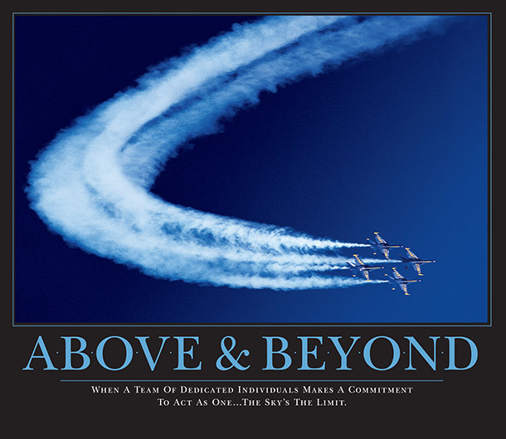
I remember these, they covered the cracks on the wall as they were cheaper than real wall paper. A true example of talking the talk, but not walking the walk.
So how do we create real positivity in the team? One idea is to treat the team like a bank account. If you are in credit, it earns interest, otherwise you can be penalised. So what do deposits and withdrawals look like? This like this:
Deposits
- Personal Recognition
- Acknowledgement
- Respect
- Trust
- Support
- Interested Inquiry
Withdrawals
- Blame
- Defensiveness
- Contempt
- Excessive Advocacy
- Blanking
So how does you bank account with the team look. How is theirs with you?

Understand Team Health
Teams should be healthy, easy to say but what on earth does it mean? When people come to work in the morning are they looking forward to another day of happiness, or is work a drudgery that must be endured so that the bills can be paid. Coming to work is more productive, more pleasant and healthier for you if you actually look forward to it. So I will assume that working with software is something you actually like to do. If not, then find something you do enjoy. But if you enjoy software but not your work then something is wrong, and it could be the team that is wrong.
Do you have conflict in the team? Are there relationships that are not working within or without the team? How does the team deal with these issues. Let look at conflict. Now most people with actively try to avoid this. But in that case it does build up. It needs to be discussed and either removed, or at least placed in a box. If you feel there is no conflict within your team, it may be a matter of time before something happens that will introduce it. The recommendation from those who are experts in team dynamics is that the team discuss their approach to conflict before it happens.
During one of your retrospectives take some time and ask the team to discuss how they would like to deal with conflict. When they are calm and not in conflict they will usually say sensible things such as, please be open and talk to me. In this case get agreement through show of hands. Then when the emotions are running you can then refer back to the calm and remind people that they agreed to be open and to discuss matters.
The model for team health is usually shown as the following diagram.
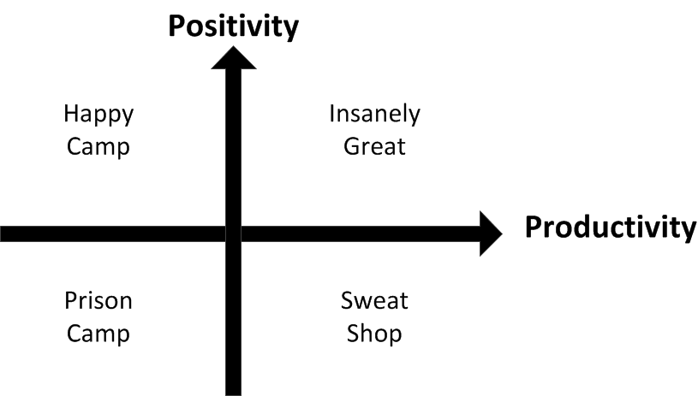
The target, as is traditional is the upper right quadrant. This reflects the combination of happiness and productivity that defines a truly healthy team happy in their work and high performing.

Understanding Team Strengths
Now there is recognition that not all teams are the same. Some are at different places in their journey and of course some have a different technical ability. We can start with the already understood individual skills that we developed earlier, and move this into attributes that apply to the team as a whole. Recall that we were looking for more than simple tick box type of skills matrix, and we do care about more than skills as a coder. Lets assume we already know who the more experienced people are. Who you would go to for Java help and who the most devious tester is. Team strengths start from there and then take off.
Us agile coaches can conduct assessments to judge the agile maturity of a team or organisation. This looks at much more than technical skills and judgesthe team’s ability to learn and adapt. It looks at the team’s adoption of agile behaviours and the success to which the team has built itself into a high performance unit. There are a number of factors that determine the actual strength of a team. Consider
- How long has the team been together? We want teams that spend year together, because they perform. breaking teams up is throwing away your investment in their development
- Does the teams leadership work? This is not the scrum master, but does the team have leaders in all the important areas such as test, design, demonstrations and so on?
- Does the team make decisions, or are they afraid of them?
- Given that the team has defined its vision, how is it performing in achieving it?
- Do the team trust and respect each other, and other teams?
- Does the team value diversity? Or do they try to emulate the hero coder?
- Does the team recognise their strengths and weaknesses and are they working to address them
- Is the team happy?
- Does the team communicate effectively internally and externally?
- Are they proactive and optimistic? Are they creative?
- Does the team have constructive interactions? Do they use conflict effectively
The various attributes above tend to contribute to either the teams productivity or their positivity. Both of these are important for a strong high performing team. The use of a team radar chart is one way to measure the strength of a team. The following is an example of one such chart.
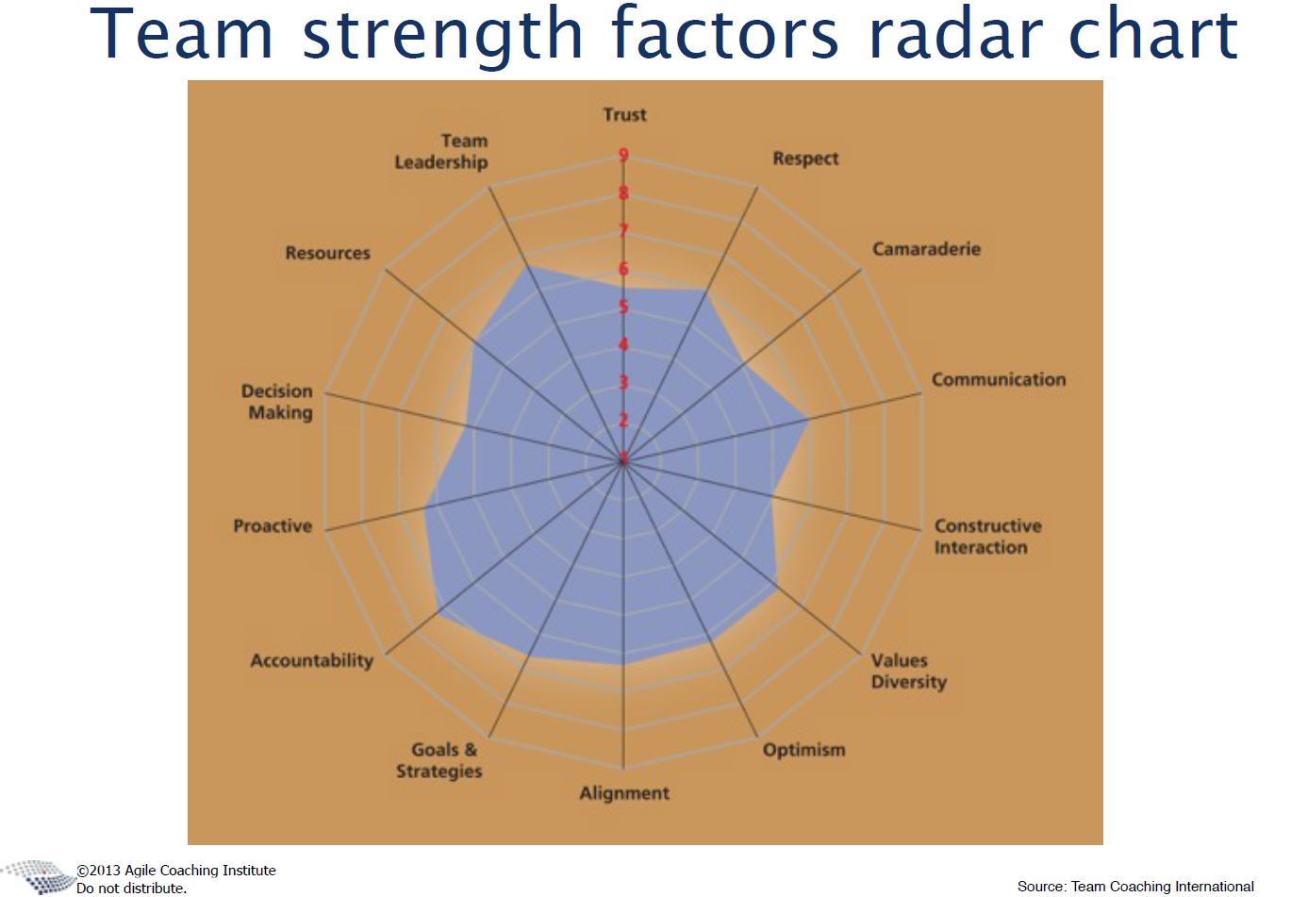
So how do you construct such a chart? Define the number of attributes to measure. For instance in the above there are 14 such attributes. Then give each team member 5 votes per attribute. Each team member can spread these votes between the attributes, up to 10 for each. They don’t have to use all their votes, but they should. Plot these and you will end up with a radar chart like the above. This can be used to help understand the team and to keep it on the path for its agile journey. Do this every six months and see how the team is growing.

Team Space
The agile team needs to have a space that allows it to really deliver. The needs are to develop the team space to encourage the needs of the team.
For example:
- The team needs to be able to look at each other, and not sit back to back
- There needs to be opportunity for discussions with plenty of whiteboard resource
- Communication needs to be supported through the availability of teleconferencing as standard (See Skype or similar as a baseline)
- Break-out rooms need to be available
- The teams information radiators need to be easy to see and review with customers and other stakeholders
- Coffee and such is not optional
While it is important to have a physical environment that encourages team formation and collaboration there is more to an environment. For starters there is also the technical environment that the team use. This needs to support the various technologies and techniques that the team employees. For instance, whatever stack you are using you will need an IDE. VI is not an IDE. This IDE will integrate many things for you. For example if you are using eclipse you may access the following using this tool.
- Code control such as SVN, GIT or starteam
- CI such as Jenkins
- JUnit
- PMD
- Findbugs
- Checkstyle
- and many others
Visual Studio will have a rich list of such tools as well.
Along with these tools there are other automated testing frameworks such as:
- selenium
- Sikuli
- A wiki and other such tools for communication
- Defect management
- An office package, apparently Microsoft make one, but so does LibreOffice
- This list is endless really
- An agile management tool such as Agile Manager, Rally, Jira …
The team need to be able to employ tools as and when they add value to the process. The HP service platform is a great place to get started.
I believe that the technical environments should be virtualised and that establishing the development environment on a laptop should be something that can be done in under 1/2 hour.
The next space is the most important space, the teams social and emotional space. This consists of the teams vision and the culture that they are creating. I would recommend that the team create some guidelines that they follow. For example
- No mobile phones in the ceremonies without prior agreement issued in exceptional circumstances. (My wife is pregnant and may be entering labour soon)
- If you’re late to a stand-up withour reason, you bring doughnuts to the next one
- If you break the build you must fix it before doing anything else
- No cheating on the done definition
The team must learn to trust each other. This is re enforced by the social space that the team creates. This provides a safe place for people to be. If a mistake is made, the team will know what happened. But to the outside world the team made the mistake. One for all and all for one. People need to feel that they can have robust debate with their team members. This will create an environment where people can perform as a team. They will be open about going to each other for help, or to engage in pair work. People outside of the team will feel the buzz.

The start-up or reset process
The team is now understood in principle. We know the people and the spirit that they bring to development. This is the time to form the team and to light the fires. At other times teams that have been together for some time need a little boost. This is also possible. Let’s examine the whole team start-up process now.
We have a number of steps that have been mentioned in this series, but we need to consider our starting point. Has this team a consistent and clear understanding if Scrum and Agile? If not using scrum, then of the approach that will be taken. If not an Agile 101 course is required. This will be minimum of one day but two days are clearly best. This will cover details such as:
- Agile culture and the Manifesto
- The scrum ceremonies
- The XP practices
- User Stories, creation and estimation
- SAFe and the planning performed in SAFe
- Exercises and experiments
During this course with the whole team the coach will draw out a number of exercises to get the team to understand themselves better. Radar charts will be filled out and constellation games or similar will be played. The coach will invite team members to apply for certification so that they can be seen to have a good understanding of the Agile Values and Principles.
Once this training period is complete the team should next perform the steps as originally identified
- Establish Vision
- Understand the individuals
- Coaching, training and mentoring
- Create positivity
- Understand Team Health
- Understand the team strengths
- Team space
These steps will establish the team at the edge of agile practice. Let’s assume that the technical environment can now be established. The team is sitting in their wonderful Agile space and raring to go. The next steps is ot get them together with the product owner to perform what is called the grooming, or elaboration ceremony. This is where the team is expose to the backlog and are invited to ask questions and to play poker to come up with their sizing estimates. The product owner may well have some VROM estimates for the stories at this time. These should be kept secret until the team has provided their sizing estimates. Otherwise the effect of anchoring can occur.
While this exercise would normally be expected to take about 2-4 hour (assuming a 2 week sprint), the first time through will take longer and the coach will stop the process to explore some of the dynamics that are happening.
With the elaboration ceremony completed the team can now perform their first sprint. Again the coach will hep them through their first planning session, and this will take longer than the expect two hours. The coach will spend much of the first sprint with the team, again with special focus on the retrospective. this first sprint is important as it establishes the pattern for the team going forward.
A re-set of a team is an edited version of the above. The coach will check the teams understanding of Agile and will tailor the reset to focus on specific points.
Both of the above events will be preceded by an Agile Readiness Assessment. The results of this will be discussed with the team and the management involved. This will usually form an Agile Transformation Office which will create and monitor the teams Agile Transformation. The coach will be a constant companion during this journey and will assist as needed.
All you need now is some luck, never be without it.

The Whole Team
The team is now poised on the brink of high performance. They have spent time to work out who they are and how they are going to go forward. They started life as a working group, but are now on their way to being a real team.
As a coach we have noticed that teams are sometimes formed by a group of people being identified and told that they are an agile scrum team, so get started here is your backlog. This approach often fails, for what we can now see are fairly obvious reasons. These reasons seem to rarely result lessons learned strangely. However, when we do have teams that work together and are really high performing the time spent to build the team looks like a great investment. It is these teams that really stand out and continue to set new levels of performance as they stay together and keep on trying to be better than they were yesterday.
High performing teams spend time to grow at a team and individual level. This is one of the characteristics of such team. The Agile retrospective is one of the main tools that they employ, along with the simple collaboration that is practised on a daily basis. The scrum master role is one that starts out with a coaching and guidance responsibility. This role helps the team to establish itself and become self managing. Once the scrum master has established the agile culture within a team, it has been noticed that the role reduces in its demands. This is a great success for the scrum master as they now know that the team is truly acting and think as one agile spirit. They only need to have a backlog and they will perform. When problems are detected the team will resolve them, often without the need to engage outside of the team itself.
Teams that behave like this have taken control of themselves and strive to become higher performing. They do not need management control, in fact they could be used to help other teams develop through relationships using communities of practice. As a coach I have created teams that I could back away from, much as a parent sends their children out into the world, having prepared them for the adventure. This is a great feeling, even though you are no longer actually needed.
Teams need to constantly revisit their vision and charters. they must look at where they can improve and grow. These teams have taken a collective ownership of themsleves, they have become self managing and work to continually improve their performance. This is not a slave camp, the advances in performance are achieved and are sustainable. The team works together to ensure that they look forward to working together. They support each other butg also challenge each other.

