Introduction to MyCSW:

MyCSW provides the CSW with another method for quick access to client case information. MyCSW is used best to access a map that provides CSWs with a visual representation of where your clients live. This allows for the identification of clients that live in the same area and increases CSW efficacy in scheduling clients. The calendar in MyCSW is an additional visual representation of tasks that need to be completed for each case. Also, this guide assists CSWs in accessing payment information for clients to see when the last Clothing Allowance and School Clothing Allowances were issued in addition to seeing the rates that caregivers are receiving and when they began to receive that rate.

Objective:

Provide CSWs with information that can be accessed that can improve service delivery and reduce workload.

MyCSW includes:
- Children on Your Caseload
- Emergency Response Referrals
- Scheduling for Contact
- Map - Shows you where your clients live on a map
- Category View Items
- Calendar - Visual set of reminders for your case (Medical, Dental, Educational, SDM & FSNA and Notices/Court Reports)
- A CSW Forum
- Quick access to payment information



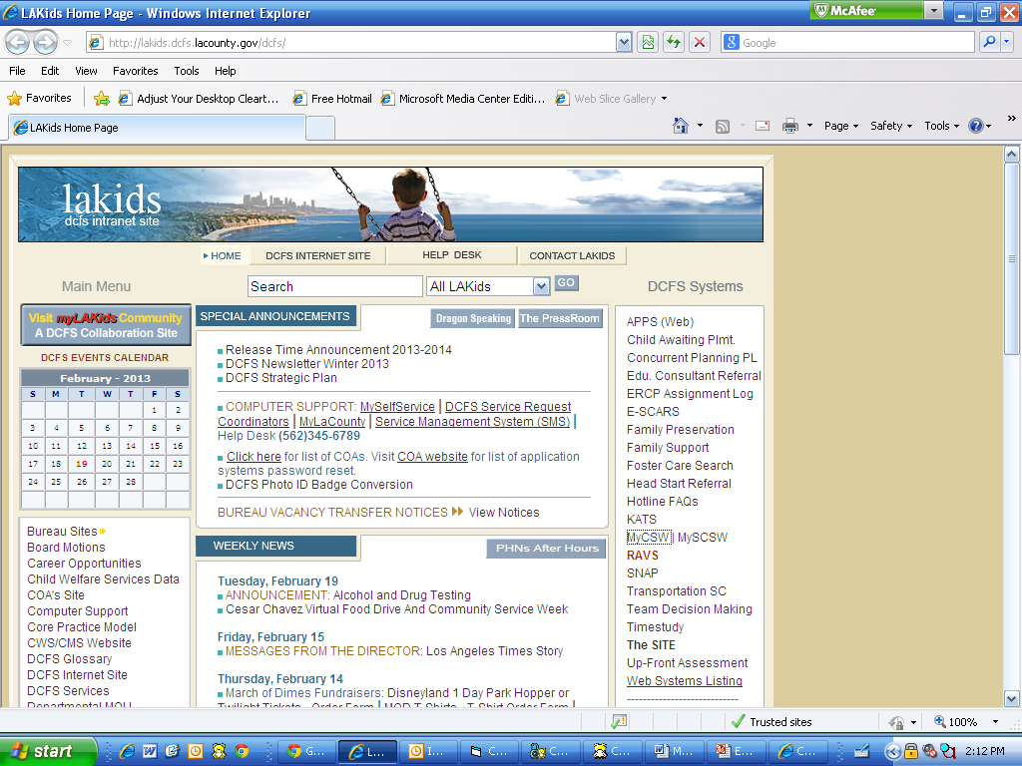
First Time Log-In Process
Step 1

Access MyCSW by clicking on
the shortcut from LAKids
“DCFS Systems” column on the
right-hand side of the page

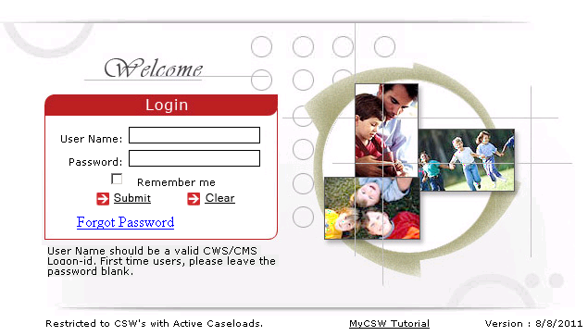
Note:
Login –

NOTE: You should have already created a
Password to log into MyCSW and there
is no need to create a new one

Username: First 5 letters of your last name
followed by the first letter of your first name
e.g.: Social Worker = WORKES
Password: Eight characters with a number and
CAPITAL letter (for extra strength add a punctuation)
e.g. G00D2GO!
*The Password is likely the first CWS/CMS
password you created

If you need your password reset, contact the DCFS Service Desk, (562) 345-6789.

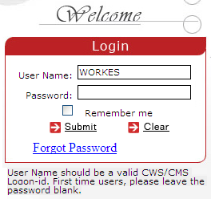
Step 2

Enter your USERNAME and PASSWORD.
Then Click “Submit”

Step 3 – Access Map

Click on the “View Map” tab
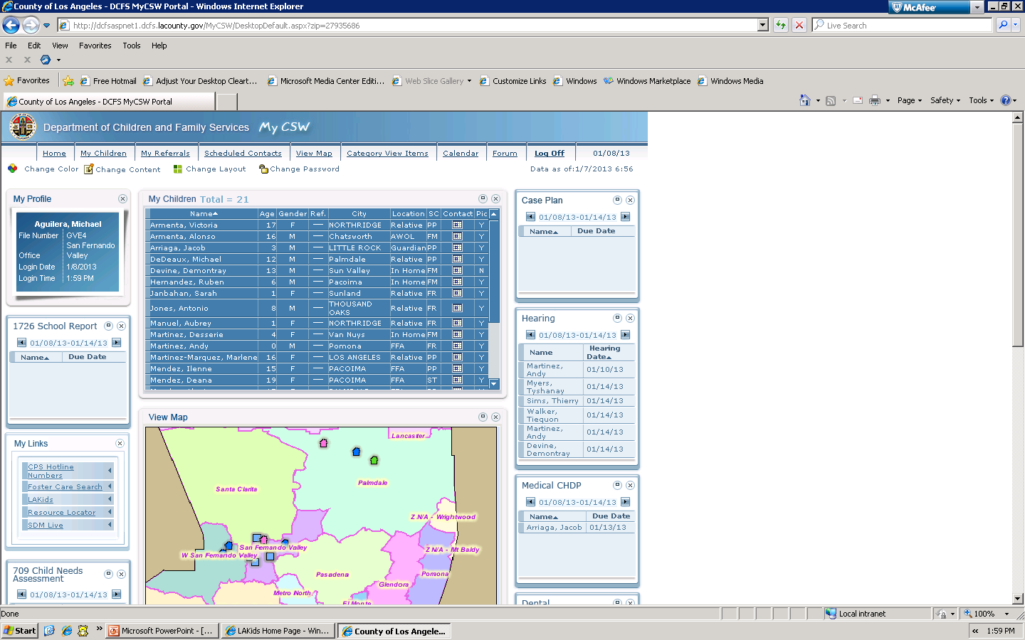

Step 4 – Access Map

Then the Map will appear on screen. You will be able to see where your clients reside and plan your contacts in the most efficient way possible when factors allow.

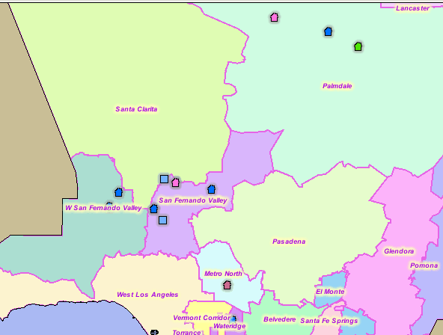

Legend

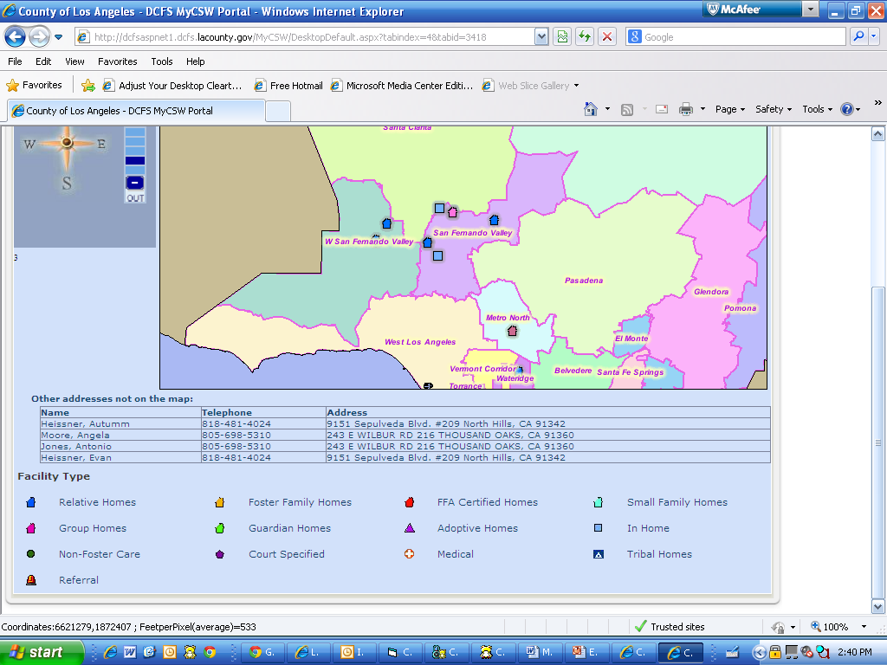

Step 5 – Access Calendar

Next Click on the “Calendar” tab.

Step 6

Then the Calendar will appear on screen. You will be able to see what is due for each of your clients. To the right of the screen can see a partial list of what each icon indicates. MyCSW will allow you to plan what documents you will need to take with you for case management.

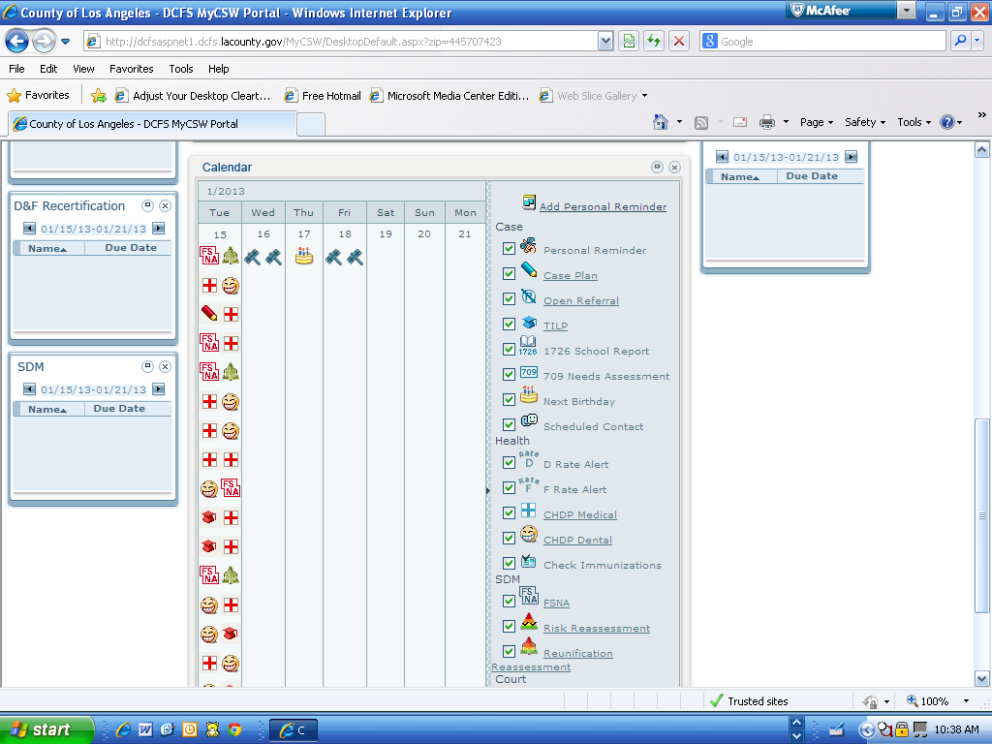

Step 7 – Accessing Cases

Click on the “My Children” tab

Step 8

Double Click on the name of the child whose information you want to access.

Step 9 – Accessing Payments
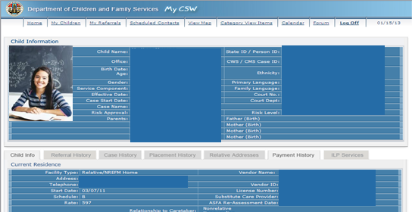
Click on the “Payment History” tab

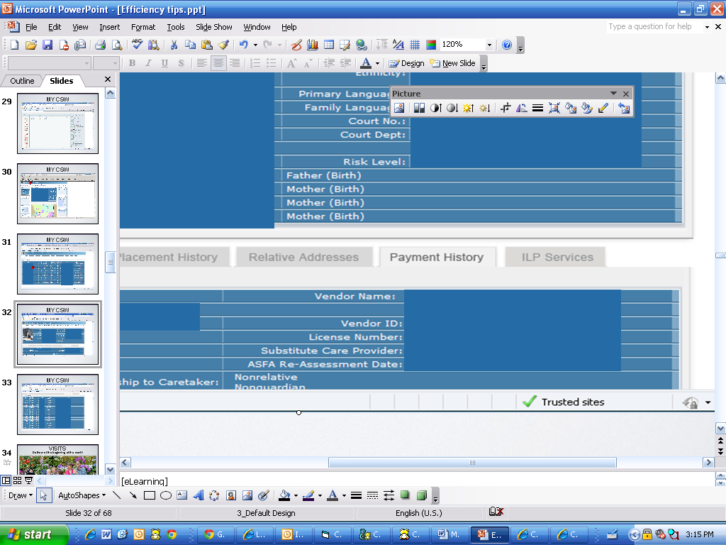

Step 10

Step 10 – Accessing Payments

Then the Payment History page will appear.

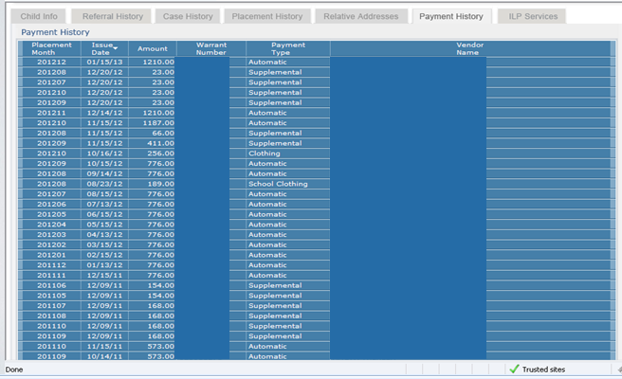

Congratulations! You have successfully accessed the Payment History! Here you can see the month the caregiver was paid for, the date the check was issued, the amount they were paid and what they were paid for (e.g. Automatic – Monthly payment, Supplemental – medical / medication reimbursement, Clothing Allowance or School Clothing Allowance, etc.)

