Introduction to SNAP (Simple Notice Application):

SNAP provides the CSW with quick access to Court Hearing information. When you receive a new case you will then have access to a court hearing calendar and an ability to Notice all parties including parents, caregivers, attorneys and children.

Objective:

Access a pre-populated list of upcoming hearing with the ability to notice for each hearing. Notices for all court hearings can be populated on CWS/CMS or through the Simple Notice Application (SNAP) system. SNAP is a computer system designed and maintained by County Counsel to help social workers fulfill court notices requirements, including ICWA notices. In SNAP, all court information comes directly from JADE, while all social work information comes from CWS/CMS. SNAP helps alleviate the burden of remembering hearing dates, who is required to be noticed and the method of service required.

SNAP Includes:

- Court Hearing list
- Ability to Notice:
  - Parents
  - Attorneys (via email)
  - Children (age 10 and older)
  - Caregiver
- ICWA Notices

Benefits of using SNAP:

- If a parent is incarcerated, the In-and-Out or Statewide removal order is prepared via SNAP.
- When a removal order is created in SNAP, SNAP automatically creates two notices for that parent, one addressed to them in the facility and one to their last known address.
- If a parent resides in Mexico, SNAP will automatically generate all required forms of service pursuant to the Hague Convention.
- It is strongly recommended that SNAP be used for ICWA notices as it provides the ability to communicate with County Counsel attorneys prior to mailing ICWA notices.
- This will help increase the probability that ICWA notices will be correct the first time, thereby reducing the social worker's workload



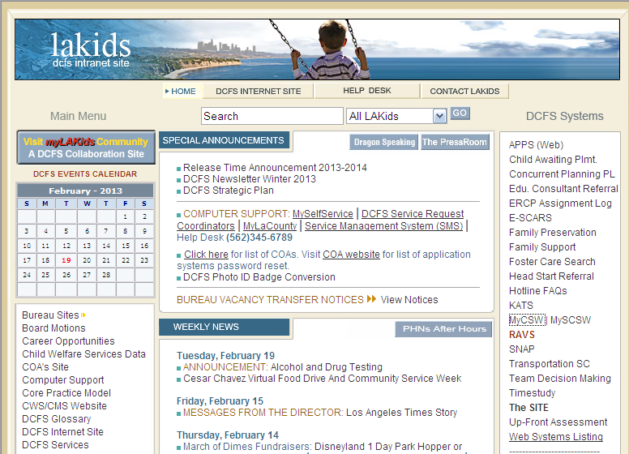
First Time Log-In Process

Step 1
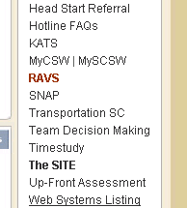
Access SNAP by clicking on
the hyperlink in the DCFS Systems
column on the right hand side of
LA Kids.

Note:
Login –

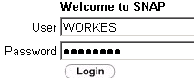
NOTE: Your Username and Password for SNAP is
the same one as your CWS/CMS.
Username: First 5 letters of your last name
followed by the first letter of your first name
e.g.: Social Worker = WORKES
Password: Eight characters with a number and
CAPITAL letter (for extra strength add a punctuation)
e.g. G00D2GO!
If you need your password reset, contact the COA in your office.

Step 2

Enter your USERNAME and PASSWORD.
Then Click “Login”

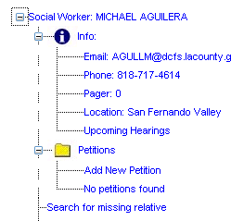

Step 3

Click on the “Upcoming Hearings”

Step 4

Then Double Click on the child’s name.

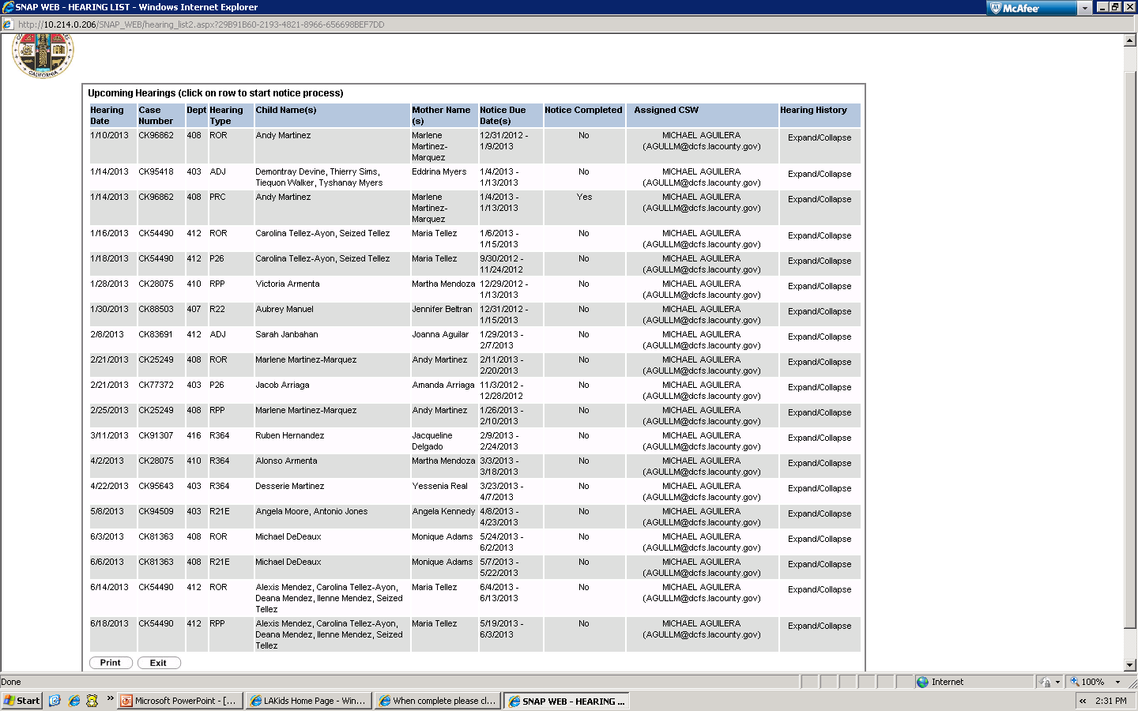

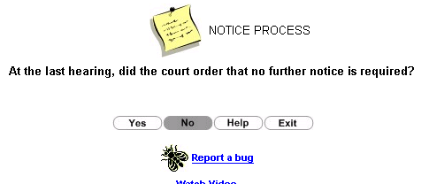
Step 5

Next Click on “Yes” or “No” indicating
if the court previously ordered no further notice.

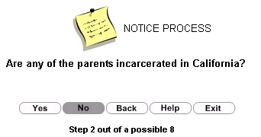  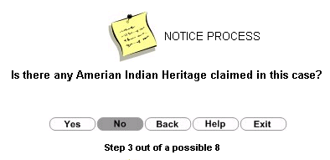  Step 6  Next Click on “Yes” or “No” indicating  if the parent is incarcerated in California. |  | Step 7  Next Click on “Yes” or “No” indicating  if there is any American Indian Heritage.
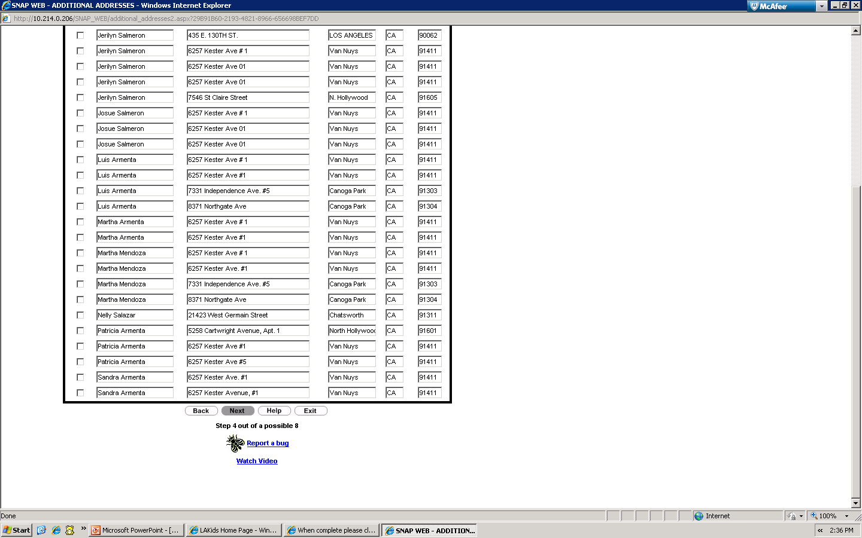  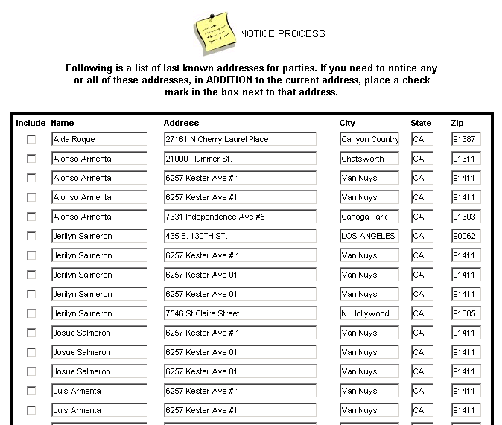  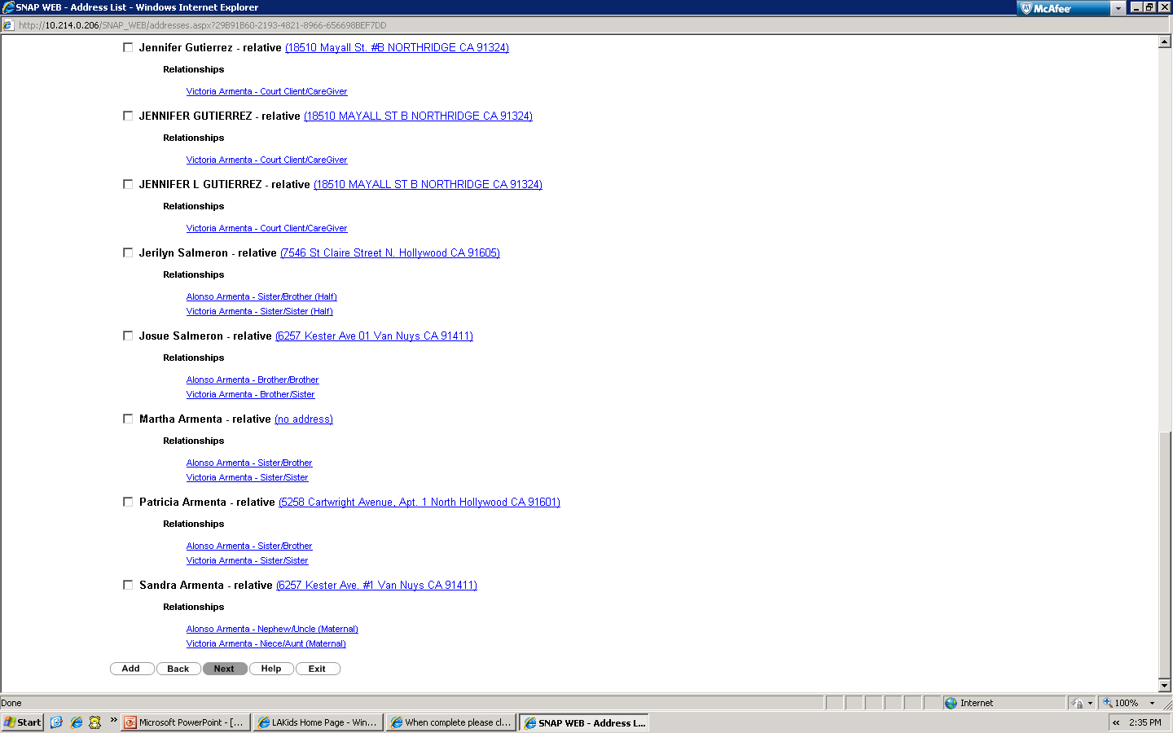  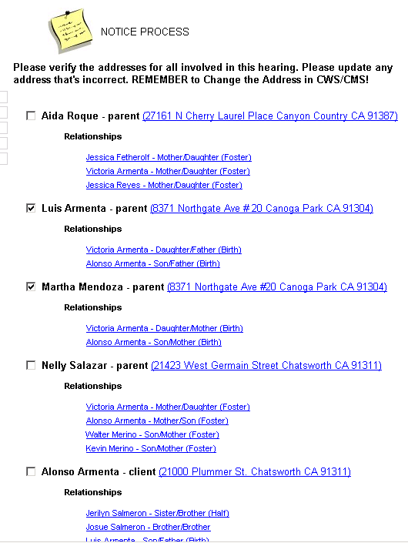  Step 8  Check boxes for all parties to be noticed and click “Next” | Step 9  Choose any another Last Known Address to notice and then click “Next”
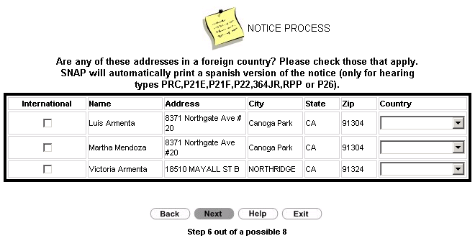  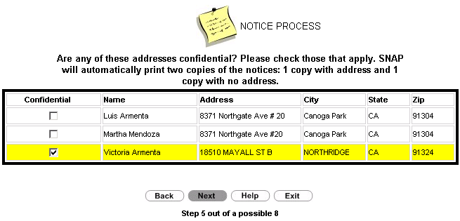  Step 10  Check boxes for confidential addresses.  Then click “Next” | Step 11  Check boxes for foreign addresses.  Then click “Next”

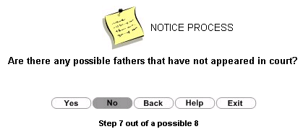
Step 12

Next Click on “Yes” or “No” indicating
if there are any possible fathers that have
not appeared in court.

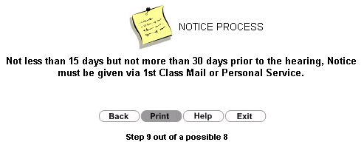  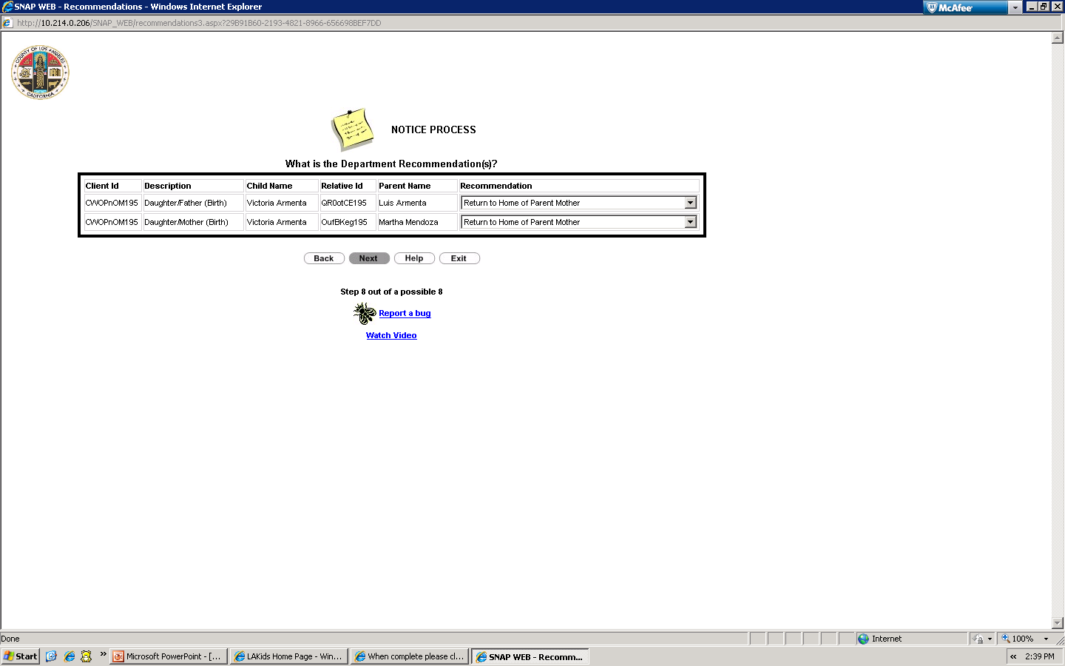  Step 13  Select your Recommendation from  the Drop-Down menu.  Then click “Next” | Step 14  Verify that you are noticing within the legal timeframe. The click “Print”

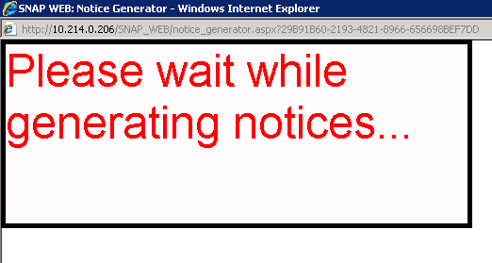  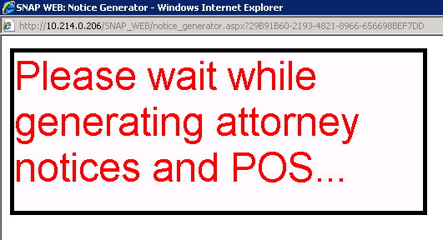  Step 15  You will then see the window below that  indicates that your notices are being generated. | Step 16  You will then see the window below that  indicates that your attorney notices and proof of service are being generated.

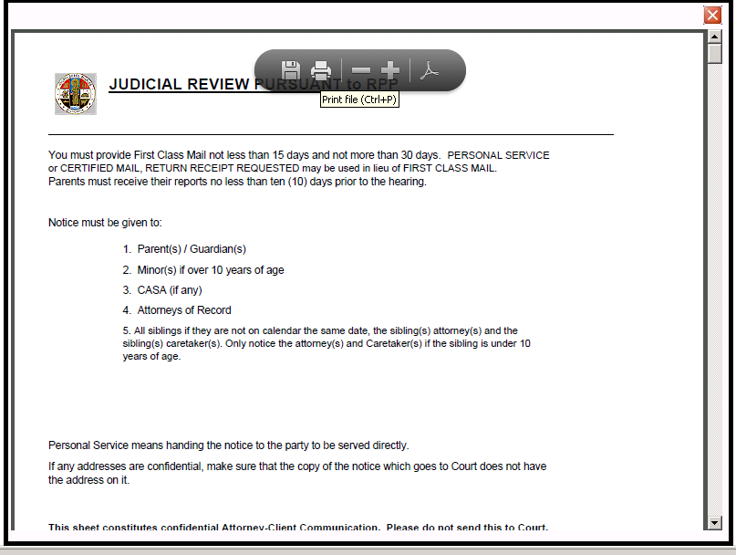  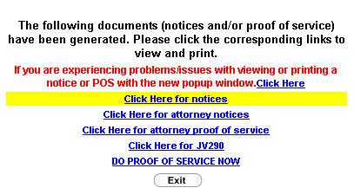  Step 17  Double Click on the  “Click here for notices” hyperlink. | Step 18  Click on the “Print” icon to print  the notices.

Step 17

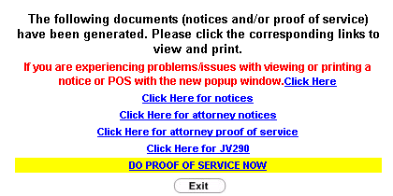  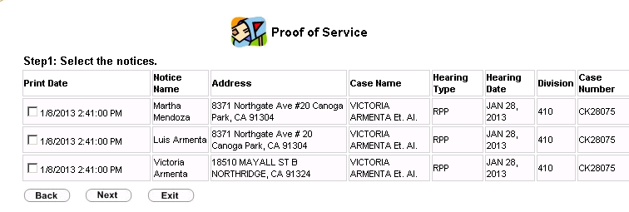  Step 19  Then click on the “Do Proof of Service” hyperlink. | Step 20  Select the boxes for all the notices.  Then click “Next”

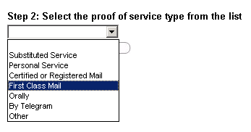  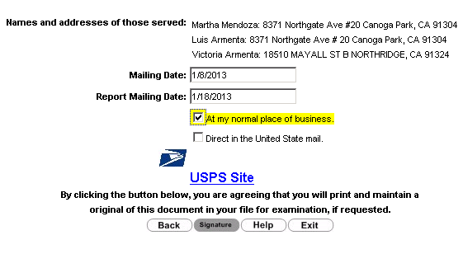  Step 21  Select the method used to serve notice.  You will usually select “First Class Mail.”  Then click “Next” | Step 22  Enter the notice mailing date, the date you mailed the Court Report, select “At My Normal Place of Business” and click “Signature.”

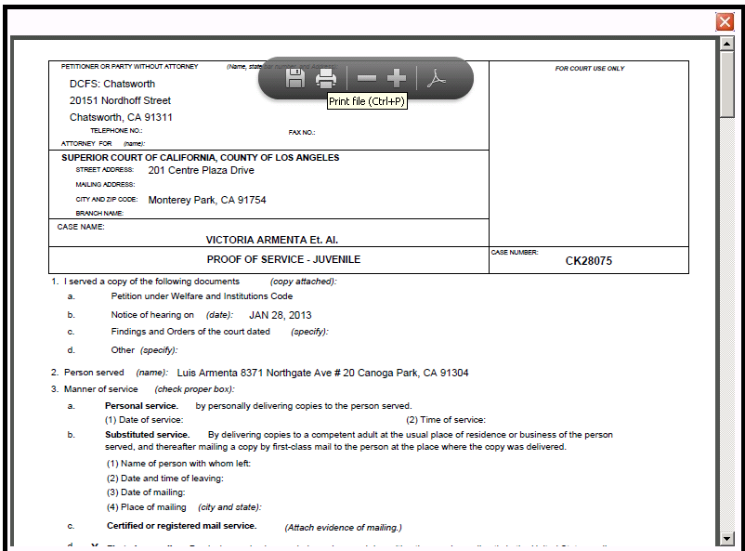  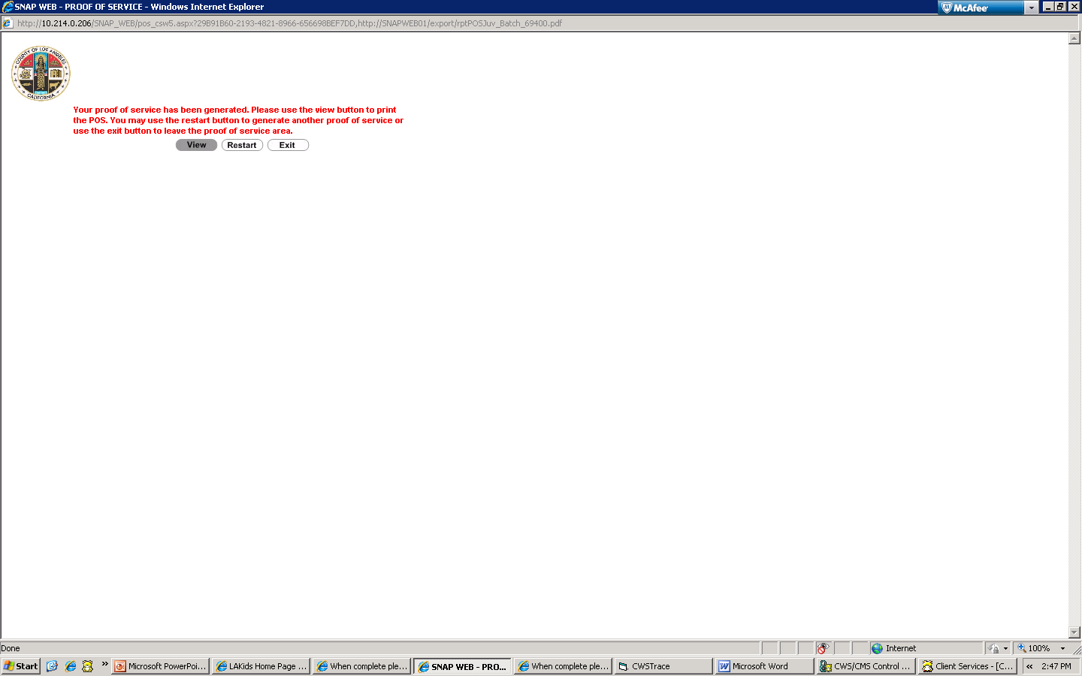  Step 23  Now your Proof of Service is ready to be generated. Click “View” to proceed. | Step 24  Enter the notice mailing date, the date you mailed the Court Report, select “At My Normal Place of Business” and click “Signature.”

Congratulations! You have successfully competed generating the Notices and Proof of Service!

