IGN Code Foo Test

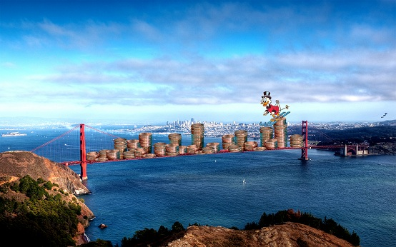

1. How many pennies can fit on the Golden Gate Bridge?
2. Assuming that the conditions of the Golden Gate bridge are optimal (no wind, no motion, no cars, no kids playing with my coins!)
3. The bridge’s dimensions from toll booth to toll booth are 2,788 m while the width of the bridge is 27 m.
4. This computes to 75,276 m of ground area
5. Unfortunately, since the bridge has a live load capacity per lineal foot of 1,814.4 kg, we may only add this much pennies per lineal foot.
6. Pennies are .0025kg each, therefore one lineal foot of the bridge may contain 725,760 pennies.
7. 75,276 meters converts to 246,968.504 square feet
8. Multiply by this by the number of pennies you may have per lineal foot and you get 179,239,861,463.04 pennies.
9. 16:9 ratio images in 12 increments can be in dimensions of 1920x1080, 1280x720 and 1600x900.
10. I have attached a file named IGN.java that demonstrates the minimum amount of moves required for a knight to traverse a chess board is 21 if there are no overlaps.
    1. The x axis represents the move number while the y axis represents the number of spaces covered.
    2. We can see that the first move will naturally cover 4 spaces; this is due to the design of a knight’s movement.
       1. Knights move 4 unique spaces on their first move and then 3 thereafter since the root space that is landed on is used as the root of the next move.
11. I have attached a text adventure game called “Adventure.java.” Please Check it out.