**How It Works** *(available only when logged in)*

We created this community for you to share your thoughts, opinions and ideas to help us improve what we do. At regular intervals we will invite you to join in new sets of activities.

The community is available to invited members only and is accessible through a password-protected site. As a valued employee, you have been selected and invited to join this community. We will invite you to new activities that we think will be of interest to you over the coming weeks, and we'll reward you for your efforts.  
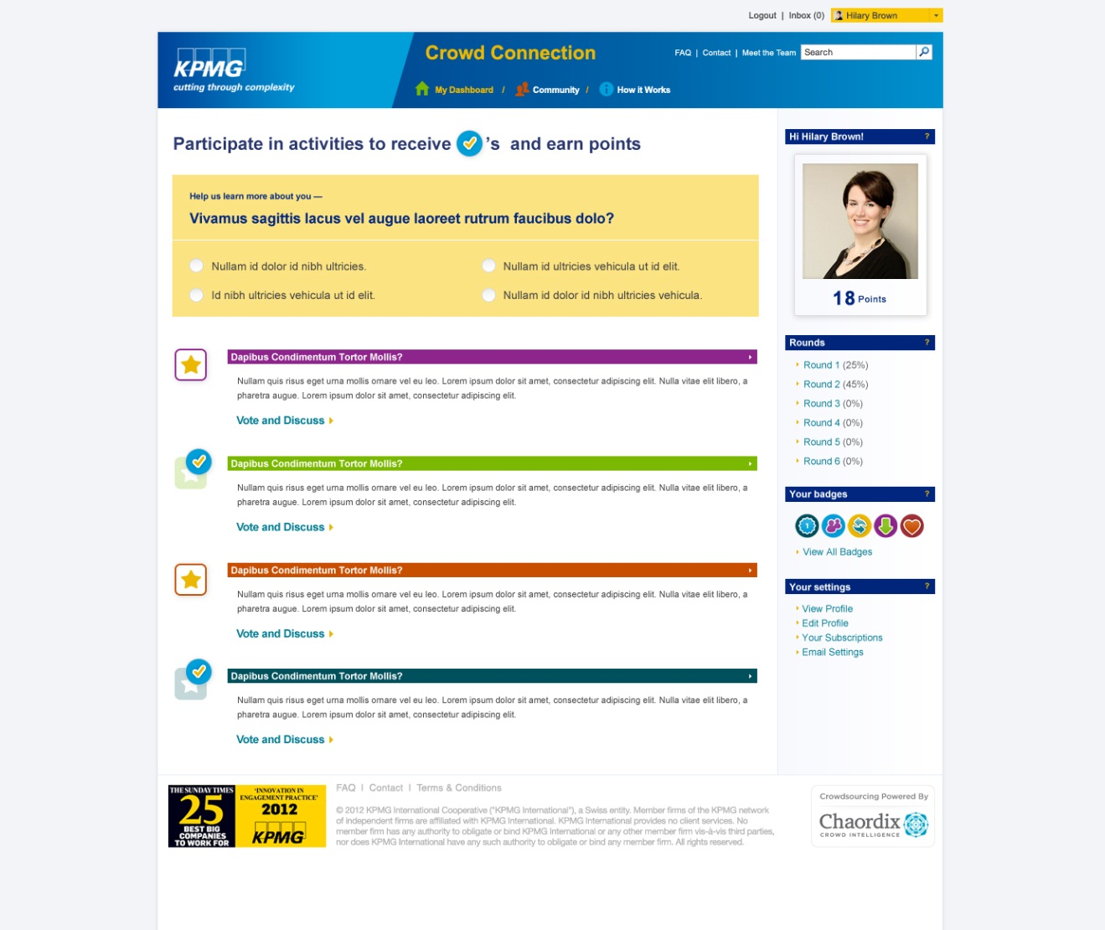

Activities are displayed under the Dashboard. You can also find out what is happening (and keep up with these discussions) from your Dashboard where you can find out who has commented on what, and when.

* Activities will be posted on the My Dashboard page
* Click on an activity underway
* Make comments and vote on other participants' submissions
* Share your ideas on the topic at hand by making a submission that will be shared with other Community members for their comments.

**It's quick and easy to participate in the activities -**

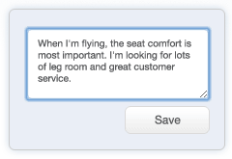

Lorem ipsum dolorsit amet, consectetuer adipiscing elit,

sed diam.

## Submit

Share your ideas and join discussions.

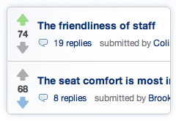

## Vote

Vote on ideas that matter to you.

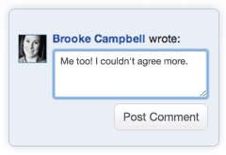

## Comment

Weigh-in on other members’ ideas.

## Get Recognized

Participating earns you entries into grand prize draws! Learn more about Rewards.

**Need More Information?**

Our Help page contains frequently asked questions and contact information. View Help section.