**How It Works**

This community is available to consumers like you. We will invite you to new activities that we think will be of interest to you over the coming weeks, and we’ll reward (link to rewards page) you for your efforts.

**Help us build a picture of how the UK maintains a healthy family and a happy home.**

This community is your chance to express your thoughts about products and processes around your health and your home. Your input is valuable and will have a real impact. We want to hear from you how we can improve products in these areas in the near future.

**Here’s how you can participate and have your say!**

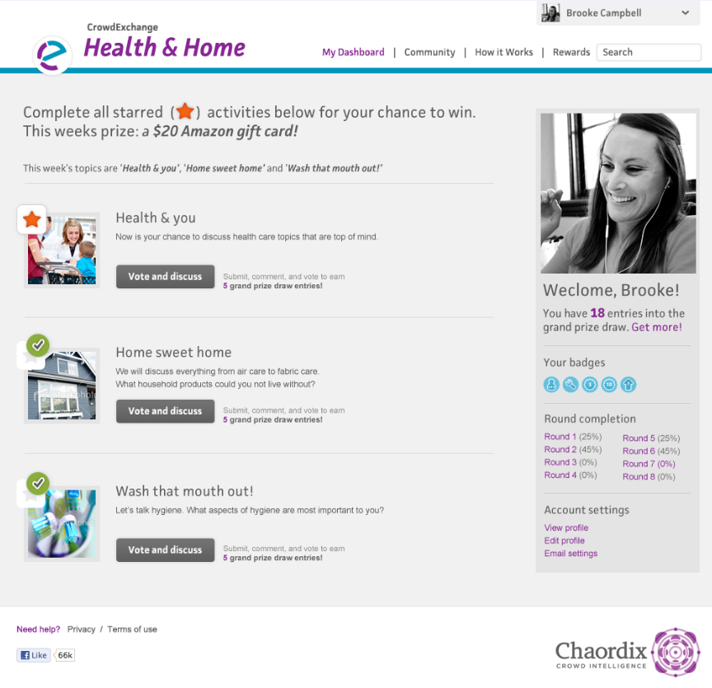

Discussions are displayed under My Dashboard (link to my dashboard). You can also find out what is happening (and keep up with these discussions) from My Dashboard (link to my dashboard) where you can find out who has commented on what, and when.

## It's quick and easy to participate in the activities –

* Activities will be posted on the My Dashboard page (link to my dashboard)
* Click on an activity underway
* Make comments and vote on other participants' submissions
* Share your ideas on the topic at hand by making a submission that will be shared with other community members for their comments and responses.

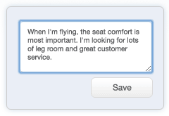

Lorem ipsum dolorsit amet, consectetuer adipiscing elit,

sed diam.

## Submit

Share your ideas and join discussions.

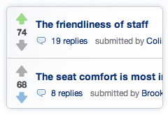

## Vote

Vote on ideas that matter to you.

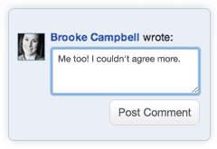

## Comment

Respond to other members’ ideas.

## Get Recognized

Participating earns you entries into weekly and grand prize draws! Learn more about Rewards(link to rewards page).

**Need More Information?**

Our help page (link to help page) contains frequently asked questions and contact information. View help section (link to help page)